The Chocolate Room - The Hotel's Best Kept Secret

January 17, 2018, Milan, Italy

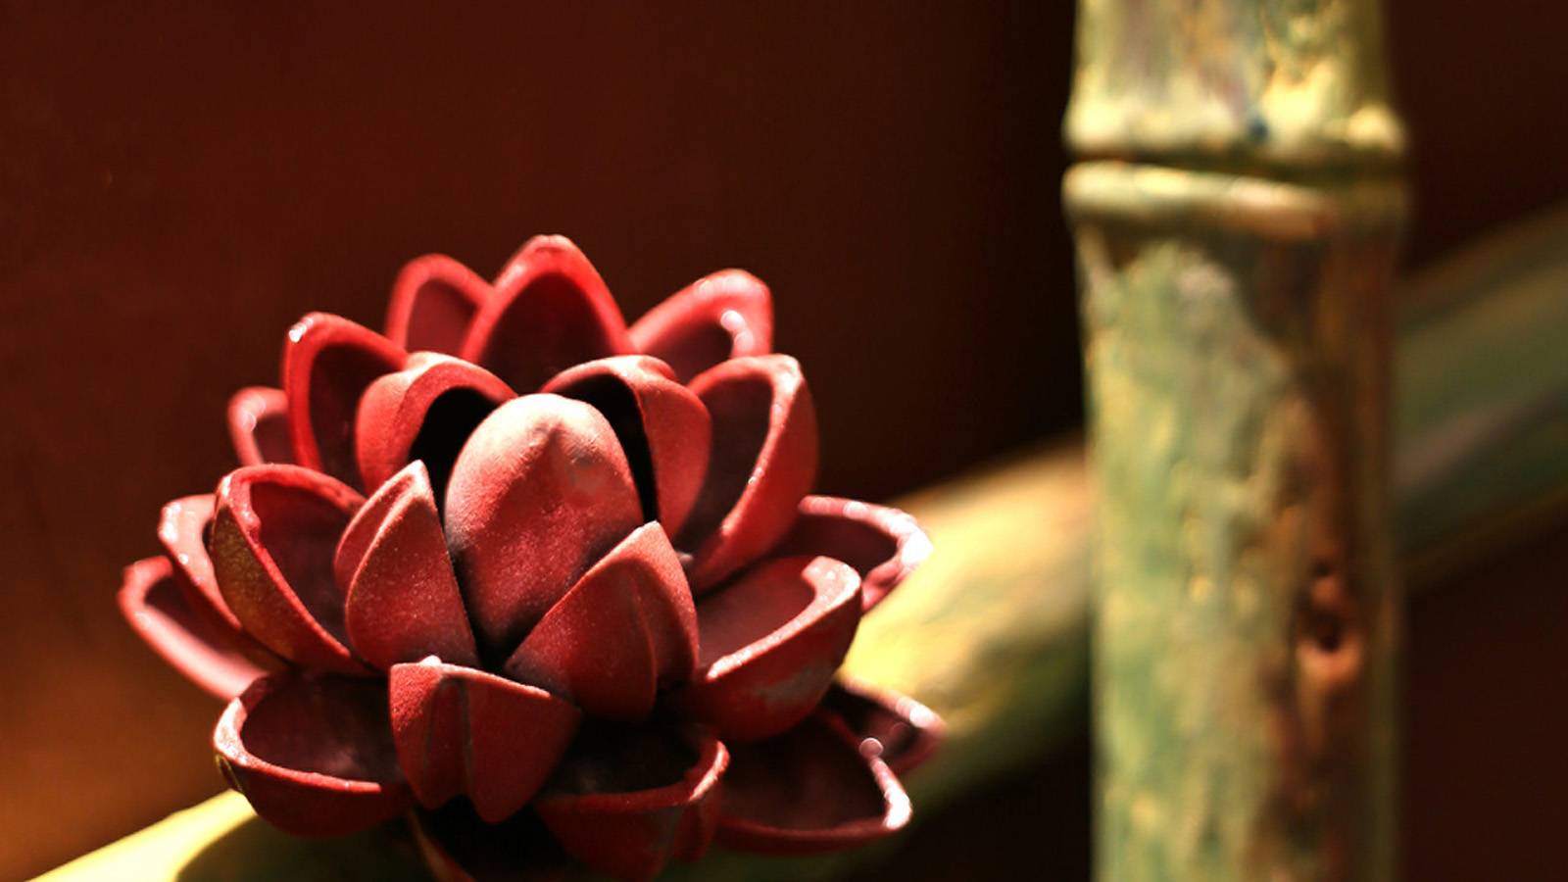
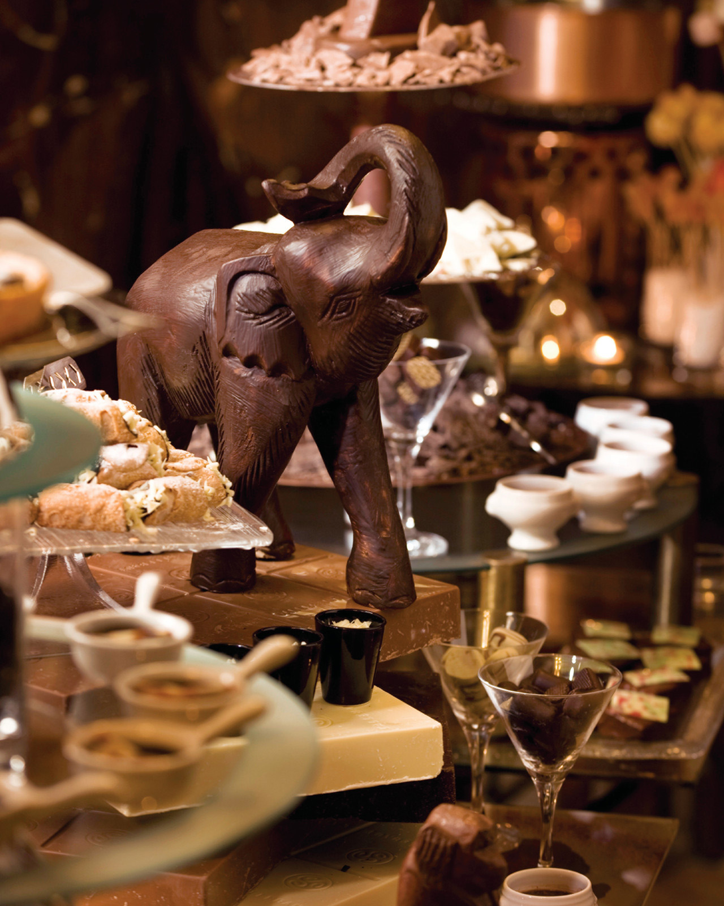 | 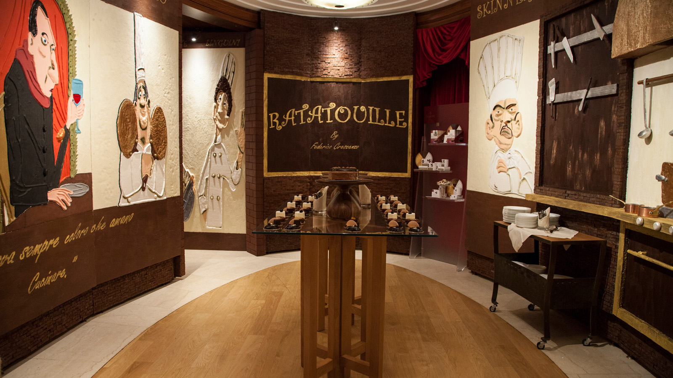 | 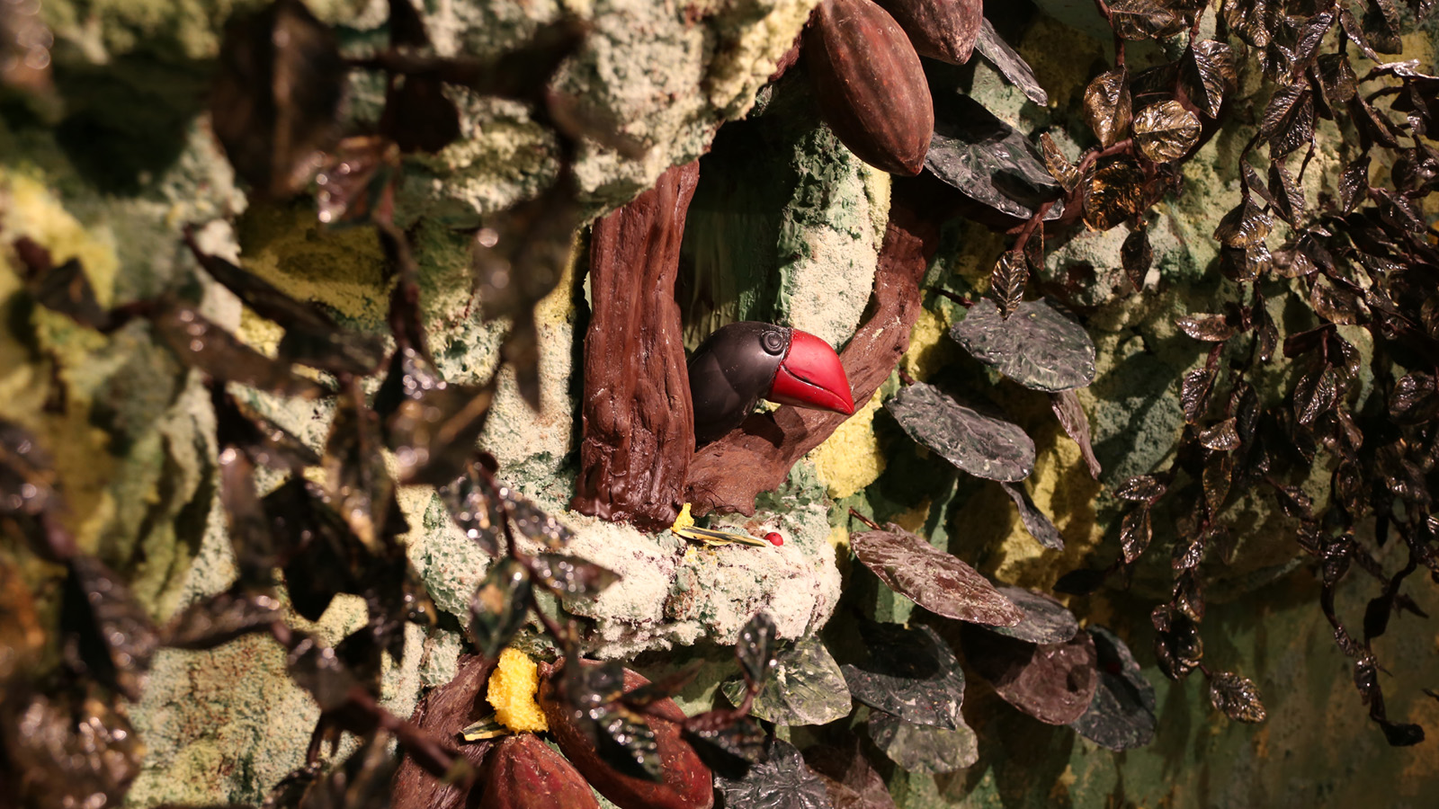
Since its creation in 2007, the Chocolate Room at
Four Seasons
Hotel Milano has become a must-see for Hotel guests and locals alike on the occasion of the seasonal Sunday Brunch.
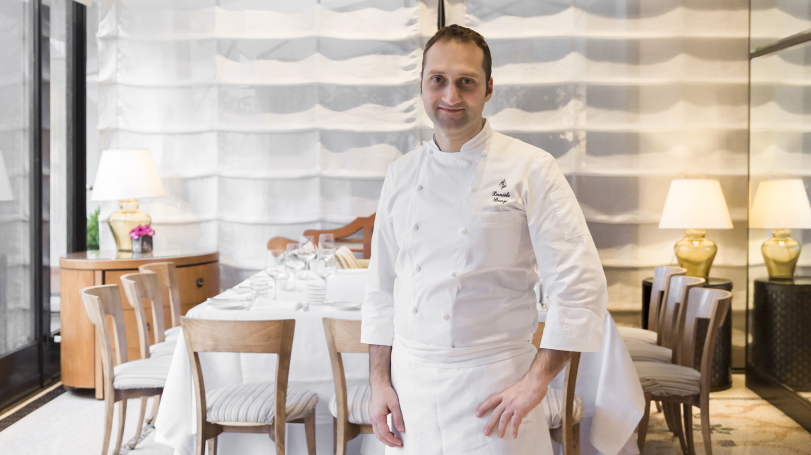
This room entirely decorated in chocolate creates the surprise every year with a new theme. It has successively taken the form of a cinema set, with a Ratatouille-themed lounge, and more recently, of a chocolate factory. Recently, the Hotel's Pastry Chef Daniele Bonzi has created the décor of a tropical forest, as a clin d’oeil to the origins of where cocoa beans grow.
It features jungle-inspired vegetation and décor with exotic animals, all entirely made of chocolate - including the walls. As they step in, guided by the appetising aromas of chocolate, guests are greeted by colourful butterflies, toucans and ladybirds who have comfortably settled into their home among the bamboo, tropical plants and water lotus flowers.
No less than 300 hours of work and 300 kilograms (660 pounds) of chocolate were needed to bring this chocolate masterpiece to life. The result is breathtaking and seems so real, temptation is high to touch and taste to believe it is all 100 percent chocolate.
Open during the Sunday Brunch, the Chocolate Room can also be booked for a private event such as a memorable family chocolate breakfast or a sweet afternoon break filled with all chocolate pastries.

RELATED

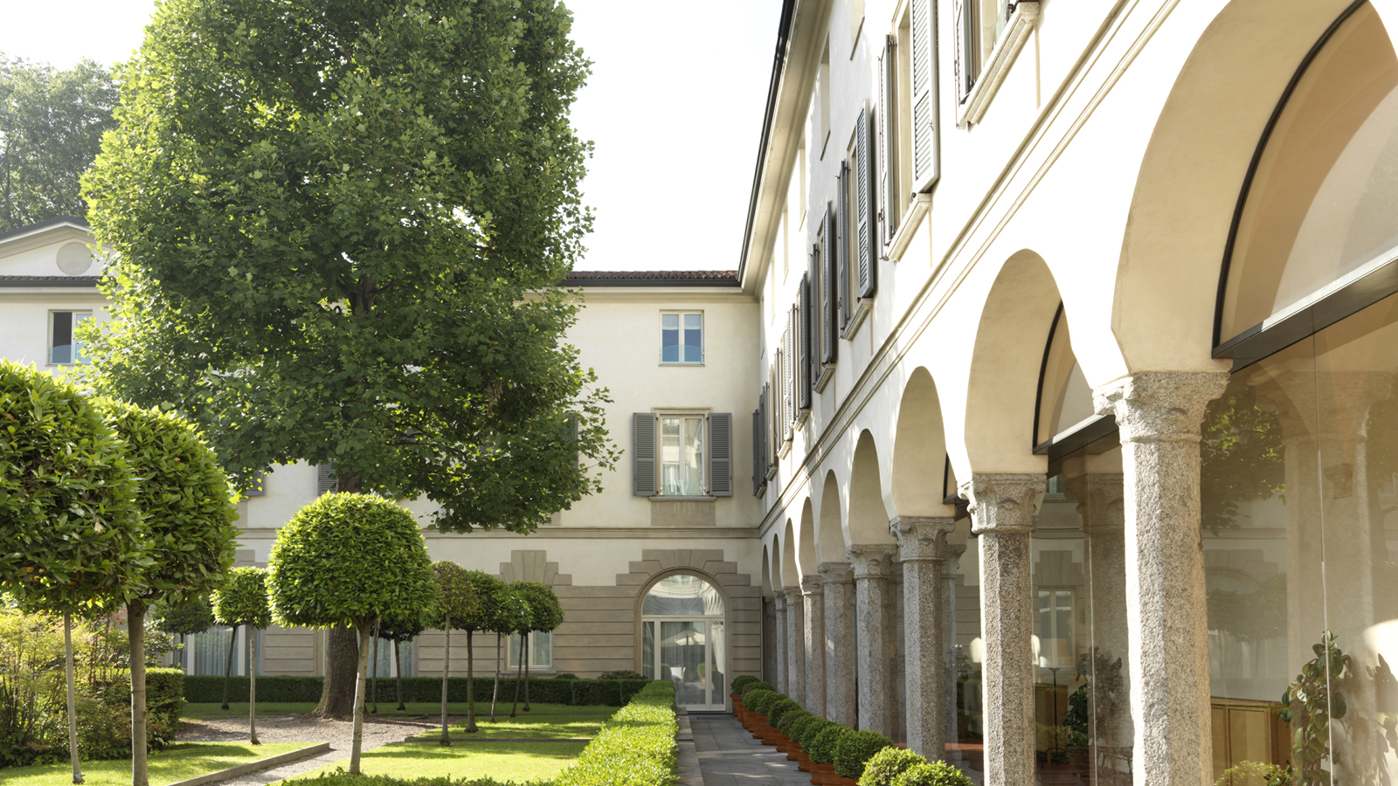 | May 22, 2018, Milan, Italy  Four Seasons Hotel Milano Celebrates Global Wellness Day  https://publish.url/milan/hotel-news/2018/global-wellness-day.html
May 22, 2018, Milan, Italy
Four Seasons Hotel Milano festeggia il Global Wellness Day con un programma di benessere e un pranzo salutare nel giardino dell’Hotel a sostegno dell’AIRC
https://publish.url/it/milan/hotel-news/2018/global-wellness-day-2.html

PRESS CONTACTS

Caroline Mennetrier
Director of PR and Marketing Communication
Via Gesù 6/8
Milano
Italy
caroline.mennetrier@fourseasons.com

+39 02 7708 1795

