Embark on an Enriching Family Vacation at Four Seasons Hotel Atlanta

Create new memories together in the heart of the South
May 18, 2022, Atlanta, U.S.A

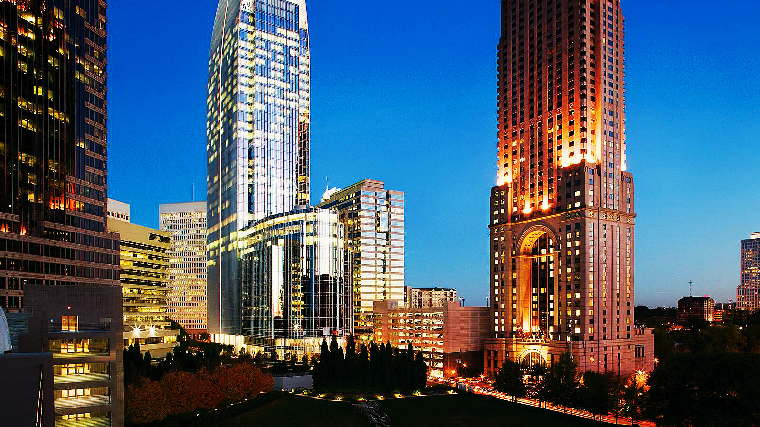 | 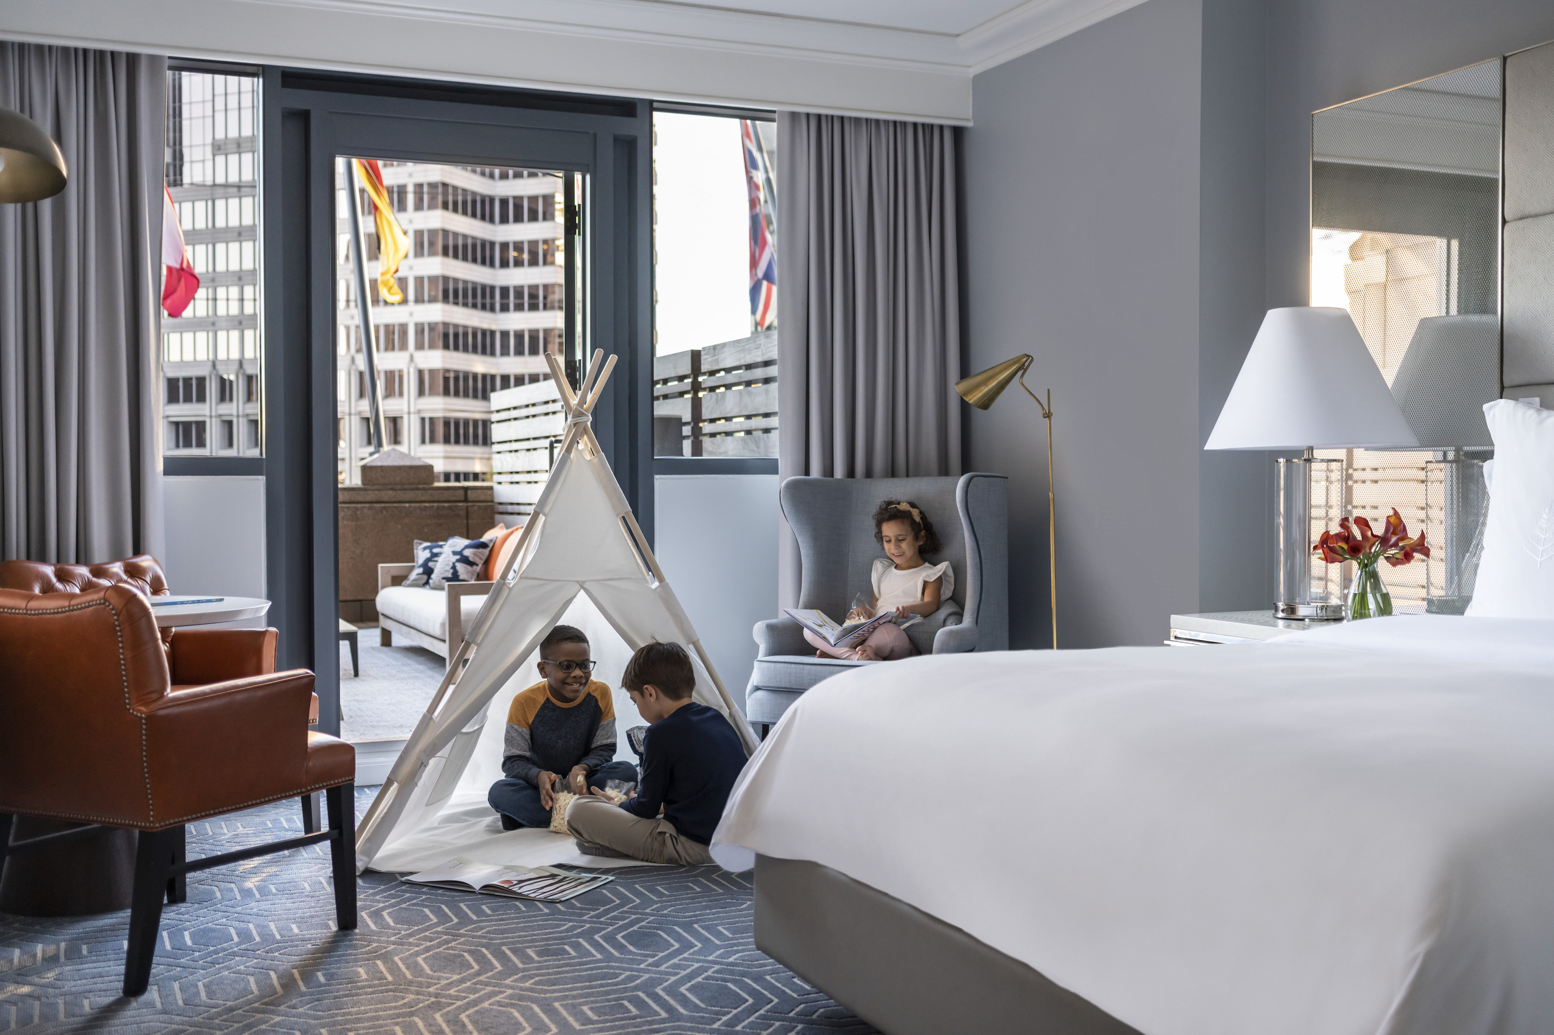 | 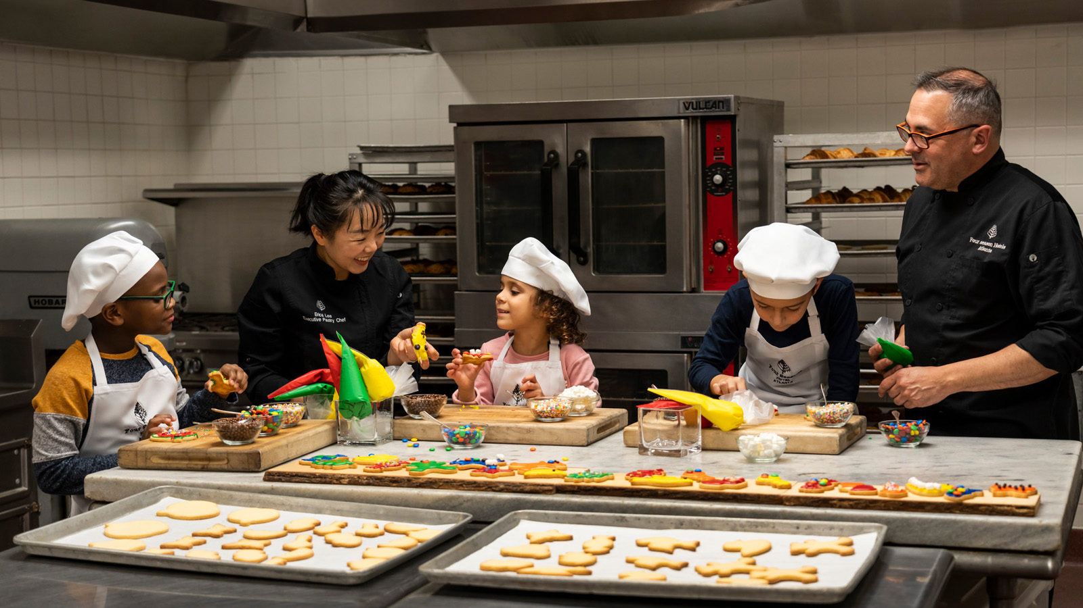
Southern hospitality and world-class service await vacationing families at Four Seasons Hotel Atlanta - the AAA Five-Diamond urban retreat located in the city’s walkable, artistic hub of Midtown. Each family stay comes with peace-of-mind and a range of in-room comforts – available on request – to help keep packing to a minimum. From age-appropriate amenities and immersive local activities to freshly-prepared treats and relaxing conveniences, Atlanta’s most iconic Hotel fosters endless ways to create newfound memories with those we love most.
 | 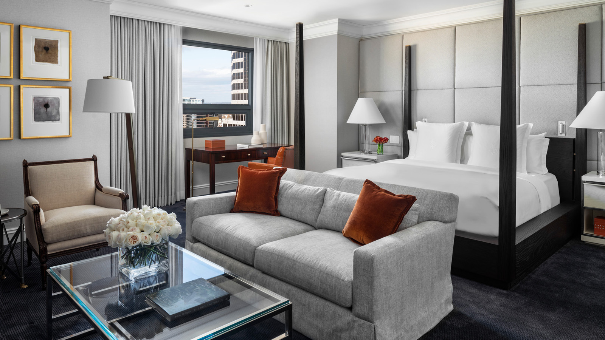 | 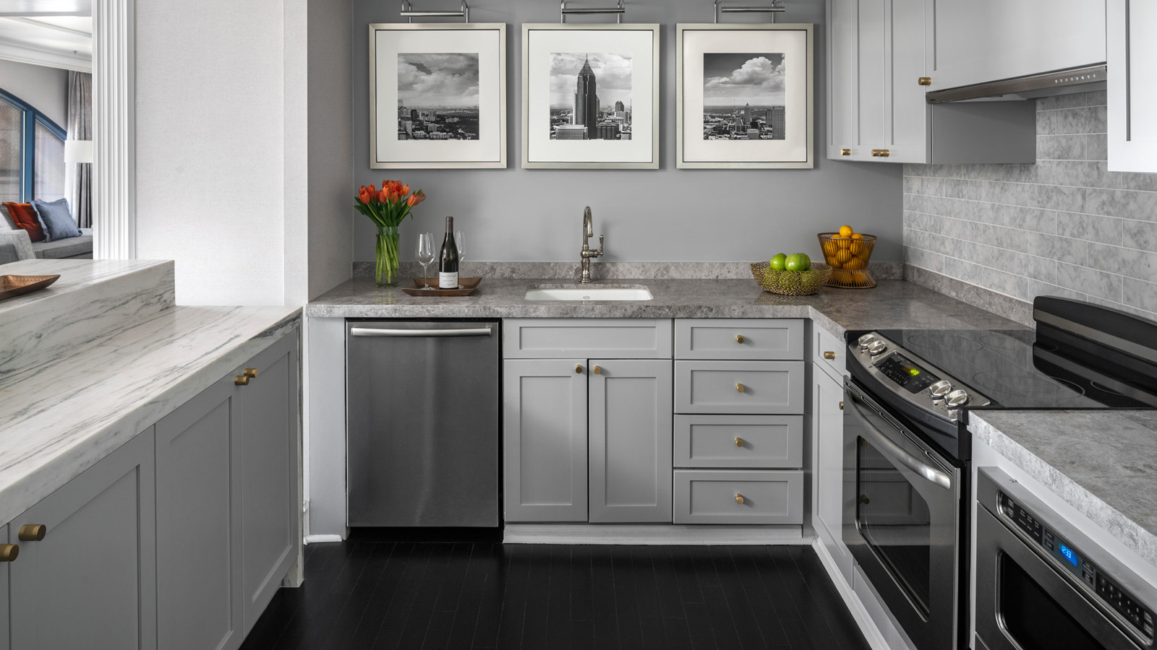
Variety of Accommodations
All 244 of the Hotel’s Meyer Davis Studio-designed guest rooms and suites exude an “aesthetic born from tradition with timeless intent” in a welcoming palette of blues, whites and charcoal grey with finishes of brass, woven upholstery and soft velvets. Ranging from furnished private terraces and stand-alone porcelain bathtubs to in-room kitchens and living rooms with wet bars, as well as connecting rooms with double beds, there are 13 unique configurations designed to provide families with the details they desire.
Upon request, rooms can be childproofed with covered electrical outlets and safety padding on all furniture corners, as well as equipped with sealed diaper disposals, noise-machines, air purifiers, humidifiers, and mini-refrigerators and kettles for storing and sanitizing bottles. Cribs, pack-n-plays and roll-away beds can be pre-placed and queen-sized sofa beds, made each evening with signature Four Seasons linens and pillows, are also available in One-Bedroom Suites.
Amenities
To ensure a sweet start to their stay, all children automatically receive a surprise welcome treat waiting in their room upon arrival – a large chocolate chip cookie personalised with their name in piped chocolate handcrafted by the Hotel’s patisserie.
Create an environment of imagination and playfulness with the addition of a personalised kids’ glamping tent, complete with A-frame tents softly illuminated by starry lights over child-sized bedding, LED lantern and a bed tray adorned with themed accents. Each glamping tent is tailored to the preferences of the child with options from favourite colour combinations to mermaids, unicorns and forest campfire vignettes. Ideal for stargazing from the privacy of a Terrace Suite or pretending to explore the great outdoors from the comfort of a spacious suite, kids’ glamping tents provide a wonderland to rest, watch a movie or strategize for the Hotel’s scavenger hunt.
Come bath time, parents can utilize the pre-placed, tear-free bathing kit of shampoo, body wash and baby lotion and bath toys, then envelope their little ones in child-sized Four Seasons bathrobes and slippers before snuggling down for bedtime.
Fur-babies are made to feel comfortable, too. Available pet amenities include comfortable beds and house-made peanut butter biscuits.
On-Property Activities
With the special arrangement of the Hotel’s concierge, children are invited to join the pastry kitchen for private cookie decorating experiences complete with embroidered chef aprons and toques.
Exclusively available to Hotel guests, families can make a splash all year long inside the Hotel’s indoor heated saltwater pool and revel in the summer sun from its adjacent terrace. Order freshly-prepared food and drinks, such as the newly crafted fruit popsicles (and adult versions with fruit and wine) from the comfort of a rattan-daybed or lounger beginning Friday, May 27 through Labor Day 2022.
Refreshing Flavours
Dine in the privacy of guest room or in either of the Hotel’s two restaurants, Park 75 and Bar Margot, all of which feature customizable children’s menus and complimentary food and drink for children five and under. For the littlest ones, made-to-order baby purees are prepared by the in-house culinary team.
Executive Chef Edgar Kano and Sous Chef Chad “Sosa” Hester have refreshed the Bar Margot menu to reflect the freshest flavours of summer, debuting on Friday, May 27, 2022. For those at least 21 years of age, Bar Margot’s new General Manager Vinnie Dugan, who was recognized by Bombay Sapphire in its Most Imaginative Bartender competition, has reinvigorated the restaurant’s signature craft cocktail menu with drinks featuring ingredients like compressed watermelon.
Summer Spa Treatments
One of Spa Director Eric Kittay’s top recommendations for achieving luminous skin is to book an exfoliating treatment at the change of each season. As summer approaches, reveal a healthy glow with the seasonal Citrus Renewal Massage that features sweet, zesty aromas reminiscent of sunshine in a bottle. This two-part body treatment begins with a renewing grapefruit and tangerine scrub with top to bottom exfoliation. The experience concludes with a moisture rich massage of Atlanta’s locally sourced Mama grapefruit and tangerine oil, leaving skin silky to the touch. 80 minutes; Monday–Thursday, USD 295; Friday–Sunday, USD 310.
Immersive Experiences
Located in the heart of this “City in a Forest,” families can easily embark on a day of activities (and two playgrounds) in Piedmont Park, biking Atlanta’s BeltLine or exploring the natural wonders found inside the Georgia Aquarium and Atlanta Zoo.
History comes to life in Atlanta, the city known as the birthplace of the Civil Rights movement, where families can visit Dr. Martin Luther King, Jr.’s birthplace and reflect upon the pivotal moments of his mission at the National Center for Civil and Human Rights.
With endless opportunities for families to connect, the Hotel’s knowledgeable concierge team can customize a visit to Atlanta with experiences ranging from private tours of famed movie locations to coordinating a birthday celebration inside a suite.
House Car
Easily move around town with the convenience of the Hotel’s house car, a hybrid BMW 745e. Available on a first-come, first-served basis, drivers transport guests within a 5-mile (8 kilometre) radius Monda –Wednesday 8:30 am to 4:30 pm, Thursdays 10:00 am to 8:30 pm and Fridays and Saturdays 10:00 am to 10:00 pm.
Hotel Offers
Ideal for families embarking on a road-trip of the southeastern United States, the Drive-in Package includes one complimentary in-room movie, late check-out of 3:00 pm and overnight valet parking. For those seeking a culturally-immersive stay, the High Museum Package includes two tickets to the High Museum of Art and a USD 50 dining credit to enjoy at the Hotel.

RELATED

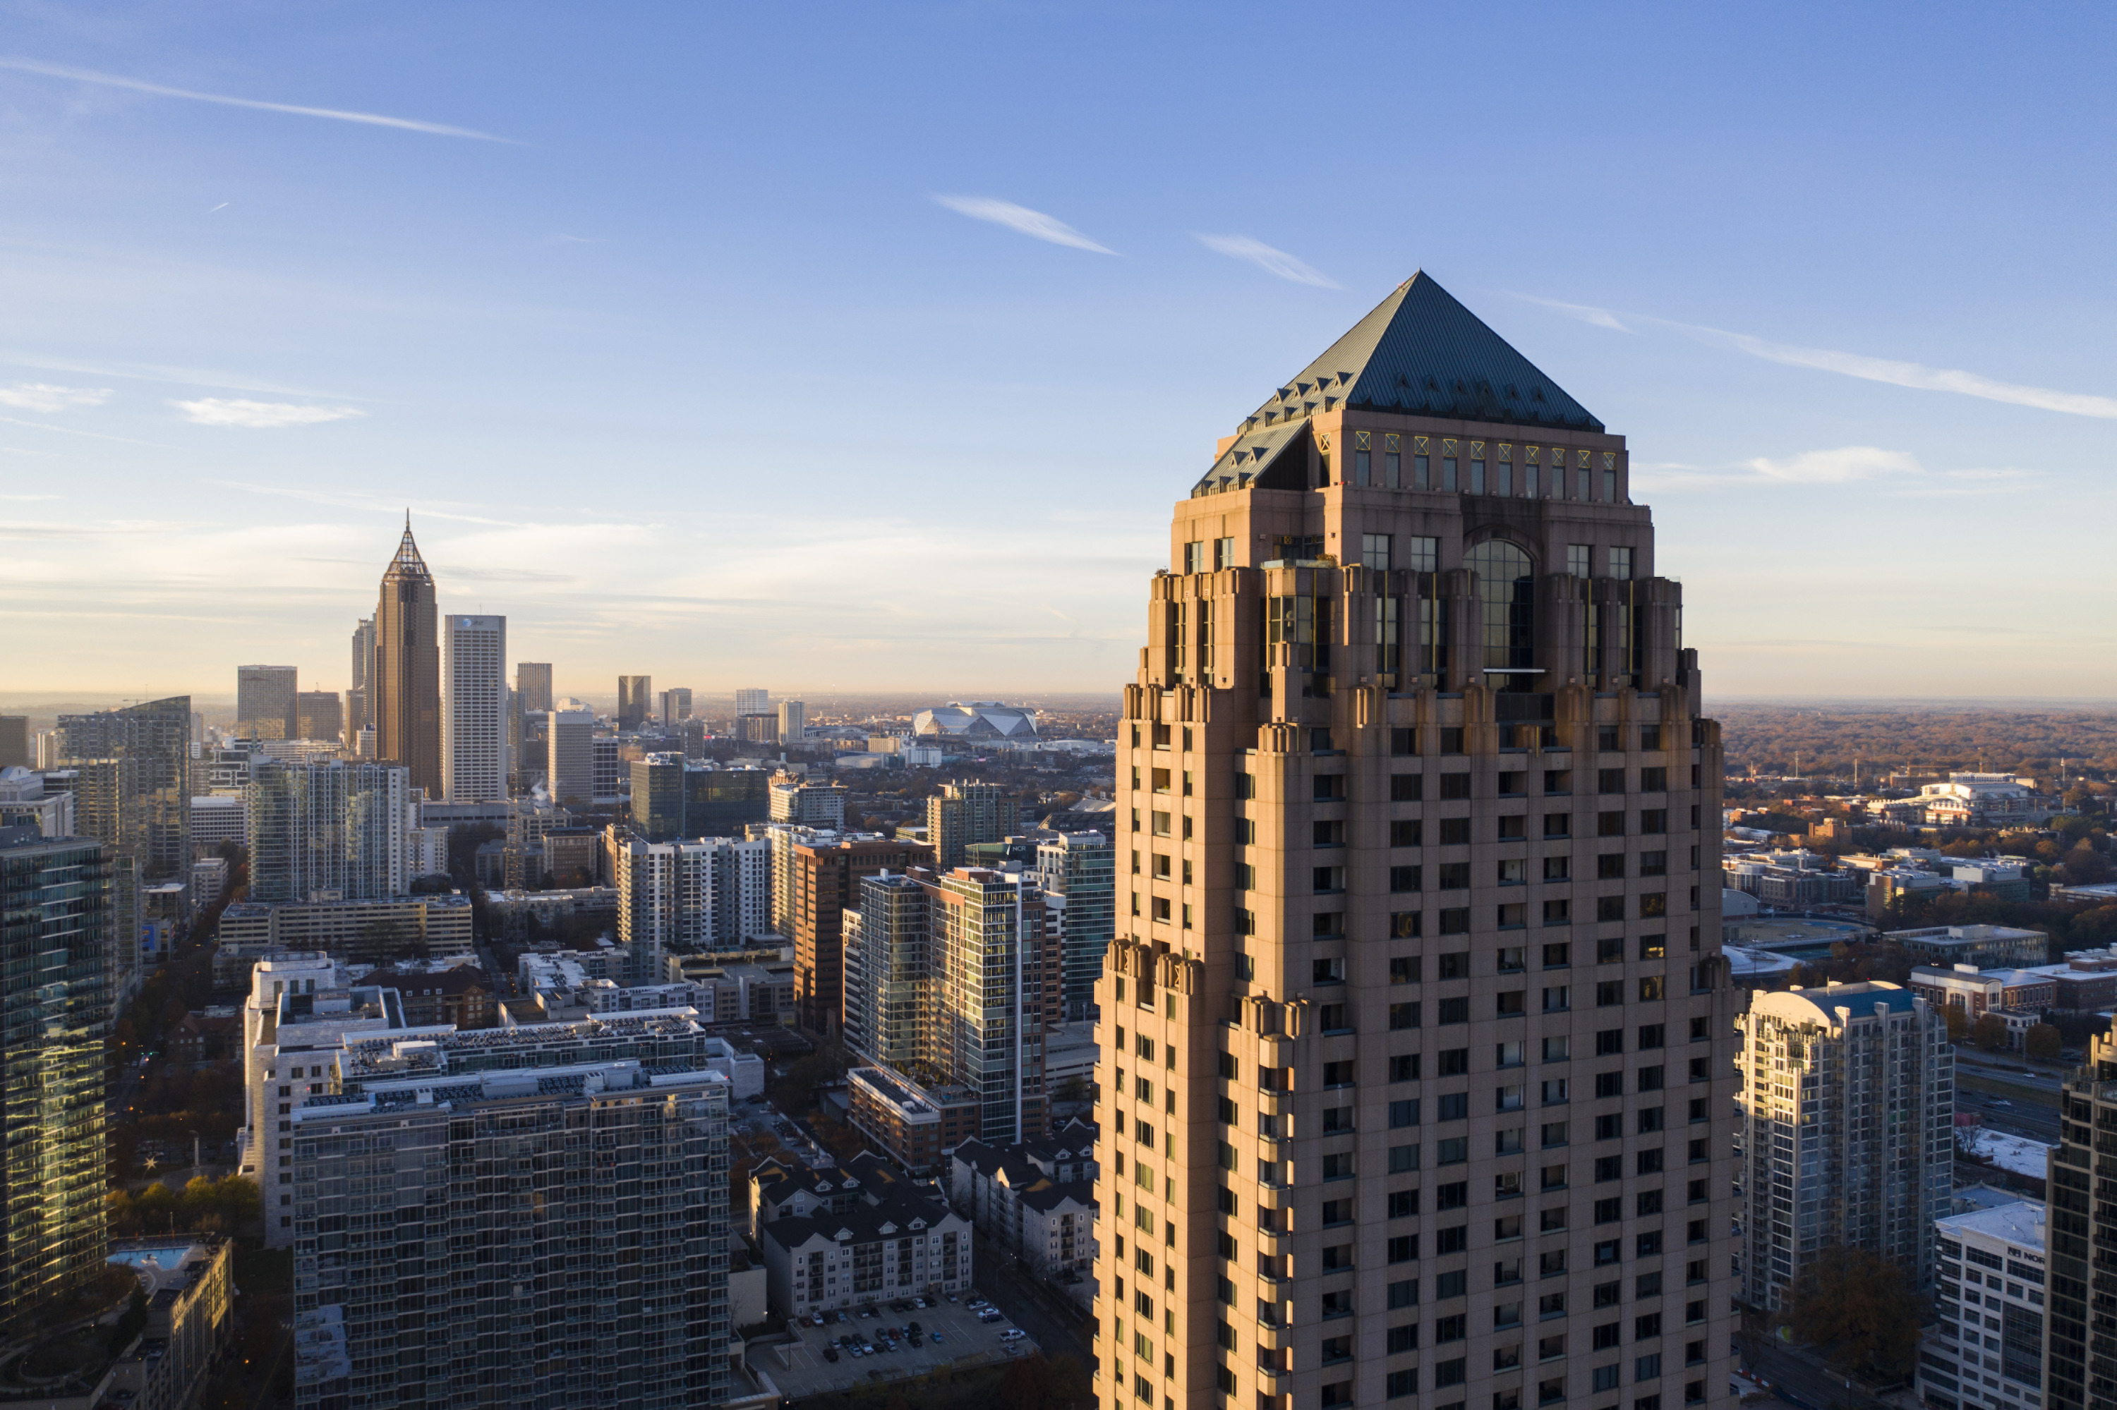 | March 7, 2022, Atlanta, U.S.A  Four Seasons Hotel Atlanta Partners with Georgia Department of Natural Resources to Install Nest for Rare Falcons  https://publish.url/atlanta/hotel-news/2022/falcon-nests.html
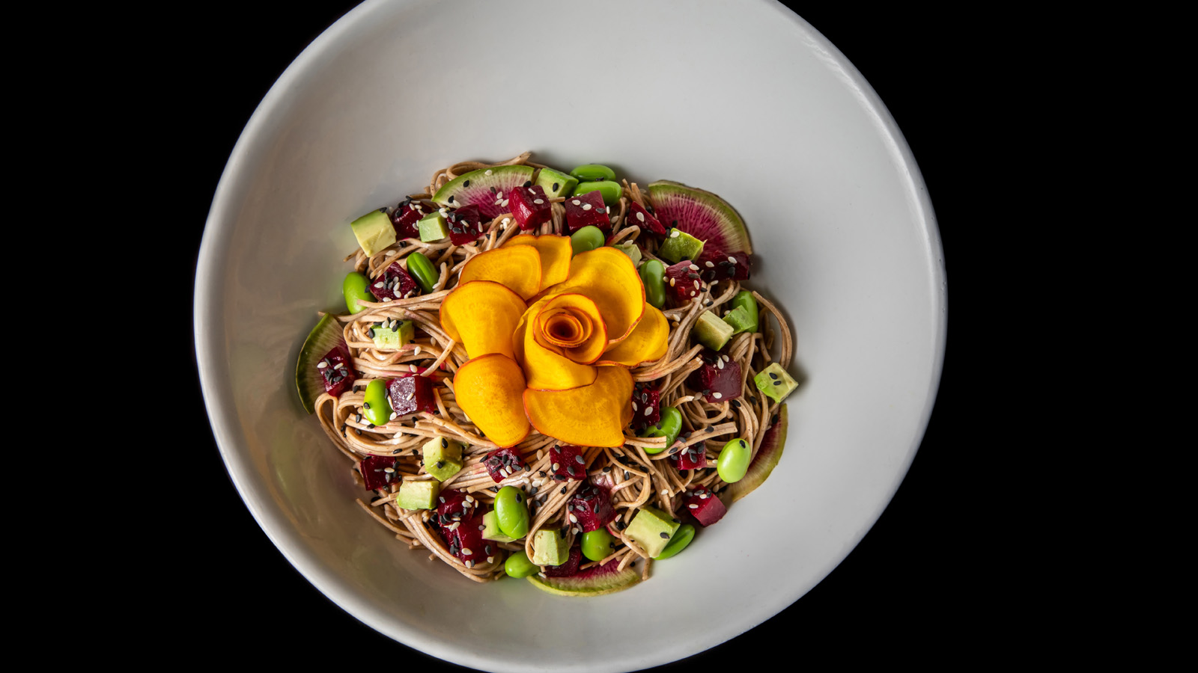 | February 24, 2022, Atlanta, U.S.A  Multicultural Inspired Plant-Based Cuisine Now Available at Bar Margot at Four Seasons Hotel Atlanta  https://publish.url/atlanta/hotel-news/2022/new-plant-based-menu-items-at-bar-margot.html

PRESS CONTACTS

Ashley Svarney
Public Relations Director
75 Fourteenth Street NE
Atlanta
USA
ashley.svarney@fourseasons.com

+1 404 253 3819

