The Iconic Club Dauphin of Grand-Hôtel du Cap-Ferrat, A Four Seasons Hotel, unveils a New Stylish Sea-Facing Cabana with Interiors Designed by Dolce&Gabbana

Offering guests total relaxation and complete privacy, the newly launched Dolce&Gabbana Cabana features a vibrant design that pays homage to the heritage of the Mediterranean’s rich culture and traditions
August 2, 2022, Saint-Jean Cap-Ferrat, France

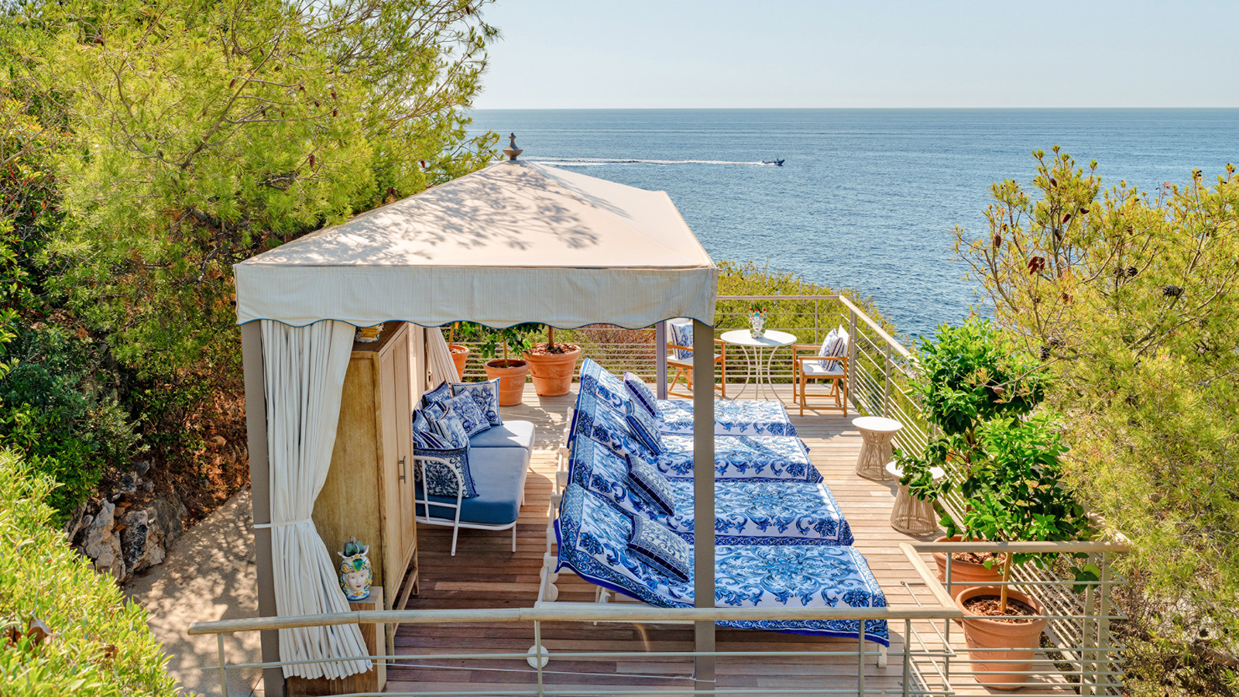
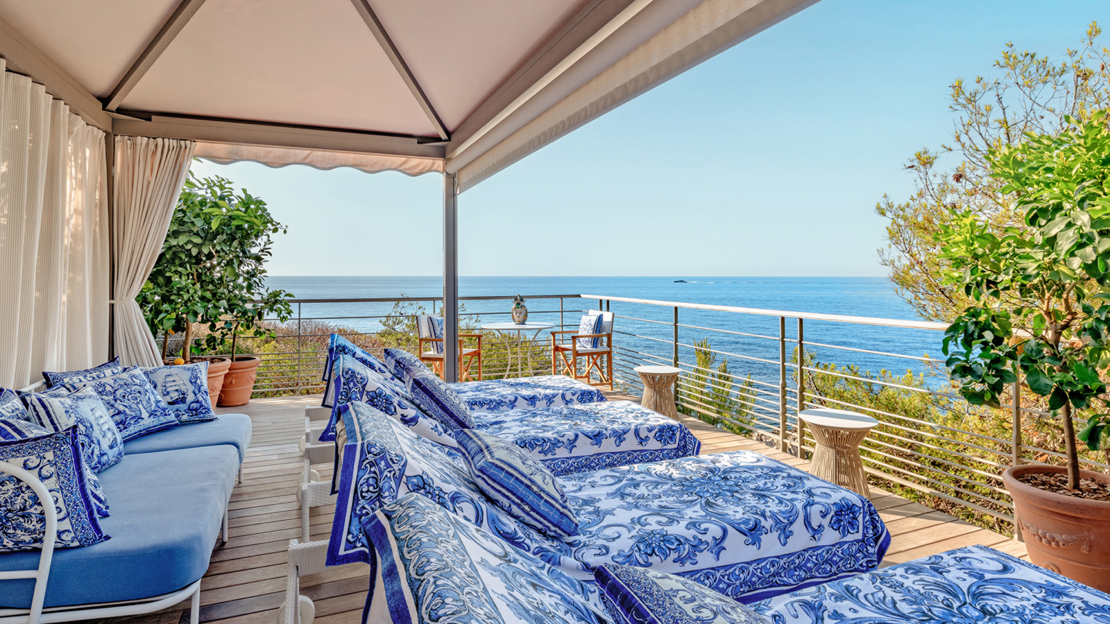 | 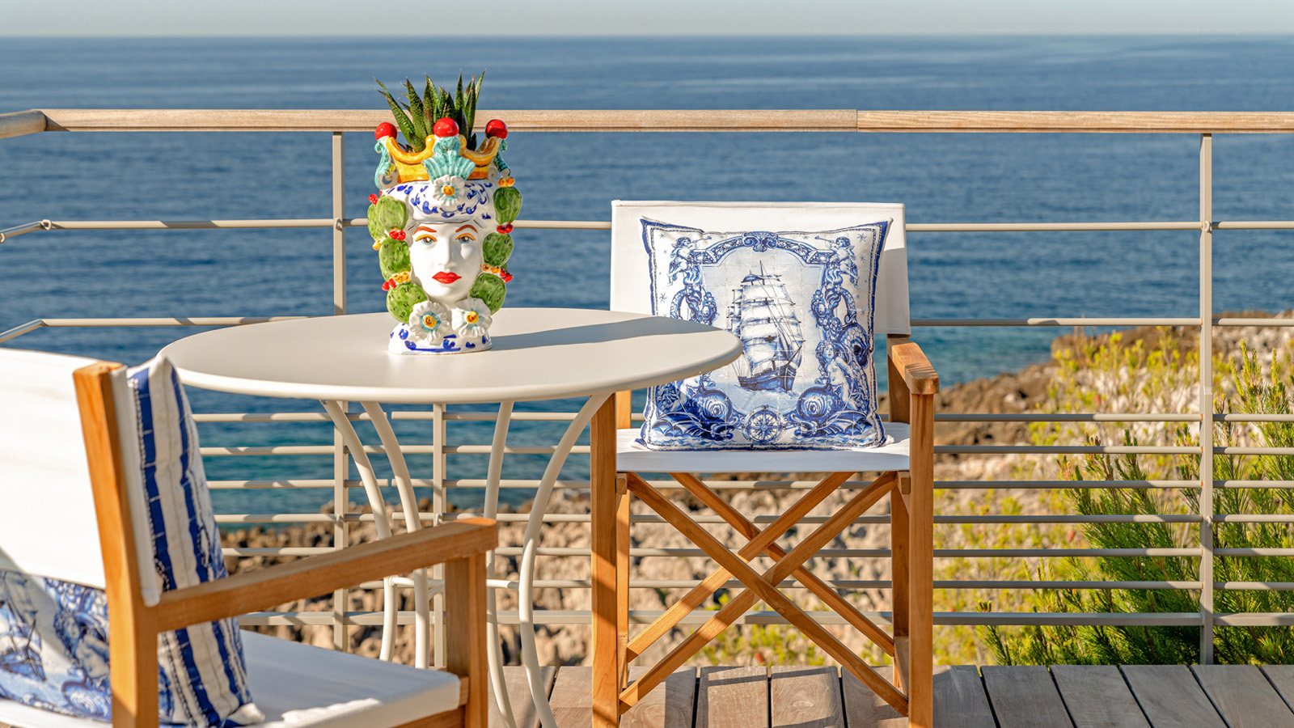 | 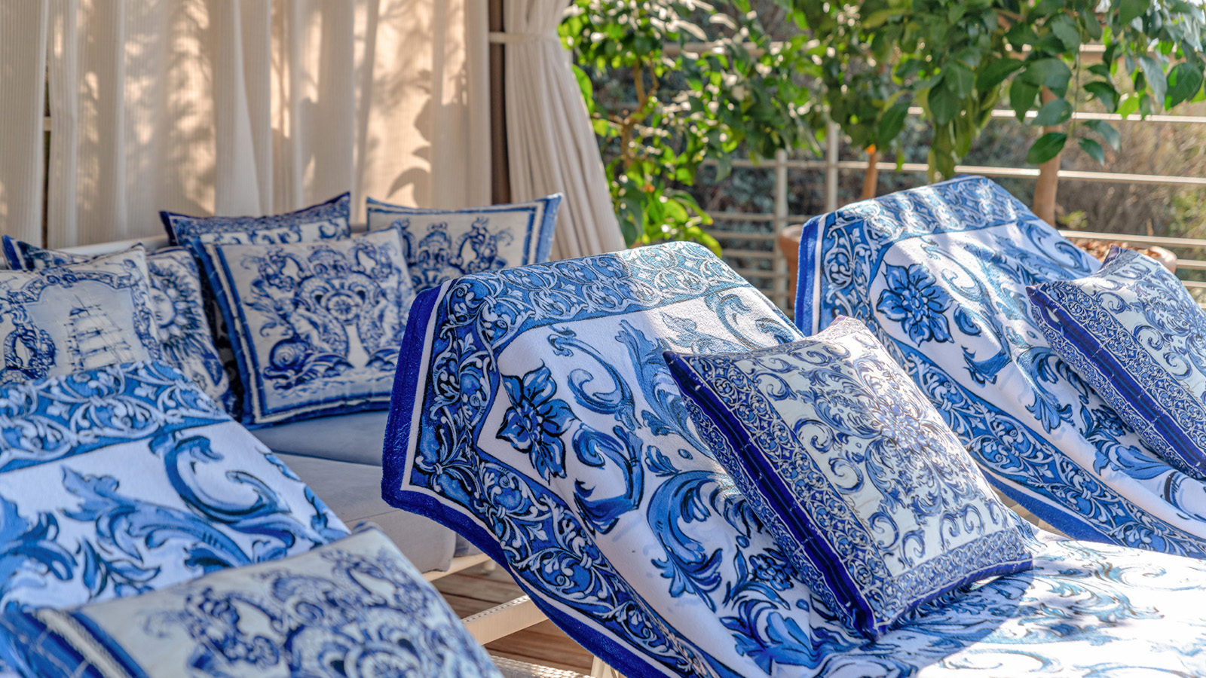
Club Dauphin, the stylish beach club and poolside restaurant of the Grand-Hôtel du Cap-Ferrat, A Four Seasons Hotel, relaunches a sophisticated cabana designed by Dolce&Gabbana. Nestled in greenery and offering spectacular views of the Mediterranean Sea, the Club’s stylish cabana is equipped with sunbeds, mini bar with bespoke drinks cabinet, integrated safe, power sockets and USB ports.
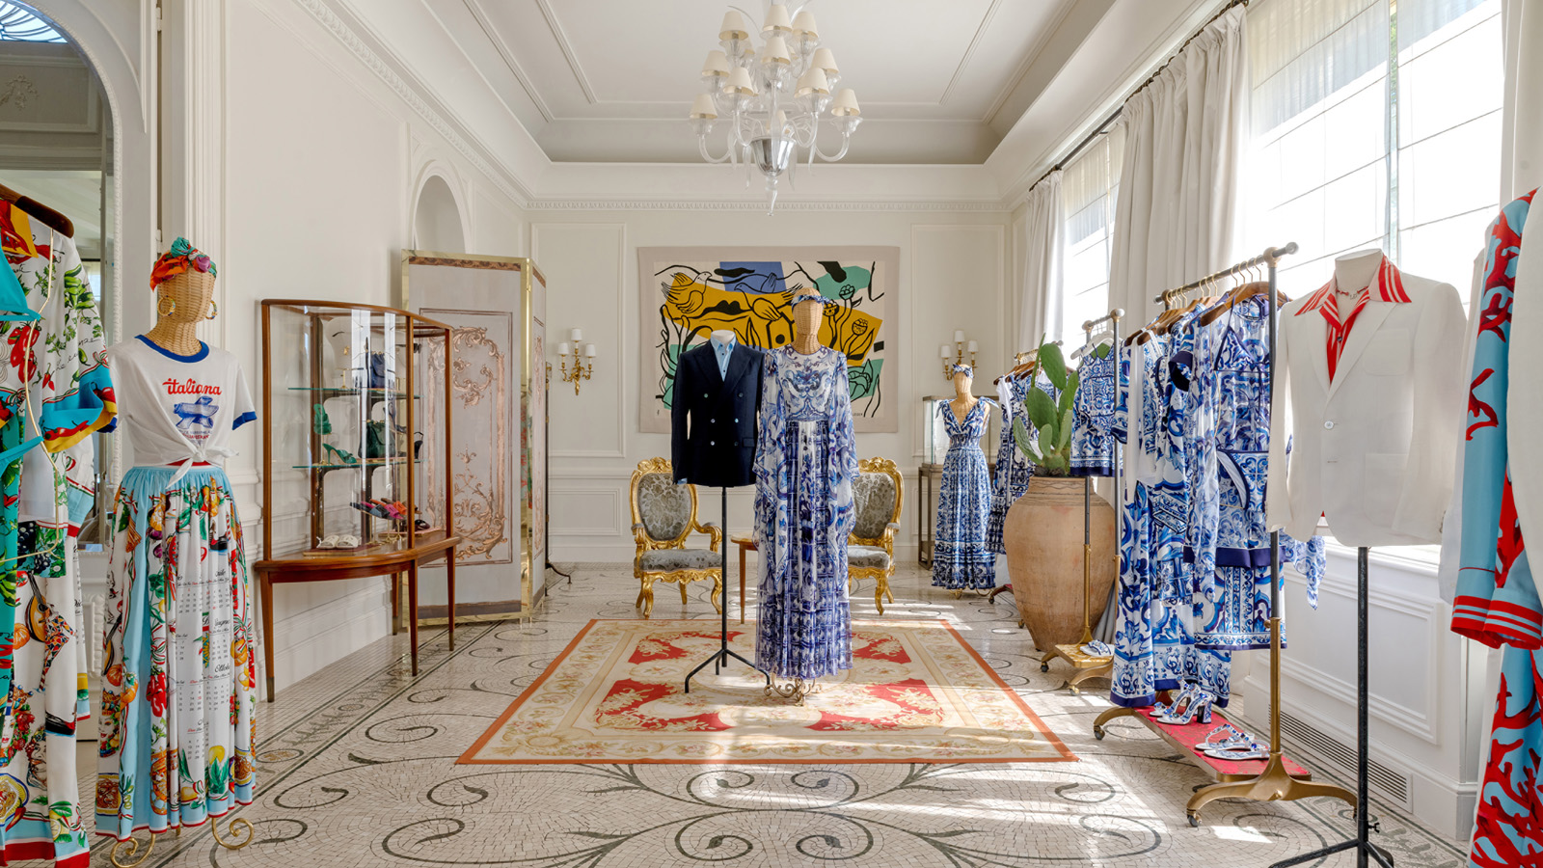
The Dolce&Gabbana Cabana returns this year with a special setup characterised by the Blu Mediterraneo theme, paying homage to the centuries-old tradition of the majolica tiles. From the purity of white to the intensity of blue, Dolce&Gabbana's Blu Mediterraneo takes the mind on a sensory journey where scents, sounds and sensations give life to a familiar and delicate aesthetic. This particular design with such an evocative character has deep roots in Southern Italy: a tribute to the values of Fatto a Mano and excellent craftsmanship, a priceless heritage to be preserved and handed down. Reflecting Mediterranean’s rich culture and ancient traditions, these intricate motifs have become one of the brand’s most iconic patterns. With its eye-catching whimsical design, the Dolce&Gabbana Cabana at Club Dauphin adds a playful touch to the sophistication and glamour of the French Riviera.
During the summer season, the Grand-Hôtel du Cap-Ferrat also hosts an eye-catching pop-up space designed by Dolce&Gabbana. The boutique is set out to resemble an elegant and luxurious wardrobe, displaying a selection of men and women’s ready-to-wear clothing and accessories.
An iconic institution on the French Riviera since the 1930s, Club Dauphin is immersed in the lush landscape of the Cap Ferrat peninsula. During its lifetime, the Club has welcomed a string of celebrity guests including Winston Churchill, Charlie Chaplin and Elizabeth Taylor. Spread out over a series of terraced gardens, Club Dauphin is renowned for its spectacular sea water infinity pool that seamlessly blends in with the surrounding landscape, offering unobstructed views of the Mediterranean Sea.
The Dolce&Gabbana Cabana adds a fashionable dimension to one of the Riviera’s most exclusive lounge bars. With its striking patterns and lively pops of colour, the space evokes a fun and casual atmosphere, lifting the spirits and lending a unique, quirky look.
Reservations
- Club Dauphin - clubdauphin.capferrat@fourseasons.com - +33 (0)4 93 76 50 92

RELATED

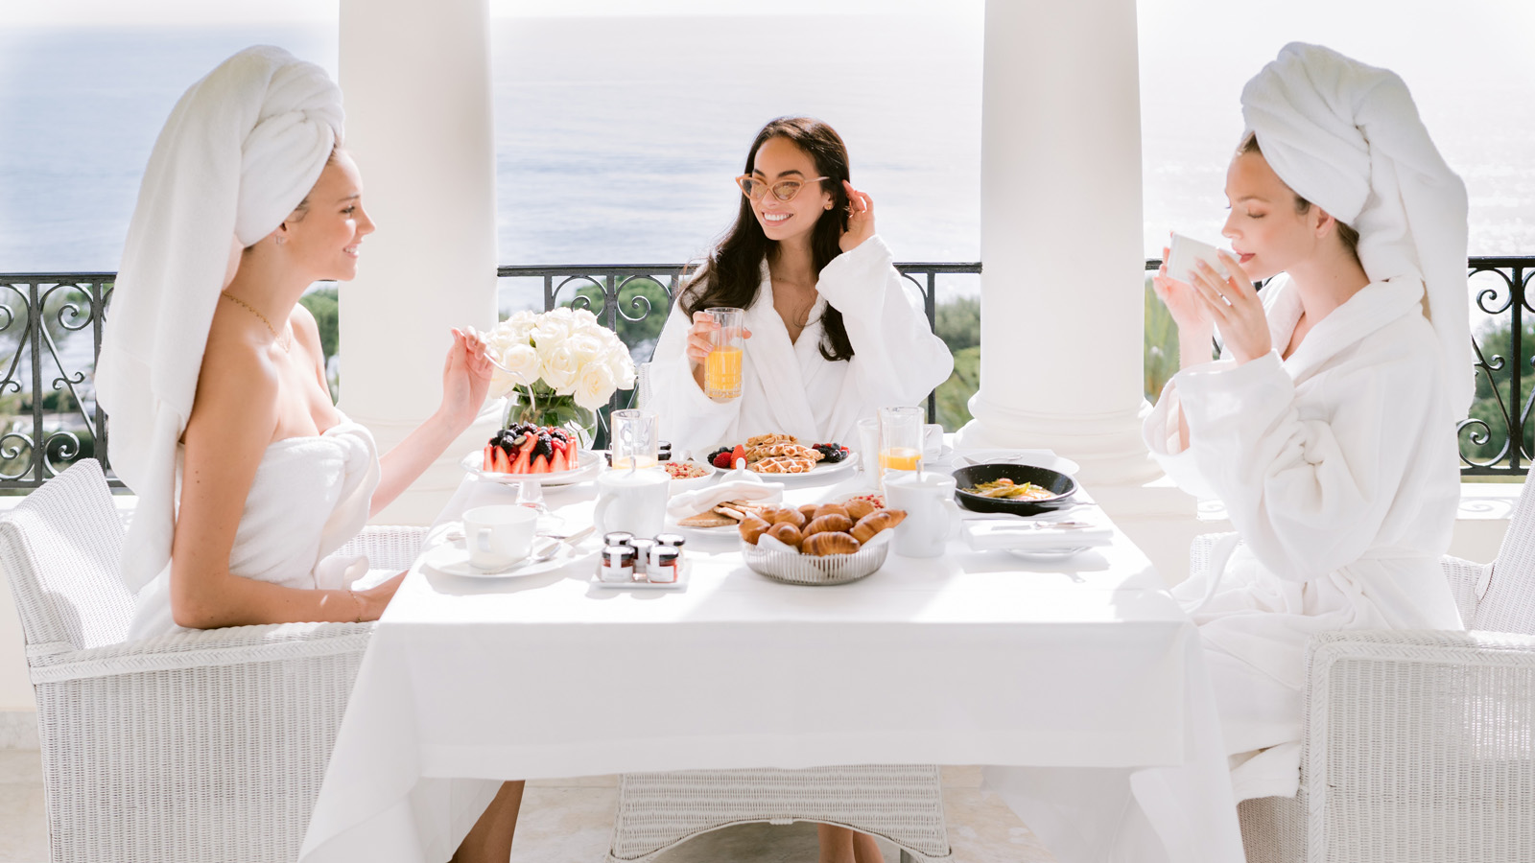 | May 17, 2022, Saint-Jean Cap-Ferrat, France  Le Grand-Hôtel du Cap-Ferrat, A Four Seasons Hotel présente “Girls trip sur la Riviera” un package directement inspiré de la série à succès Emily in Paris, dont la saison 2 a été en partie tournée à l’Hôtel  https://publish.url/fr/capferrat/hotel-news/2022/girls-trip-on-the-french-riviera-package-2.html
May 17, 2022, Saint-Jean Cap-Ferrat, France
The French Riviera’s Iconic Grand-Hotel du Cap-Ferrat, A Four Seasons Hotel Launches a Glamorous Package That Follows in the Footsteps of Hit TV Series Inspired by “Emily in Paris”
https://publish.url/capferrat/hotel-news/2022/girls-trip-on-the-french-riviera-package.html

PRESS CONTACTS

Caroline Mennetrier
Director of PR and Marketing Communication
71 Boulevard du General de Gaulle
Saint-Jean Cap-Ferrat
France
caroline.mennetrier@fourseasons.com

+33 6 26 39 96 76

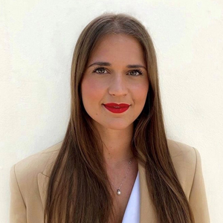 | Marie Cazaudumec  PR and Social Media Manager  71 Boulevard du General de Gaulle  Saint-Jean Cap-Ferrat  France  marie.cazaudumec@fourseasons.com  +33 (0)4 93 76 50 10

