Make Four Seasons Safari Lodge Serengeti Your Natural Choice This Festive Season

Celebrate on a Serengeti safari - naturally distanced, innately connected
October 9, 2020, Serengeti, Tanzania

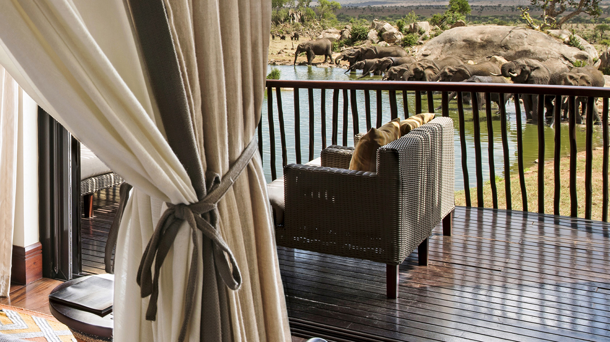
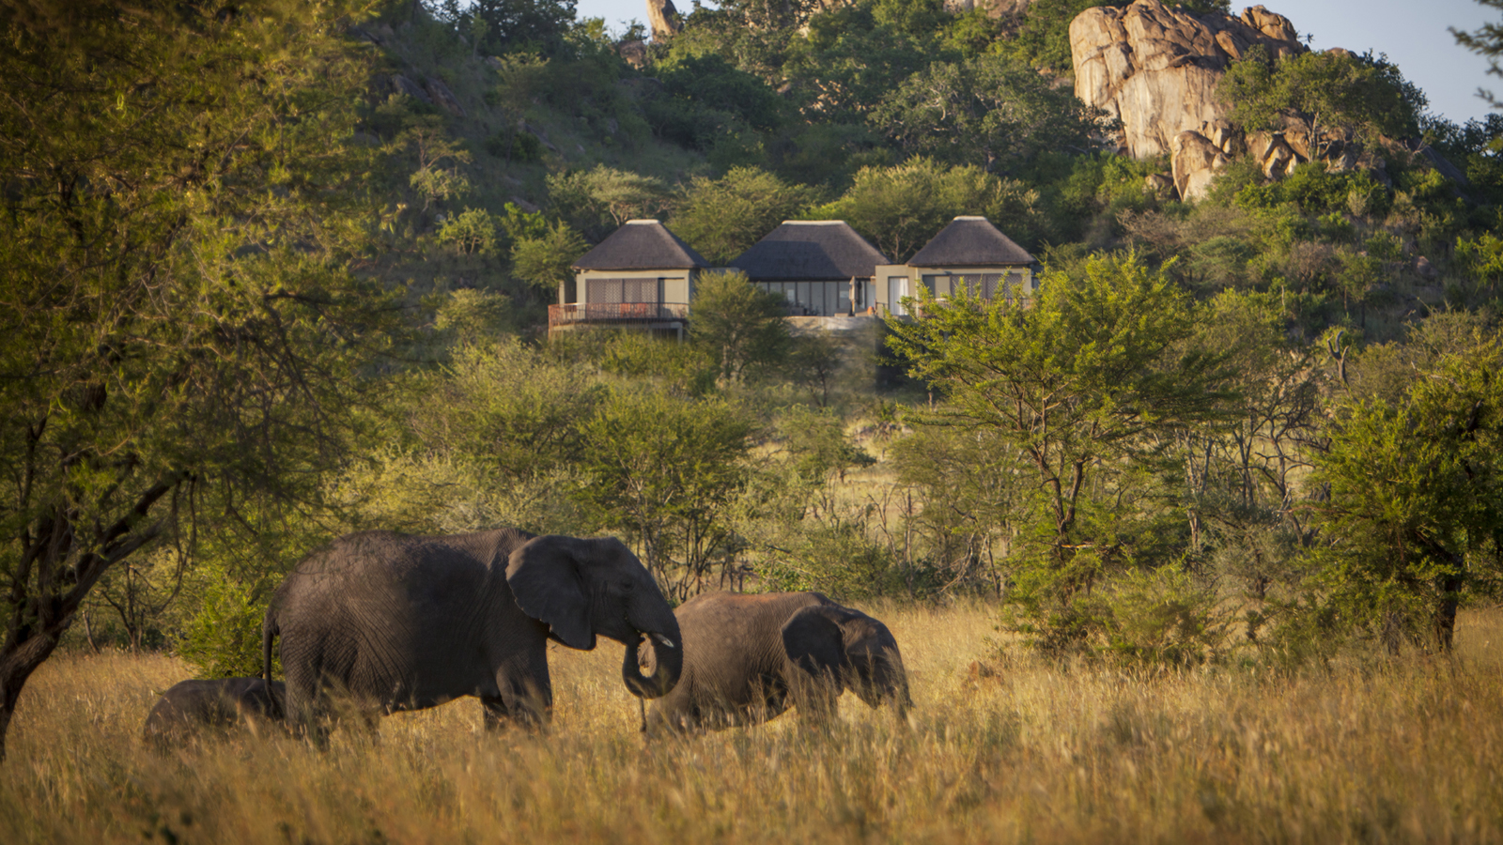 | 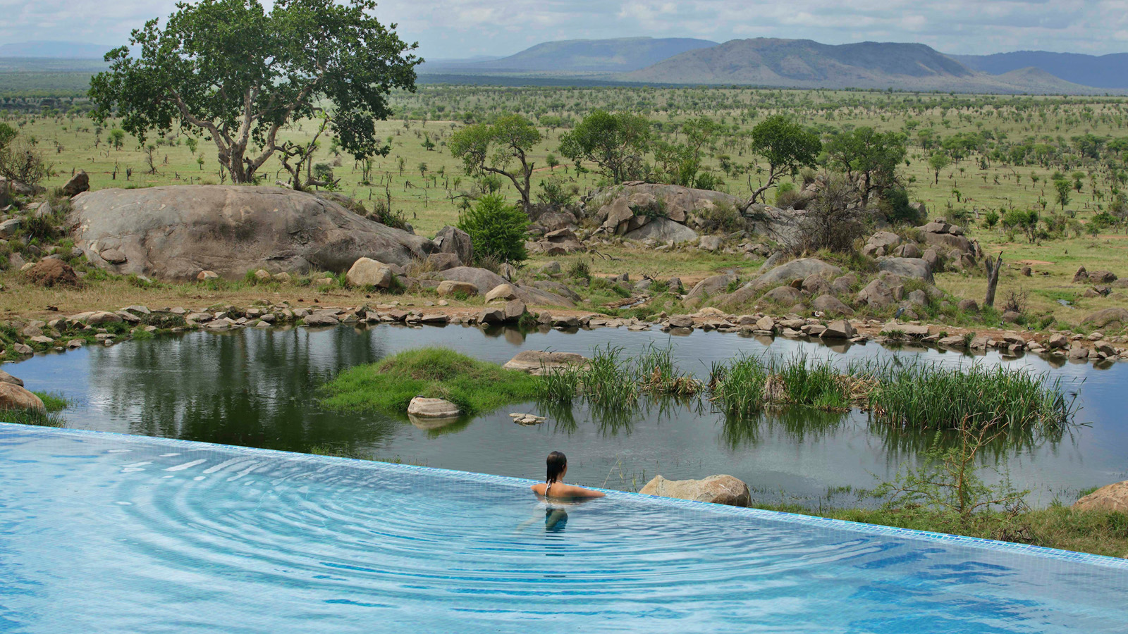 | 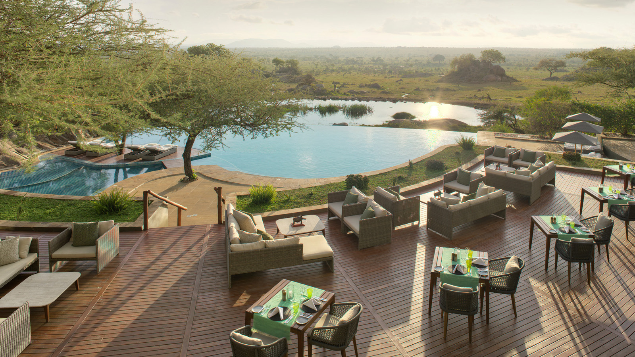
Measuring more than 5,700 square miles, the Serengeti (translated from Swahili to English as “endless plains”) is home to some of the world’s most incredible wildlife. Located in the centre of the National Park, Four Seasons Safari Lodge Serengeti boasts abundant animal sightings all year round, which combined with a host of activities for all ages to enjoy, creates the perfect package for families this Christmas and New Year.
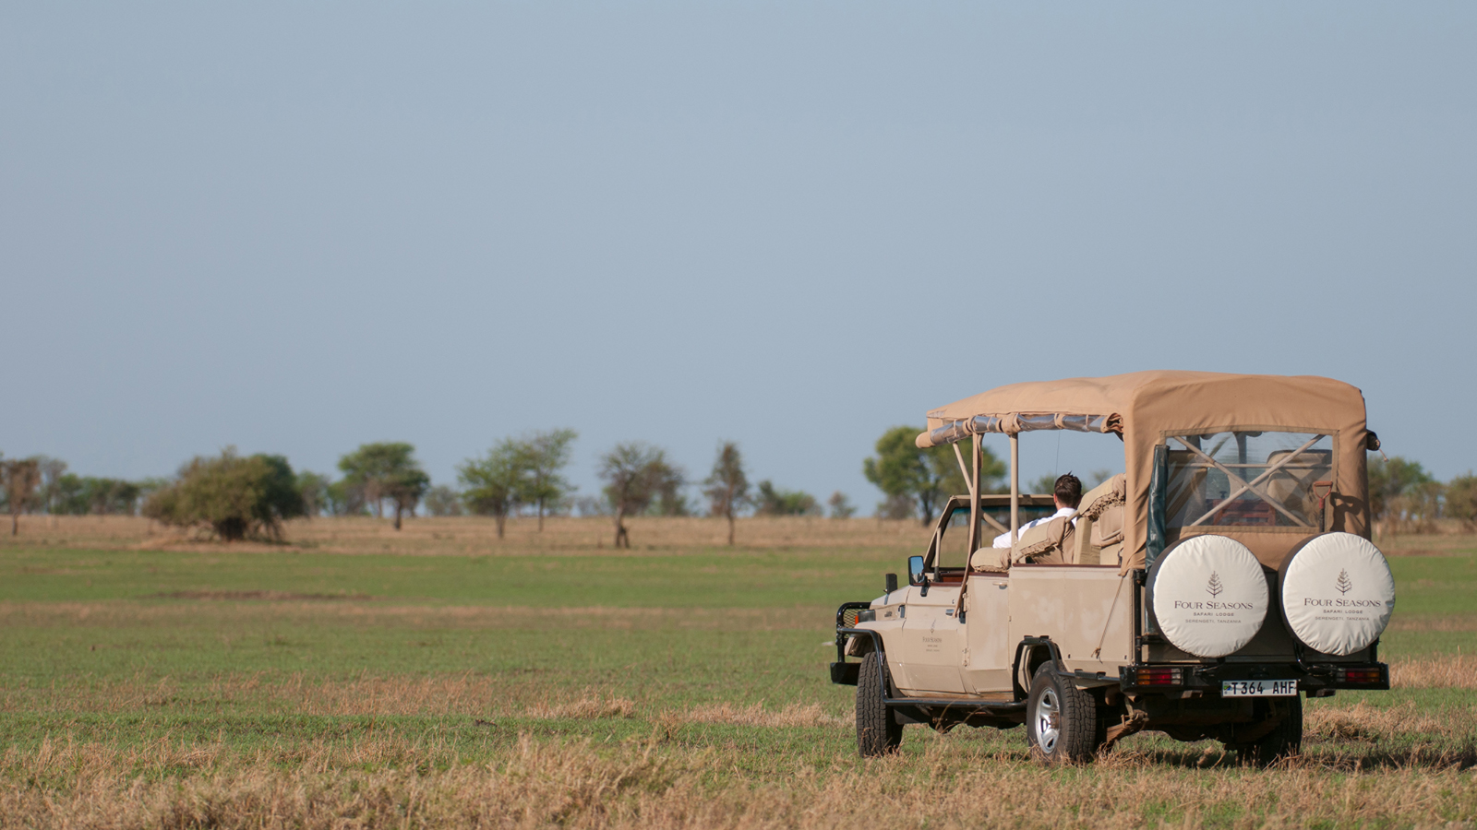
Whether keen to head out on full day game drives each day or preferring to customise each day to suit individual preferences, Four Seasons Safari Lodge offers every opportunity to enjoy the very best of wildlife sightings – be this on a nearby game drive, a full day adventure to the Ngorongoro Crater, or simply sipping a cocktail at the Lodge’s infinity pool and watching the animals pass by.
No matter the category of accommodation booked, all of the Lodge’s rooms, pool suites and five free-standing villas boast uninterrupted savannah views from a private balcony, while Four Seasons new global Lead With Care program and contactless Chat experience offer the ultimate reassurance and care in a new era of travel.
In addition to the choice of game drives available, guests may select from a wide range of recreational options, including guided walking safaris, birding and nature safaris and time engaging with the educational displays at the onsite Discovery Centre.
For children, time at the Lodge may be filled with trying their hand at the local style of Tinga Tinga painting, sound safaris and even taking part in a Maasai Olympics, as part of the Lodge’s kids’ program, Mini Maasai Adventure. All activities will take place in a protected outdoor area to continue every opportunity to connect with the savannah surroundings.
For full details of the festive program and availability at Four Seasons Safari Lodge contact: res.serengeti@fourseasons.com.
Lead With Care
Grounded in health care expertise and enabled by access to leading technologies and tools, the Lead With Care program is focused on providing care, confidence and comfort to all Four Seasons guests, employees and residents within the new COVID-19 environment. The new program outlines clear procedures that educate and empower Four Seasons employees to take care of guests and each other. While guests will see many of the enhanced Lead With Care procedures, behind-the-scenes measures will also take place through employee training, additional food handling protocols, and enhancements to ventilation systems and other back-of-the-house operations. In addition, Four Seasons continues to invest in its award-winning App and Chat that further allows guests to control how they engage with others – limiting face-to-face interactions while maintaining the highest levels of personal service. Features include the ability to make and manage reservations, request luggage pickup, airport transfers, room service, restaurant and spa reservations, and much more. Wait-free check-in and check-out is also offered, while Four Seasons Chat integration offers instant translation of 100+ languages giving guests the flexibility for contactless engagement throughout their stay.

RELATED

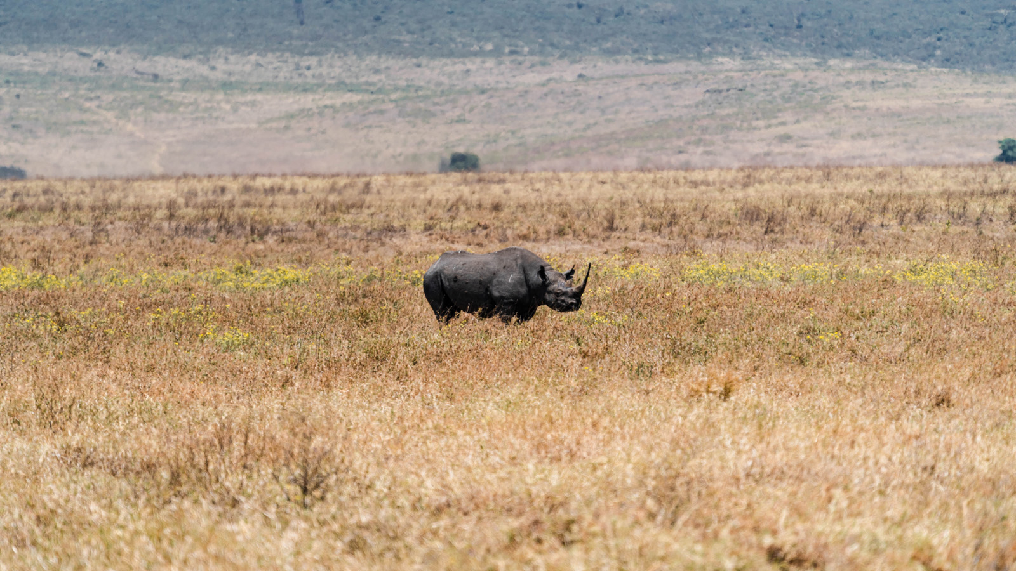 | September 22, 2020, Serengeti, Tanzania  A Commitment to Rhino Conservation: Four Seasons Safari Lodge Announces Long-Term Funding for Rhino Conservation Project in the Serengeti in Partnership with Frankfurt Zoological Society  https://publish.url/serengeti/hotel-news/2020/world-rhino-day-commitment.html
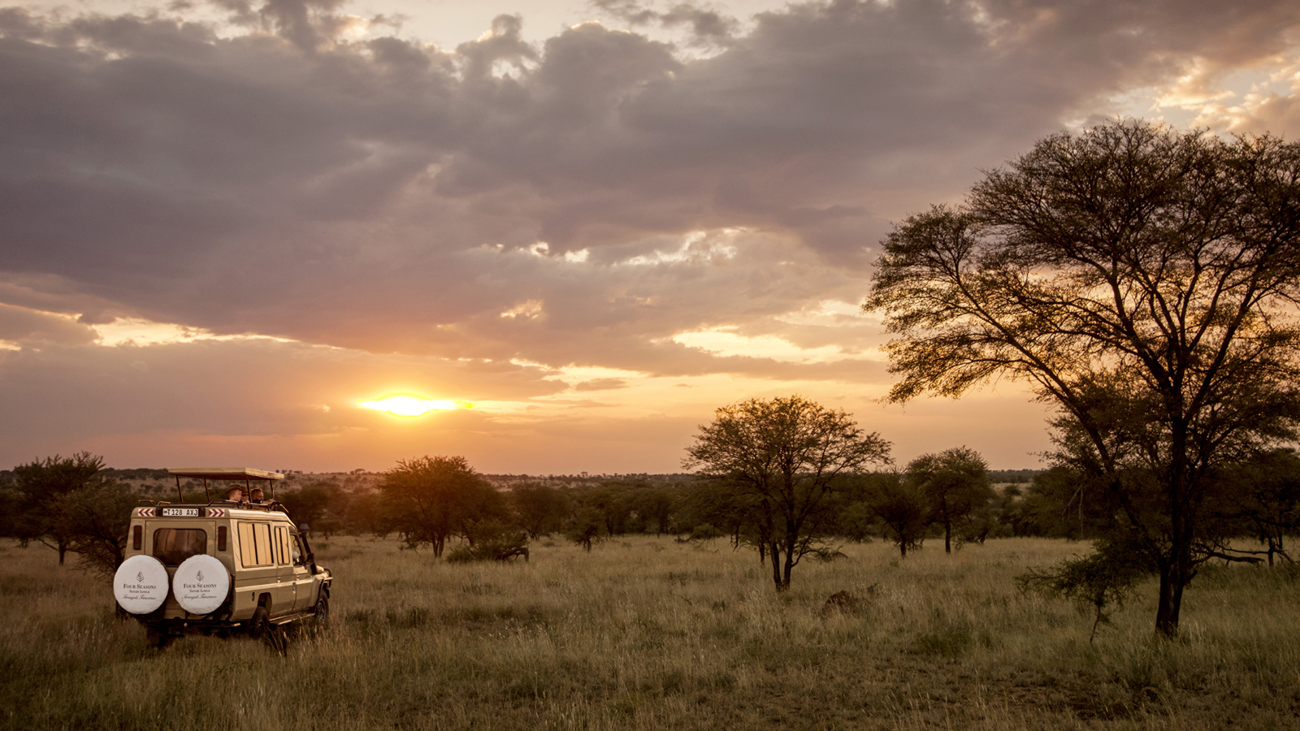 | August 25, 2020, Serengeti, Tanzania  Return to the Wilderness with Four Seasons Safari Lodge Serengeti  https://publish.url/serengeti/hotel-news/2020/reopening.html

PRESS CONTACTS

Debbie Duval
Senior Director of Public Relations and Communications

Beau Champ
Mauritius
debbie.duval@fourseasons.com

(230) 402 3100

