The Spa at Four Seasons Hotel Las Vegas Named Five Star in Forbes Travel Guide 2023 Star Awards

The Spa at Four Seasons Hotel Las Vegas earns prestigious accolade for the third consecutive year
February 15, 2023, Las Vegas, U.S.A.

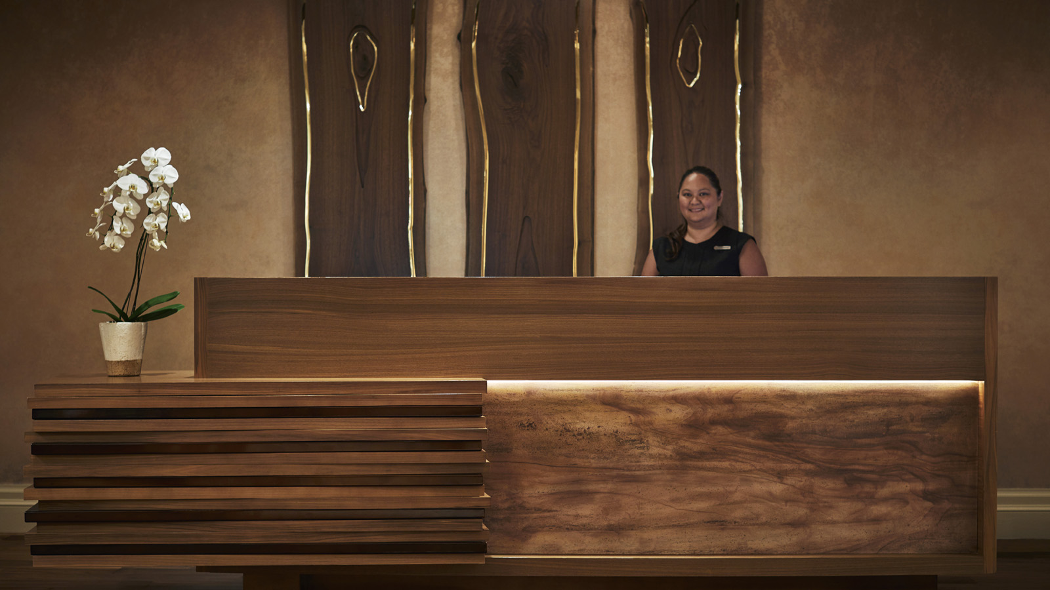
 | 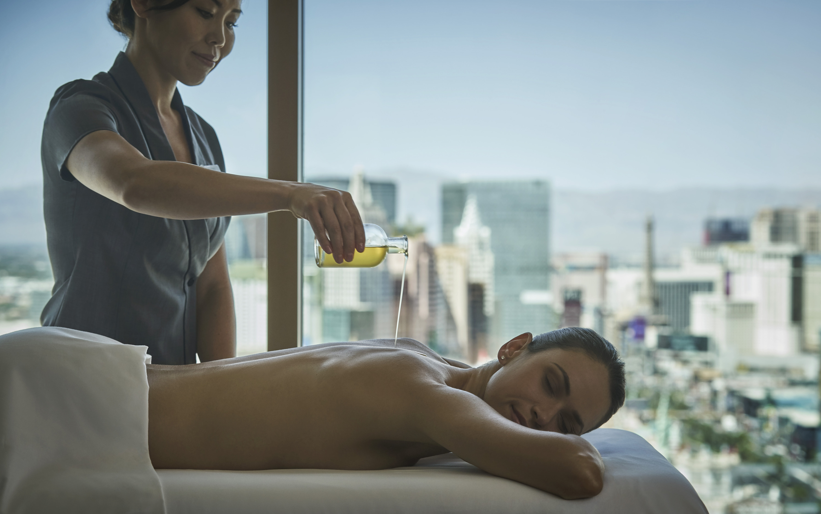 | 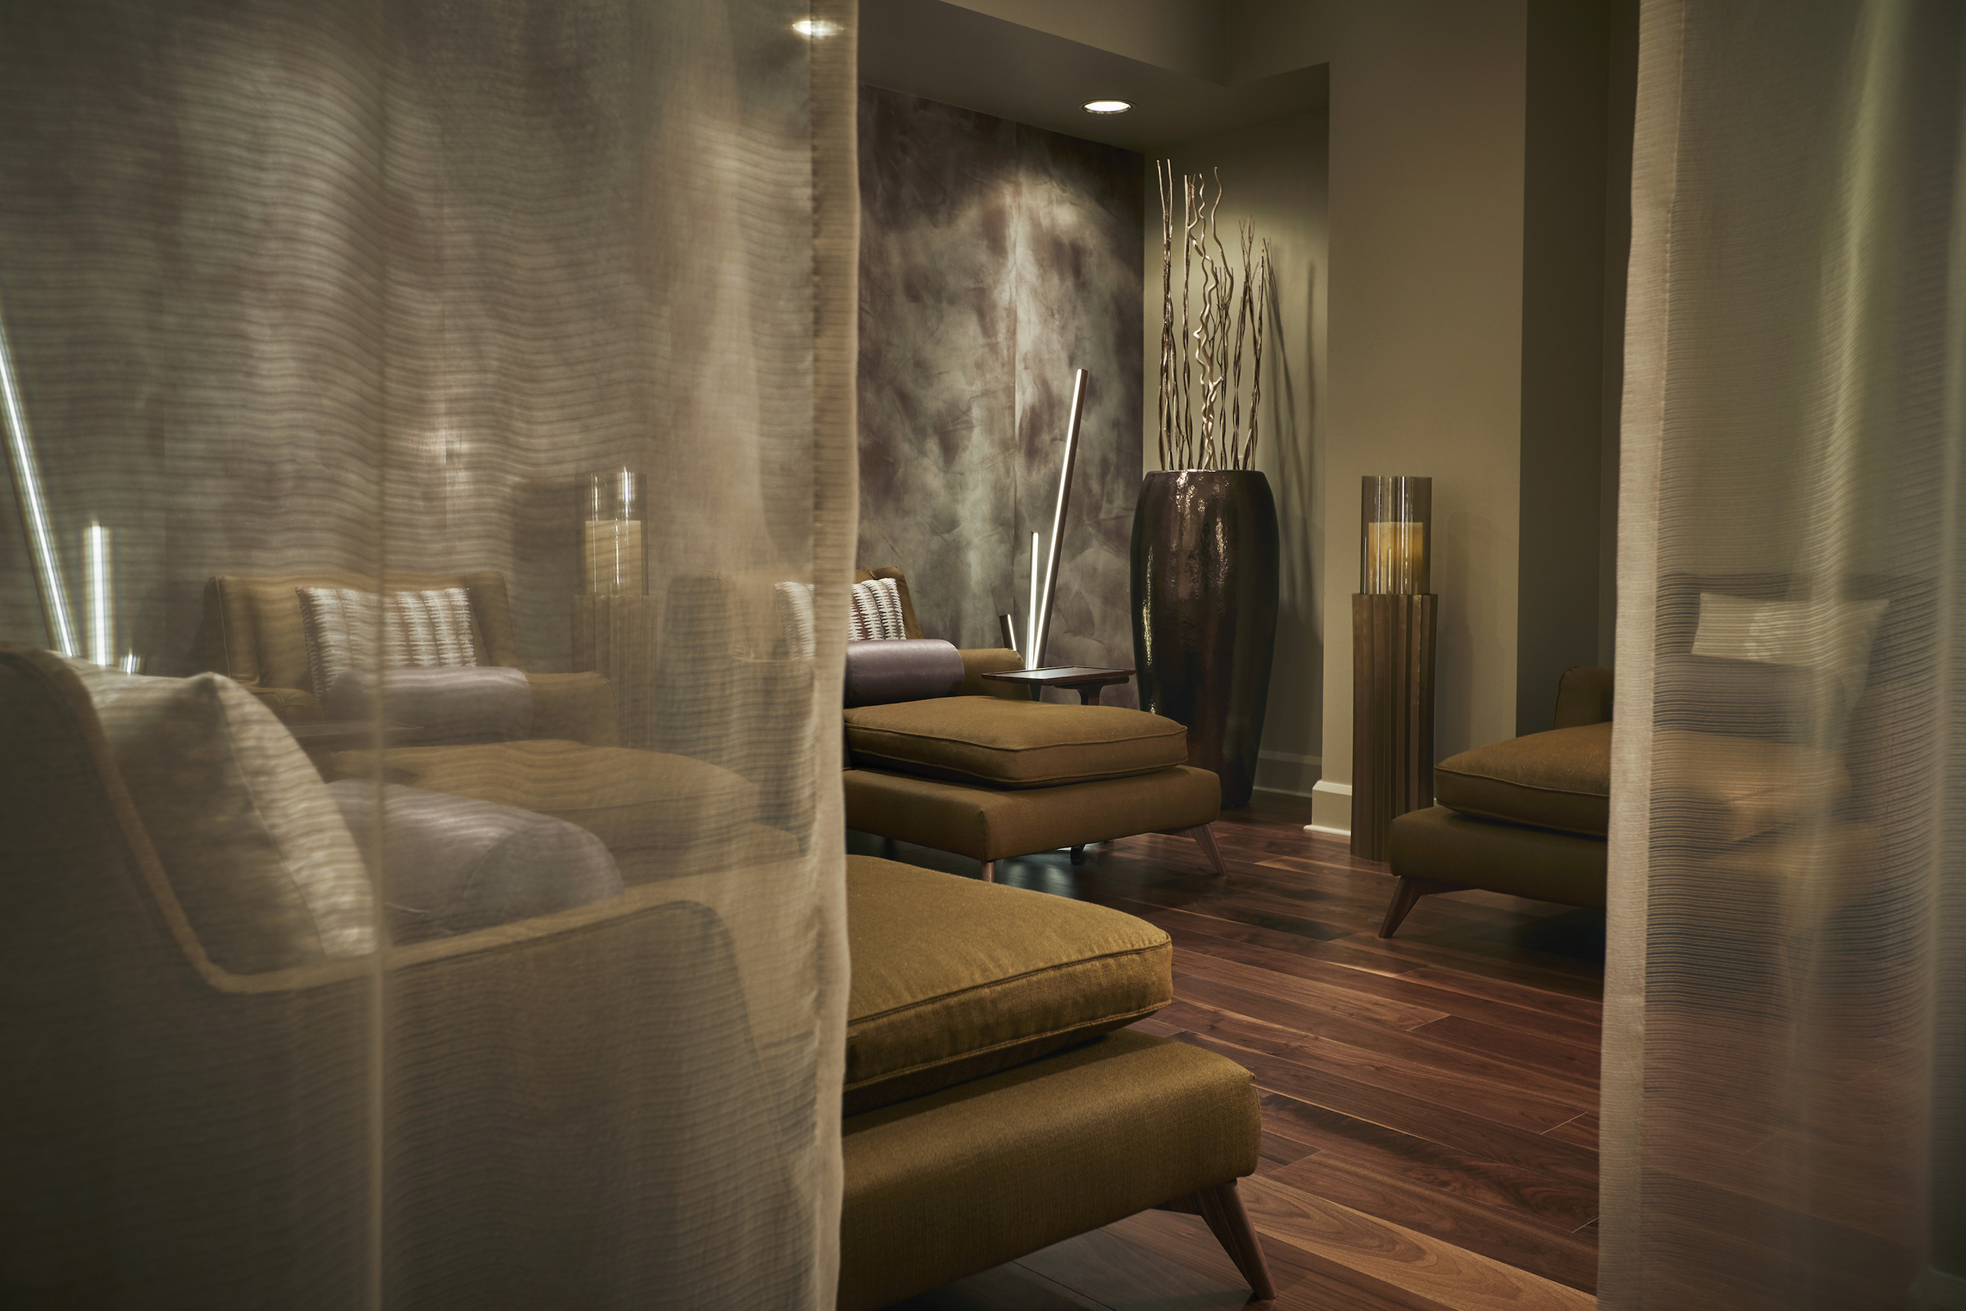
Forbes Travel Guide, the only global rating system for luxury hotels, restaurants, spas and ocean cruises, today announced its 2023 Star Awards. The Spa at Four Seasons Hotel Las Vegas has earned once again earned a Forbes Travel Guide Five Star award.
“We are honoured to once again be recognised with the Five Star award from Forbes Travel Guide,” says Shannon Mariani, Spa Director for The Spa at Four Seasons Hotel Las Vegas. “Our team is passionate about sharing their expertise and knowledge with every guest who enters the Spa. This incredibly high accolade is the direct result of their dedication to the health and wellness of our guests.”
Mariani, who brings twenty years of luxury spa experience to Four Seasons, leads an expert team of the top estheticians, massage therapists and nail technicians. The Spa delivers a menu of progressive services and techniques utilizing top-of-the-line products such as KNESKO, Natura Bissé and Éminence, as well as highlighting local and women-owned businesses such as Eu’genia Shea and Will2Wow Jewelry.
Guests have access to a variety of evergreen signature treatments and a rotating menu of seasonal offerings throughout the year. The Warm Salt Stone Ritual Massage draws on the healing benefits of the surrounding Mojave Desert through salt crystal stones, which resupply the body with 84 essential minerals. The Head to Toe Candle Massage is an ultra-hydrating blend of aromatherapy and massage leaving the skin feeling silky and muscles warmed from the outside in. Guests can choose from a selection of scents to customize the experience. Featured through February, the Spa offers the New Year Radiance Facial, featuring the hydrating benefits of collagen masks enhanced with gemceuticals for anti-inflammatory and mood-boosting properties, and the My Sweet Valentine Body Wrap, a Chocolate Truffle Body Wrap rich in antioxidants followed by a lightweight Strawberry Hyaluronic moisturizing application to rejuvenate and reveal radiant-looking skin.
Anonymous professional Forbes inspectors evaluate based on hundreds of exacting standards, with an emphasis on exceptional service, to help discerning travellers select the world’s best experiences. The only way to get a Five Star, Four Star or Recommended rating is by earning it through the independent inspection process. For a detailed explanation of how Forbes Travel Guide compiles its Star Ratings, click here.

RELATED

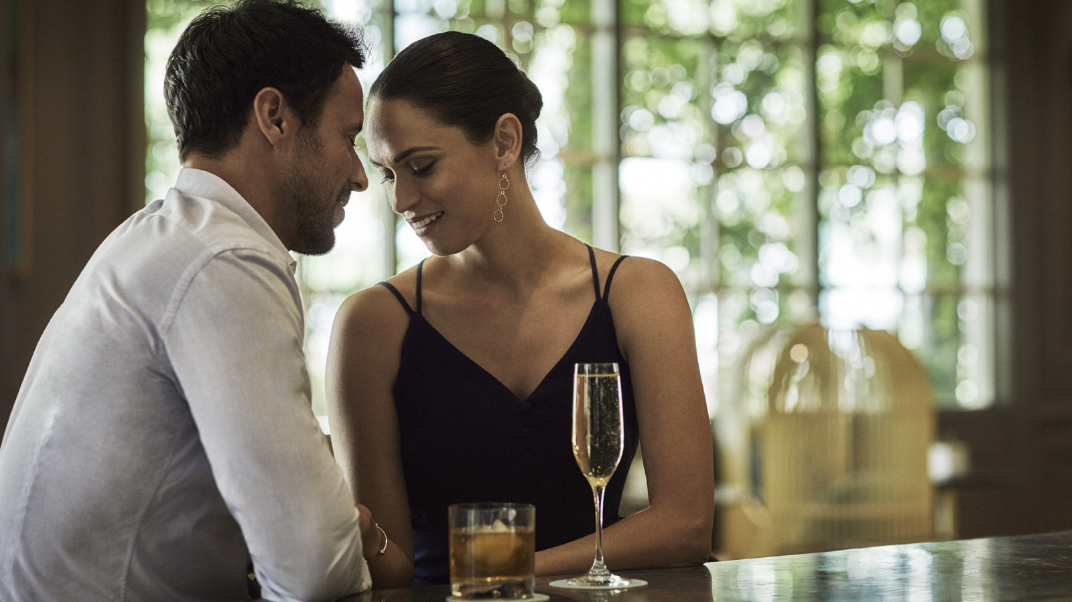 | January 26, 2023, Las Vegas, U.S.A.  Celebrate Love in All Forms at Four Seasons Hotel Las Vegas  https://publish.url/lasvegas/hotel-news/2023/valentines-day.html
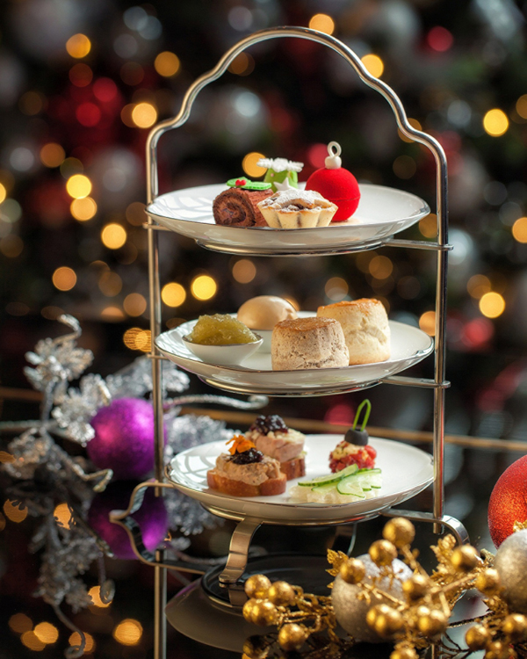 | November 28, 2022, Las Vegas, U.S.A.  Four Seasons Hotel Las Vegas Presents Holiday Afternoon Tea Benefitting The Smith Center for the Performing Arts  https://publish.url/lasvegas/hotel-news/2022/holiday-afternoon-tea.html

PRESS CONTACTS

Jeff Lovari
Director of Communications
3960 Las Vegas Boulevard South
Las Vegas
USA
jeff.lovari@fourseasons.com

+1 702 632 5103

