Four Seasons UAE Collection Properties Retain Prestigious Five-Star Ratings in Forbes Travel Guide 2020

All three Four Seasons properties in Abu Dhabi and Dubai achieve the highest commendation in illustrious annual rundown of the world’s finest luxury hotels
February 13, 2020, Abu Dhabi, U.A.E.

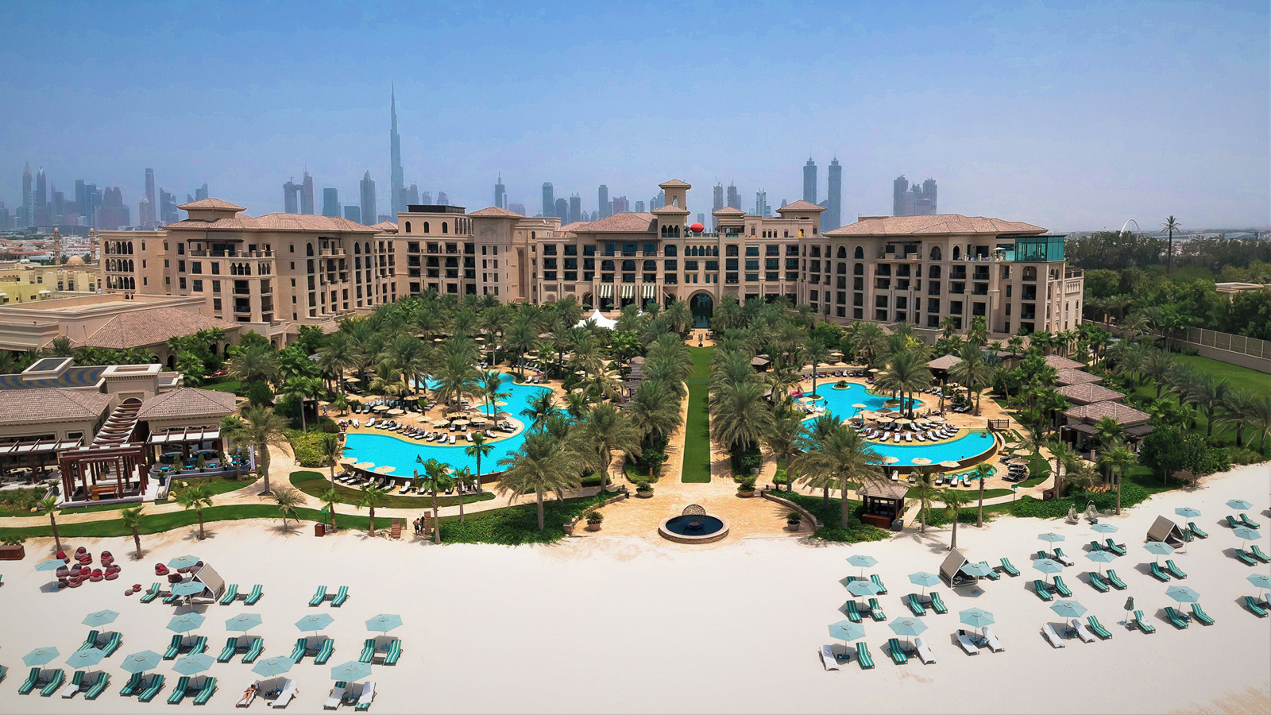 |  | 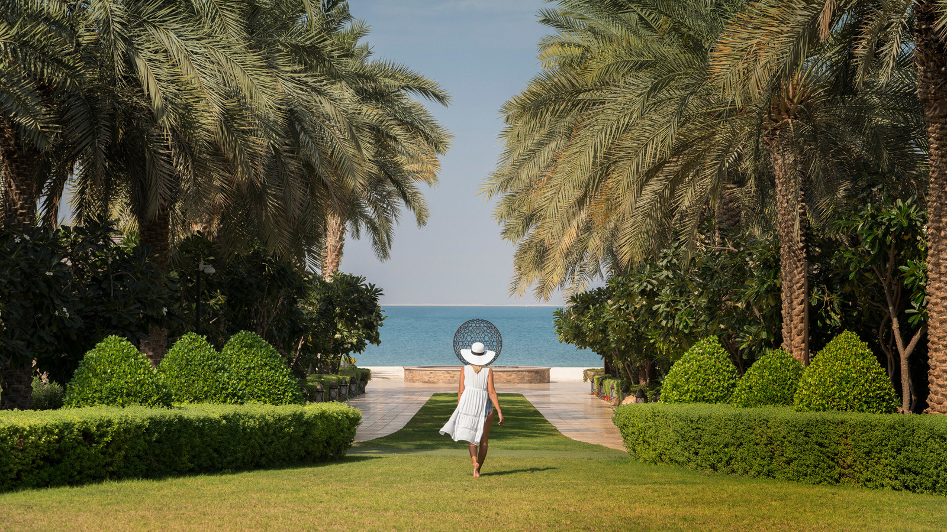
Four Seasons Hotels and Resorts, the world’s leading luxury hospitality company, has been awarded Five Star ratings for all three of its UAE Collection properties in the Forbes Travel Guide for the second year running. The awards reflect the impeccable service, delectable dining and luxurious facilities enjoyed by guests, and represent the highest honour available in the prestigious guide to the world’s top hotels.
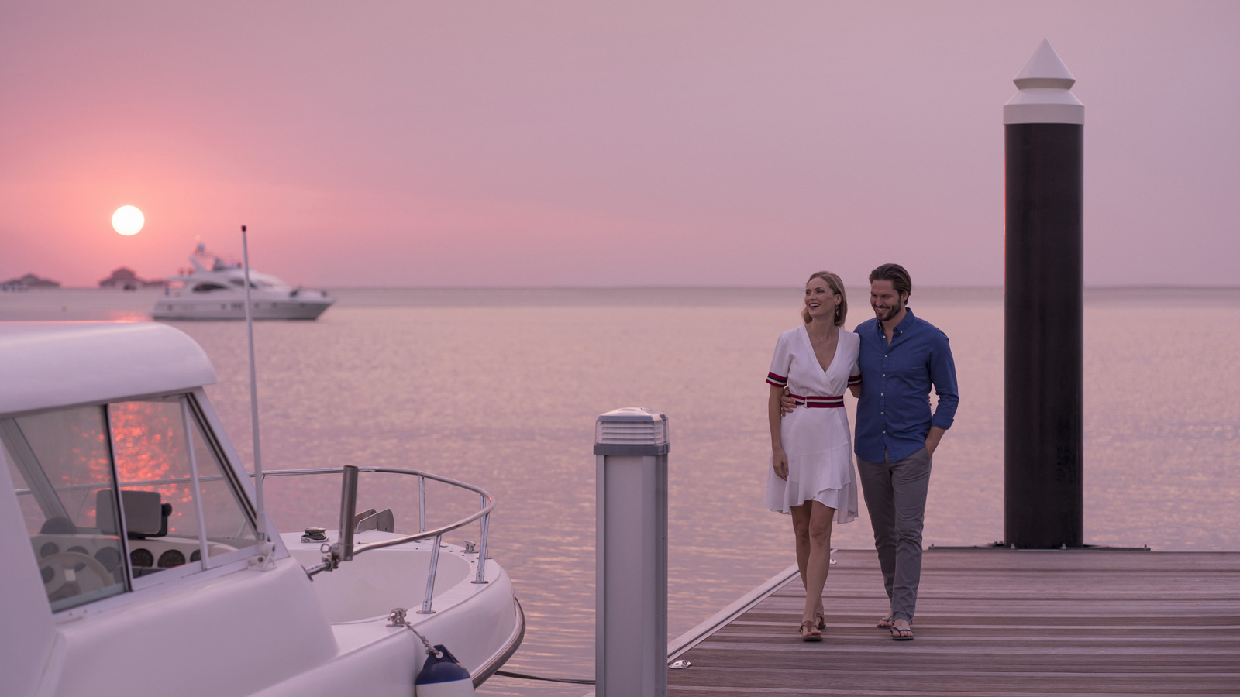 | 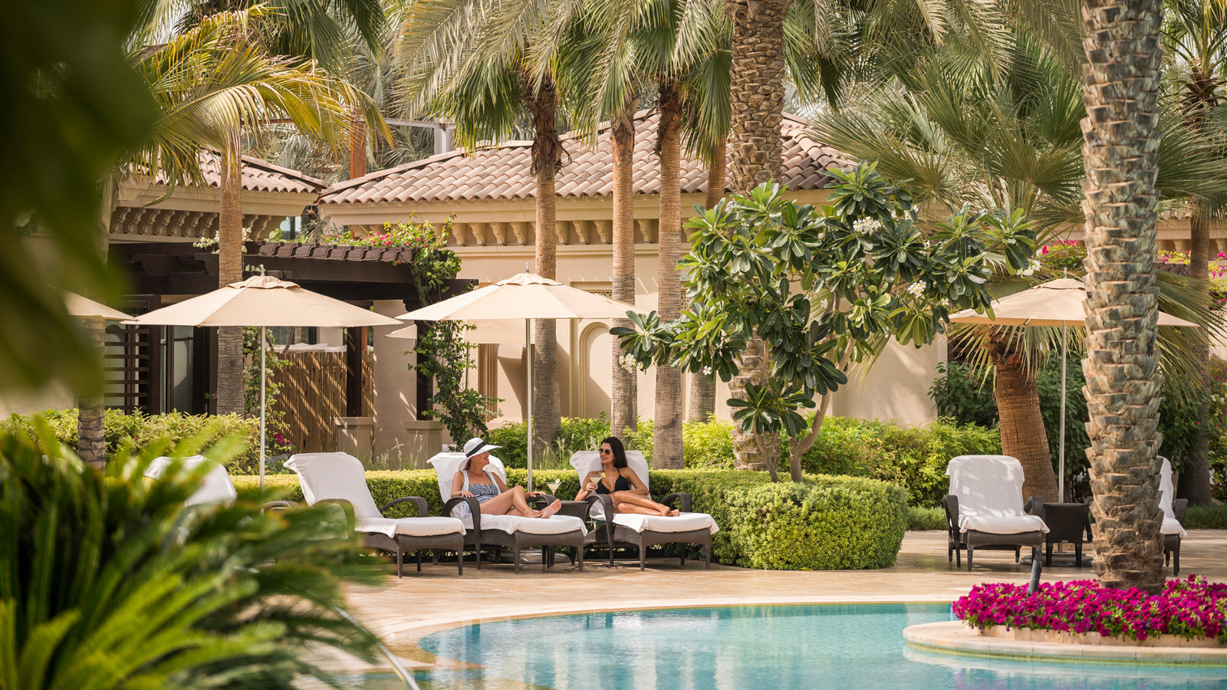 | 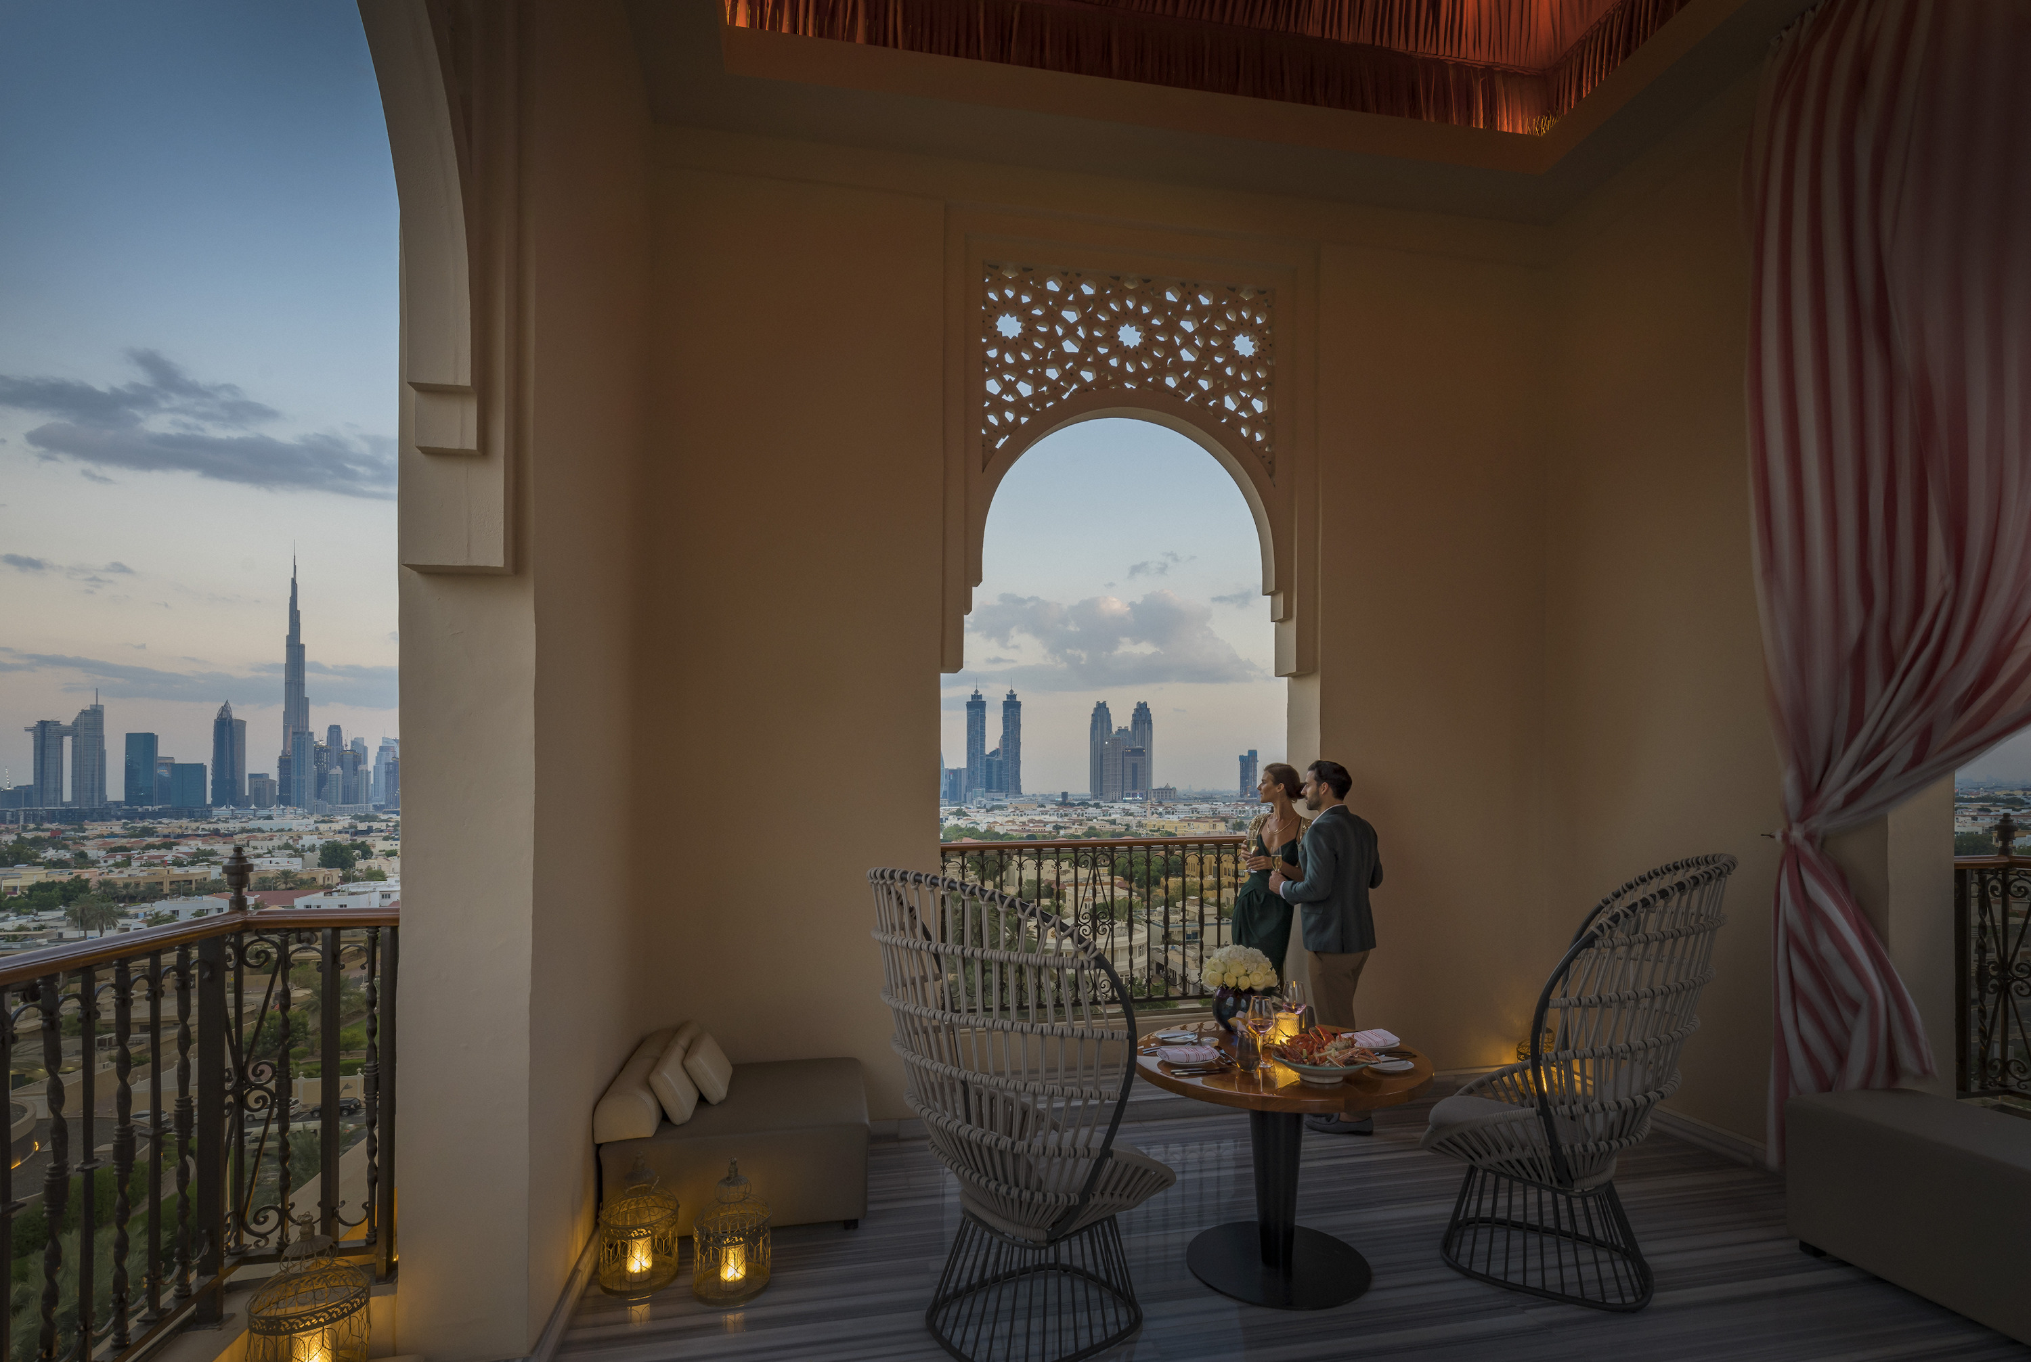
Published annually, the Forbes Travel Guide is globally recognised for creating the original concept of five-star service. Four Seasons Resort Dubai at Jumeirah Beach and Four Seasons Hotel Dubai International Financial Centre retained their Five-Star ratings for the third year running, while Four Seasons Hotel Abu Dhabi at Al Maryah Island features in the guide for the second year in a row. In addition, Four Seasons Resort Dubai at Jumeirah Beach received a Four-Star rating for The Pearl Spa, which offers a comprehensive range of beauty treatments, massage and wellness therapies.
Leonardo Baiocchi, Regional Vice President and General Manager of Four Seasons Resort Dubai at Jumeirah Beach, comments, “The Forbes Travel Guide Five-Star rating is considered among the industry’s highest accolades, and so I am delighted to have all three of our UAE collection properties attain this honour for a second consecutive year. It is particularly rewarding to note that the ratings awarded are independently verified and assessed based on the level of service at each property. This outstanding achievement reflects our teams’ shared passion for delivering exceptional guest experiences that create treasured memories to last a lifetime.”
Enjoy Dubai at its Best with Two Distinctive Properties
Located just minutes from the city's main shopping and business hubs, Four Seasons Resort Dubai at Jumeirah Beach is a verdant oasis in the city’s upmarket Jumeirah Beach district. The Resort is home to 11 upscale dining and lounge venues, three stylish pools and a pristine private beach. Its expansive grounds provide endless opportunities for meetings, events and special occasions, while The Pearl Spa offers a collection of exclusive beauty treatments and rejuvenating wellness therapies in luxurious surroundings.
Situated in the heart of Dubai’s vibrant financial district, Four Seasons Hotel Dubai International Financial Centre is a boutique-style sanctuary characterised by an intimate, home-away-from-home ambiance. The Hotel’s bespoke approach ensures that guests experience signature Four Seasons hospitality with a personal touch. Featuring chic interiors by New York designer Adam Tihany and a glass-enclosed rooftop pool with stunning views over the city, this stylish property introduces a relaxed yet refined approach to luxury.
Experience an Elegant Escape in the UAE Capital
Located within a striking 34-storey glass tower on the upscale Al Maryah Island, Four Seasons Hotel Abu Dhabi at Al Maryah Island blends modern urban chic with understated luxury. The Hotel welcomes guests with bright, open spaces complimented by panoramic views of the city skyline and the sparkling waters of the Arabian Gulf. In addition to 200 elegant rooms and suites, the property is home to six highly-acclaimed restaurants and lounges, the recently launched Butcher & Still Food Truck, the opulent Dahlia Spa and a stunning outdoor pool area, making it one of Abu Dhabi’s most exciting waterfront destinations.
Olivier Thomas, General Manager at Four Seasons Hotel Abu Dhabi at Al Maryah Island, says, “We are thrilled to have our beautiful Hotel featured in the Forbes Travel Guide for the second year running - and to be the only Forbes Five Star hotel in Abu Dhabi. This award underlines our deep commitment to elevating the guest experience for visitors to Abu Dhabi. I’d like to thank each and every member of my team, whose exemplary craftsmanship and intuitive service continues to showcase the best of this remarkable destination.”
Discover the Emirates with Four Seasons
Discerning travellers who wish to experience the acclaimed Four Seasons UAE Collection are invited to explore one of the world’s most exciting destinations in unrivalled comfort and convenience with the Discover the Emirates package. Guests can enjoy a world of exquisite dining, luxurious spas and unique cultural experiences with stays at all three Four Seasons properties in Dubai and Abu Dhabi. This exclusive package includes:
- One night at Four Seasons Resort Dubai at Jumeirah Beach
- One night at Four Seasons Hotel Dubai International Finance Centre
- Two nights at Four Seasons Hotel Abu Dhabi
- An exciting array of bespoke cultural experiences
- Impeccable half-board dining at all properties
- Luxury transfers between Dubai and Abu Dhabi
For reservations, book online or call +971 (0)4 270 7788.

RELATED

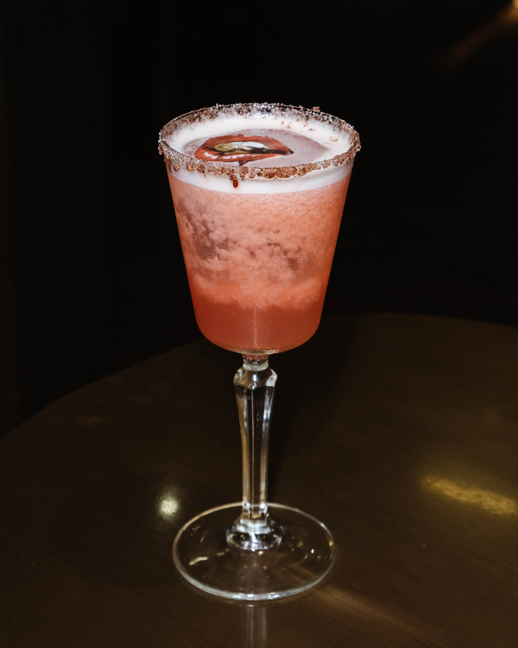 | January 21, 2020, Dubai, U.A.E.  Luna Sky Bar at Four Seasons Hotel Dubai International Financial Centre Launches 12 New Astrology Cocktails for Every Zodiac Sign  https://publish.url/dubaidifc/hotel-news/2020/zodiac-cocktails.html
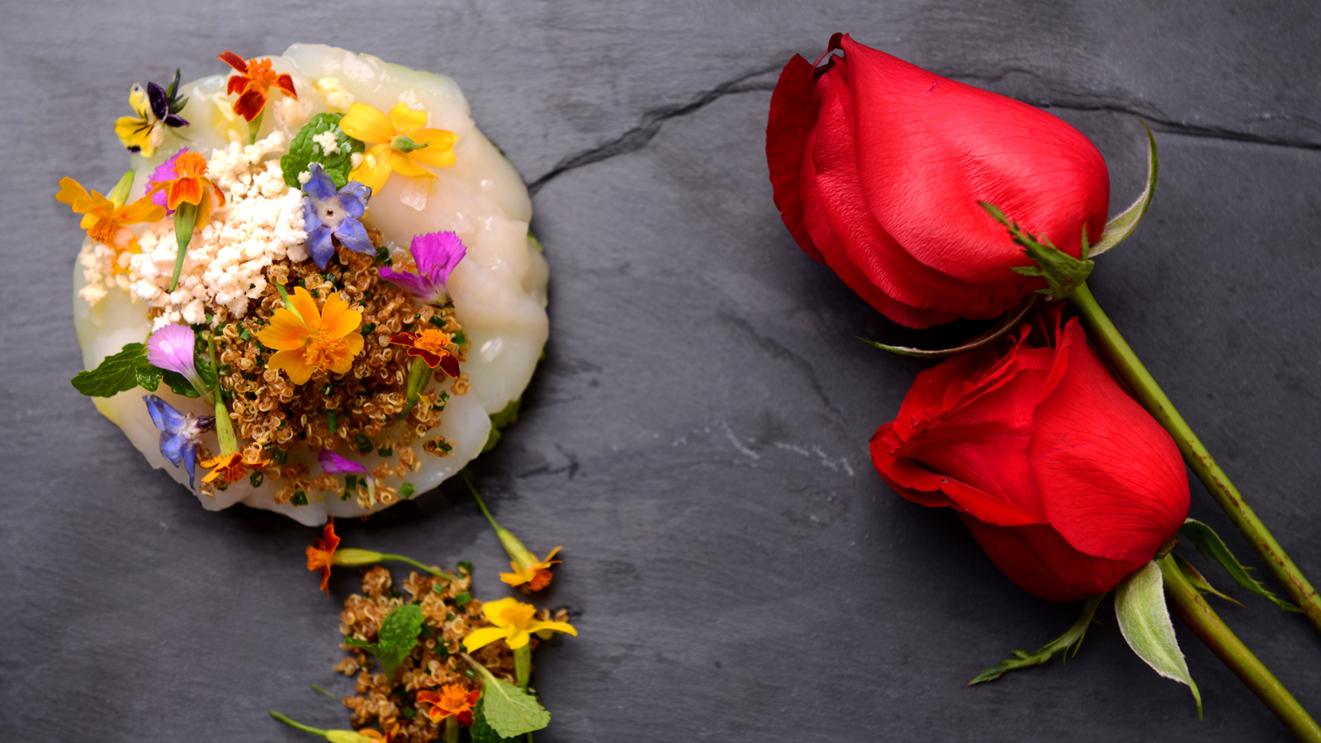 | January 17, 2020, Abu Dhabi, U.A.E.  Seven Reasons She Will Fall in Love This Valentine’s Day at Four Seasons Hotel Abu Dhabi at Al Maryah Island  https://publish.url/abudhabi/hotel-news/2020/valentines-day.html

PRESS CONTACTS

Veronika Szabo
Director of Public Relations
P.O.Box 107032, Al Maryah Island
Abu Dhabi
United Arab Emirates
veronika.szabo@fourseasons.com

+971 2 333 2222

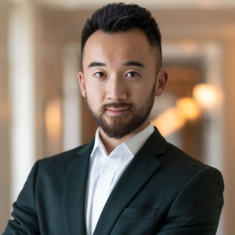 | Mazhit Ismailov  Senior Director of PR and Communications  Jumeirah Road  Dubai  United Arab Emirates  mazhit.ismailov@fourseasons.com  + 971 4 270 7723

