A Dance with Flames

Fire spinners make memorable nights a routine at Four Seasons Resort Koh Samui
May 10, 2021, Koh Samui, Thailand

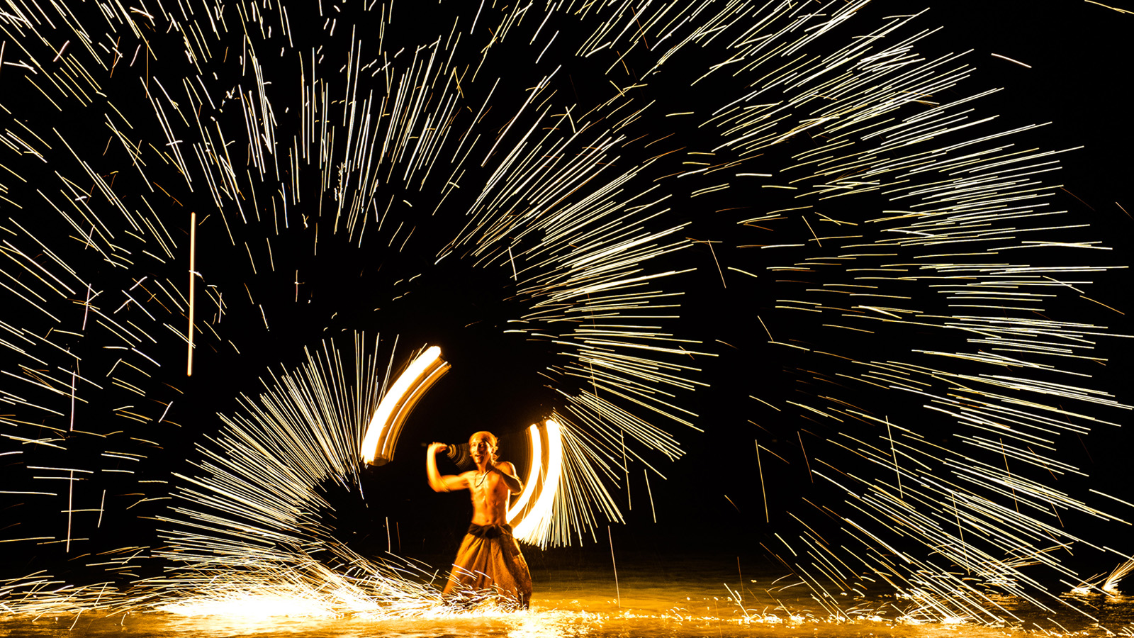
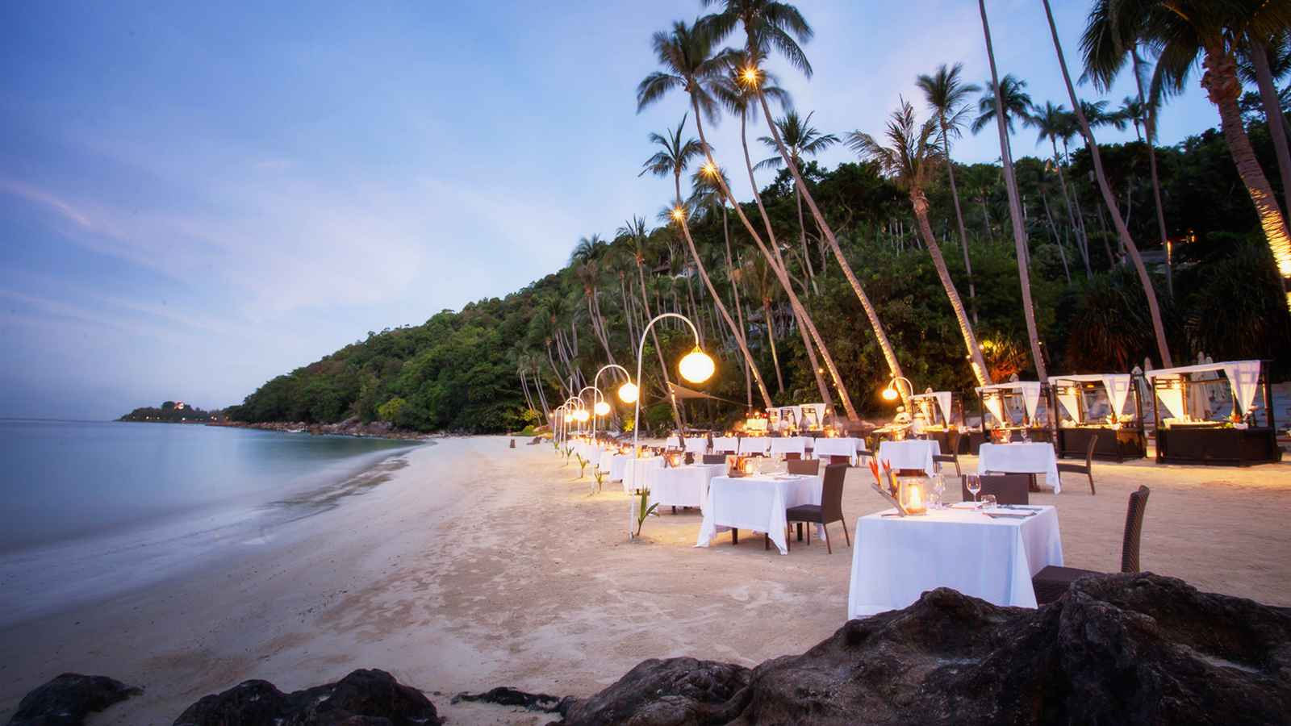 | 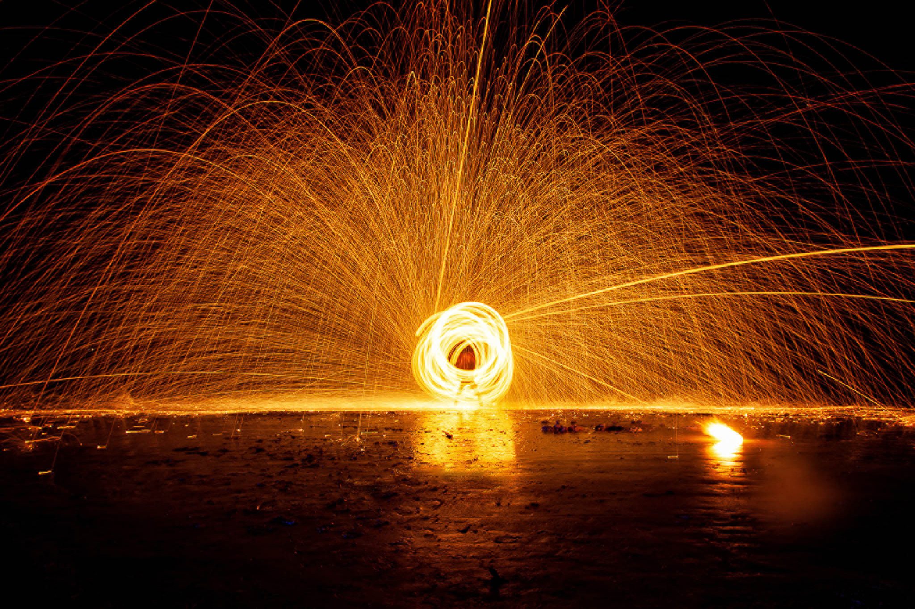
There are few things more dazzling than a star-lit night sky, highlighted by a moonrise. Watching fire spinners in action on Koh Samui’s pristine beaches sure competes! Shining brighter than the moon, fire spinners light up the horizon with artistic moves and tricks, best experienced at the private beach at Four Seasons Resort Koh Samui during pop-up dinner events or private celebrations.
As the name suggests, fire spinners use their physical skills and props such as fire sticks and fireballs to showcase the unique art of dancing with flames. The origin of fire dance is difficult to trace, evolving over time by adopting techniques and knowledge from various dance forms. Besides extensive training in acrobatic skills and to ensure the safety of both the audience and themselves, performing on stage is much more than just knowing how to spin the firestick. Being kissed by flames as part of a daily routine, scars and bruises are check-in stamps for an average fire spinner. “To overcome the fear of fire is a big deal, especially when you have to interact with it at such close quarters,” shares Pipat Suwapat, Fire Spinner. “But after all the practice, it is gratifying to receive the applause and cheers from the audience – the biggest motivation to keep perfecting my performance. One minute on the stage takes ten years of practice off it.”
Guests at Four Seasons Resort Koh Samui have come to appreciate the fire spinners and the magic that this experience offers. “They always leave guests in awe!” says Vallapha Srijame, Conference Services and Sales Manager. Needless to say, fire spinning is a highlight of any event or social gathering organised by Vallapha at the Resort. Accompanied by the pleasant evening breeze and crashing waves on the white sand beach, the fire spinners weave magic with flames every night, giving guests lasting memories of their beachside get-togethers.

RELATED

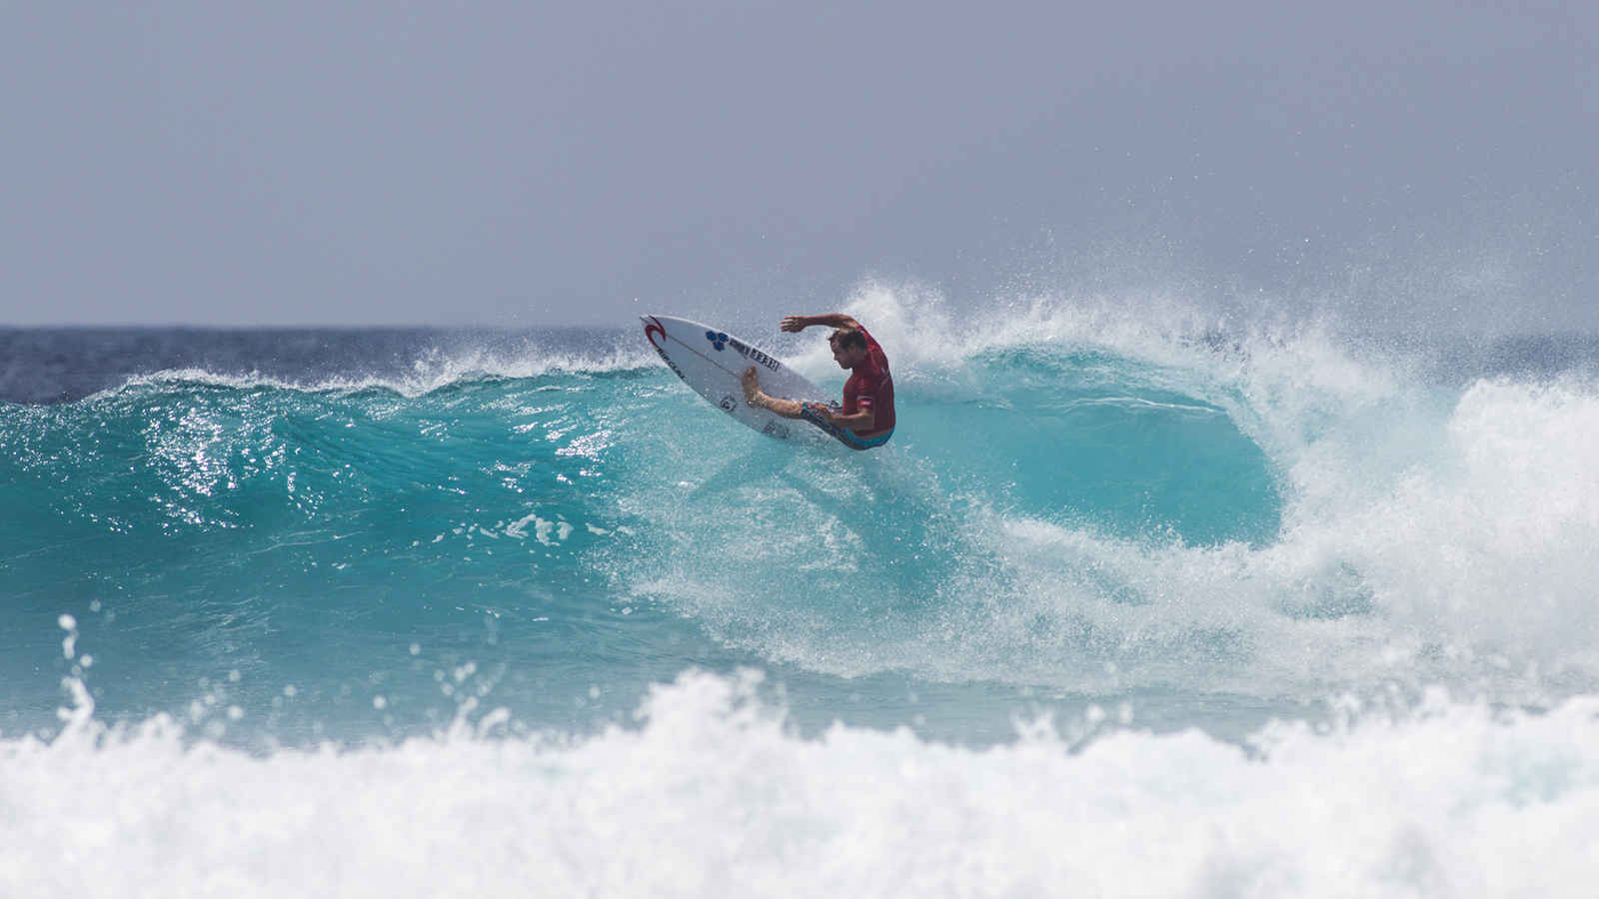 | August 5, 2022, Maldives at Kuda Huraa, Republic of Maldives  Taylor Knox and Hussain "Iboo" Areef Join the Lineup for Upcoming Four Seasons Maldives Surfing Champions Trophy 2022  https://publish.url/maldiveskh/hotel-news/2022/more-competitors-added-to-surfing-champions-trophy-event.html
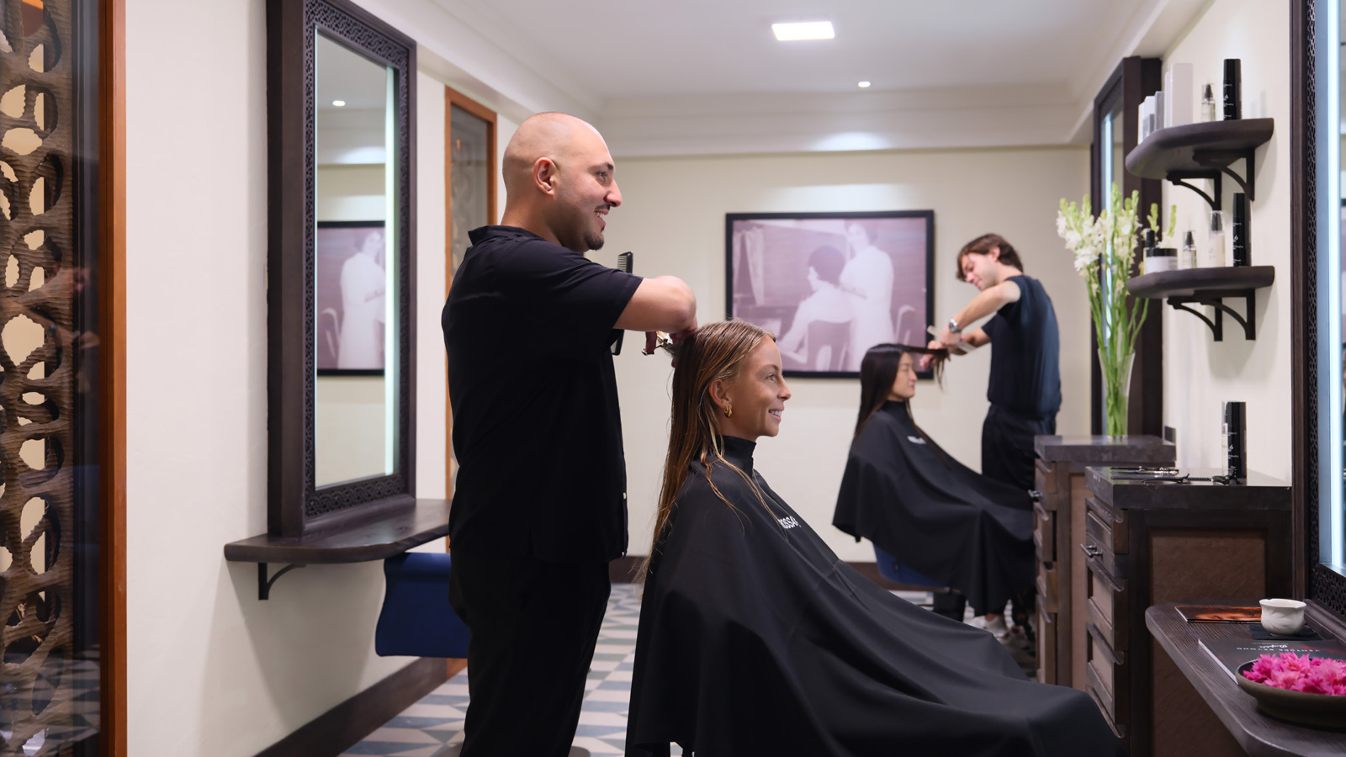 | July 28, 2022, Bali at Jimbaran Bay, Indonesia  Luxury Escape Four Seasons Resort Bali at Jimbaran Bay Welcomes the First South-East Asian Outpost of the Esteemed Rossano Ferretti Hair Spa  https://publish.url/jimbaranbay/hotel-news/2022/new-rossano-ferretti-hair-spa.html

PRESS CONTACTS

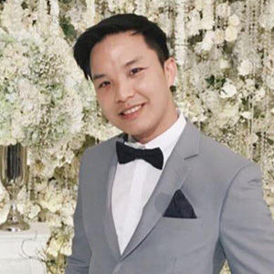 | Paponpat Sapsuwan  Assistant Public Relations Manager  3/F, 159 Rajadamri Road  Bangkok  Thailand  paponpat.sapsuwan@fourseasons.com  +66 02 207 8999
Waratah Jongsaeng
Assistant Manager – Digital Marketing
3/F, 159 Rajadamri Road
Bangkok
Thailand
waratah.jongsaeng@fourseasons.com

+66 2207 8918

Karuna Amarnath
Senior Director of Sales
3/F, 159 Rajadamri Road
Bangkok
Thailand
karuna.amarnath@fourseasons.com

+66 2207 8916

