Explore the Art of Muay Thai and the Spa at Four Seasons Resort Koh Samui

November 23, 2018, Koh Samui, Thailand

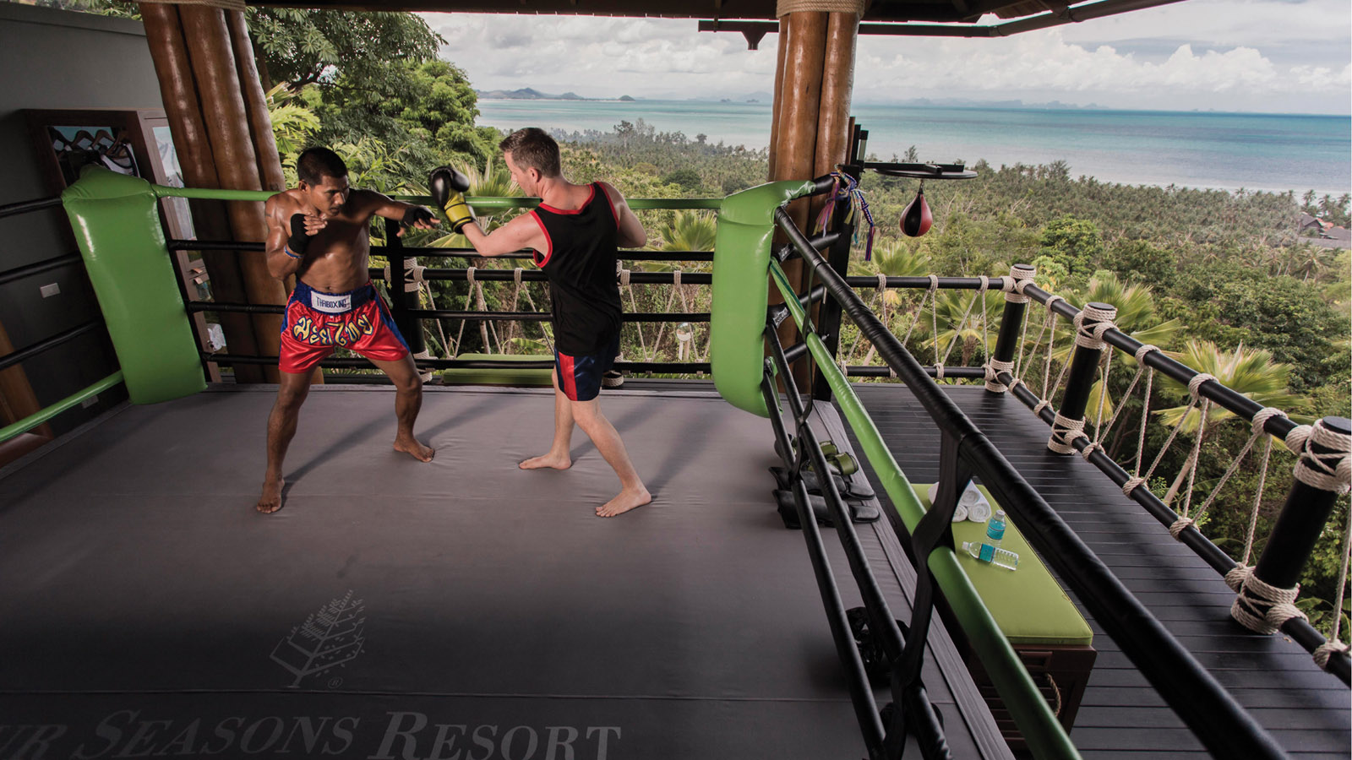
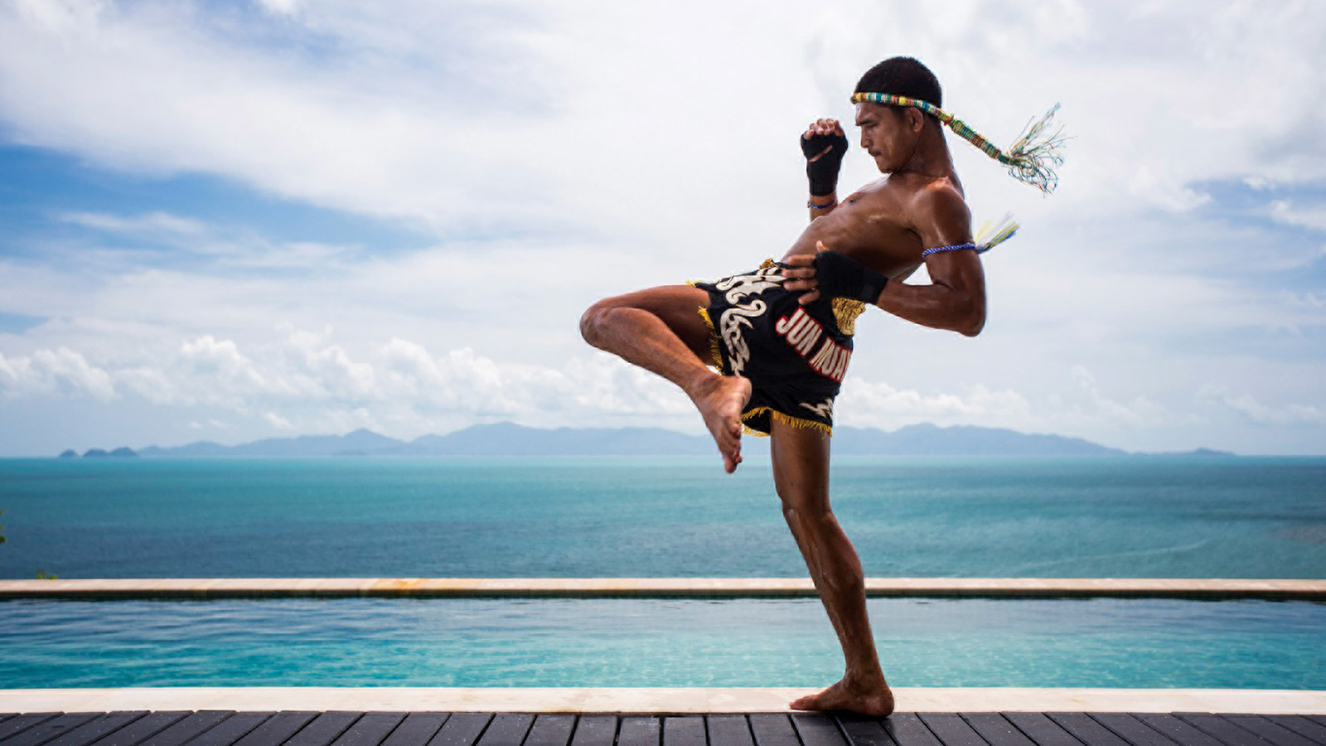 | 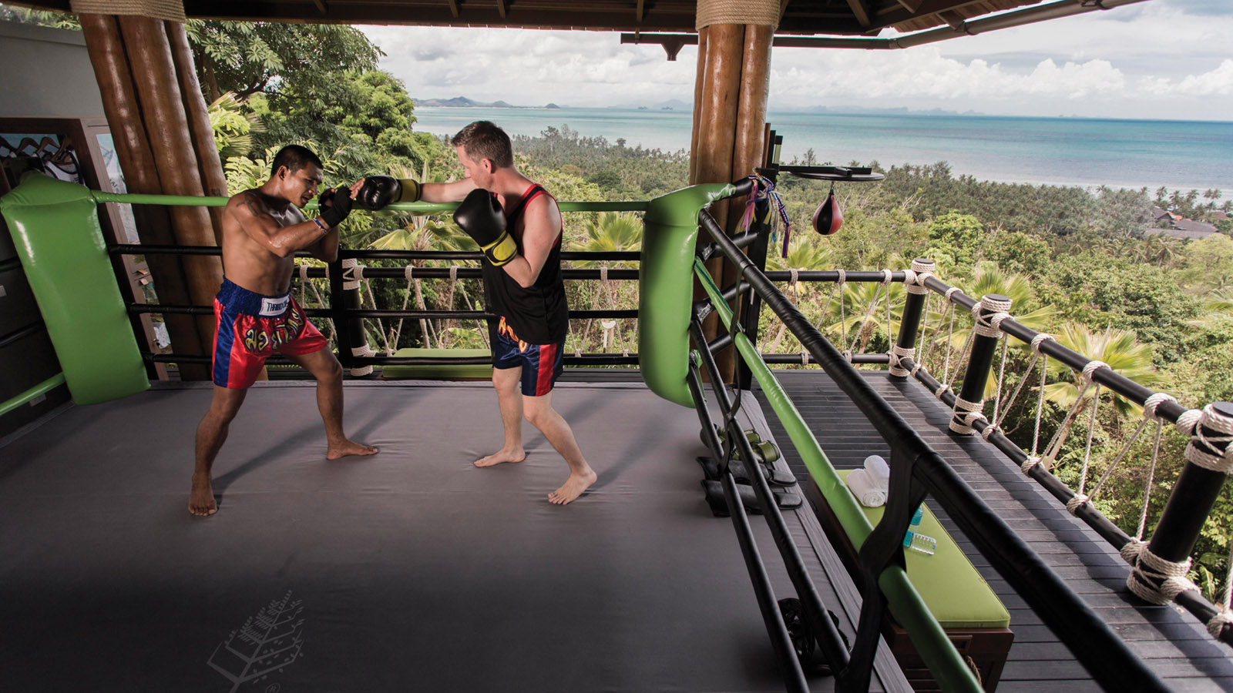 | 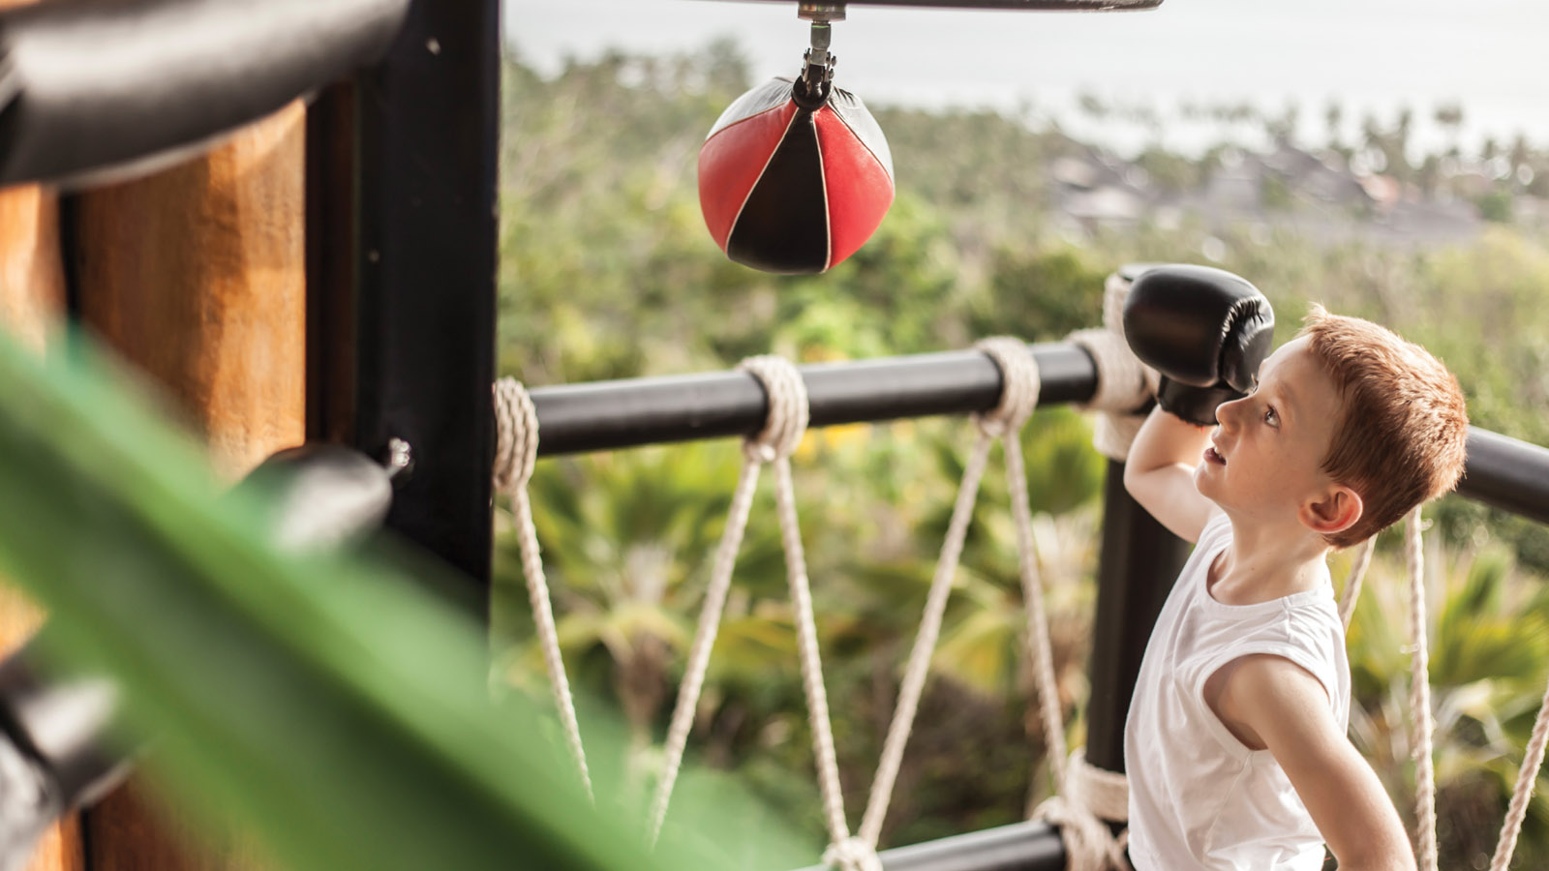
Four Seasons
Resort Koh Samui invites travellers seeking unique experiences to enjoy its popular accommodation package that includes an authentic, personally-customised Thai kickboxing workout counterbalanced with a soothing recovery treatment at the Resort’s amazing spa, The Secret Garden Spa.
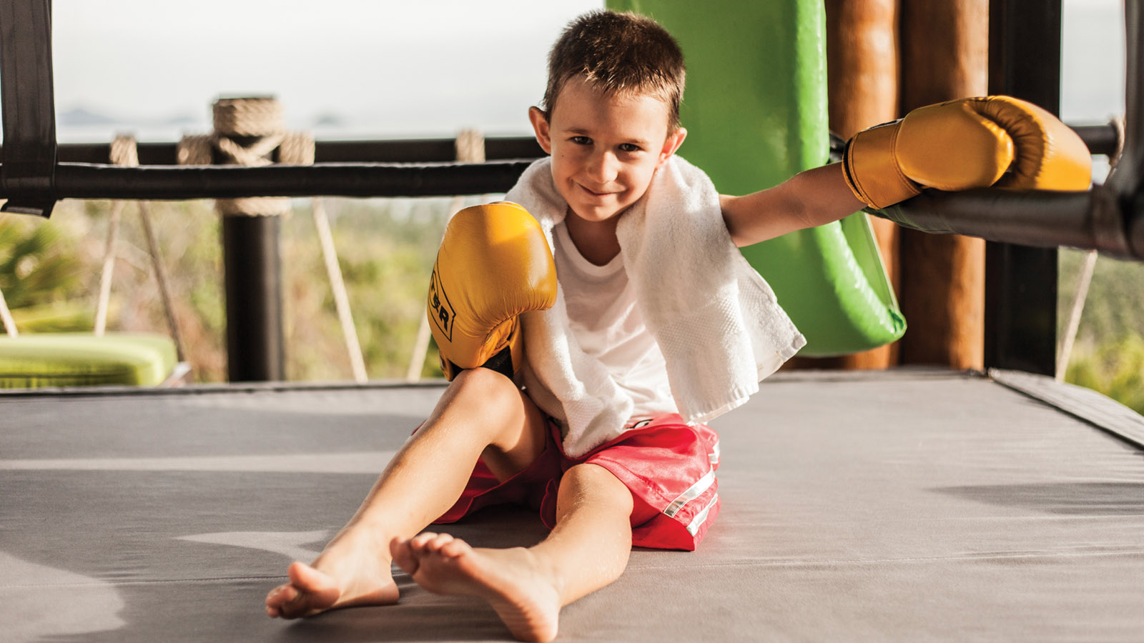
From now through December 22, 2018, guests can learn the art of Muay Thai kickboxing from a professional fighter and give it a try in the Resort’s own boxing ring, which is spectacularly located on top of a hill within the Resort’s grounds and enjoys panoramic views of the Gulf of Thailand.
Offering the opportunity to "go local" for a day, the package also includes a visit to Chaweng Boxing Station to watch some professional action from VIP seating. Guests conclude a day of discovery and recover fully from their boxing exertions with a muscle-soothing customised Muay Thai Recovery Treatment in the pristine natural setting of The Secret Garden Spa.
Priced from THB 35,500 per night with a minimum of three nights required, the Muay Thai Package includes:
- Luxurious accommodation in a private villa with pool
- Daily buffet breakfast for two at KOH Thai Kitchen & Bar restaurant
- Round-trip airport transfers
- Thai kickboxing session with a professional trainer for one person (once per stay)
- Souvenir Thai kickboxing workout gear on arrival for one person
- Muay Thai Recovery Treatment for two at the Secret Garden Spa (once per stay)
- Private tour to live Thai kickboxing competition at Chaweng Boxing Stadium for two persons
- Laundry credit for Thai kickboxing workout gear
For further information or make a reservation, contact the Reservations Department at +66 2207 8900 or E-mail: Reservations.Thailand@fourseasons.com

RELATED

August 24, 2018, Koh Samui, Thailand
The Ultimate Island Indulgence: Lava Shell Massage at Four Seasons Resort Koh Samui
https://publish.url/kohsamui/hotel-news/2018/lava-shell-massage.html

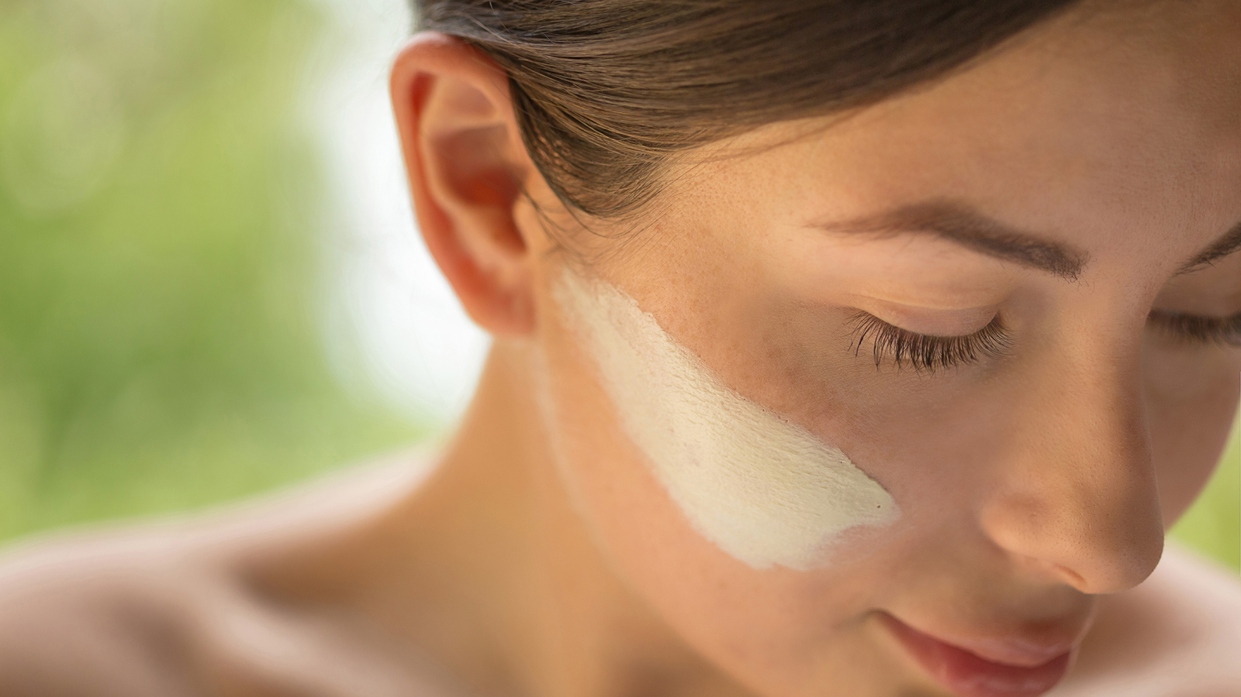 | July 27, 2018, Koh Samui, Thailand  Four Seasons Resort Koh Samui Unveils "Reasons To" Indulge in Wellbeing  https://publish.url/kohsamui/hotel-news/2018/reasons-to-indulge-in-wellbeing.html

PRESS CONTACTS

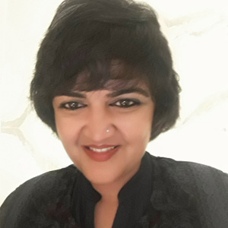 | Karuna Amarnath  Director of Public Relations and Communications  3/F, 159 Rajadamri Road  Bangkok  Thailand  karuna.amarnath@fourseasons.com  +66 2207 8916
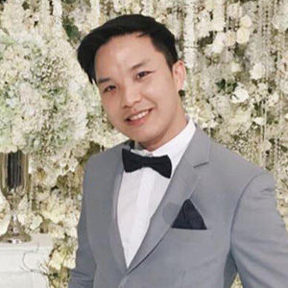 | Paponpat Sapsuwan  Assistant Public Relations Manager  3/F, 159 Rajadamri Road  Bangkok  Thailand  paponpat.sapsuwan@fourseasons.com  +66 02 207 8999
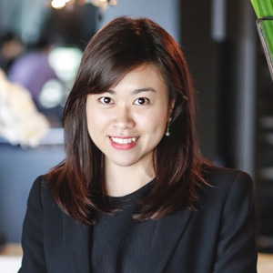 | Chomploy Yavirach  Assistant Social Media Manager  3/F, 159 Rajadamri Road  Bangkok  Thailand  chomploy.yavirach@fourseasons.com  +66 02 207 8999
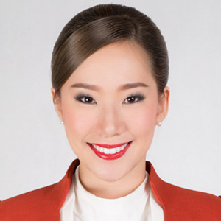 | Metanee Promjai  PR Executive  219 Moo 5  Angthong  Thailand  metanee.promjai@fourseasons.com  + 66 (0)77 243 201

