A New World of Wellness at Four Seasons Hotel Hampshire

Experience pioneering health and wellbeing concepts surrounded by history
January 8, 2020, Hampshire, England

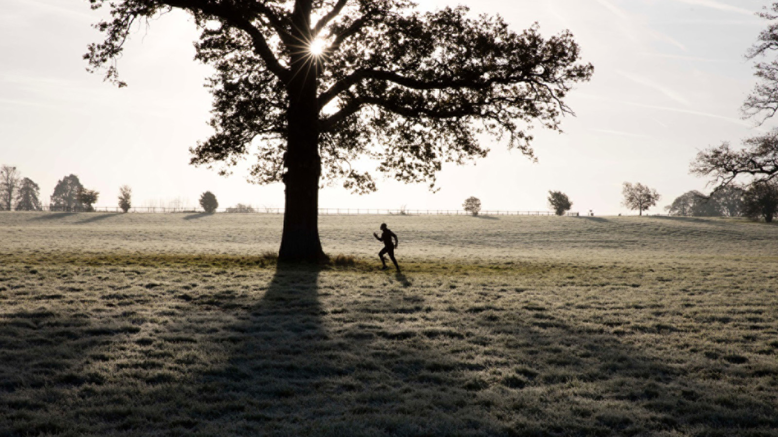
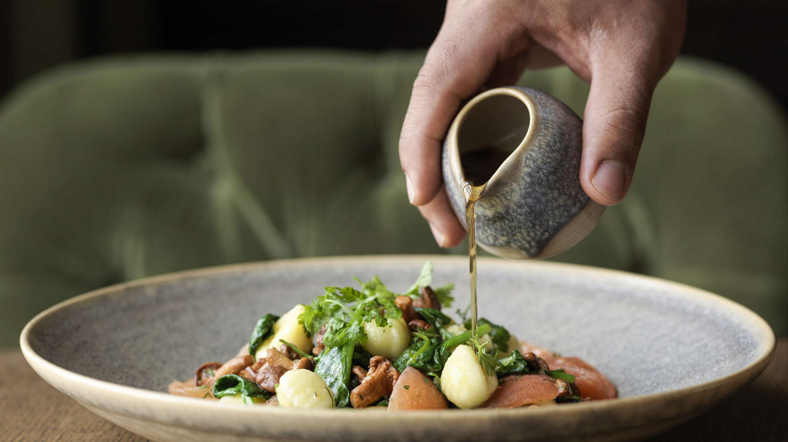
As a new decade begins, the entire world of wellbeing is changing and Four Seasons Hotel Hampshire is leading the way with a variety of pioneering concepts for the luxury traveller.
Designed to recognise that society has become increasingly mindful of both mental and physical wellbeing, the Hotel is joining forces with a team of trained experts to deliver a wellness experience that goes far beyond traditional offerings.
Four Seasons Hotel Hampshire Spa Director Reka Seres explains, “Health and wellness is extremely important to our guests, and being set deep within the Hampshire countryside, the Hotel provides the perfect place for them to reconnect with themselves.”
Located in the Manor House’s original 18th century stable block, the Spa specialises in developing the latest wellness concepts with the world’s leading professionals, while creating an environment that feels far removed from the modern-day stresses of guests’ day to-day lives.
With these unique wellness experiences, the property hopes to offer guests opportunities that they not only enjoy during their Four Seasons visit, but that stay with them for a lifetime.
Deep Mind Massage
Working with trained hypnotherapist Mark Williams, Four Seasons Hotel Hampshire will offer a unique new Deep Mind Massage therapy. With Mark guests will reach new goals and improve their mental well-being, whether they want to lose weight, reduce stress, combat sleep disorders, break a bad habit or overcome a phobia – DeepMind Massage could be the answer to achieve this and much more. During the one hour session, Mark will personalise the process to fit the guest’s needs and individual requirements. After the session, guests will then be able to continue the therapy with a complimentary hypnosis recording to listen to at home to reinforce what was achieved in the session.
Spiritual Yoga
Guided by the property’s in-house yoga instructor Bodgan, guests can reconnect with themselves and enjoy a spiritual yoga session in the Hotel's picturesque walled garden. Here, based on the traditional yoga techniques and principles, guests will learn a series of exercises, improving their posture with a focus on core body strength, alignment and mindful movement.
Escape Fitness Boundaries
Designed by US military-trained Joshua Blackmer, the Hotel has created an extreme exercise program, pushing participants to their fitness limits. The journey will begin as guests are issued with their personalised Escape kit and with all of their mobile devices locked away, they will meet their team of fitness professionals. The orientation will then commence with a tour across the Estate via Landrover, mountain bikes and on foot, to familiarise them with their local terrain before a boot camp like no other. Only once the boot camp is completed and they have dived into an invigorating ice bath will they be able to enjoy a tailored treatment in the serene Spa at Four Seasons Hotel Hampshire.
Well Feeling Menus
The property’s Executive Chef Paolo Belloni is helping guests to get excited about nutritional eating and rethink their definition of healthy food with his new menu offerings. From lunch at the Spa’s Café Santé with oriental light bites such as teriyaki glazed salmon and pak choi to fresh seasonal choices at the Hotel restaurant Wild Carrot with the delicious signature salad and wild seabass, hungry guests are spoiled for healthy choices.
To book a spa experience today contact 01252 853 000.

RELATED

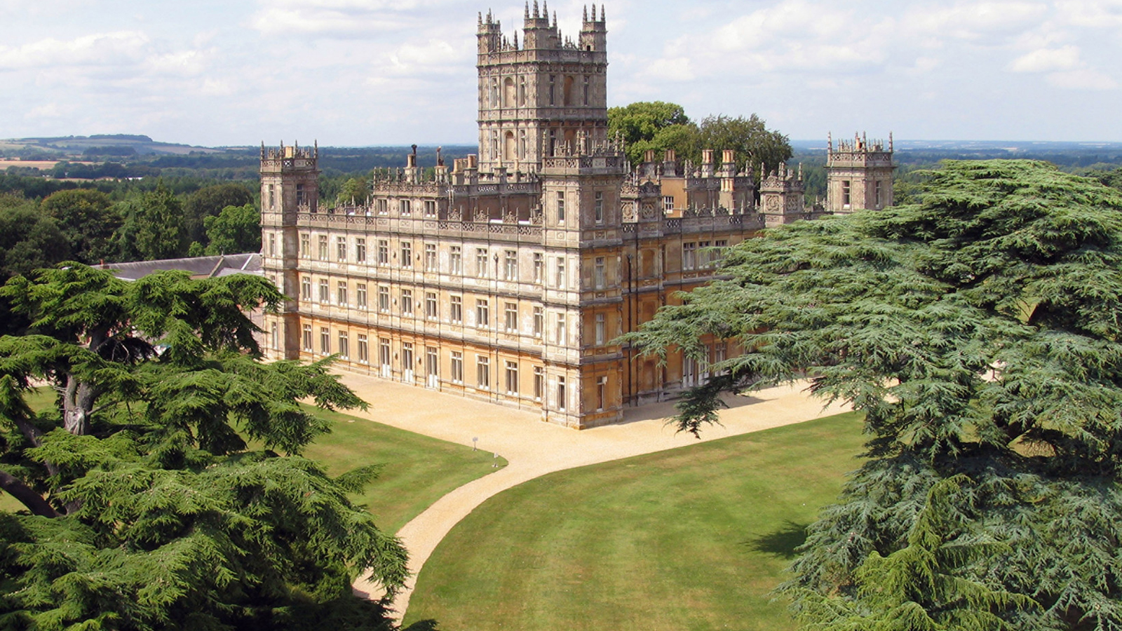 | November 13, 2019, Hampshire, England  城堡，文化和美食：和英国汉普郡四季酒店一起探索“唐顿庄园”的秘密  https://publish.url/zh/hampshire/hotel-news/2019/highclere-castle-extraordinary-experience-2.html
November 13, 2019, Hampshire, England
Castles, Culture and Cuisine: Discover the Secrets of Highclere Castle with Four Seasons Hotel Hampshire
https://publish.url/hampshire/hotel-news/2019/highclere-castle-extraordinary-experience.html

PRESS CONTACTS

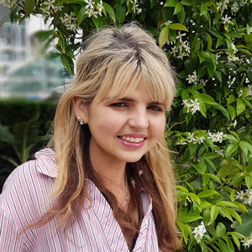 | Alana Hebenton  Public Relations Executive  Dogmersfield Park, Chalky Lane  Hook  UK  alana.hebenton@fourseasons.com  +44 (0)1252 853 000
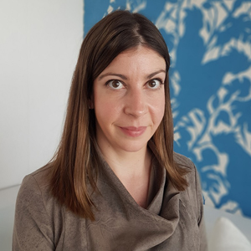 | Caroline Drayton  Director of Communications UK Collection  Hamilton Place, Park Lane  London  United Kingdom  caroline.drayton@fourseasons.com  +44 (20) 7319 5344

