Mei Ume at Four Seasons Hotel London at Ten Trinity Square Wins Best Luxury and Best Overall UK Restaurant at Restaurant & Bar Design Awards 2018

October 10, 2018, London at Ten Trinity Square

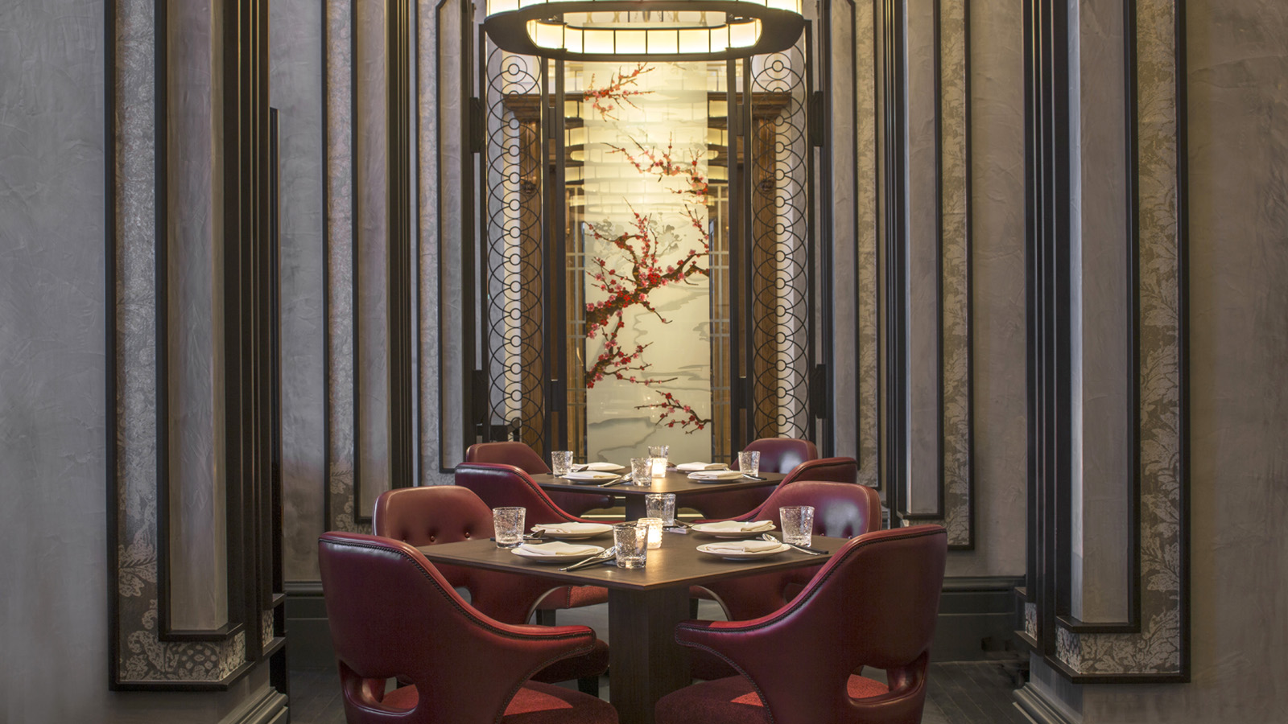
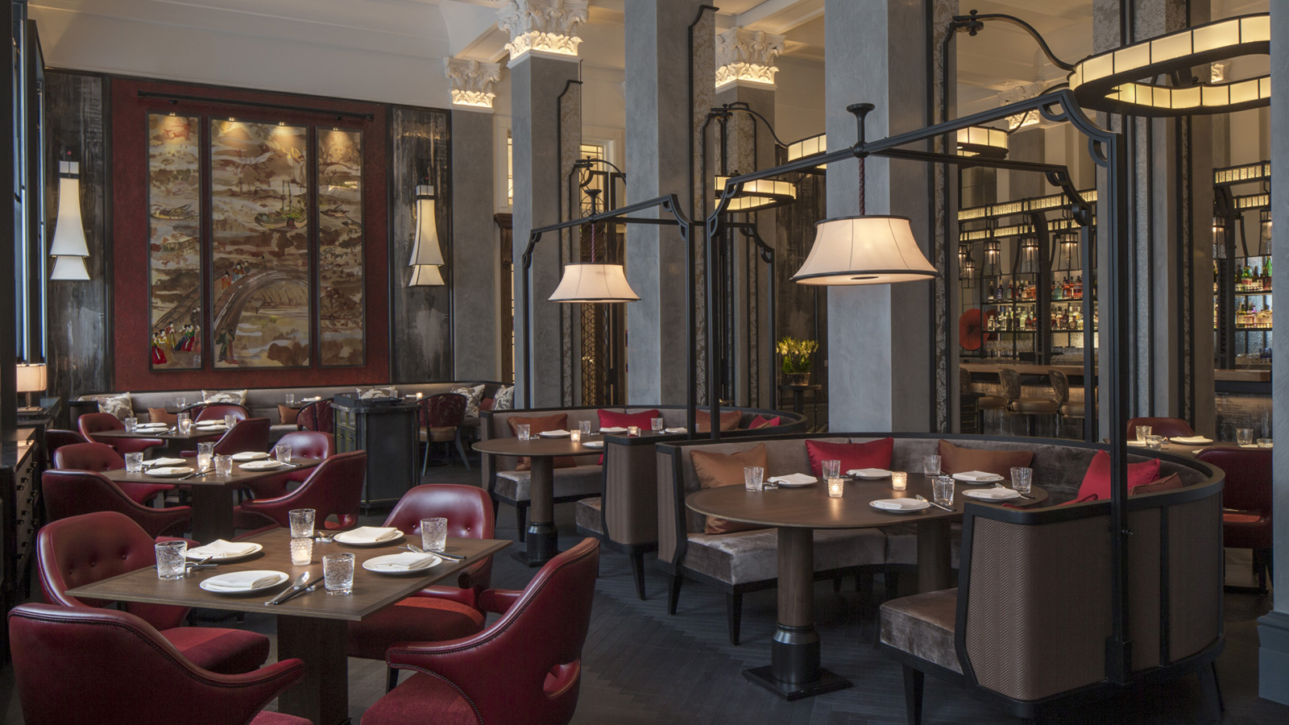
Mei Ume at Four Seasons Hotel London at Ten Trinity Square has taken home the awards for Best UK Restaurant and Best Luxury UK Restaurant at the annual Restaurant & Bar Design awards. As well as winning the two awards, Mei Ume was also shortlisted as Best London Restaurant, Best Restaurant or Bar in a Hotel and Best Restaurant or Bar in a heritage building.
Designed by Ed Ng and Terence Ngan of AB Concept, Mei Ume takes inspiration from the building’s heritage as a gateway for merchants from the east and west as well as from the restaurant’s name Mei Ume, which is a combination of the Japanese and Chinese language words for "plum blossom." A large screen at the entrance made with enamel paint on glass depicts the signature plum blossoms. Strategically placed at the entrance, this piece fuses the two worlds into one as a common language.
Celebrating its tenth year, the globally-recognised awards are dedicated to the design of food and beverage spaces and were attended by more than 600 of the UK and world’s best designers and their clients.
To make a reservation at Mei Ume contact 020 3297 3799 or email diningreservations.tri@fourseasons.com.

RELATED

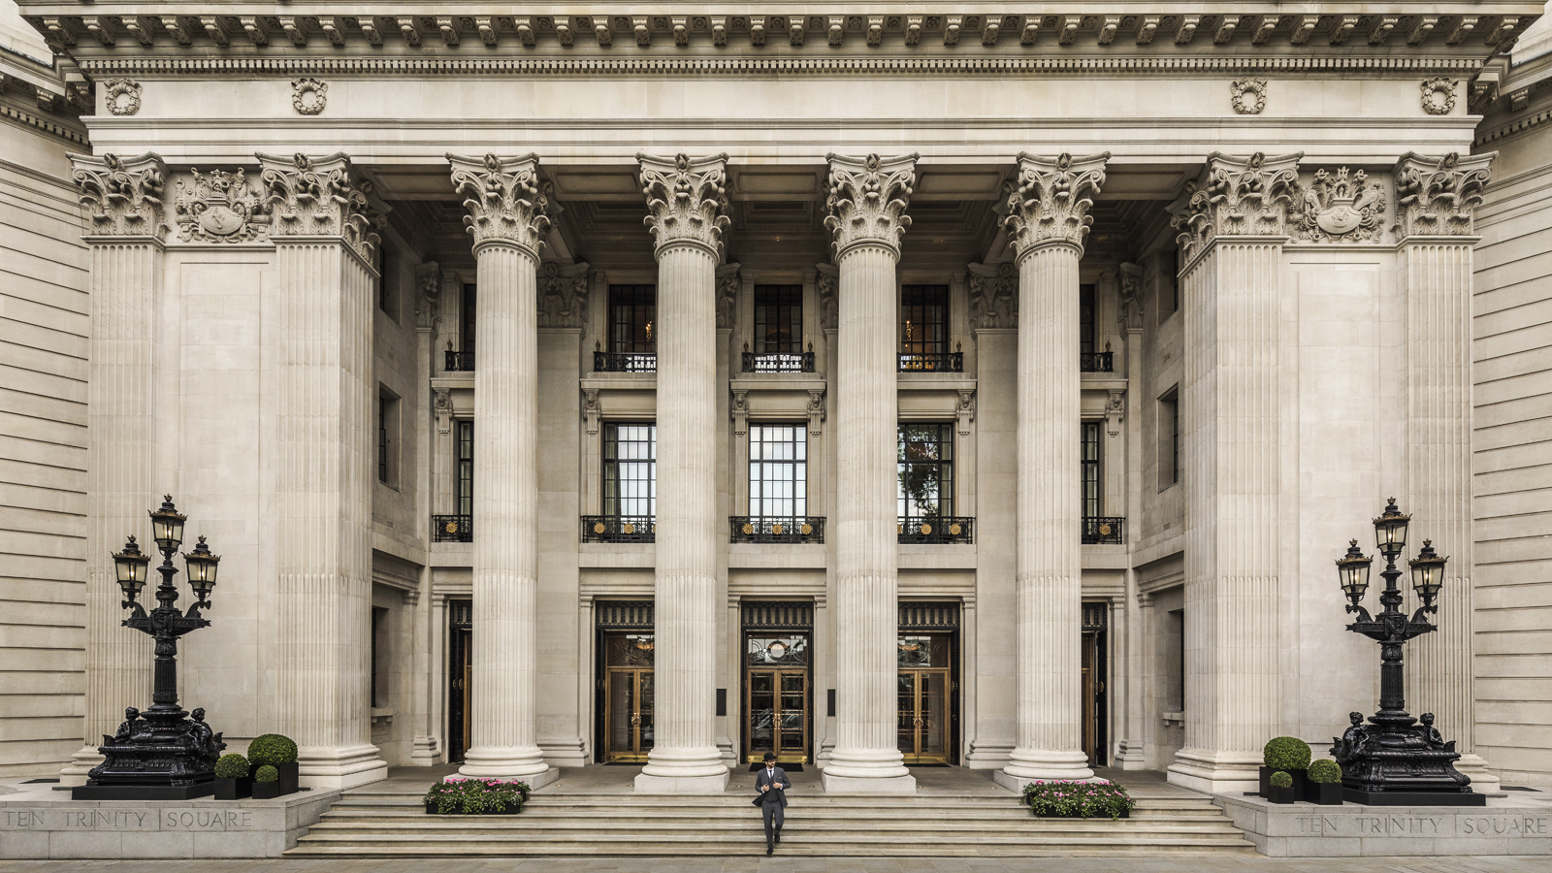 | September 25, 2018, London at Ten Trinity Square  Four Seasons Hotel London at Ten Trinity Square is Named AA Hotel of the Year London 2018-2019  https://publish.url/tentrinity/hotel-news/2018/aa-hotel-of-the-year-london.html
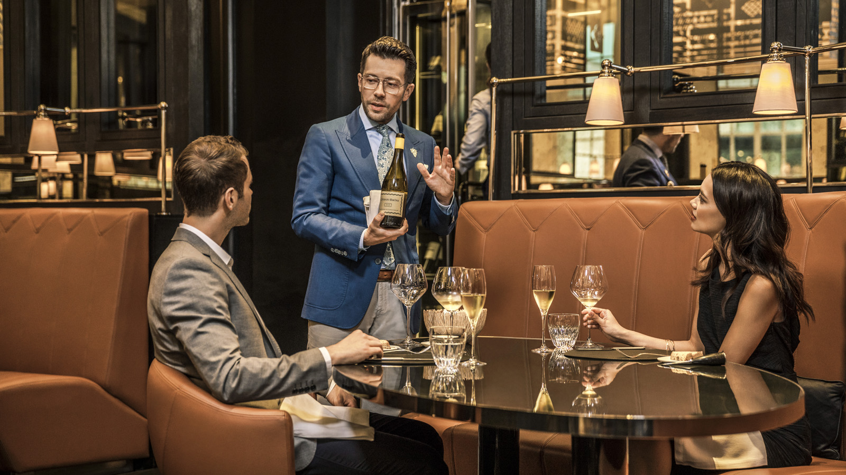 | September 17, 2018, London at Ten Trinity Square  La Dame de Pic London at Four Seasons Hotel London at Ten Trinity Square Awarded Best Medium Sized Wine List in the World 2018  https://publish.url/tentrinity/hotel-news/2018/best-medium-sized-wine-list-in-the-world.html

PRESS CONTACTS

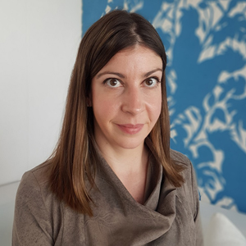 | Caroline Drayton  Director of Communications UK Collection  Hamilton Place, Park Lane  London  United Kingdom  caroline.drayton@fourseasons.com  +44 (20) 7319 5344
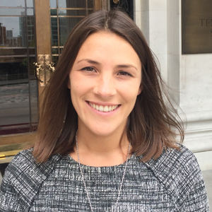 | Gemma Minto  Director of Public Relations  10 Trinity Square  London  UK  gemma.minto@fourseasons.com  +44 (0) 203 297 9232

