Four Seasons Hotel Westlake Village Announces the Opening of Coin & Candor

Highly anticipated California brasserie opens inside LA’s urban retreat
April 2, 2019, Los Angeles, Westlake Village, U.S.A.

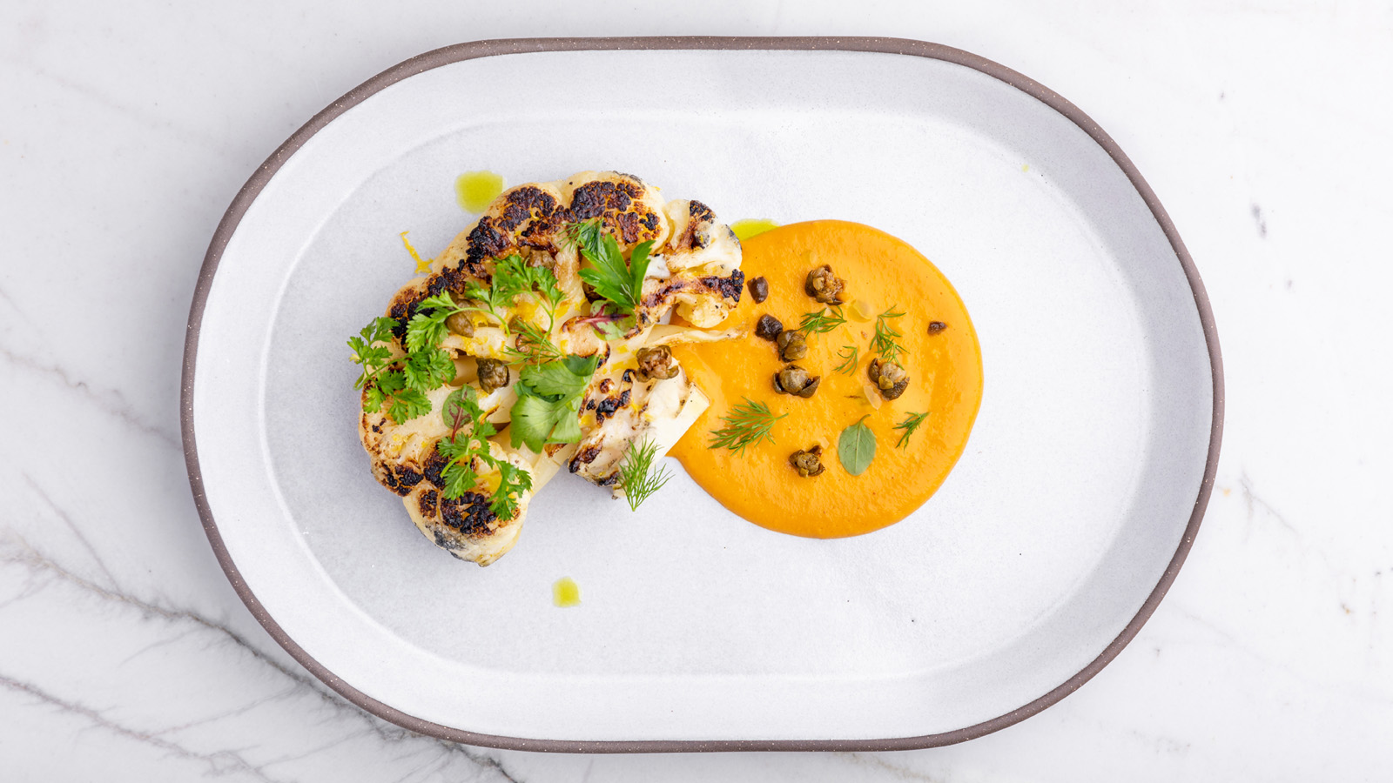
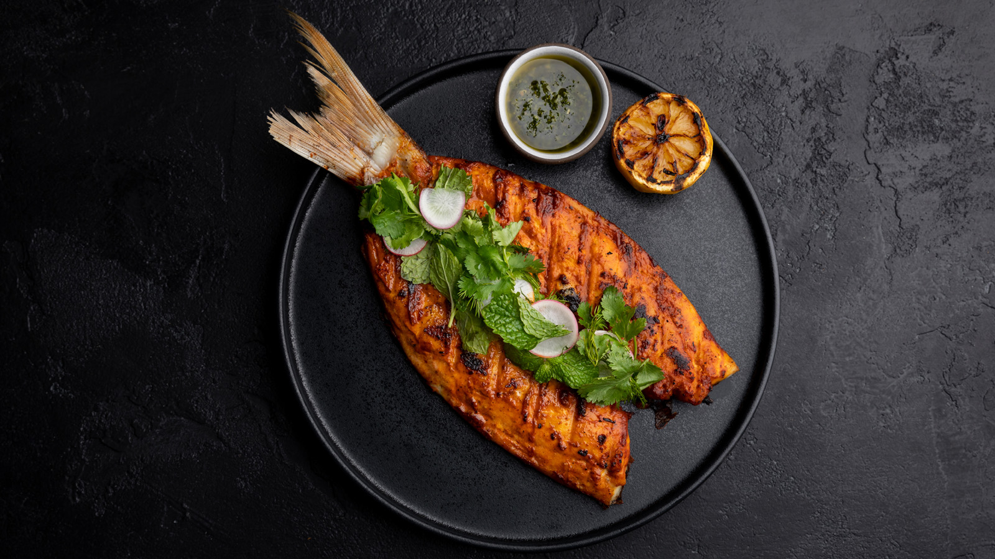 | 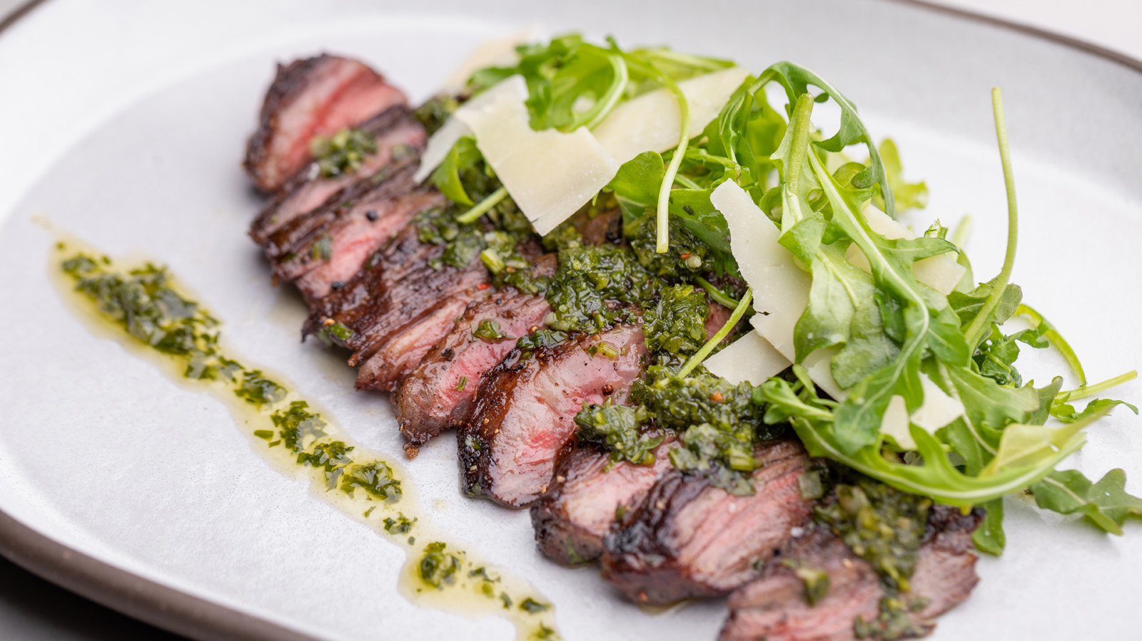 | 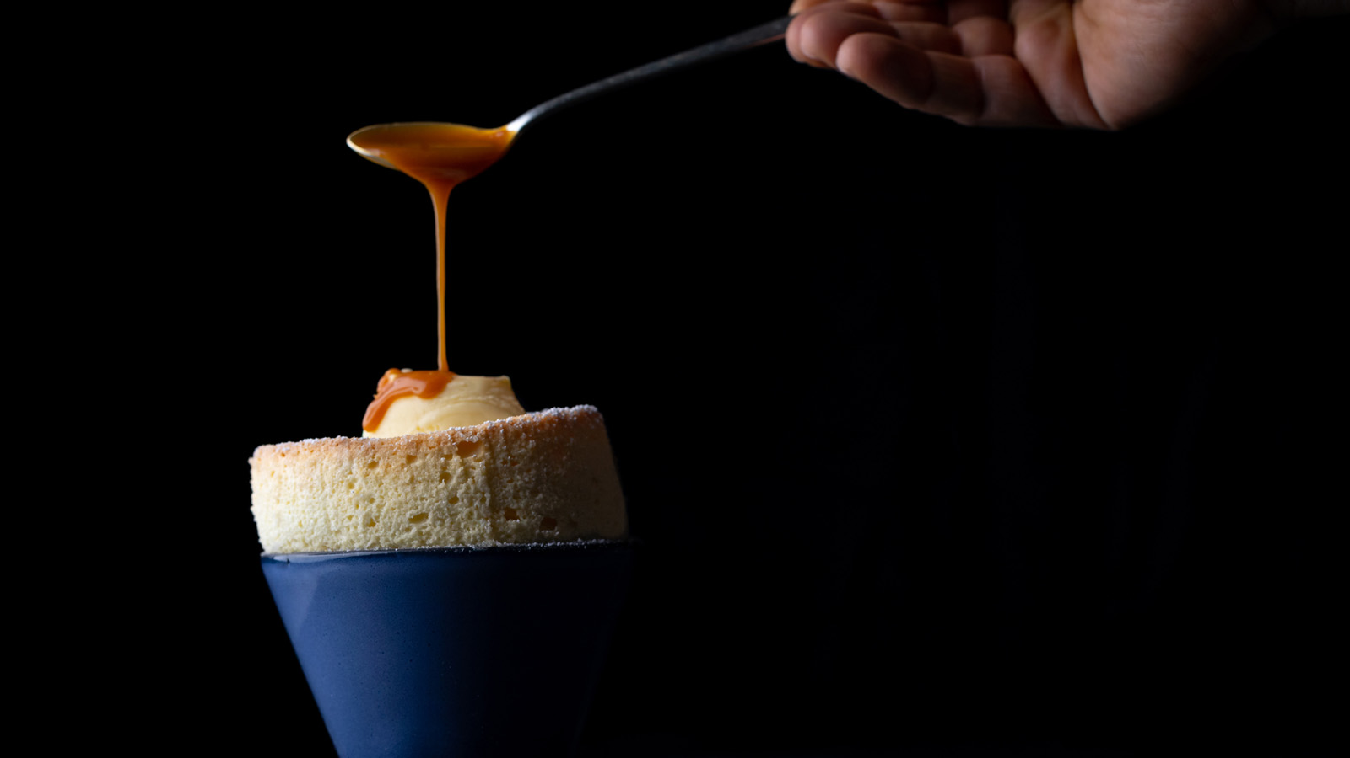
Four Seasons Hotel Westlake Village, a AAA Five-Diamond Los Angeles urban retreat, announces the grand opening of Coin & Candor.
A lively neighbourhood gathering place, Coin & Candor features a casual yet sophisticated indoor and outdoor space with stunning views of the Santa Monica Mountains. The regionally-inspired breakfast and all-day dining menus present ingredient driven dishes that incorporate wood–fired cooking techniques. The vibrant bar features innovative cocktails, craft beers, and a diverse wine list.
Led by Chef Jose Fernandez, Coin & Candor’s seasonal kitchen showcases California’s best growers and purveyors. Signature dishes include wood-fired cabbage with bacon jam and heirloom tomato tartare with Malibu grown tomatoes, basil, and Ojai extra virgin olive oil. The Baja California red snapper with adobo herb salad and the Snake River Farms skirt steak with house-made chimichurri are enhanced by maple and oak wood used on the wood-burning grill. Nearly eighty percent of Coin & Candor’s menu is cooked on the wood-burning grill.
“We have created a dynamic seasonal menu that is made possible by our unique partnerships with the best local growers and purveyors – most are located right here, in our own backyard,” says Chef Fernandez. “Our relationships with these artisans drives the seasonality of our menu and allow for us to evolve our dishes as the seasons change.”
In addition to the seasonal kitchen, Coin & Candor’s guest-facing guild station is led by Pastry Chef Patrick Fahy. The open pastry kitchen fills the California brasserie with tantalising aromas from signature pastries and breads; the thirty-three layer croissant and the house-milled Red Fife grain sourdough bread baked daily at 450 degrees. Signature desserts include the Coin & Candor soufflé with candied hazelnut bananas foster ice cream and pavlova with cara cara orange, satsuma tangerine, blood orange pink champagne sorbet and vanilla ice cream.
Coin & Candor’s design aesthetic combines natural textures, bright colours and fresh tones with mid-century design. The chic oculus bar creates a social focal point for the bustling space and features stylish gold accents with a white marble stone bar top. Guests can also enjoy the spectacular views of the Santa Monica Mountains from Coin & Candor’s sun filled outdoor patio, which is complete with both tabletop and lush lounge seating.
“I've been in this business for thirty-five years, and worked in twenty-five different Four Seasons hotels. This is one of the finest restaurants in design that I have been a part of,” explains Robert Cima, Regional Vice President and General Manager of Four Seasons Hotel Westlake Village. “The team is thrilled to bring guests a remarkable experience complete with thoughtful service, an approachable menu and a standout design aesthetic.”
Coin & Candor is open daily from 6:30 am to 11:00 pm for breakfast, lunch and dinner. For reservations visit www.coinandcandor.com or dial 818 575 3044.
Getting Candid with Coin & Candor
Inspired by the life story of billionaire, philanthropist and hospitality enthusiast David Murdock, Coin & Candor’s name pays homage to humble beginnings and an early rise to success.
In 1943 David Murdock found himself homeless after returning from serving in the United States Army during World War II. Destitute and with only a nickel and a penny in his pocket, Murdock’s life soon changed after a serendipitous encounter with a good samaritan who gave him a loan to purchase a closing coffee shop. It was during this time that Murdock developed his keen sense for business and passion for hospitality. In a few short months following his ownership, he paid back the loan and generated a small profit after selling the business. This was only the beginning of Murdock’s entrepreneurial success. From there, his ventures included real estate opportunities and Murdock later acquired shares in many multinational companies including Dole Food Company.
Today Murdock is also the owner of Four Seasons Hotel Westlake Village, California Health & Longevity Institute, and Coin & Candor.

RELATED

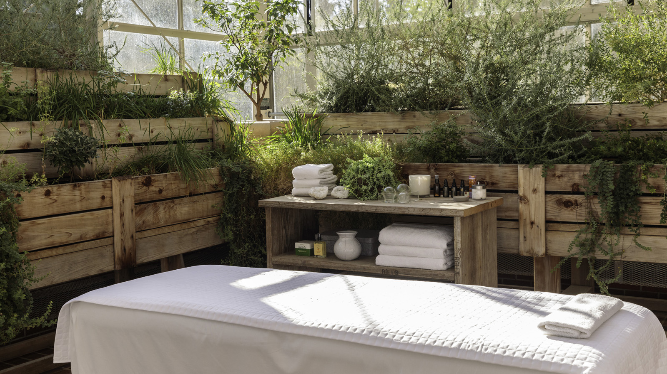 | March 6, 2019, Los Angeles, Westlake Village, U.S.A.  Three Reasons to Enjoy Spring at Four Seasons Hotel Westlake Village  https://publish.url/westlakevillage/hotel-news/2019/spring-packages.html
January 25, 2019, Los Angeles, Westlake Village, U.S.A.
Fall in Love with Wellness at Urban Resort Four Seasons Hotel Westlake Village, Los Angeles
https://publish.url/westlakevillage/hotel-news/2019/valentines--day.html

PRESS CONTACTS

Jacqueline Kerns
Director of Public Relations and Communications
Two Dole Drive
Westlake Village
USA
jacqueline.kerns@fourseasons.com

+1 818 575 3089

