Deck the Halls! Four Seasons Hotel Milano Unveils its Enchanted Holiday Forest

Celebrate the holidays at Four Seasons Hotel Milano - step into the magical Enchanted Forest by artistic director Vincenzo Dascanio, shop for panettone from the Hotel's trolley, enjoy a Festive Afternoon Tea or try the special Christmas and New Year’s menus conceived by Chef Borraccino
December 1, 2021, Milan, Italy

 | 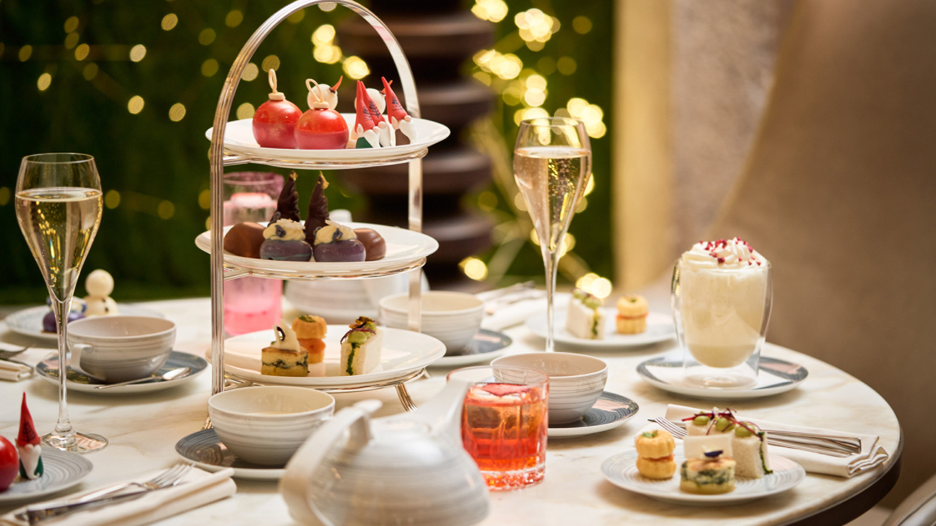 | 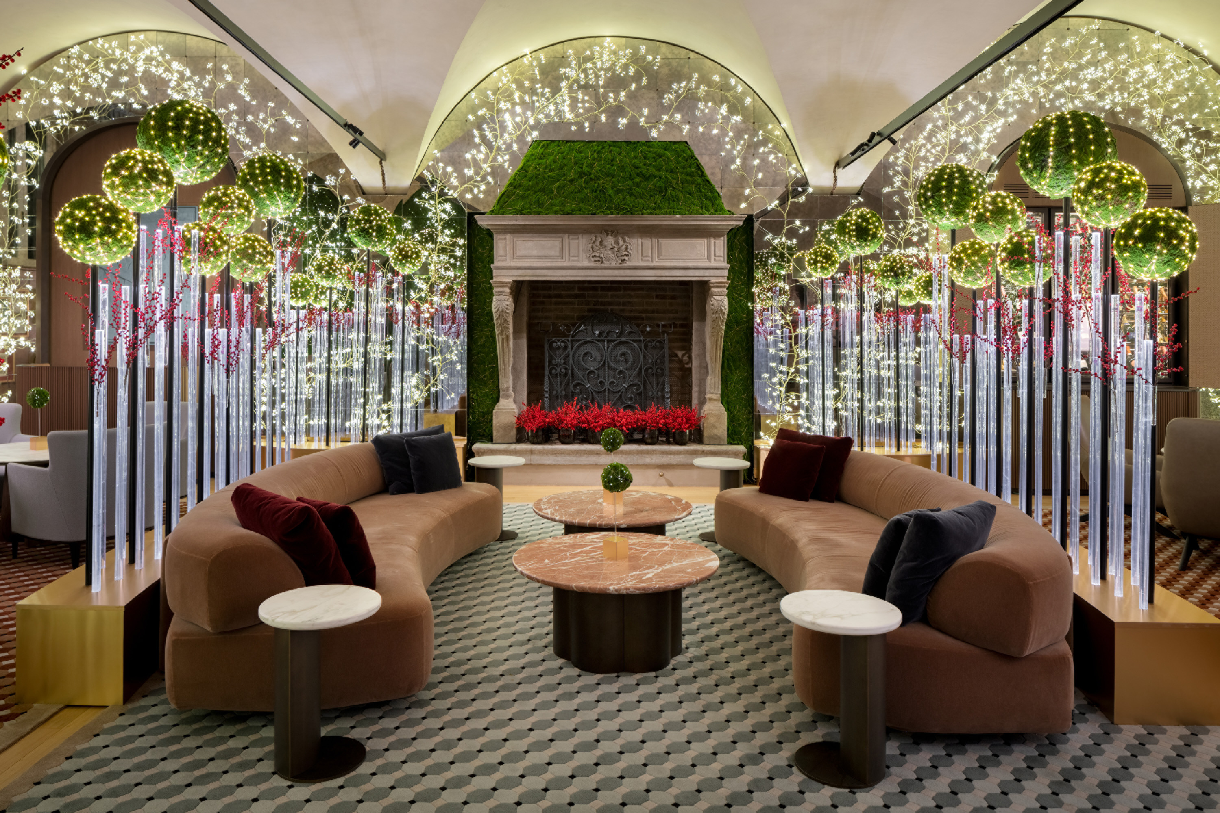
Ideally situated in the heart of Milan’s fashion district, Four Seasons Hotel Milano has long been and continues to be the city’s favourite holiday destination, for Milanese and tourists alike. Every year people flock to the Hotel, not only to admire the extraordinary decorations conceived by artistic director Vincenzo Dascanio, but also to enjoy the sweet surprises by Pastry Chef Daniele Bonzi and indulge in Chef Fabrizio Borraccino’s excellent culinary creations.
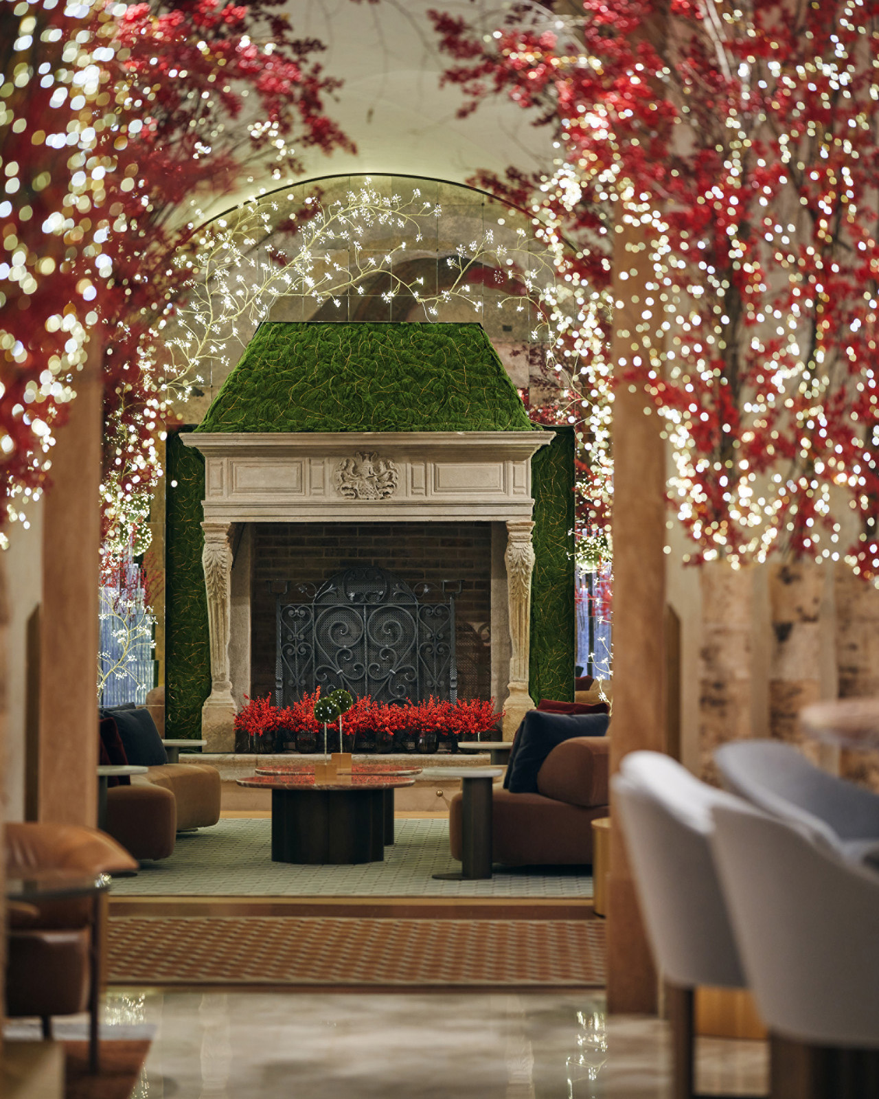 | 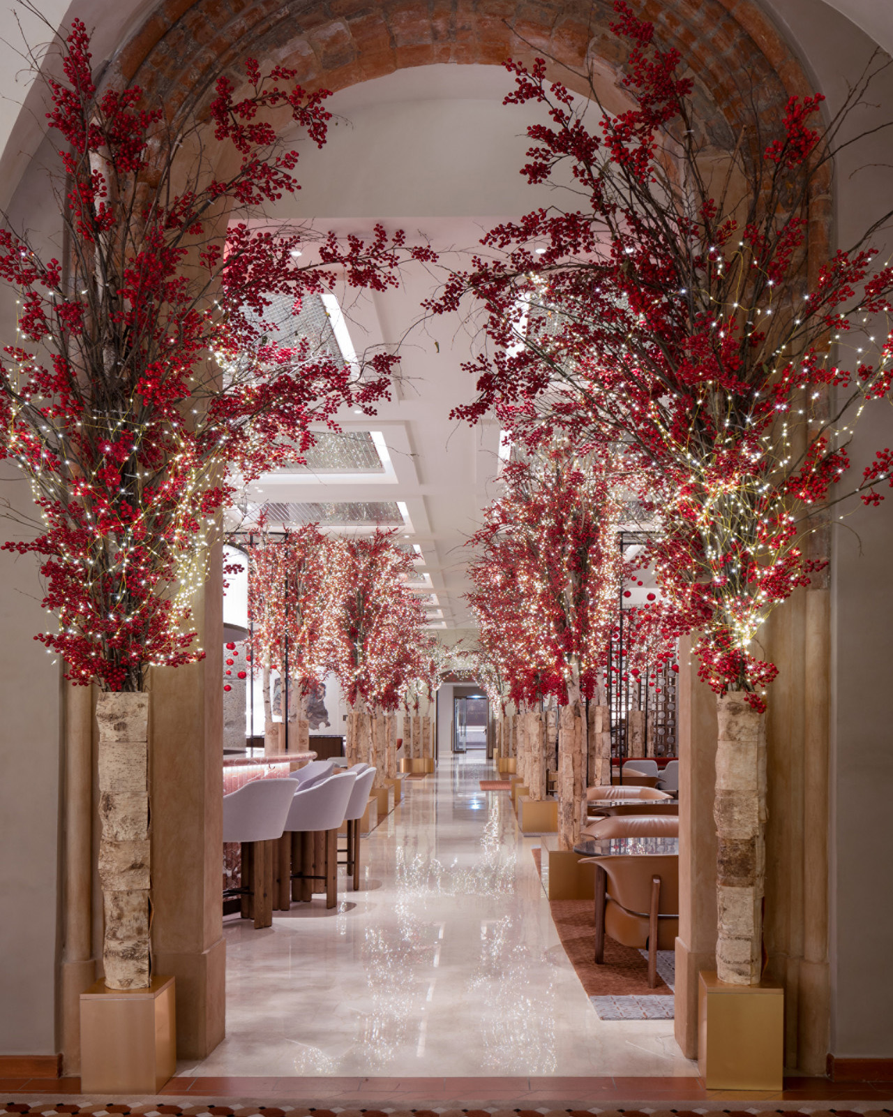 | 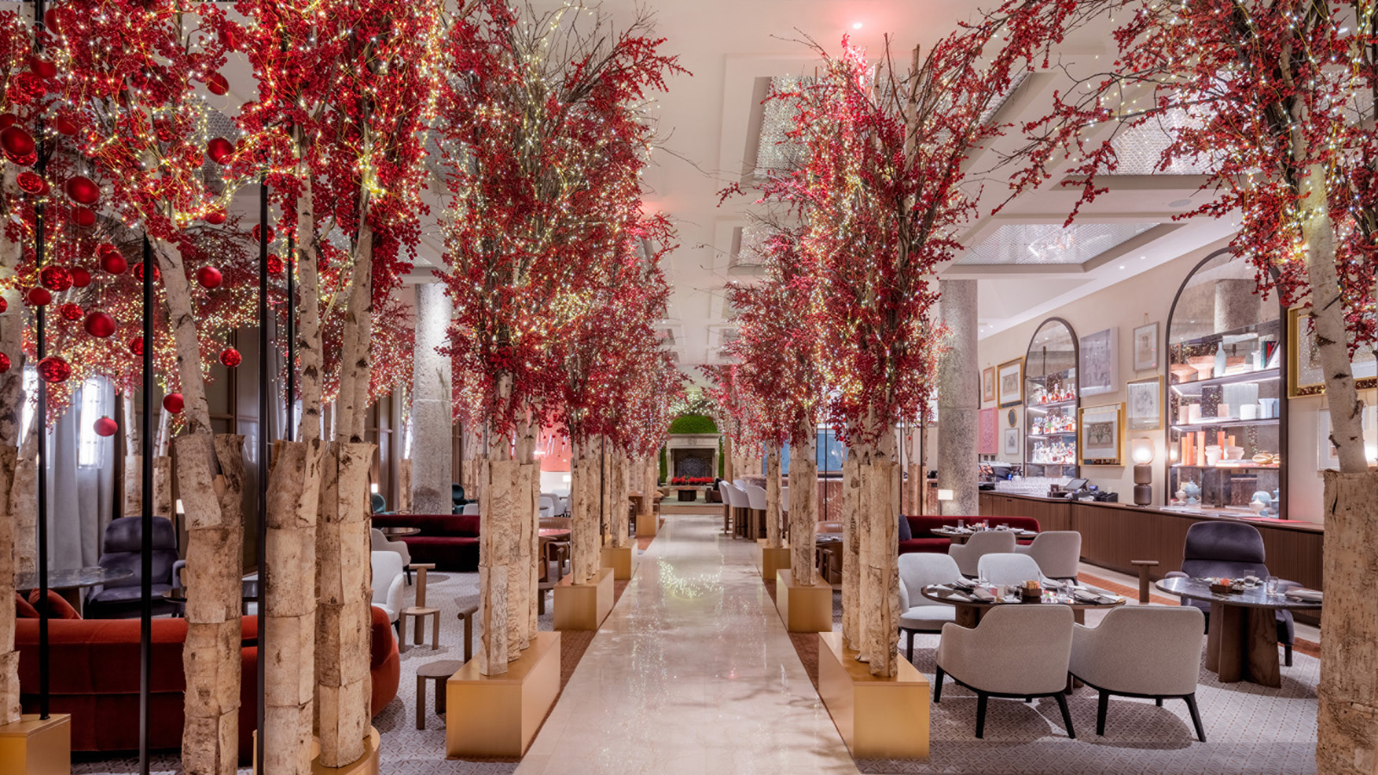
The Enchanted Forest
Renowned for this exceptional floral creations and unexpected decorations, Vincenzo Dascanio has done his magic once again. This season’s decorative leitmotif is the “Enchanted Forest.” Dascanio has given this theme a contemporary twist to mirror the recent renovation of the Hotel’s common spaces by Patricia Urquiola. The resulting holiday wonderland is both sophisticated and inspiring. In the lobby and bar, aisles of sculptural trees decked with holly berries and thousands of glittering lights adorn the space. While in the Camino (the Hotel’s beloved fireplace room), the décor takes an even more modern turn. The trees of our magical forest become more abstract, with icy glass trunks and boxwood topiaries punctuated by an abundance of little lights. Dark green moss and festive lighting cover the walls, underlining the period features of this historic space.
The Panettone Trolley
For the second year in a row, Pastry Chef Daniele Bonzi proposes his artisanal interpretation of panettone, Italy’s famous Christmas cake. The novelty this year is the Panettone Trolley, a festive cart positioned outside the Hotel from which guests will be able to purchase the delectable creation starting on December 1, 2021. Talented Pastry Chef Daniele Bonzi and his team have perfected their recipe of the celebrated traditional cake, which involves more than 36 hours of preparation and the finest ingredients available including a rich Grand Cru vanilla from Tahiti, acacia honey, and Italian candied fruits and raisins.
- Panettone is available for purchase on site for EUR 55
Festive Afternoon Tea
Nothing is cosier during the winter months than to indulge in a sumptuous Afternoon tea. This holiday season Four Seasons Hotel Milano presents its festive version with adorable edible Christmas baubles and a selection of sweet and savoury bites, paired with specially blended teas, or a flute of champagne.
- Afternoon Tea every day from 3:00 to 5:30 pm at Bar Stilla and Camino, from EUR 40
Chef Fabrizio Borraccino’s Festive Menus
For Christmas Eve and Day, Chef Fabrizio Borraccino has conceived new menus for the Hotel’s restaurant Zelo. For the 24th, the menu focuses on fish, while for Christmas lunch on the 25h tradition reigns supreme with a few surprising twists. New Year’s Eve at Four Seasons Hotel Milano is always a favourite and elegant destination. See here for the complete festive program.
- December 24, 2021: Christmas Eve dinner only on reservation: EUR 165 per person excluding beverages
- December 25, 2021: Christmas Lunch only on reservation: EUR 195 per person excluding beverages
- December 31, 2021: New Year’s dinner only on reservation: EUR 360 per person excluding beverages
The iconic Four Seasons Hotel Milan is ready to celebrate the most magical time of the year with its enchanting decorations and impeccable service.

RELATED

December 1, 2021, Milan, Italy
Il Four Seasons Hotel Milano si trasforma nella Foresta Incantata dove celebrare la magia delle feste
https://publish.url/it/milan/hotel-news/2021/festive-season-2.html

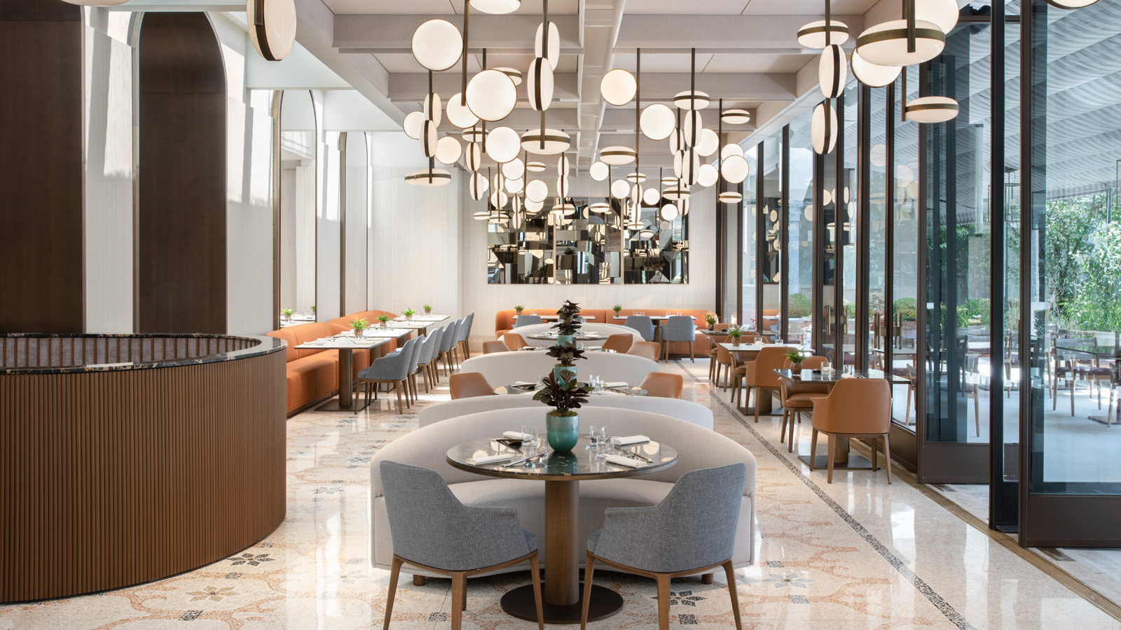 | July 6, 2021, Milan, Italy  The New Four Seasons Hotel Milano: Milan’s Iconic Hotel Reopens Unveiling New Lobby, Restaurant Zelo, Bar Stilla and Beloved Garden  https://publish.url/milan/hotel-news/2021/renovations-and-reopening.html

PRESS CONTACTS

Ilaria Alber-Glanstaetten
Senior Director of Communications
Via Gesu, 6/8
Milan
Italy
ilaria.alber@fourseasons.com

+39 340 646 7881

Anita Ruozzi
Public Relations and Marketing Communication Coordinator
Via Gesu, 6/8
Milan
Italy
anita.ruozzi@fourseasons.com

+39 02 7708 1123

