10 Reasons to Visit Vail in the Summer

May 3, 2018, Vail, U.S.A.

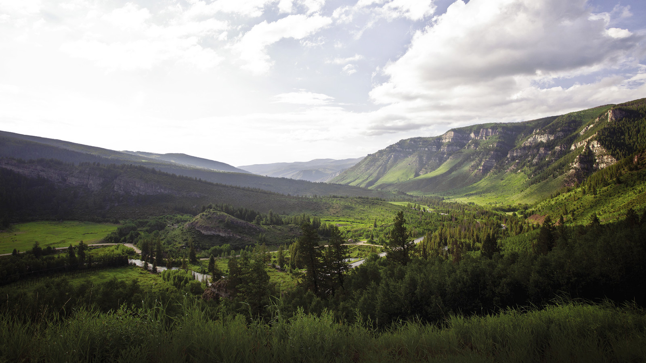
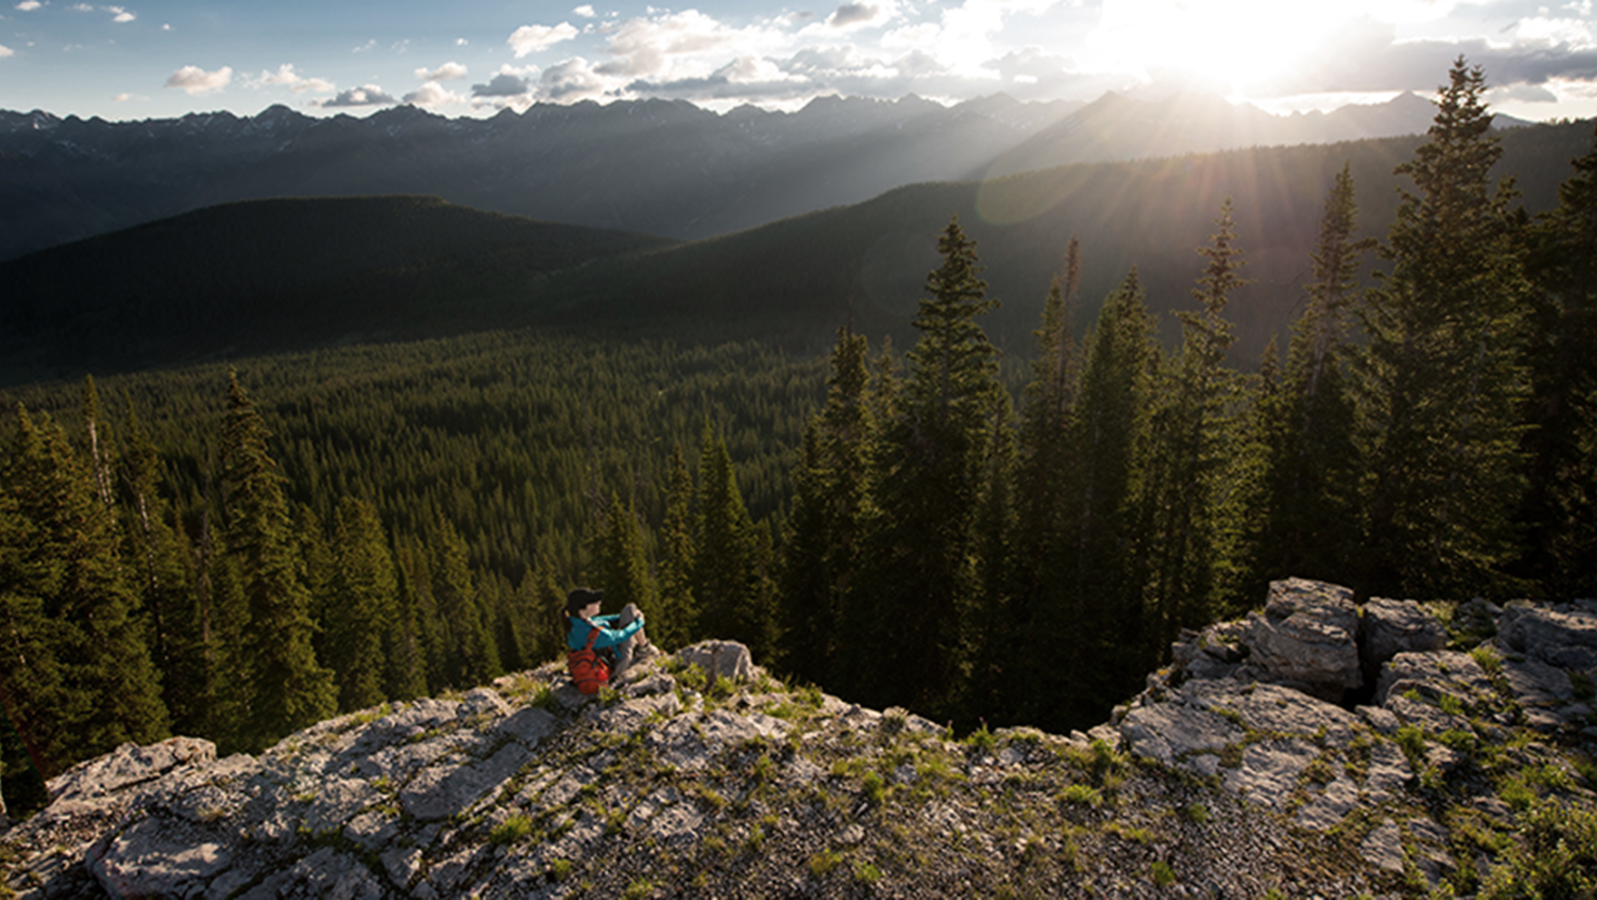 | 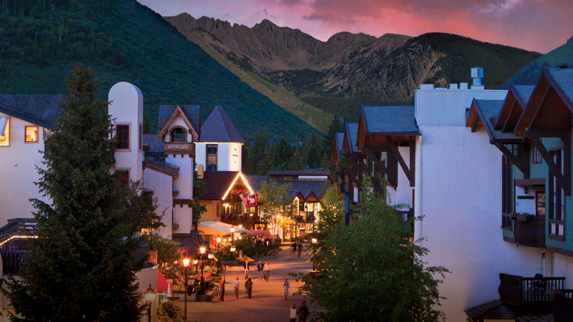
It’s said people come for winter, and stay for the summer. Because truly, there is nothing quite like summer in the mountains. With calm mornings, warm afternoons and cool evenings, Vail is the perfect escape. Summers provide long days and plenty of activities to keep you going from sun up to sun down. Here a just a few of favourite reasons to visit Vail in summer from the Concierge team at Four Seasons Resort and Residences Vail:
1. Festivals and Celebrations
In Vail, music and dance festivals abound. Many people focus on the Bravo! Vail Music Festival, featuring resident orchestras such as the New York Philharmonic, performing at the spectacular outdoor Gerald R. Ford Amphitheater. Additional summer festivals include the Vail International Dance Festival and the Vail Jazz Festival.
2. Local Markets
The Vail Farmers’ Market and Art Show offers something for everyone in the family, from world class galleries and Colorado crafts to locally sourced produce. For a slightly funkier version, check out the Minturn Market on Saturday’s for a local vibe.
3. Betty Ford Alpine Gardens
Just a short walk outside of Vail Village lays the internationally acclaimed Betty Ford Alpine Gardens. These are the highest elevation botanical gardens in the world. Open seven days a week, head over and explore the alpine flora and exquisite colours. Guided tours are available Mondays and Thursdays throughout the summer.
4. Hiking in Vail
Summer in Vail offers endless opportunities to hike and explore the mountains. Experts can push their limits on Mount of the Holy Cross, Eagle County’s only 14er (a mountain peak higher than 14,000 feet, or 4,270 metres), or head to nearby Leadville to conquer Mt Elbert - Colorado’s highest peak towering more than 14,443 feet (4,400 metres). Locals and tourist flock to Booth Falls for a hike with a big waterfall reward, and perfect place to dip your feet in the cool waters while enjoying a picnic lunch made by the Resort’s team of culinarians. For the novice hiker, head up to the top of Vail Mountain on the Gondola and take in the 360 degree views on Eagle’s Loop. Guided hikes on Vail Mountain are available by reservation and are a great way to get introduced to Vail.
5. Vail Village
Transport yourself to a Euro-style Alpine village in Vail’s Tyrolean-tinged pedestrian core, where mild temperatures, wildflowers and gentle mountain breezes provide the backdrop for a day of shopping some of the finest galleries in Colorado, followed by an alfresco cocktail. Enjoy a stein of beer at Pepi’s, the best Margarita in Vail at Sweet Basil, or the award-winning Intense Blueberry cocktail at La Tour. Relax on the patio at The Remedy Bar at Four Seasons, complete with breathtaking mountain views and large fire pits to keep you warm well into the night.
6. Golfing Game
Driving a golf ball at 8,000 feet (2,400 metres) in elevation can be worth the greens fees at one of the Vail Valley’s many incredible courses because the balls fly farther due to our high elevation! Several of the Vail Valley’s acclaimed golf courses are designed by pros such as Jack Nicklaus, Greg Norman, Arnold Palmer and Tom Fazio. No matter which course you choose, you will not be disappointed with your view.
7. Fly Fishing
This is one of the fastest growing sports in Vail. The calming sounds of the water combined with the rush of hooking your first rainbow trout on Gore Creek’s Gold Medal waters will give you bragging rights among your friends. Guided float trips along the Upper Colorado are not only the best way to snag the big fish, but the surrounding beauty will have you returning each year.
8. River Rafting
From gentle float trips on the Upper Colorado River, known locally as the “Upper C,” to slightly more challenging whitewater rafting in spectacular Glenwood Canyon, to the pulse-pounding Numbers and Brown’s Canyon stretches of the nearby Arkansas River, Vail is situated in the epicentre of some of the best rafting in the West.
9. World Class Mountain Biking and Road Cycling
Biking in Vail can be one of the most rewarding ways to experience the mountains. Vail Mountain offers mountain bike lift services so you are able to enjoy a leisurely stroll down one of the beginner trails, which offer sweeping views of the surrounding mountains and you may even get lucky a wildlife sighting. The bike lift services also provides access to cross-country trails that cover Vail’s extraordinary back bowls, and thrill seekers can get a rush on any of the newly designed downhill mountain biking trails. The Eagle Valley Trail provides miles of paved trail from the top of Vail Pass to Edwards. Enjoy an easy pedal from Vail to Lionshead Villages, or try your times against the pros as you race to the top of Vail Pass.
10. Vail's Epic Discovery
Head to the top of Vail Mountain at Eagle’s Nest to find fun and excitement for the entire family. Ropes courses will challenge your agility and the Forest Flyer Alpine Coaster will let you cruise the mountain top. Epic Discovery’s Zip Line features more than 2 miles (3.2 kilometres) of high flying fun that is must do while visiting.

RELATED

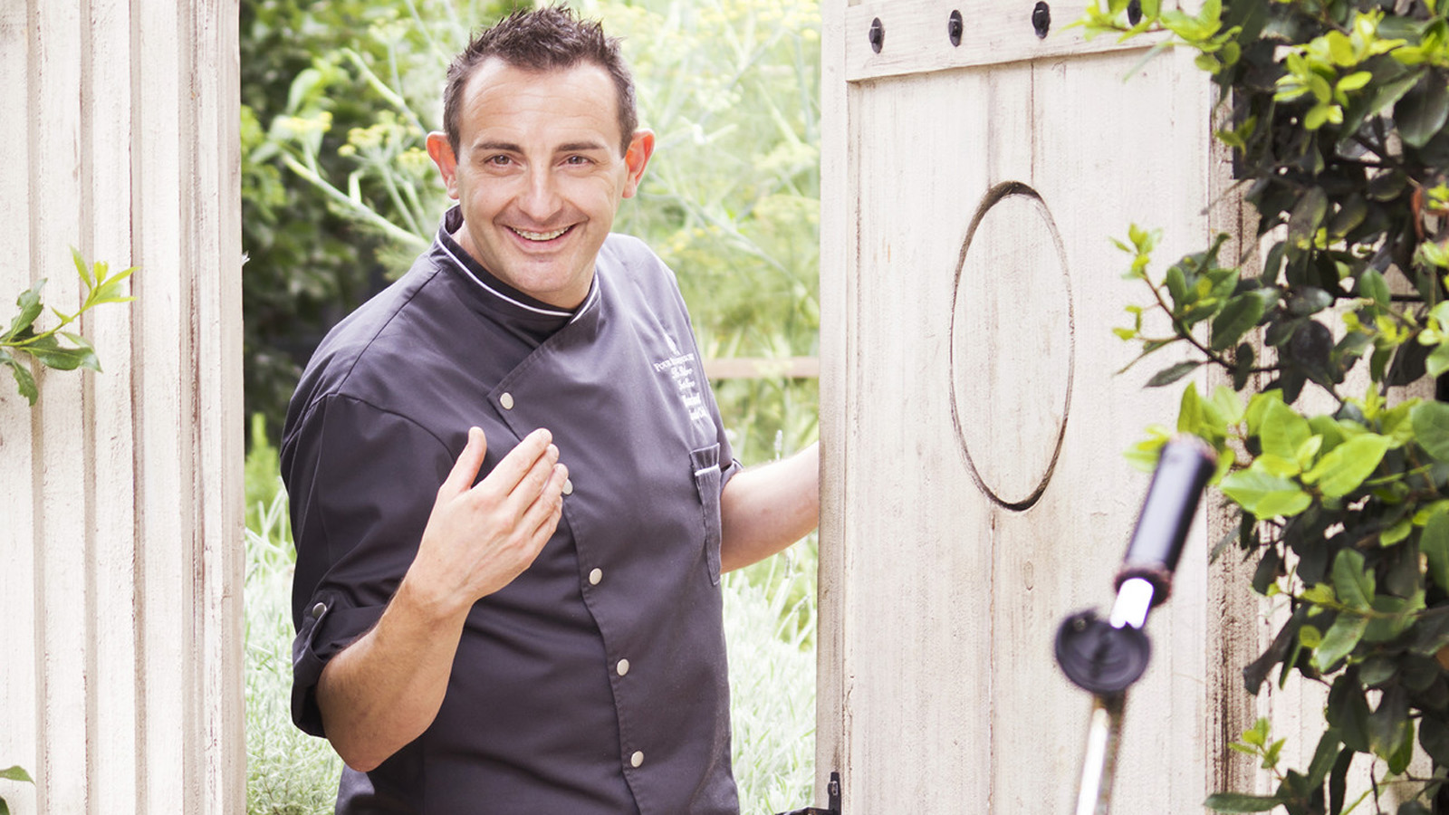 | July 30, 2019, Vail, U.S.A.  Four Seasons Resort and Residences Vail Announces New Executive Chef Marco Fossati  https://publish.url/vail/hotel-news/2019/new-executive-chef-marco-fossati.html
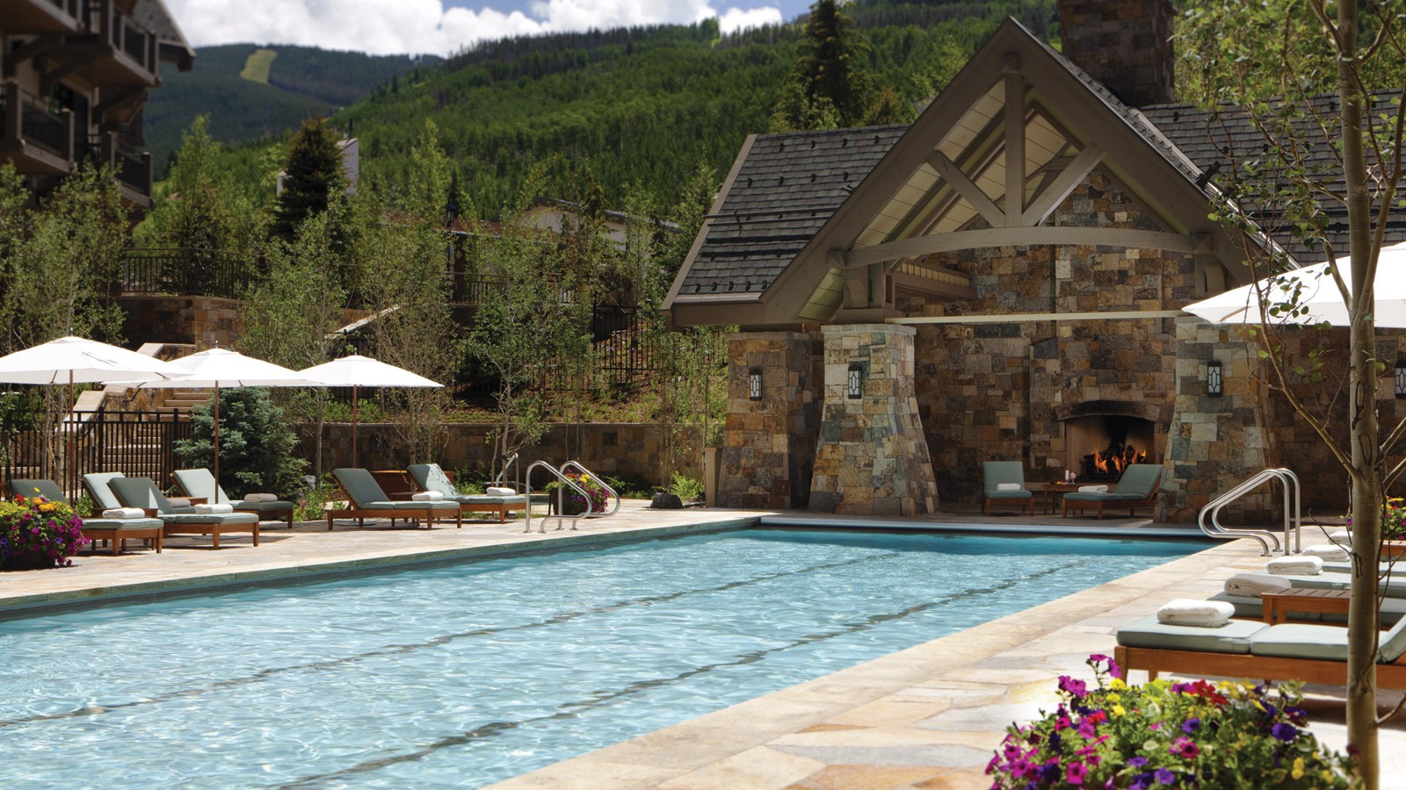 | May 2, 2019, Vail, U.S.A.  Four Seasons Resort and Residences Vail Commences Phased Resort Enhancement Project  https://publish.url/vail/hotel-news/2019/resort-enhancement-project-and-new-restaurant.html

PRESS CONTACTS

Jonathan Reap
Director of Public Relations
One Vail Road
Vail
USA
jonathan.reap@fourseasons.com

+1 970 477 8687

