Four Seasons Resort Koh Samui Announces the 12th Edition of the Cancer Care Charity Fun Run

May 13, 2019, Koh Samui, Thailand

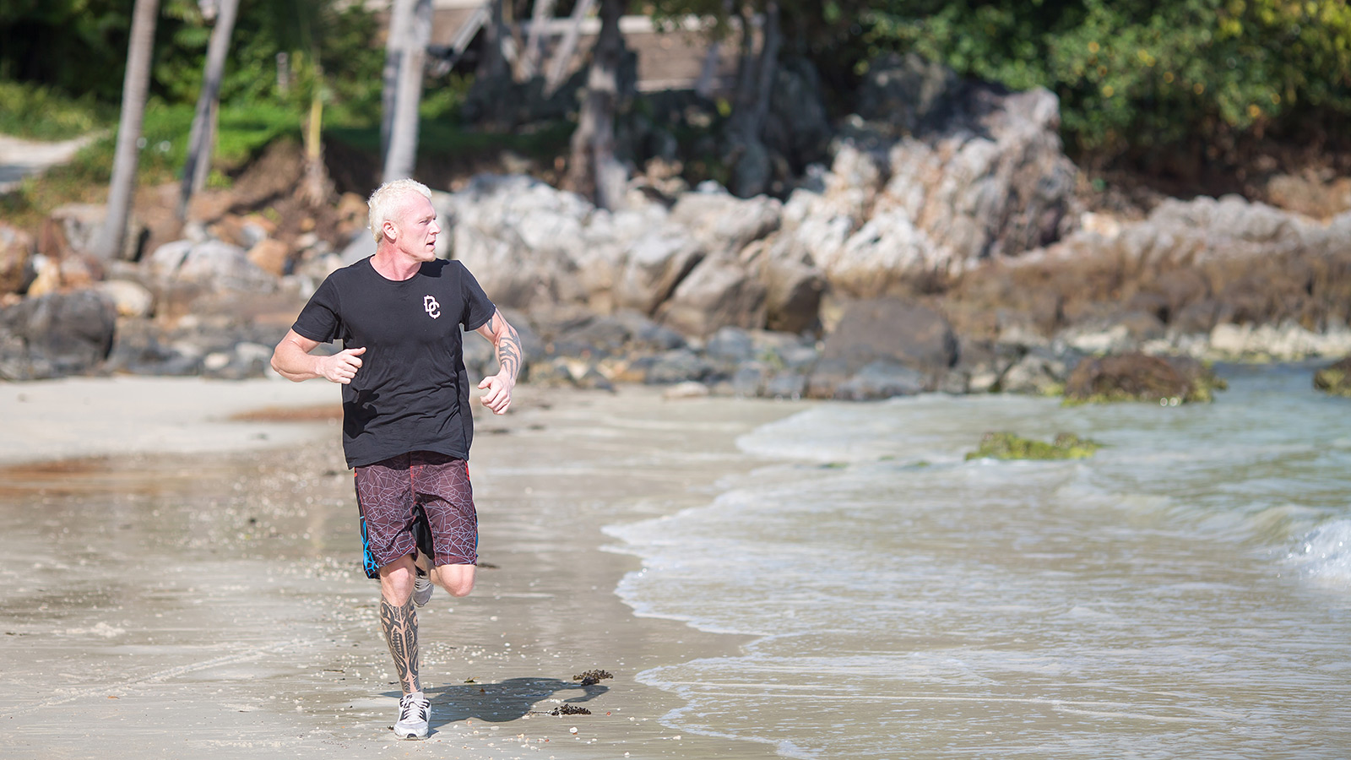
Four Seasons Resort Koh Samui, in association with The Thai Red Cross Society, is back with the Cancer Care Charity Fun Run for the 12th consecutive year. The run will take place on Saturday, June 15, 2019, starting at Nathon Pier. All proceeds from the event will go to the Cancer Research Centre at King Chulalongkorn Memorial Hospital, Thailand.
Commenting on the success of the event over the years, Sean Mosher, General Manager Four Seasons Resort Koh Samui says, “Having been a part of Four Seasons for 17 years in multiple locations, I have witnessed the passion for this global charitable event by individuals, families and local companies. It gives us the pride and privilege as Four Seasons to continue hosting the run annually, and for years to come.”
Registration for the event begins at 6:00 am, followed by a group warm-up to get into the mood of the proceedings. Participants can choose to run or walk the two, five or ten kilometre routes, as the event kicks off at 7:00 am.
Donations are priced at THB 300 per person including a race t-shirt, or THB 400 for a polo shirt. All entries include a breakfast box and a chance to win prizes in the lucky draw.
More than a decade since Four Seasons Resort Koh Samui first staged its Charity Run, the event has so far raised an amazing THB 10 million for cancer research projects in Thailand. Last year saw a record participation of more than 900 people at the run and raised THB 1.4 million. The Haematological Cancer Research Centre and the Genetic Cancer Research Centre at King Chulalongkorn Memorial Hospital under the auspices of Her Majesty Queen Sirikit, President of the Thai Red Cross Society, will receive the proceeds from this charity event to further their vital work in the field of cancer care and awareness.
For further information about the event and participation, call 0 7724 3000 or e-mail cancercare.kohsamui@fourseasons.com

RELATED

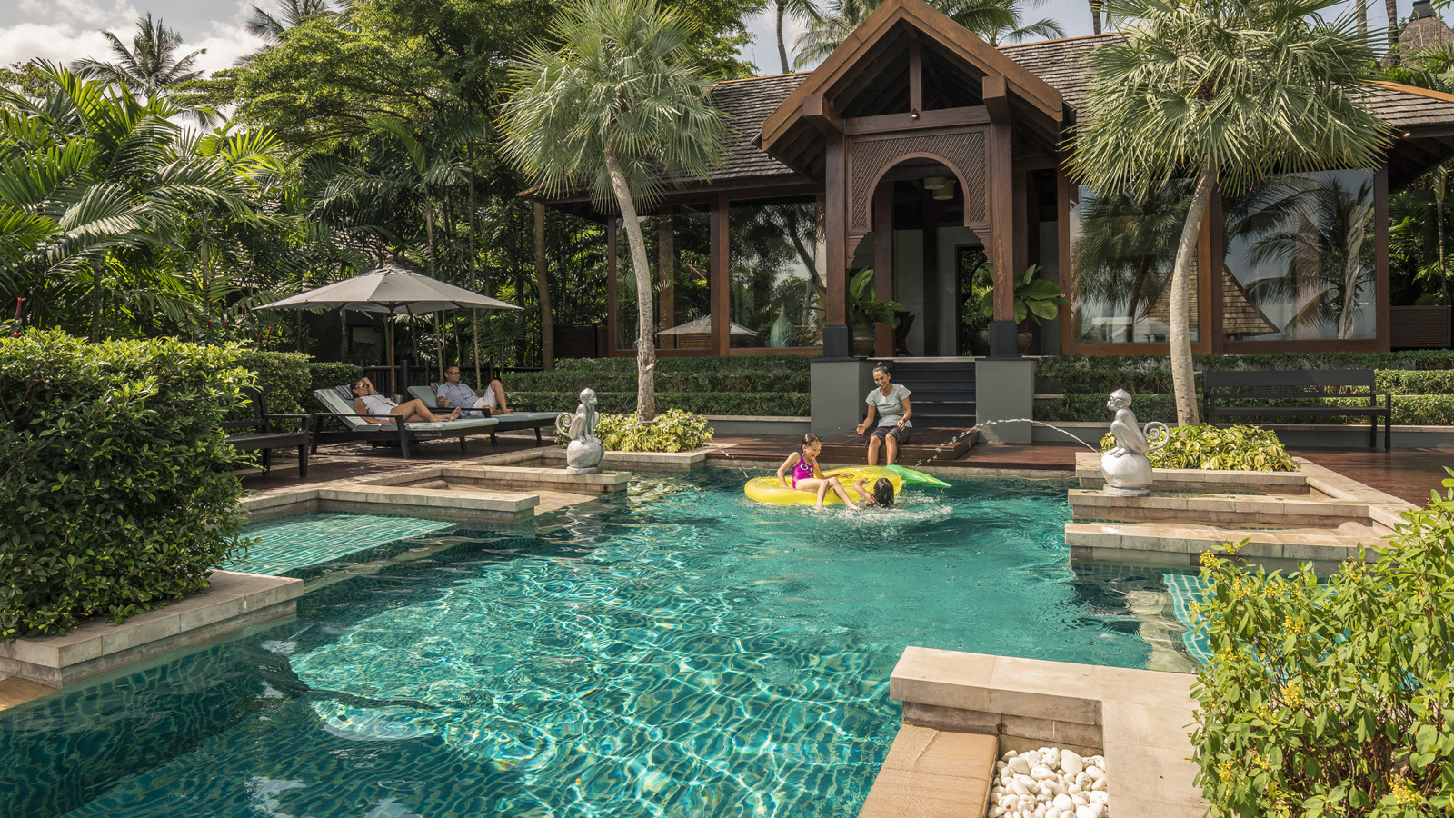 | March 29, 2019, Koh Samui, Thailand  Family Travel Made Perfect at the Private Retreats at Four Seasons Resort Koh Samui  https://publish.url/kohsamui/hotel-news/2019/private-retreats-for-families.html
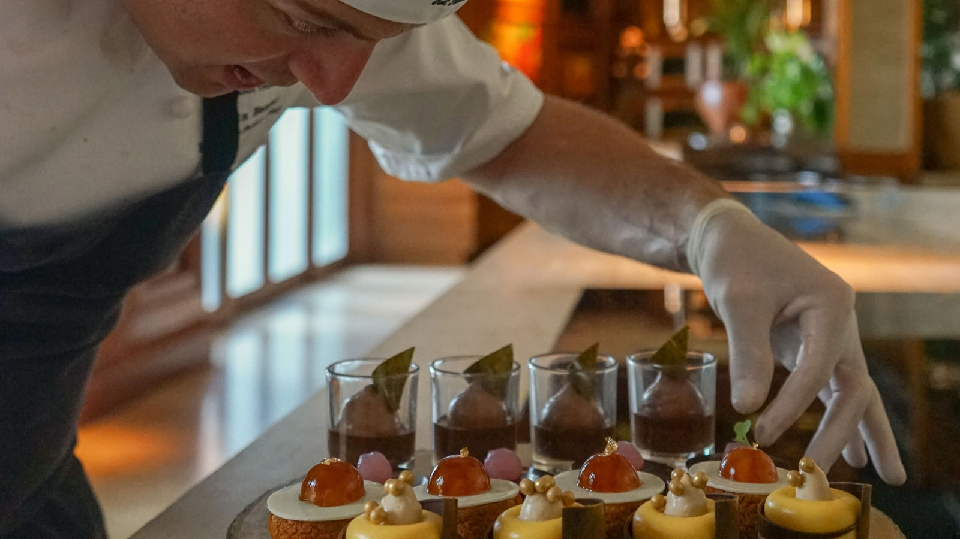 | February 27, 2019, Koh Samui, Thailand  苏梅岛四季度假酒店专享巧克力下午茶  https://publish.url/zh/kohsamui/hotel-news/2019/chocolate-afternoon-tea-2.html

PRESS CONTACTS

Karuna Amarnath
Director of Public Relations and Communications
3/F, 159 Rajadamri Road
Bangkok
Thailand
karuna.amarnath@fourseasons.com

+66 2207 8916

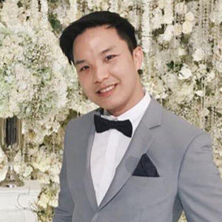 | Paponpat Sapsuwan  Assistant Public Relations Manager  3/F, 159 Rajadamri Road  Bangkok  Thailand  paponpat.sapsuwan@fourseasons.com  +66 02 207 8999
Chomploy Yavirach
Assistant Social Media Manager
3/F, 159 Rajadamri Road
Bangkok
Thailand
chomploy.yavirach@fourseasons.com

+66 02 207 8999

Metanee Promjai
PR Executive
219 Moo 5
Angthong
Thailand
metanee.promjai@fourseasons.com

+ 66 (0)77 243 201

