Four Seasons Hotel George V, Paris Pastry Chef Michael Bartocetti Awarded Chevalier des Arts et des Lettres

February 16, 2023, Paris, France

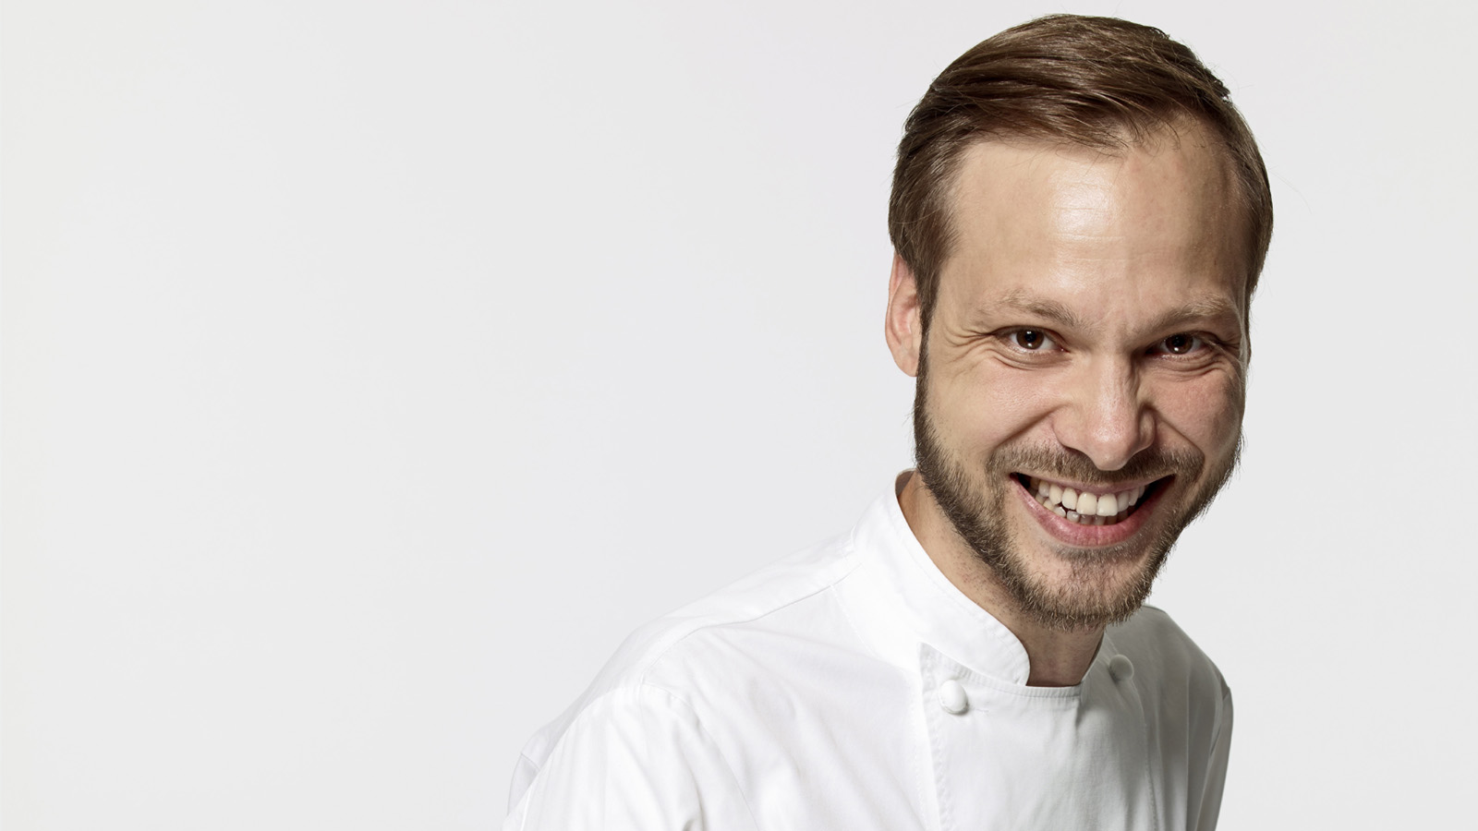
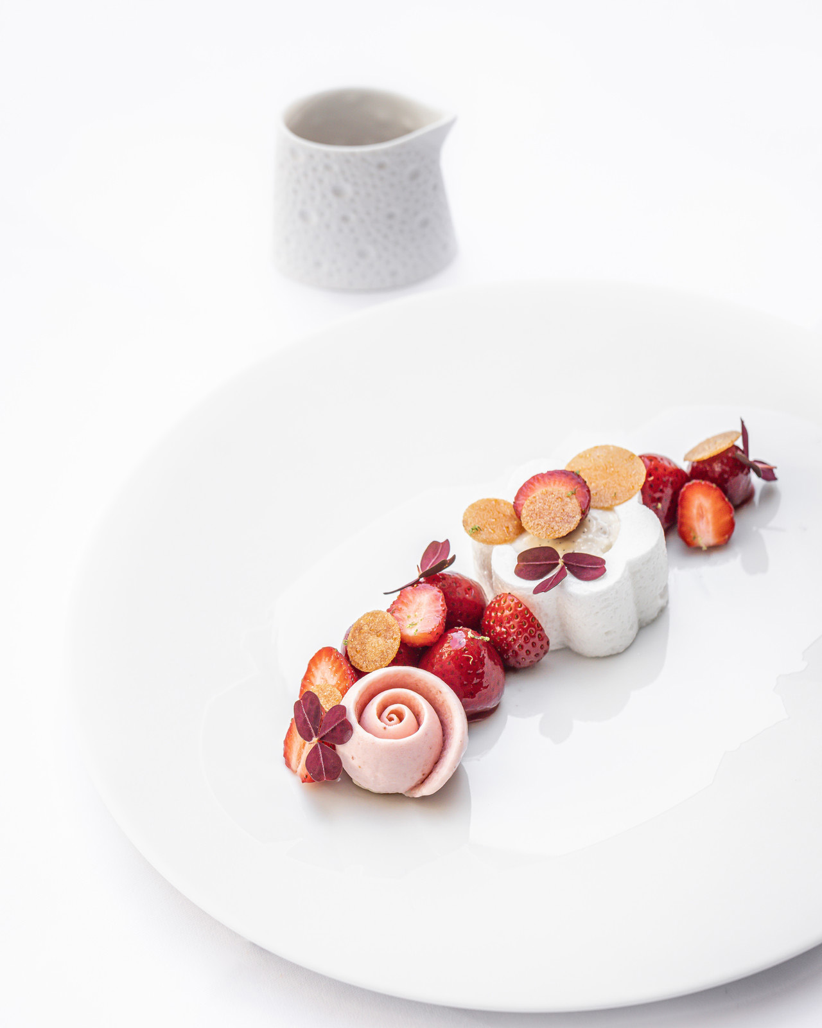
In the company of close friends and family, Four Seasons Hotel George V, Paris pastry chef Michael Bartocetti was awarded Chevalier des Arts et des Lettres at a prestigious medal ceremony held in the sumptuous reception rooms of the French Ministry of Culture. The award honours those who have significantly contributed to the country’s cultural and artistic legacy.
The distinction recognises the talent, creativity and exceptionally high standards Michael daily brings daily to his work, honouring him for his remarkable contribution to the French culinary arts.
Michael was brought up surrounded by accomplished cooks. He spent his childhood hopping between the kitchens of two family restaurants, where he became familiar with myriad smells, flavours and textures from a young age. Several of his parents’ friends were pastry chefs who eagerly shared their love and passion for the profession. Michael soon knew he wanted to become a pastry chef.
A hardworking and dedicated individual, but above all keen to share his knowledge and expertise with others, Michael is now a key figure in French haute cuisine and in the world of pastry-making. He is committed and responsible, personally selecting his own producers, choosing small, sustainable growers with an integrated approach to agriculture. A veritable artisan who favours high quality produce, he has won the hearts of both French and international sweet tooths as well as of hundreds of thousands of social media followers.
Recognised by the general public as well as by fellow chefs for his meticulous craftsmanship that is both bold and precise, he constantly strives for excellence, crafting exceptional sweet creations with painstaking attention to detail.
"It’s a great honour and pride to be awarded the Chevalier des Arts et des Lettres medal, furthering the culinary arts in France and internationally through my creations. This award also acknowledges the hard work of my entire pastry and bakery team who support me daily in everything I do. I am determined to make the George V's pastry offering shine now more than ever," explains Michael Bartocetti

RELATED

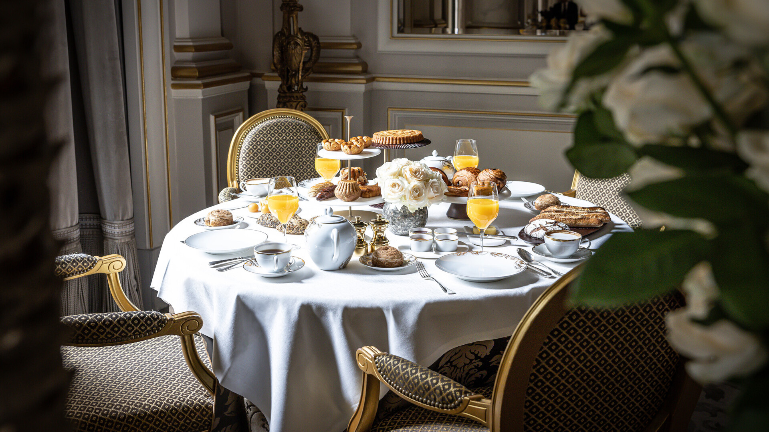 | February 9, 2023, Paris, France  Four Seasons Hotel George V, Paris Launches New Signature Breakfast at Le Cinq, with Exquisite Dishes Crafted by Guillaume Cabrol and Michael Bartocetti Promising a Memorable Gastronomic Experience  https://publish.url/paris/hotel-news/2023/new-le-cinq-signature-breakfast.html
February 9, 2023, Paris, France
Le Palace de la Gastronomie dévoile le Petit-déjeuner Signature du Cinq, une nouvelle expérience gastronomique imaginée par les chefs Guillaume Cabrol et Michael Bartocetti
https://publish.url/fr/paris/hotel-news/2023/new-le-cinq-signature-breakfast-2.html

PRESS CONTACTS

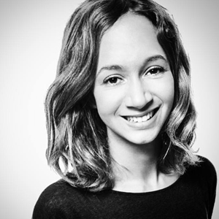 | Samuelle Dorol  Associate Director of Public Relations and Communication  31, avenue George V  Paris  France  samuelle.dorol@fourseasons.com  +33 1 49 52 71 69

