Reconnect and Rediscover: Four Seasons Hotel Washington, DC Invites Couples to See the Capital City in a Different Light

Experience Washington, DC at its most romantic, by moonlight
September 21, 2021, Washington, DC, U.S.A.

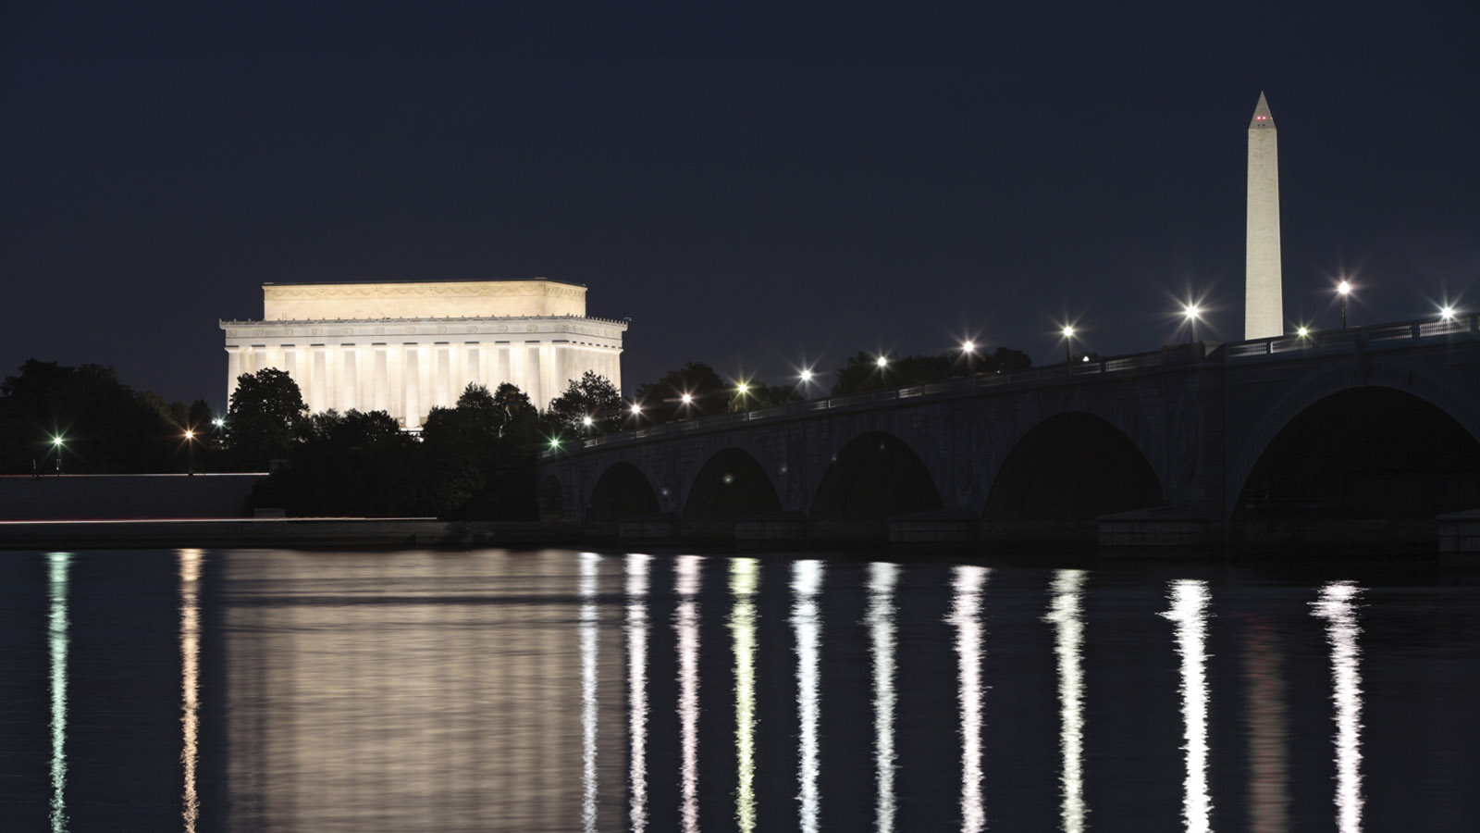
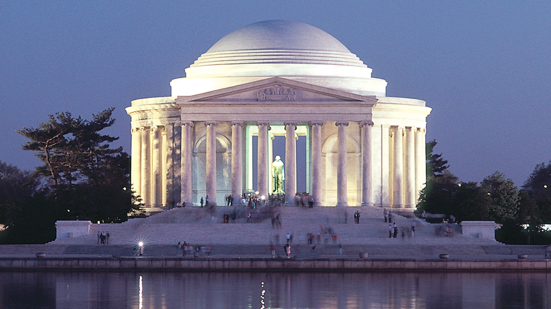 |  | 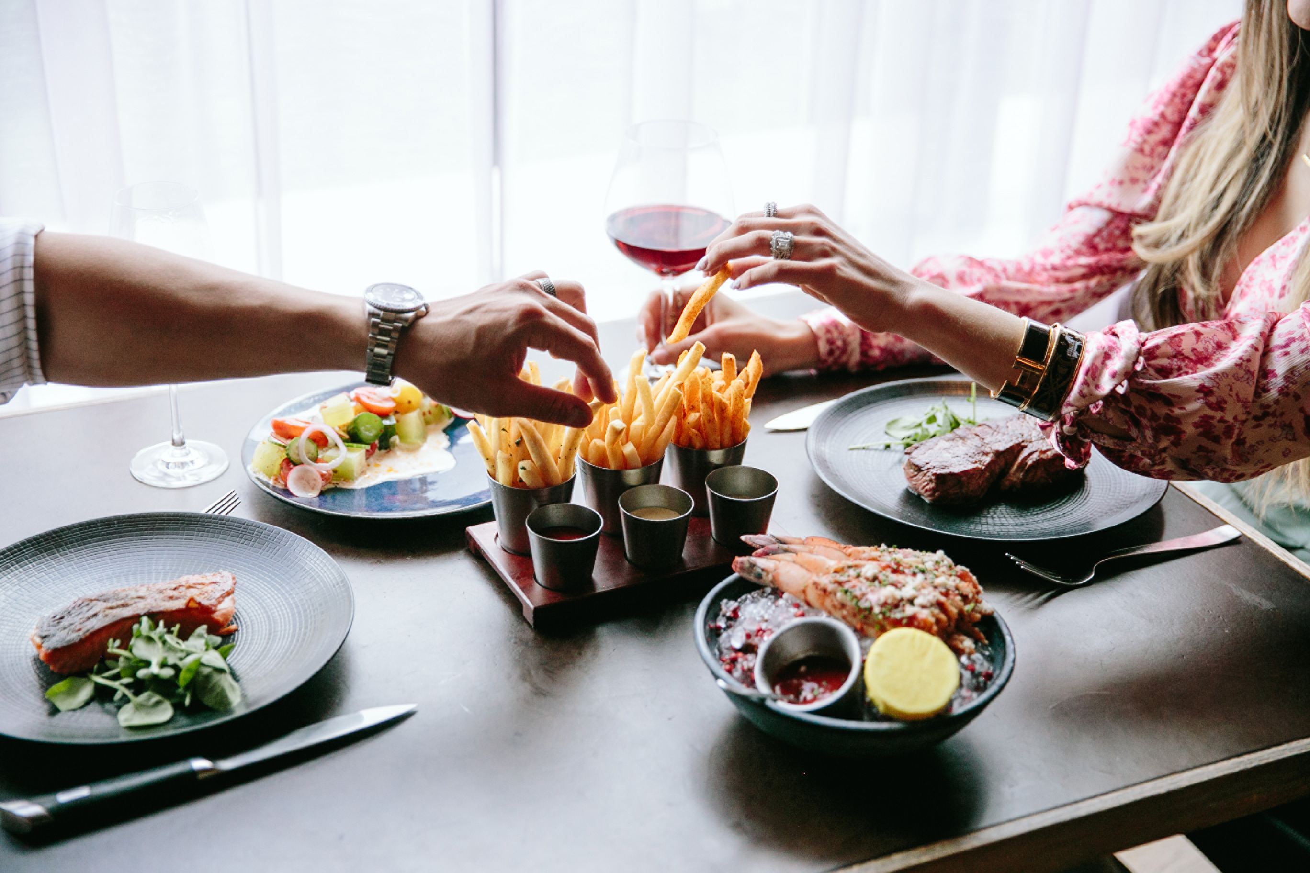
Four Seasons Hotel Washington, DC participates in Four Seasons Reconnect and Rediscover with a Monuments by Moonlight package.
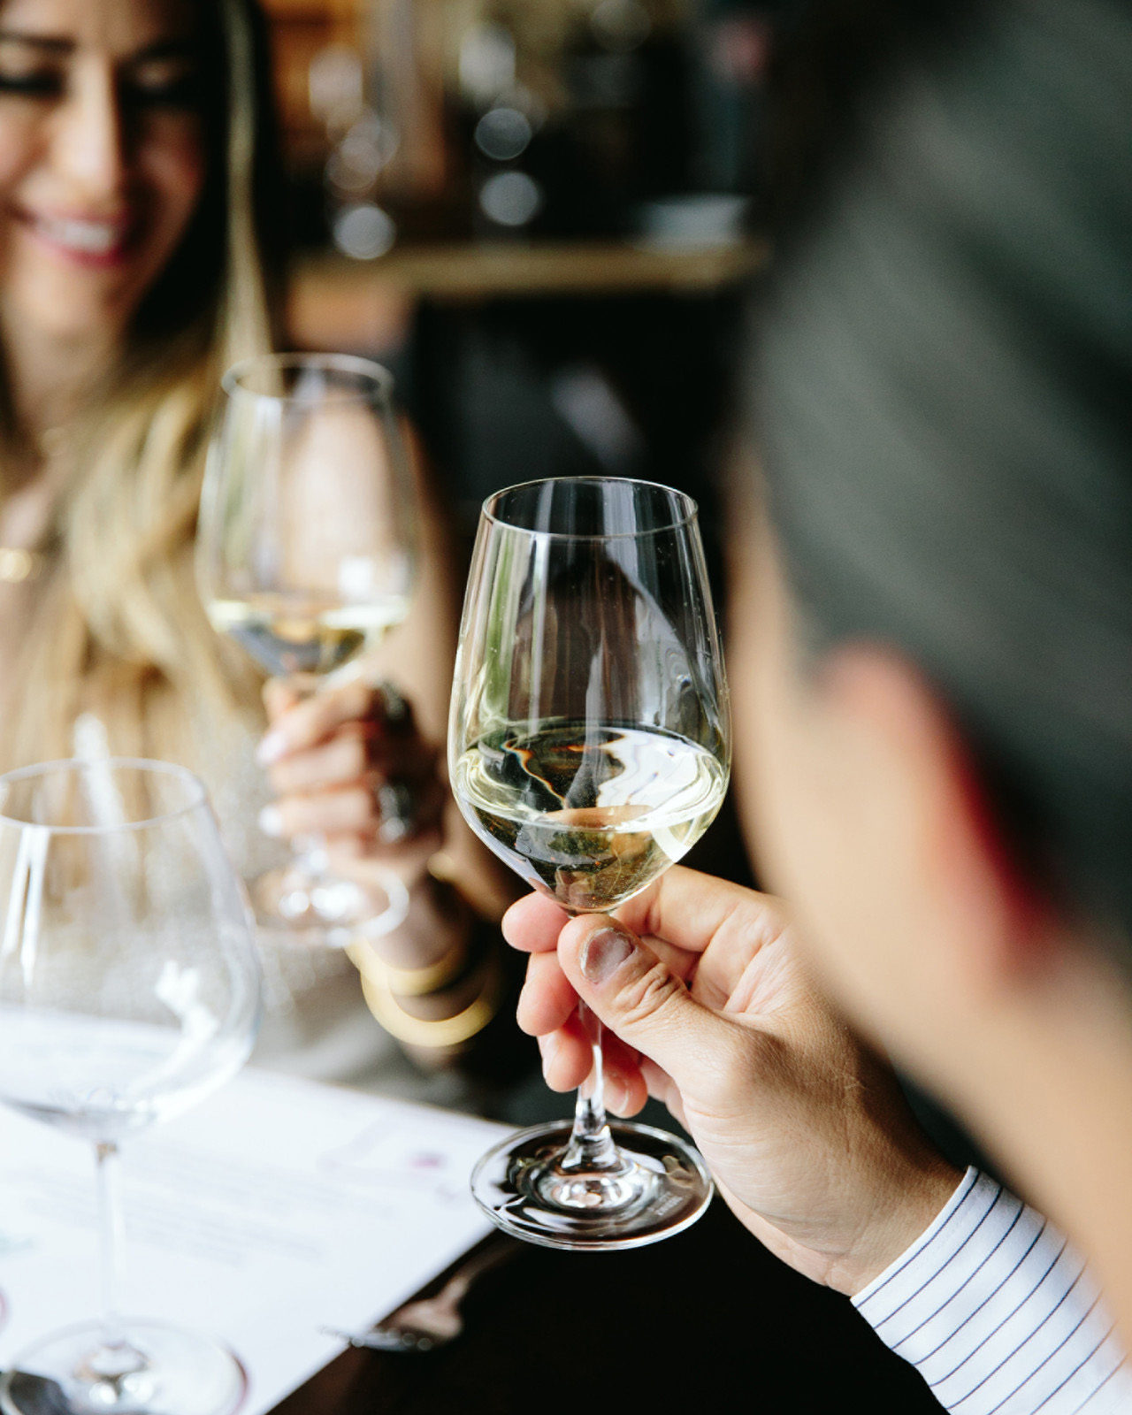 | 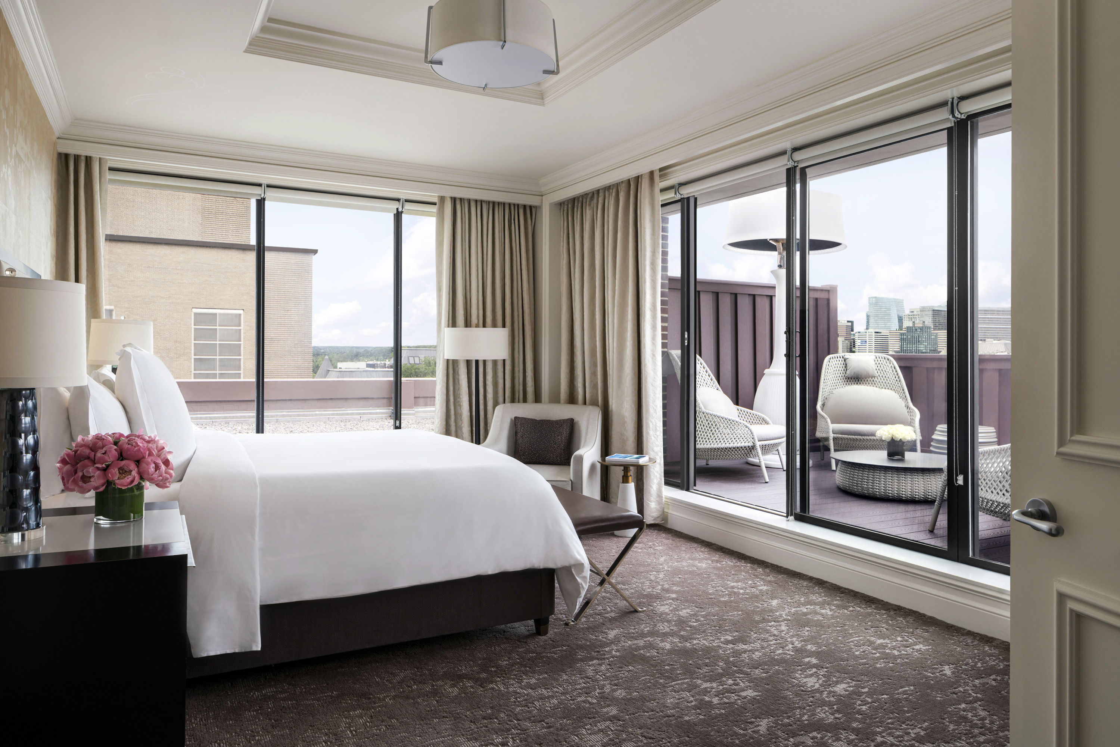 | 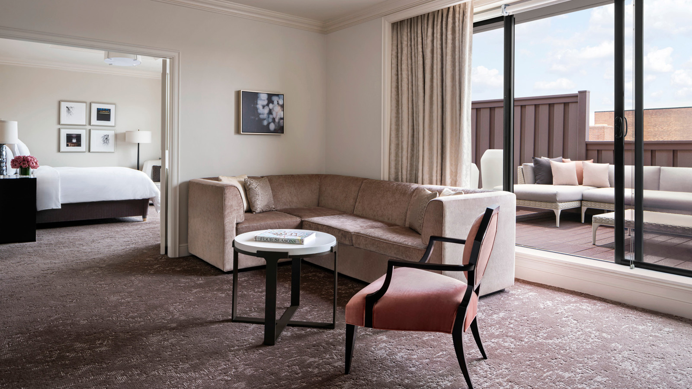
“Our city offers so much more than politics and power,” says Regional Vice President and General Manager Marc Bromley. “We enjoy surprising our guests with something new, creating a lasting memory for them.”
It is the culture of offering something out of the ordinary that prompted the team at Four Seasons Hotel Washington, DC to create an elevated Monuments by Moonlight itinerary, designed specifically with couples in mind.
First, guests are treated to a champagne welcome as they check into their luxurious guest room. The stage is then set for romance with a dinner for two at BOURBON STEAK, celebrated Chef Michael Mina’s award winning new American steak house, highlighting the craftsmanship of Executive Chef Robert Curtis.
“Date nights are extra special at BOURBON STEAK,” says BOURBON STEAK General Manager Jose Gonzalez. “From a curated cocktail list to our iconic wine list, we bring our guests on a sensory discovery from the moment they sit down. Each bite, from the hot miso butter shellfish platter to the 18 oz bone-in dry-aged New York strip from Seven Hills Farm is perfection. Evocative pastries such as our smoked s’mores or the bourbon chocolate bar finish the meal on a decadently sweet note.”
After dinner, once the sun has set on Washington, DC, the couple is whisked away for a romantic excursion – a night-time tour of the Capital’s most stunning monuments in a luxury sedan with driver. From the Lincoln Memorial to the Washington Monument, Jefferson Memorial and across the Potomac for an unforgettable view of the city, guests are transported by the cinematographic views of Washington, DC.
For couples looking to immortalise the moment, a photography package is available with a recommended local photographer.
Plan a getaway to Four Seasons Hotel Washington, DC and call +1 202 342 0444 or book online to reserve the Monuments by Moonlight Package.

RELATED

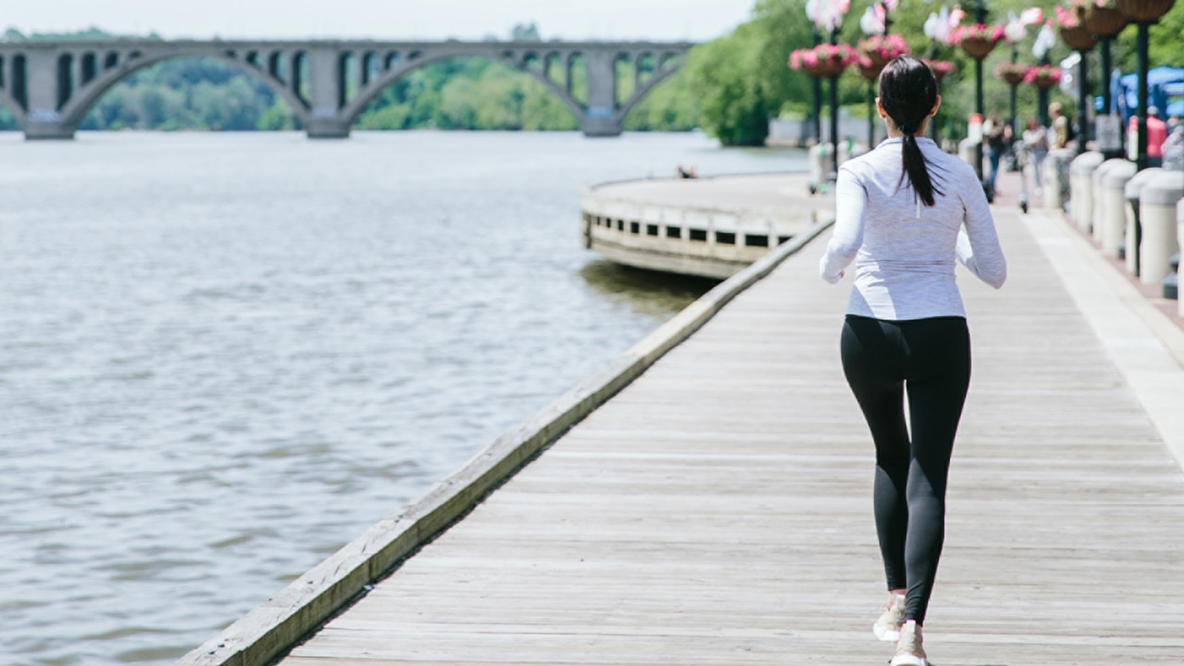 | September 16, 2021, Washington, DC, U.S.A.  Four Seasons Hotel Washington, DC Hosts 41st Annual Race to Beat Cancer Beginning September 25, 2021  https://publish.url/washington/hotel-news/2021/race-to-beat-cancer.html
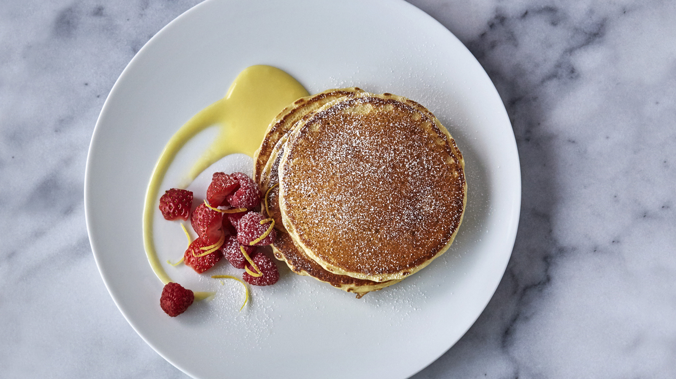 | September 9, 2021, Washington, DC, U.S.A.  The Return of the Award-Winning Sunday Brunch at Seasons at Four Seasons Hotel Washington, DC  https://publish.url/washington/hotel-news/2021/sunday-brunch-at-seasons.html

PRESS CONTACTS

Anina Belle Giannini
Director of Public Relations
2800 Pennsylvania Avenue N.W.
Washington
U.S.A.
aninabelle.giannini@fourseasons.com

+1 202 944 2074

