Four Seasons Resort Oahu at Ko Olina and ANA Partner to Present First Class Menu from Noe Chef de Cuisine Ryo Takatsuka

Consecutive Two Glass Wine Spectator Awards complement culinary accolades
February 13, 2019, Hawaii, Oahu, U.S.A.

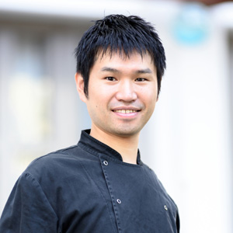
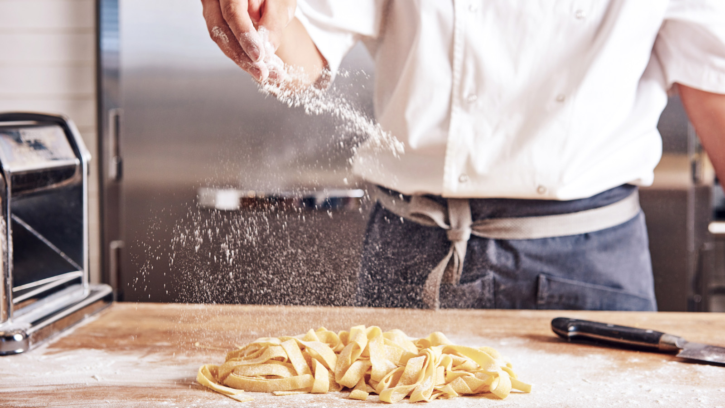 | 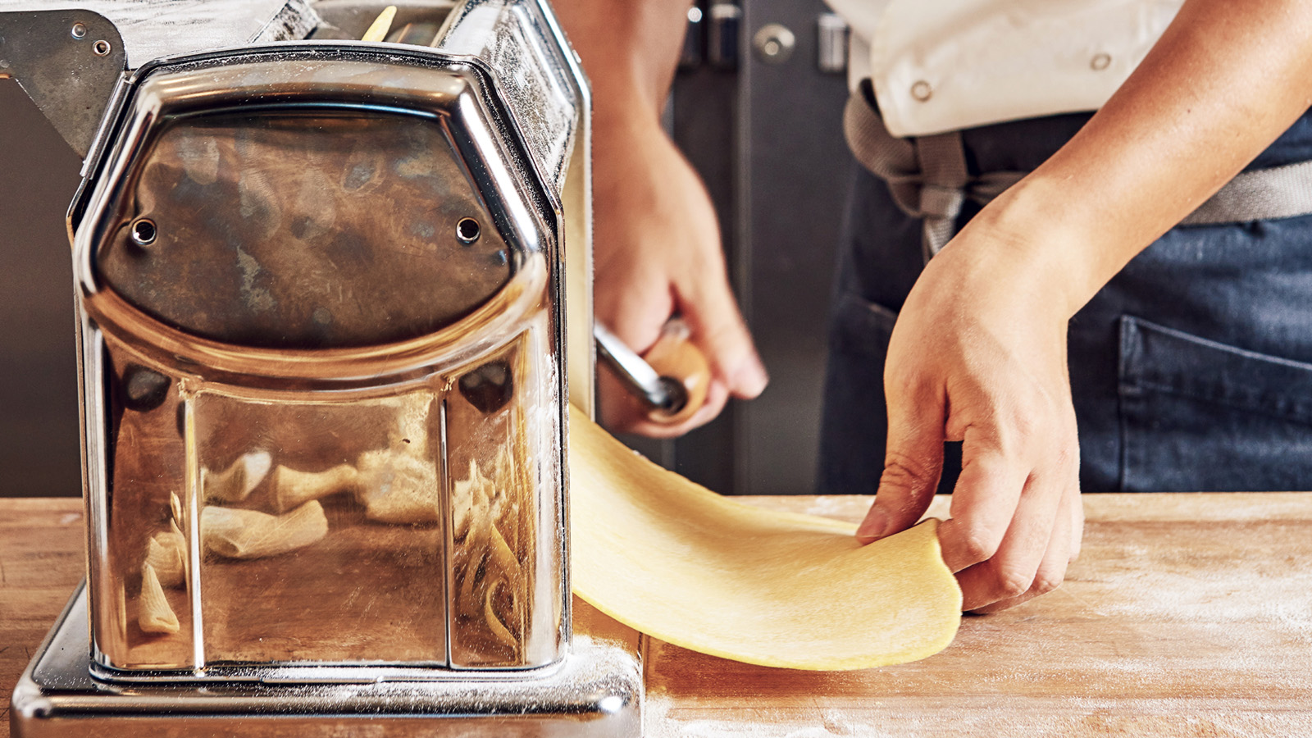 | 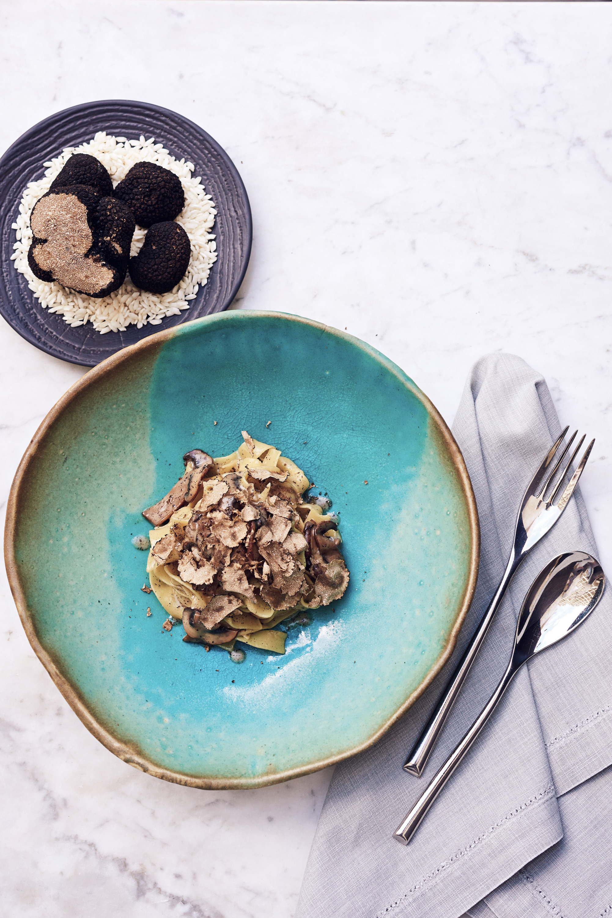
Passengers travelling first class on All Nippon Airways (ANA)’s first Airbus A380 will discover the flavours of southern Italy in a menu expressly developed for the occasion by Noe Chef de Cuisine Ryo Takatsuka of Four Seasons Resort Oahu at Ko Olina for the A380’s inaugural Tokyo to Honolulu route. The inaugural menu will be offered from May 24 through August 2019.
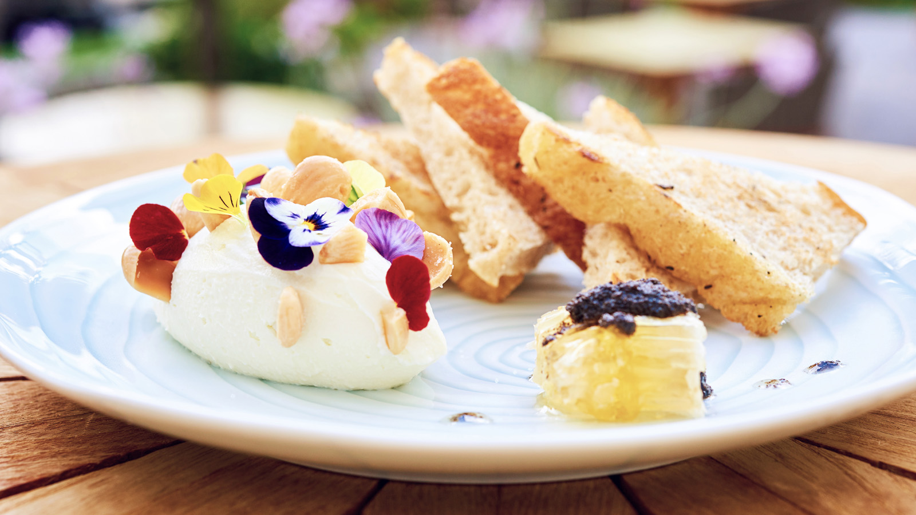 | 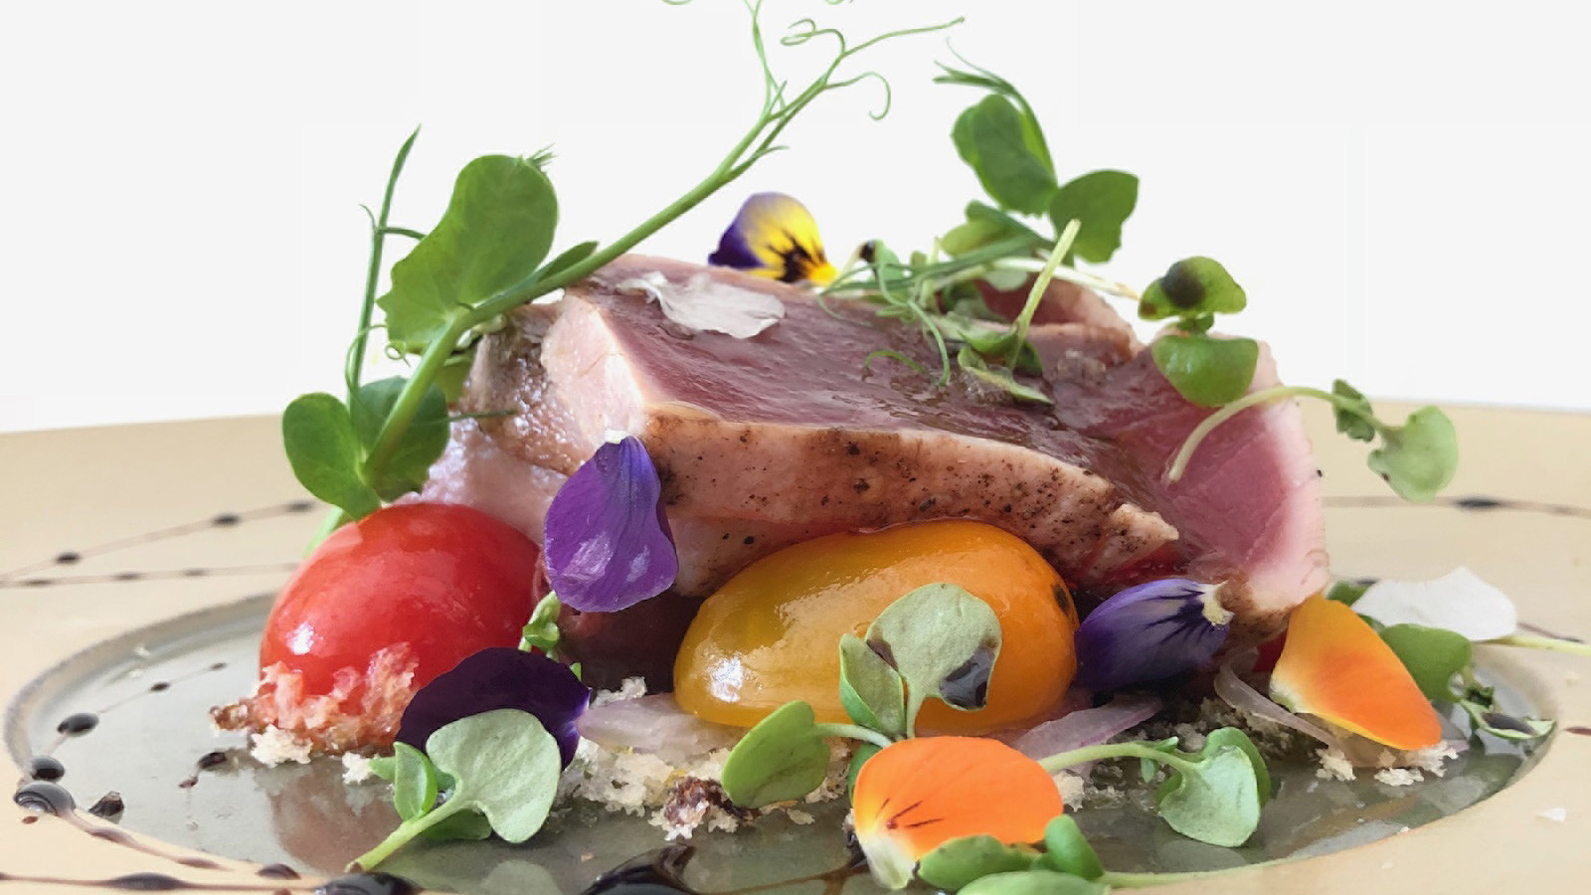 | 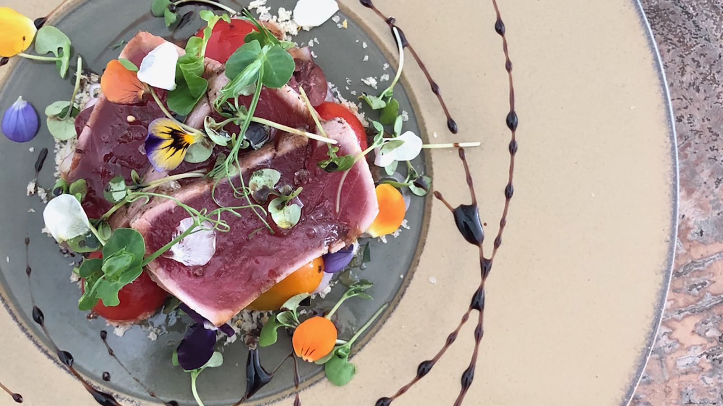
Chef Takatsuka came to Noe by way of Italian chef Marco Calenzo, who worked under Four Seasons Director of Food & Beverage and former Executive Chef Martin Knaubert at Four Seasons Hotel Beijing.
“Chef Takatsuka’s cuisine balances Michelin-level skill and training with a disciplined simplicity,” wrote food writer Melanie Kosaka in Modern Luxury Hawaii when Noe opened to glowing reviews in May 2016.
Takatsuka’s selection by ANA for the creation of their first class menu complements a growing list of accolades for the young chef, who spent ten years in Italy mastering the heart and essence of Italian cuisine at restaurants including the Michelin starred Ristorante Il Songo di Angelo in La Spezia and Hotel Eden La Terrazza in Rome, before returning to Japan in 2008 as chef de cuisine for the acclaimed Yamazaki restaurant in Tokyo.
“We are honoured that Noe and Chef Ryo will be celebrated from Tokyo to Oahu in this exciting new venture with ANA,” says Noe Restaurant General Manager Simone Orlandini.
Chic, intimate and casually glamorous, Noe has food lovers returning again and again to try dishes best described as Capri-meets-Oahu. Southern Italy’s characteristic light flavours shape dishes inspired by local seafood, top quality meats and homemade pastas, accompanied by an unrivalled selection of Italian wines – many never before available in Hawaii – and a sumptuous selection of desserts including tiramisu made in house. Most tables are outdoors, overlooking the ocean and the neighbouring Lanikuhonua Cultural Estate – ideal for romantic sunset and starlight dining.
An Award-Winning Wine List
Awarded a Two Glass Wine Spectator Award of Excellence for two consecutive years, Noe boasts an extensive list of more than 500 wine references, with a well-chosen assortment from quality producers ranging from Brewer Clifton to Ruinart, the world’s oldest established Champagne house.
Its cellar offers a rare opportunity to enjoy classics such as Chateau Petrus, Margaux, Romanee St. Vivant, Colgin and Harlan wines. Oenophiles will find significant depth with 10 different vintages of Opus One and 30 vintage champagnes sourced from both powerhouse producers and artisan growers, including more than 70 cabernet sauvignons, more than 40 chardonnays from the United States and more than 80 wines from the Burgundy and the Bordeaux region.
Noe’s Italian selection is focused on a well assembled variety of brunellos, super Tuscans, amarones and barolos such as Ornellaia, Sassicaia, Sandrone and Dal Forno Romano.
“Noe brings a newfound dining experience to the island, with authentic Italian-inspired cuisine, while capturing the story of grape, soil and climate from some of the world’s finest wine regions,” says Orlandini. “Tasting freshly made pastas and a glass of Greco di Tufo, one can truly say this is where Capri meets Oahu.”

RELATED

February 7, 2019, Hawaii, Oahu, U.S.A.
Proper Rideshop x Four Seasons Resort Oahu at Ko Olina Skateboarding Camp Dropping in This Spring Break
https://publish.url/oahu/hotel-news/2019/skateboarding-camp.html

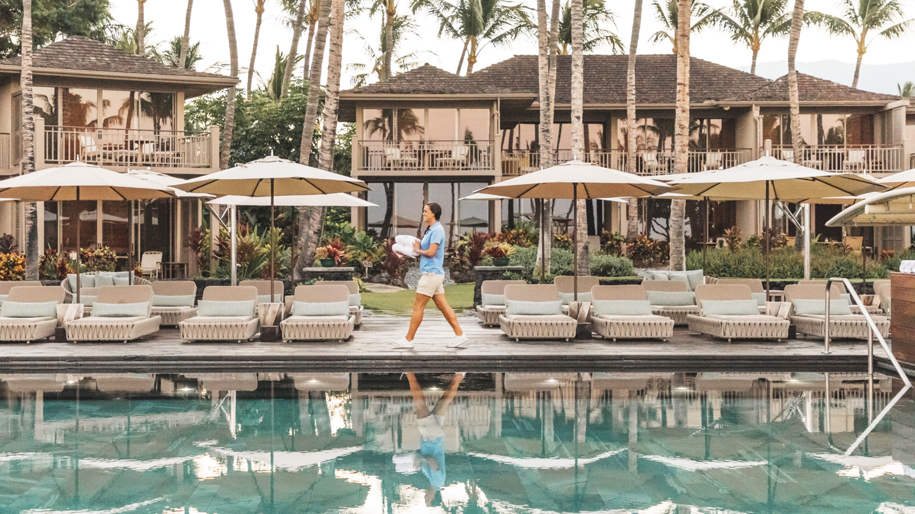 | February 6, 2019, Hawaii, Hualalai, U.S.A.  U.S. News & World Resport Names Four Seasons Resort Hualalai #1 Hotel in the United States and Hawaii  https://publish.url/hualalai/hotel-news/2019/best-hotel-in-the-united-states-and-hawaii.html

PRESS CONTACTS

Yvonne Hunter
Director of Public Relations
92-1001 Olani Street
Kapolei
U.S.A.
yvonne.hunter@fourseasons.com

+1 (808) 377-0746

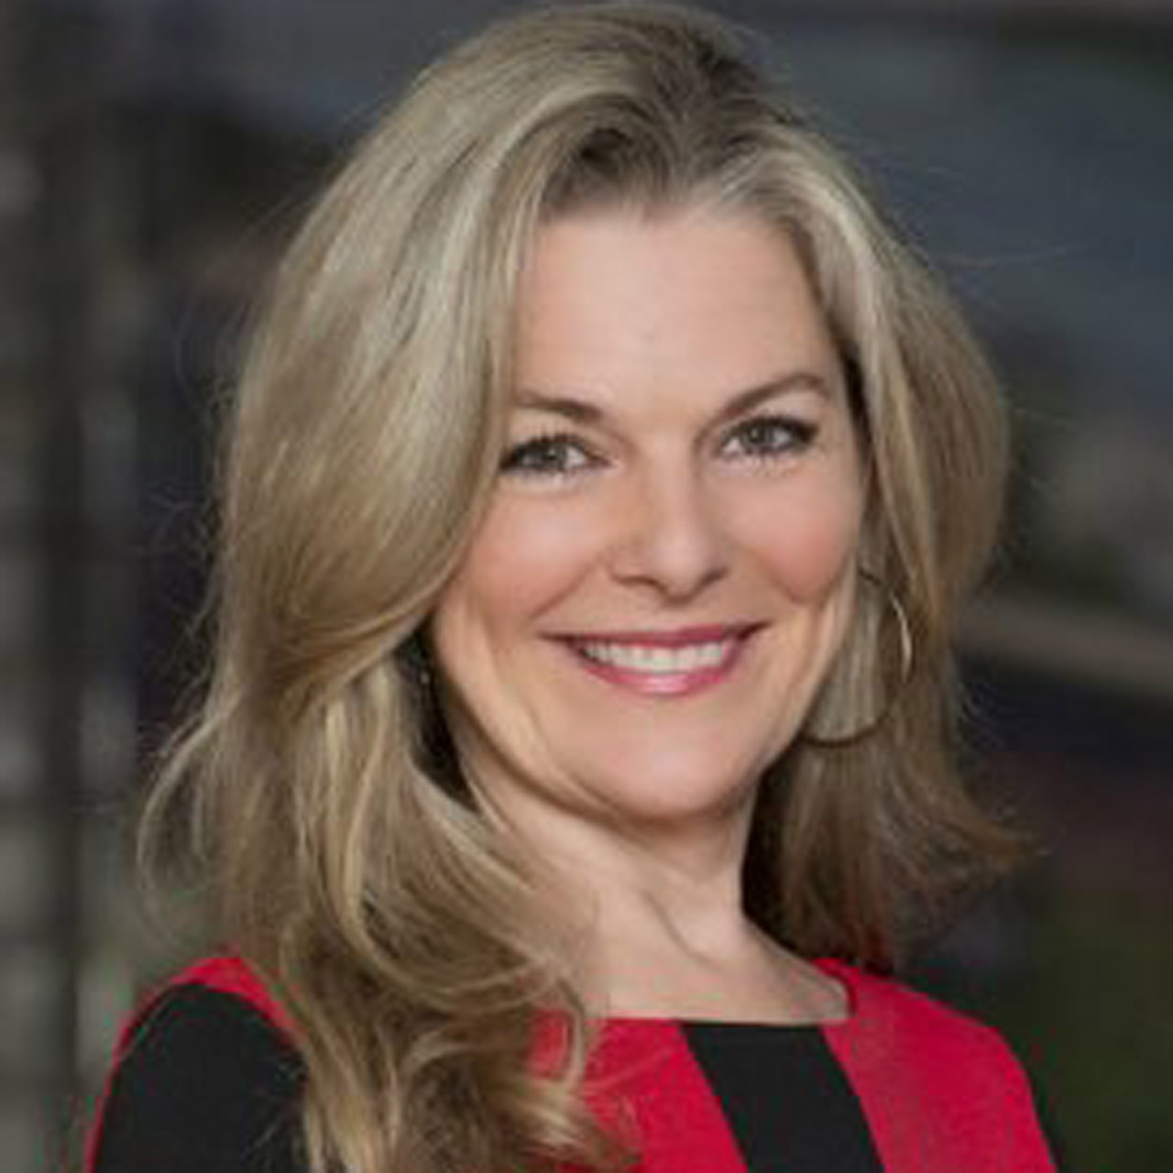 | Laura Fairweather  Director of Public Relations, Americas  1165 Leslie Street  Toronto  Canada  laura.fairweather@fourseasons.com  @FourSeasonsPR  +1 416 441 4233

