Jiang-Nan Chun at Four Seasons Hotel Singapore Awarded Michelin Star Once More

September 18, 2019, Singapore

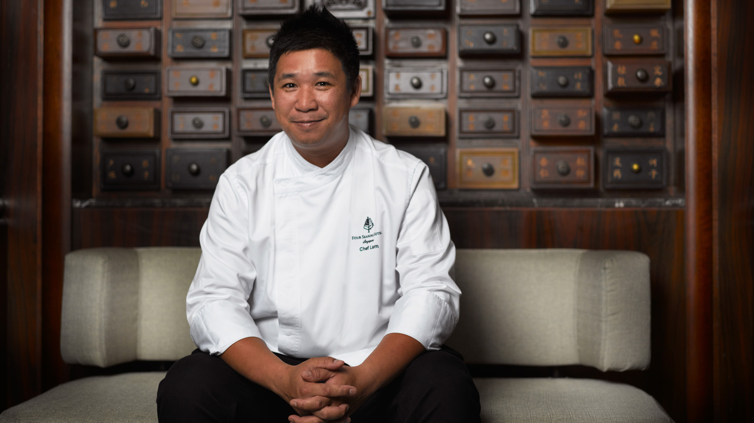
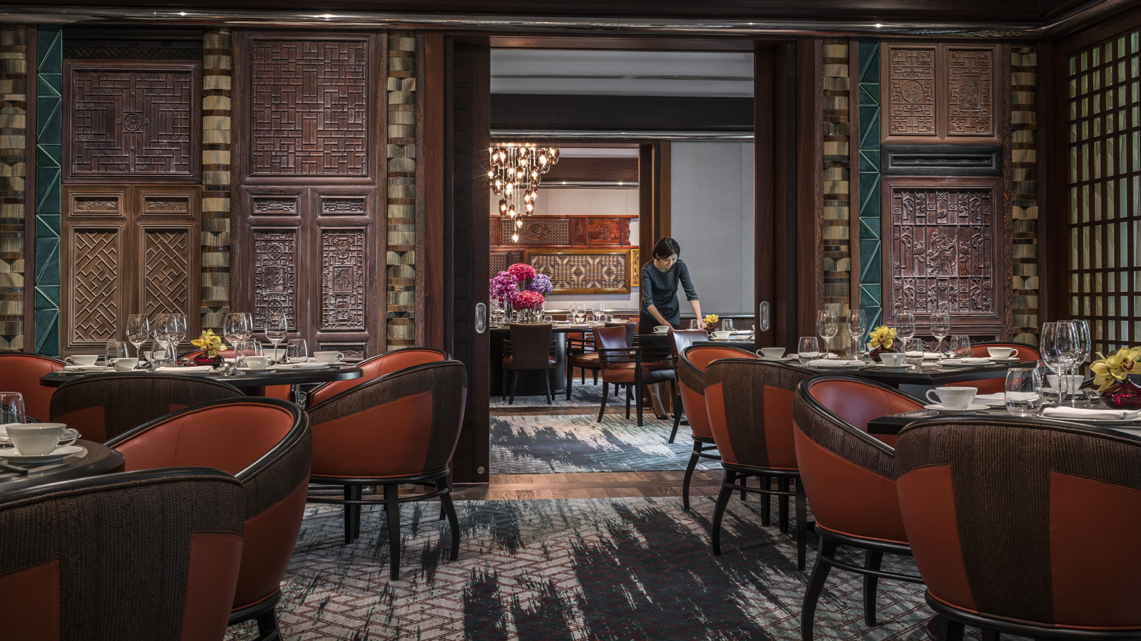
Jiang-Nan Chun, the fine dining Cantonese restaurant at Four Seasons Hotel Singapore, received the coveted one-star rating for the second consecutive year in the Michelin Guide Singapore 2019.
“We are exceptionally thrilled that Jiang-Nan Chun has once again been awarded the one-star Michelin rating by the acclaimed Michelin Guide. This award underscores our dedication to remarkable craftsmanship and culinary excellence, a commitment to authentic flavours and the promise of using only the freshest ingredients. It is a thoughtful, innate appreciation and understanding of the craft, pushing our boundaries to bring back the best of traditional Cantonese cuisine. We celebrate with both our culinary and restaurant operations team, while sincerely thanking our loyal patrons on this notable achievement,” says Peter C. Draminsky, Regional Vice-President and General Manager, Four Seasons Hotel Singapore.
Leading the culinary brigade at Jiang-Nan Chun is Executive Chinese Chef Tim Lam 林漢添. With more than 25 years of culinary experience in prestigious Chinese restaurants in Hong Kong and Macau, Chef Lam has a keen eye for perfection, a preference for seasonal ingredients and a taste for the finest quality. Creative yet authentic, Chef Lam’s menu excites palate and soul, where each dish is executed with thoughtful yet creative culinary finesse.
Born to a family of chefs and raised in Macau, Chef Lam has been following his passion for creative cooking since he was 14 years old. He said, “At a young age, I knew being in the kitchen was my calling as it allows me to convey my passion for food while showcasing my culinary skills. At Jiang-Nan Chun, the principle of enjoyment and happiness resonates with me as this is exactly what I want my guests to experience when savouring my creations.”
About Jiang-Nan Chun
Award-winning Cantonese restaurant Jiang-Nan Chun is inspired by Jiang Nan, the paradise-like region of southern China whose cities are celebrated in the famous saying, "born in Suzhou, live in Hangzhou, eat in Guangzhou," while chun, which means spring, completes the restaurant name and radiates the promise of renewal, growth and pleasure associated with the season.
An experience at the restaurant indulges the senses in the beauty of Jiang-Nan through elegant interiors, evocative furnishings and through exquisite gastronomy while embodying the concept of Xiang Le Zhu Yi 享乐主义or "the principle of enjoyment and happiness," where only the most exalted flavours, premium ingredients and special preparation are used to seduce the palate. Indulge like an epicure with special seasonal menus, authentic chef-crafted dim sums, nutritious double-boiled soups, hearty claypots and its one-of-a-kind signature Peking duck roasted in a mesquite wood-fired oven and served with caviar, paired with a premium selection of wines.
- Lunch and Dim Sum: 11:30 am to 2:30 pm
- Dinner: 6:00 to 10:30 pm

RELATED

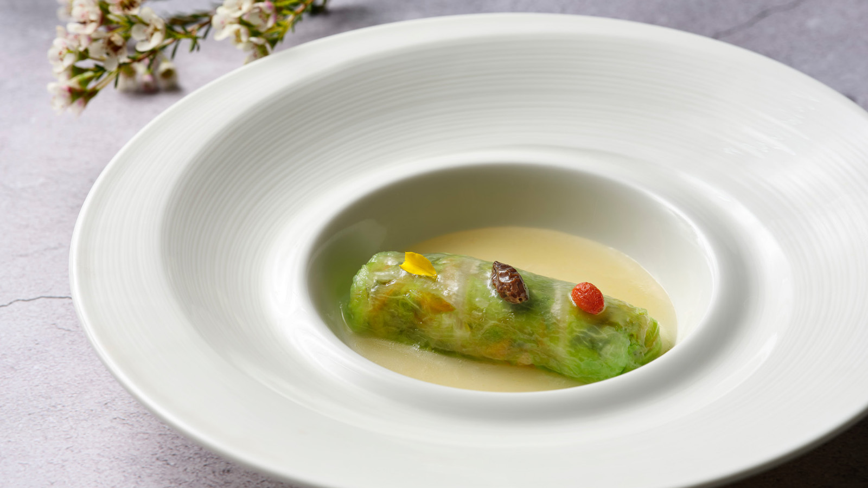 | July 12, 2019, Singapore  Flavours of Summer at Michelin-Starred Jiang-Nan Chun at Four Seasons Hotel Singapore  https://publish.url/singapore/hotel-news/2019/summer-menu-at-jiang-nan-chun.html
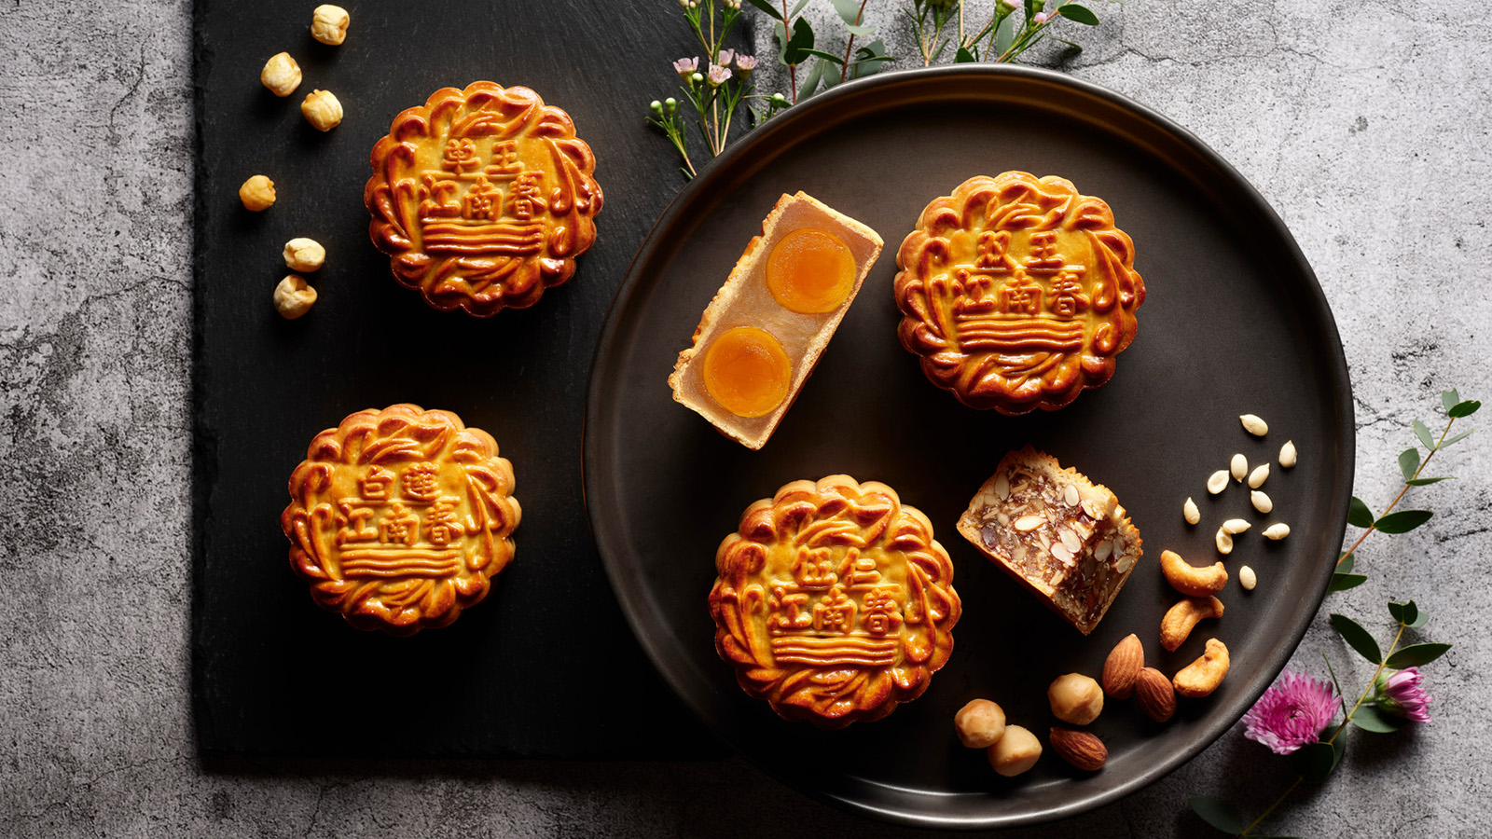 | June 27, 2019, Singapore  Four Seasons Hotel Singapore Unveils Elegant Mooncake Collection with Tropical Twist  https://publish.url/singapore/hotel-news/2019/mooncakes.html

PRESS CONTACTS

Valerie Loy
Director of Public Relations and Communications
190 Orchard Boulevard
Singapore
Singapore
valerie.loy@fourseasons.com

(65) 6831 7130

