Four Seasons Hotel Bogota Welcomes Guests Back to Colombia’s Capital, Reopening on April 5, 2021

Dine, spa and stay at the intimate and elegant 64-room address in vibrant Zona Rosa
March 31, 2021, Bogota, Colombia

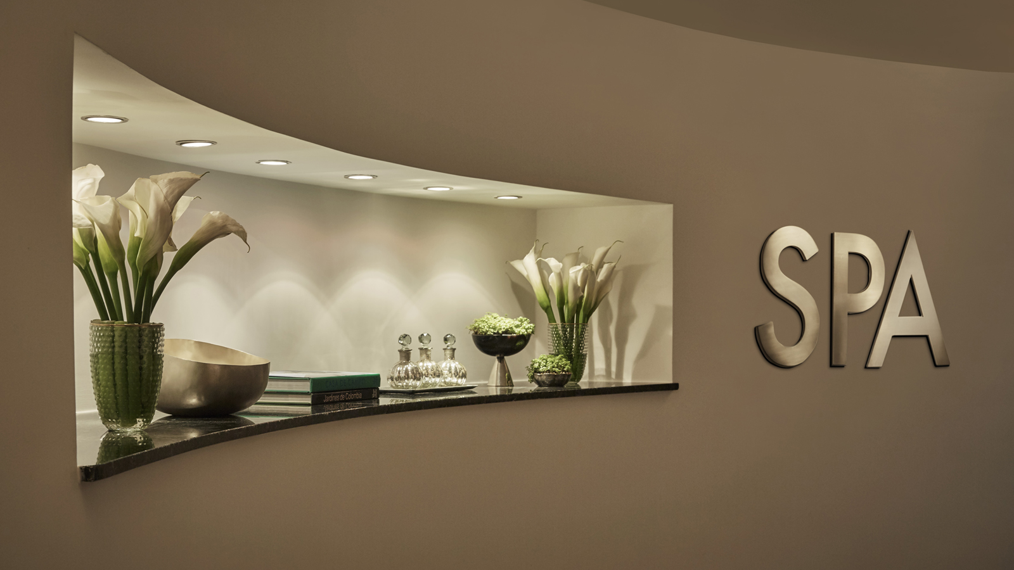
The height of luxury hospitality is returning to the capital of Colombia with the reopening of Four Seasons Hotel Bogota scheduled for April 5, 2021. The sleek, sophisticated, thoroughly modern Hotel will welcome guests following a yearlong closure, with their health and safety as top priorities and Four Seasons global Lead With Care program offering genuine care and reassurance.
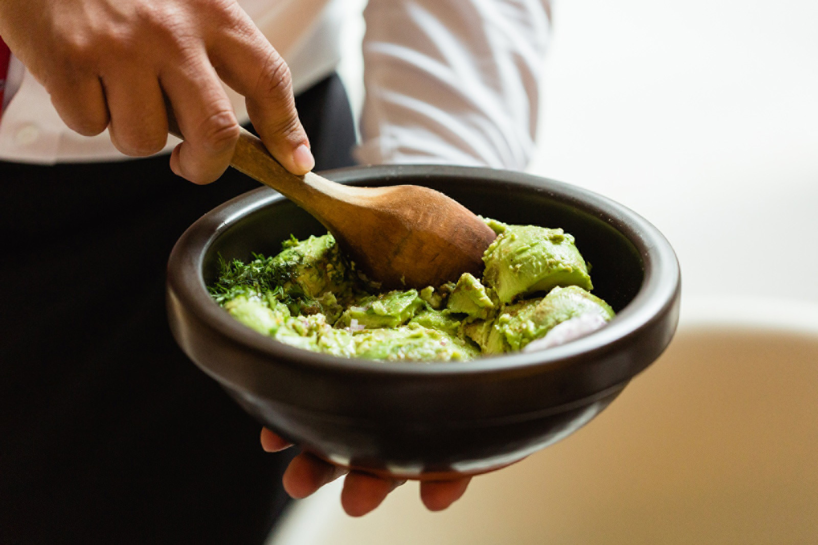
Intimate and elegant, designed with clean lines and contemporary tones, Four Seasons Hotel Bogota offers 35 rooms and 29 suites arrayed with special touches such as hand-knotted carpets and marble bathrooms. The property is set in Zona Rosa, a vibrant district in the northern part of the city that’s a scene all its own, with beautiful streets dotted with designer shops, cafés, bars, nightclubs and some of the best restaurants in the country.
The Spa will be open and aglow as well, with everything on the treatment menu except facials available. That leaves plenty for guests and locals to enjoy: Eease out of stress with a Deep Tissue & Stretching treatment combing a variety of compressions, stretches, and cross-fibre friction techniques; or go traditional with a Swedish Massage, ideal for first-time spa-goers or anyone seeking pure relaxation, with massage techniques combining light to medium pressure and long gliding strokes to reduce tension, soothe muscles, and increase circuling for another stay.
Health and safety are top priorities for the team at Four Seasons Hotel Bogota, with physical distancing measures added for all public spaces and services, including contactless check-in, checkout, and housekeeping. The Hotel has further embraced Four Seasons Lead With Care program conceived with an international healthcare leader to enhance health and safety throughout the property and provide care, confidence, and comfort to guests and employees alike. Four Seasons award-winning App and Chat are also available, the better for guests to control how they engage with others and enable them to limit face-to-face interactions while maintaining high levels of personal service.
To reserve a stay at Four Seasons Hotel Bogota, see your travel professional, contact +57 (1) 3257900, or book online.

RELATED

June 11, 2021, Bogota, Colombia
A Wellness Takeover at Four Seasons Hotels in Bogota in Celebration of Global Wellness Day on June 12
https://publish.url/bogota/hotel-news/2021/global-wellness-day.html

June 11, 2021, Bogota, Colombia
El bienestar se toma las propiedades de Four Seasons Hotels Bogotá durante la celebración del Global Wellness Day este 12 de junio
https://publish.url/es/bogota/hotel-news/2021/global-wellness-day-2.html

PRESS CONTACTS

Paula Gamboa
Director of Marketing
Cra 7 No. 69A-22
Bogotá DC
Colombia
paula.gamboa@fourseasons.com

+57 1 325 7912

