This Holiday Gather with Friends and Family at Four Seasons Resort Lanai

Celebrate the season on the most exclusive, secluded paradise in Hawaii
October 4, 2019, Hawaii, Lanai, U.S.A.

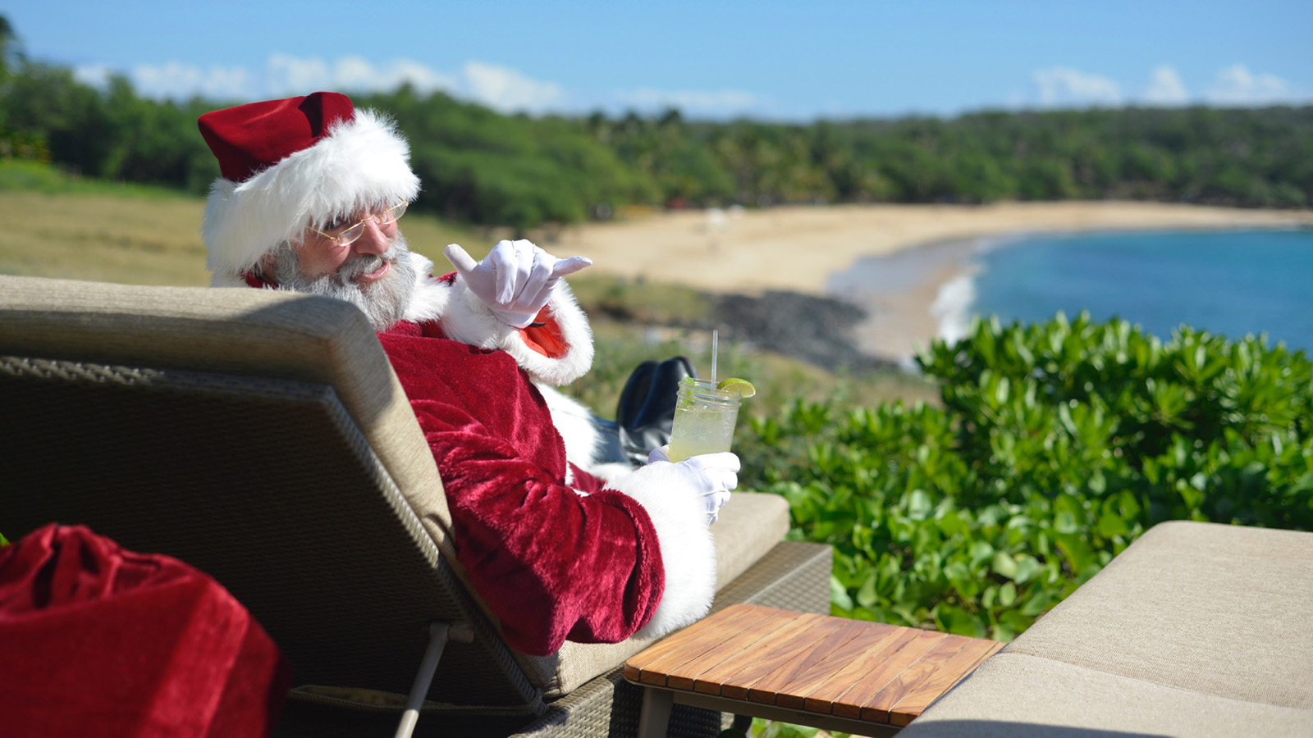
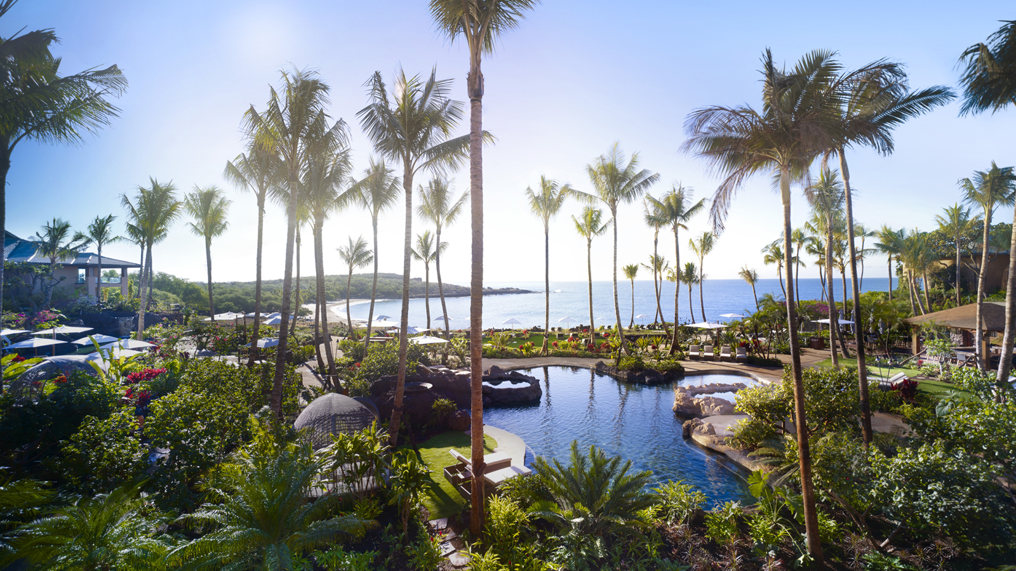 | 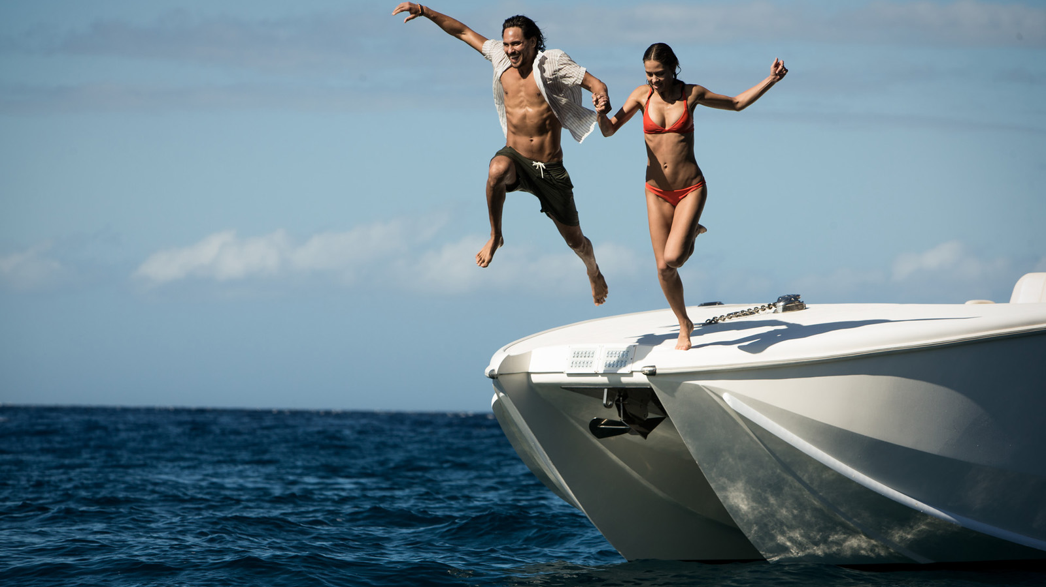 | 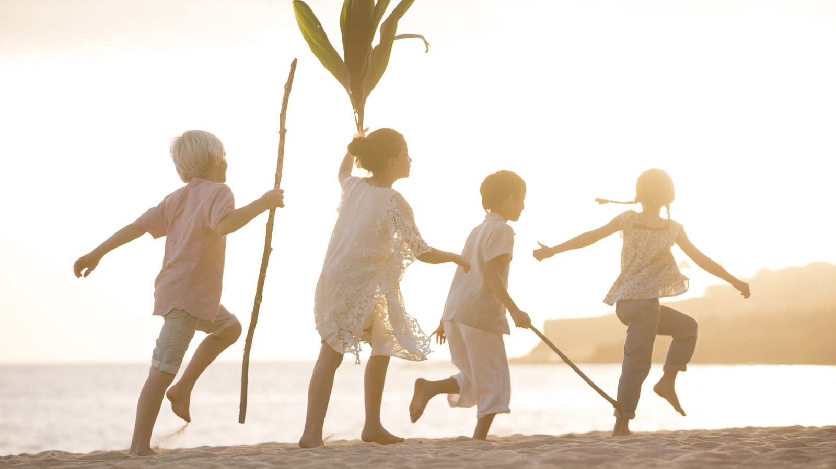
Make the season your own with a stay at Four Seasons Resort Lanai, the most exclusive, secluded paradise in Hawaii. Ring in the New Year at the AAA Five Diamond and Forbes Five Star Four Seasons Resort Lanai, offering seasonal spa and golf events, special holiday menus, festive décor, kids programming and more to ensure this holiday has something for everyone.
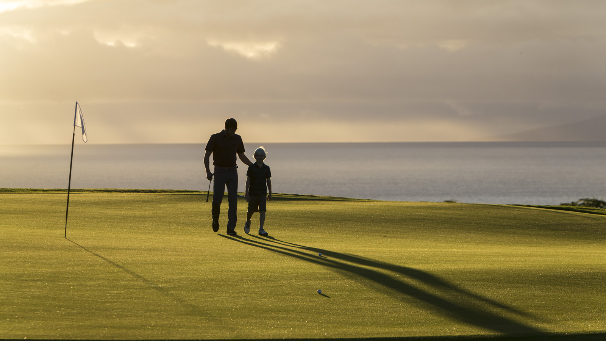
Overlooking Hulopoe Bay, a marine sanctuary that is home to spinner dolphins, the Resort offers a gateway to an unspoiled, exotic paradise. Lanai offers a variety of activities, many managed by Four Seasons, on land, ocean and air to create a Hawaiian island adventure. A selection of special events, many complimentary, during the holidays include:
Golf
Some guests will feel a round on the Signature Jack Nicklaus Manele Golf Course, with ocean views on every hole, is gift enough! Test skills in a “Take Down Billy the Kid” competition against resident golf pro Will Foster or relax with family and friends après golf at Jingle Bell Rock ‘N Range or the Manele Golf Shop Social. Even non-golfers can take a swing with Merry, Merry Mini-Manele, a complimentary 6 hole, par-3 course right on the practice facility.
Spa and Wellness
Festive spa events at Hawanwana Spa include a Total Wellness Retreat for couples, aerial yoga (for families too), couples’ massage class and Zen Sports Wellness, blending tennis, golf or horseback riding with yoga, meditation and massage. Holiday treatments on the menu include a Festive Blossom Experience or Passion FruitCake Mani-Pedi along with special gifts for spa-goers.
Join in a variety of complimentary classes such as beach yoga, meditation, tai chi or enjoy private sessions upon request.
Love Lanai Cultural Programs
Join the Resort’s Lanai Cultural Advisors for complimentary Hoolauna and Talk Story sessions and learn Hawaiian history, how to play the ukulele, leaf weaving, hula and more. The Cultural Resort tour will showcase art and artifacts from Hawaii and Polynesia, while outdoors meet the Resort Aviarist or take a tour of the botanical gardens. A nightly pu blowing ceremony will mark the end of the day and welcome a new evening.
Keiki (Kids)
Kids of all ages won’t be bored with the choices this season – Keiki Tennis Karnival, s’mores, daily torch lighting and cookie decorating are just some of the fun activities on offer. The complimentary Kids For All Seasons program, daily for kids 5-12, also has nightly parties with themes such as Red Carpet Movie, Slime Night, Mermaids and Pirates and Become a Chef; parties include dinner, gifts and more. And don’t miss Santa on December 25, taking a beach break in paradise.
Air, Sea and Land Activities
Experience an unmatched diversity of activities outside the Resort: horseback riding, guided Polaris UTV tours, hiking and biking on land. Or rent a 4x4 jeep to explore the distinctive landscapes of the island, visit the charming plantation town of Lanai City or beachcomb some of Hawaii’s most pristine sands. Take to the air for helicopter journeys around Lanai and Maui Nui or day trips to Oahu and the Big Island. Dive into the blue sea with snorkel and sunset sails, scuba excursions and fishing trips – keep an eye out for whale sightings!
Tennis
Grab a racquet and head to the Resort’s Tennis Garden, featuring two outdoor Plexipave hard courts and one Har-Tru clay court. Book court time, private lessons or join in a variety of programs and events.
Shopping
The collection of luxury boutiques at the Resort, golf course and spa incorporate of-the-moment women’s, men’s, children’s apparel and accessories, jewellery, home décor items, logo merchandise and more - perfect for last minute gifts, or getting a sneak peak on the coming season’s fashion at festive trunk shows held throughout the holiday period.
Spectacular Events
Enjoy special dining options at NOBU LANAI, ONE FORTY and Malibu Farm as well as festive events including:
- Family Holiday Luau - enjoy authentic luau cuisine and live Polynesian performances
- Cooking lessons with Chef Helene Henderson of Malibu Farm
- Gather on the luau with games, food and refreshments from the Kau Kau Tin Food Truck
- Nightly Menorah lighting with latkes and more
- Live music nightly, including Kuana Torres Kahele
- New Year’s Eve celebrations with dancing, fireworks and a champagne toast at midnight; special musical guests including the Montreal Rhapsody Orchestra
- Kids can also ring in the New Year with their own festive party
Holiday Rates
At Four Seasons Resort Lanai rates begin at USD 2,120 per night from December 21, 2019 to January 5, 2020. Reservations will be subject to minimum length of stay requirements from December 21 through December 31, 2019. Contact 800 321 4666, res.lanai@fourseasons.com or visit your travel professional for reservations.

RELATED

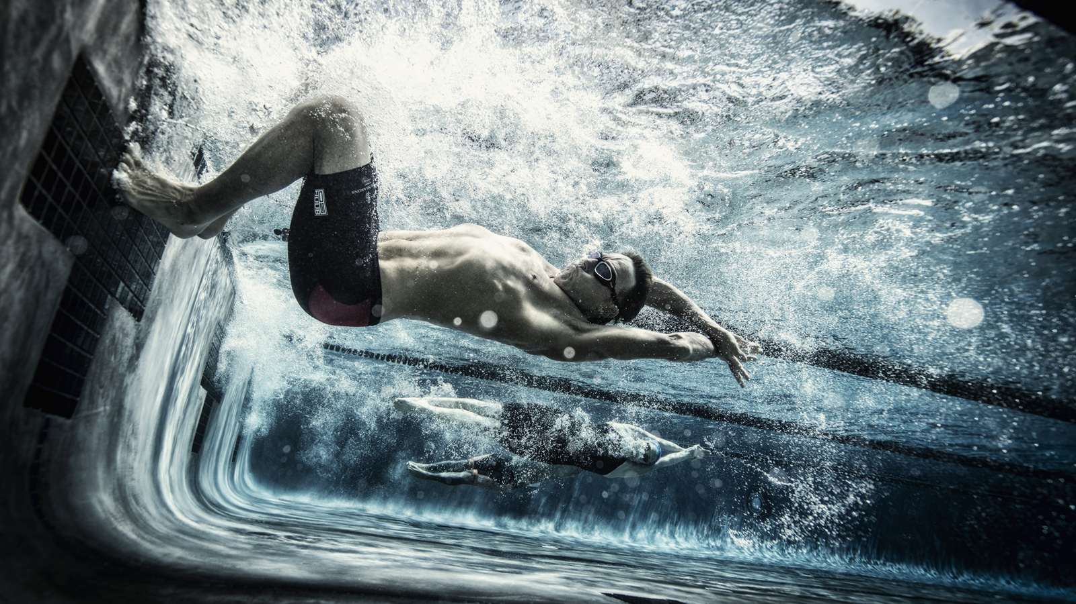 | September 27, 2019, Hawaii, Hualalai, U.S.A.  Four Seasons Resort Hualalai Hosts Annual Evening of Champions Celebrating the 2019 IRONMAN World Championships in Kona  https://publish.url/hualalai/hotel-news/2019/ironman-evening-of-champions.html
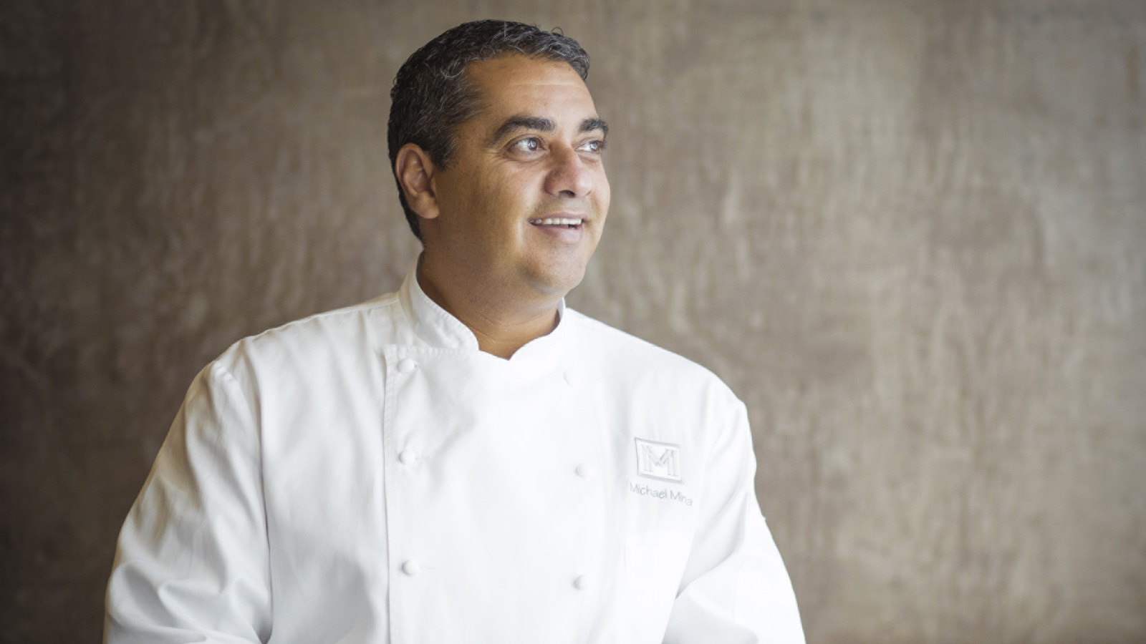 | September 25, 2019, Hawaii, Oahu, U.S.A.  Mina’s Fish House – the Signature Line-to-Table Restaurant at Four Seasons Resort Oahu –Takes Over Michelin-Starred MICHAEL MINA San Francisco  https://publish.url/oahu/hotel-news/2019/minas-fish-house-san-francisco-event.html

PRESS CONTACTS

Lori Holland
Director of Public Relations
6100 Center Drive, Suite 1250
Los Angeles
U.S.A.
lori.holland@fourseasons.com

+1 (201) 294-7810

Olivia Kragen
Digital Marketing Manager
6100 Center Drive, Suite 1250
Los Angeles
U.S.A.
olivia.kragen@fourseasons.com

+1 (310) 695-3385

