Four Seasons Resort and Residences Jackson Hole Named Five Star Property by Forbes Travel Guide in Official 2023 Star Rating Announcement

Award marks 16th consecutive year for property recognition
February 15, 2023, Jackson Hole, U.S.A.

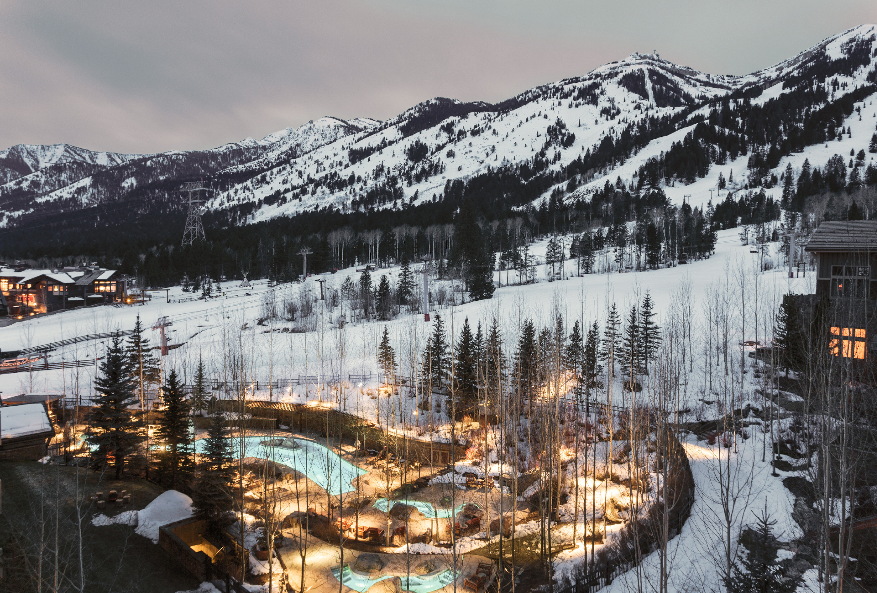
 | 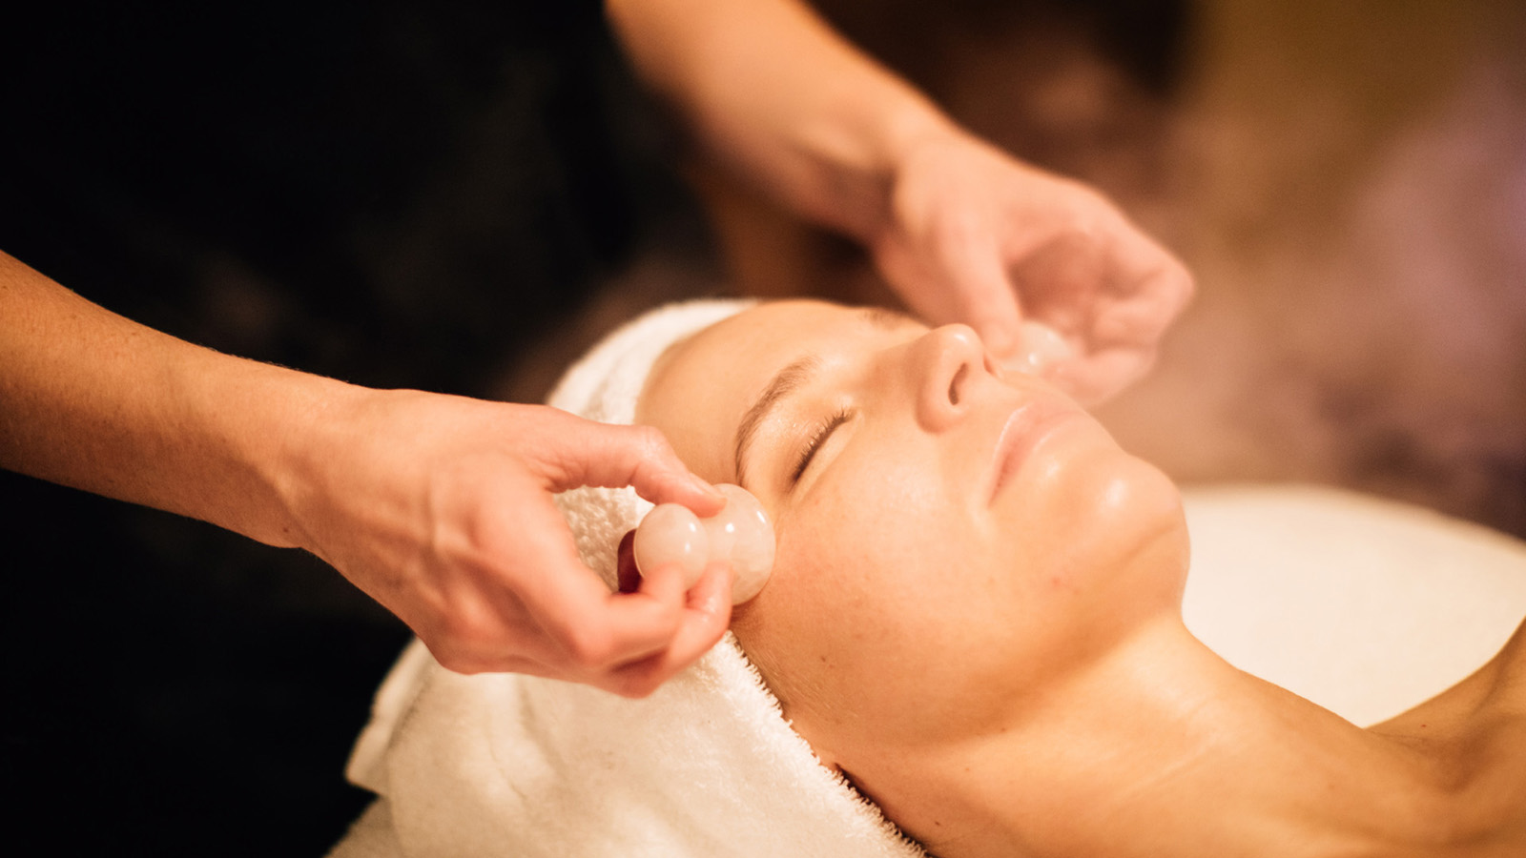 | 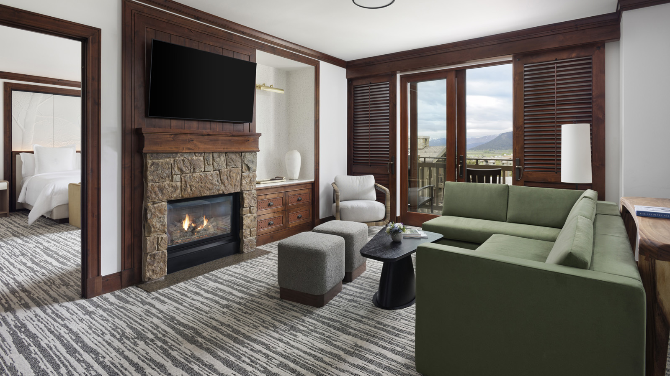
Forbes Travel Guide, the world-renowned rating system for luxury hotels, restaurants and spas, today announced its annual Star Rating list, presenting Four Seasons Resort and Residences Jackson Hole with its 16th consecutive Five Star award. Complete with an adventure basecamp, and three dining outlets, the Resort lends itself to anticipate and meet its guests every need. Its full-service Four Star Spa is the only Forbes rated spa in the state of Wyoming.
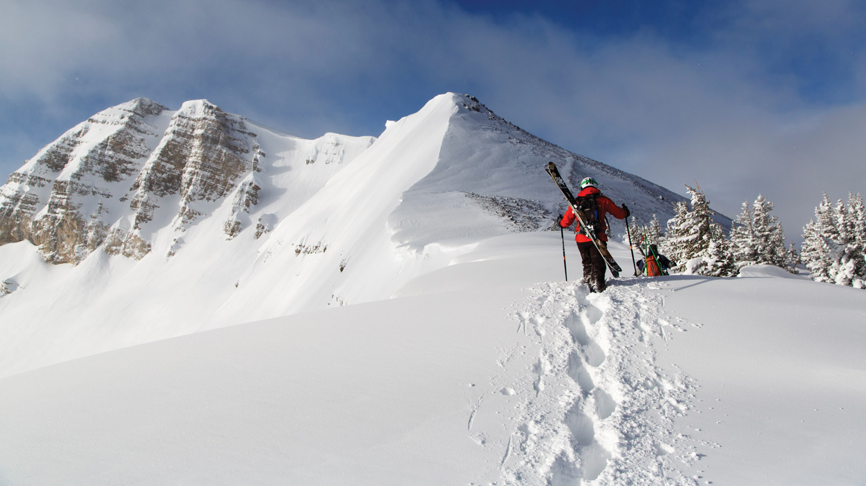 | 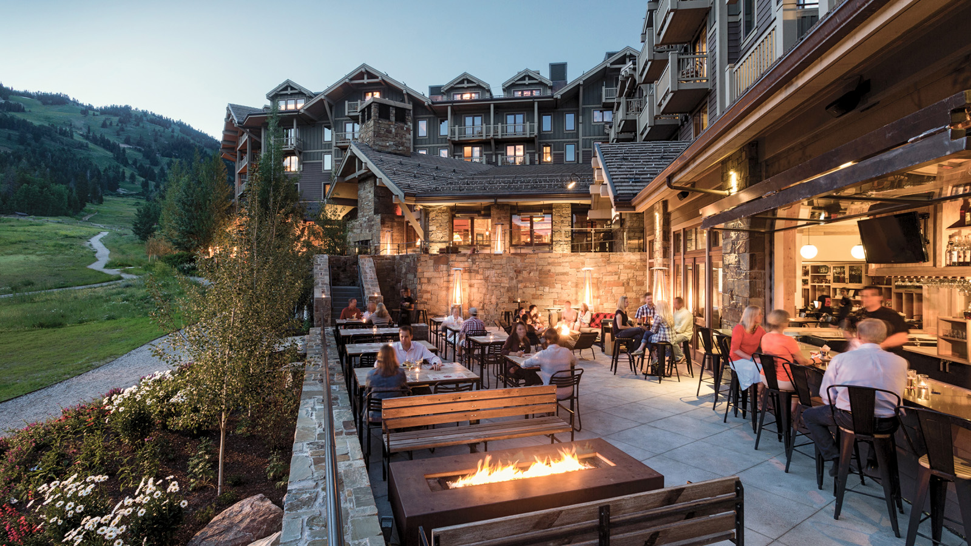
“This recognition is a testament to the efforts of our tenured staff, along with the continued investment of our ownership group in maintaining a level of product excellence,” says General Manager Ryan Grande. “We are thrilled to shine a spotlight on our alpine destination with this award. Jackson Hole truly is a year-round destination, with premier winter sports, summer adventure and the natural beauty of two nearby national parks every season of the year.”
Located only one mile from the entrance to Grand Teton National Park, guests of Four Seasons Resort Jackson Hole can explore the beauty of the park with guided tours and special summer passes, as well as year-round wildlife safaris. New for winter 2023, guests can embark on an immersive adventure into Yellowstone National Park, with the chance to see the native gray wolf population in their natural habitat. Winter guests also will enjoy the ease of the onsite basecamp and dedicated ski concierge, taking winter sports to a new level of ease. Guests enjoy on-property demo level rentals, ticket purchasing options and exclusive retail selections.
Culinary-motivated travellers will enjoy three unique dining outlets and 24-hour room service. Ascent Lounge provides an array of crafted cocktails, and a selection of creative cocktails and light bites. The Handle Bar, run in collaboration with celebrity Chef Michael Mina, provides an elevated pub experience and the perfect dining spot after a day on the mountain. The signature mustache pretzel with warm cheese and dipping sauce is a menu staple not to be missed. Westbank Grill offers fine dining with a view. Guests are invited to enjoy a glass of wine from Sommelier Anthony Puccia’s curated wine list accompanied by Executive Chef Michael Goralski's creative, seasonally inspired cuisine. Executive Pastry Chef Rhonda Ashton and her team’s delectable delights are the perfect finale to every meal.
The full-service Spa offers an array of treatments, many incorporating locally sourced botanicals and influences. From facials to body rituals, a true sense of wellness is met with both targeted results and complete rejuvenation. With an emphasis on holistic wellbeing, The Spa also offers a seasonal calendar of fitness offerings such as yoga and Pilates. New for 2023, guests also can enjoy an array of wellness offerings including oxygen and IV drip therapy.
Four Seasons Resort and Residences Jackson Hole completed a full-scale renovation of all guest rooms, suites and public hallways in summer 2022. The renovation included all new vanities and mirrors, furniture, artwork, beds, lighting, wall coverings, carpet and private bar. A well-defined work area allows guests to remain productive, with top-of-the-line new technology for communication and entertainment. The latest renovations build upon recent enhancements in Westbank Grill and Ascent Lounge within the past five years.
Forbes Travel Guide anonymously rates luxury hotels and resorts throughout the world against up to 900 rigorous standards. Star ratings are awarded by a team of anonymous professional inspectors who travel the world to assess hotels, restaurants and spas based on 900 objective standards. Star ratings ultimately emphasize quality of service. Five-Star properties are defined as “outstanding, often iconic properties with virtually flawless service and amazing facilities.”

RELATED

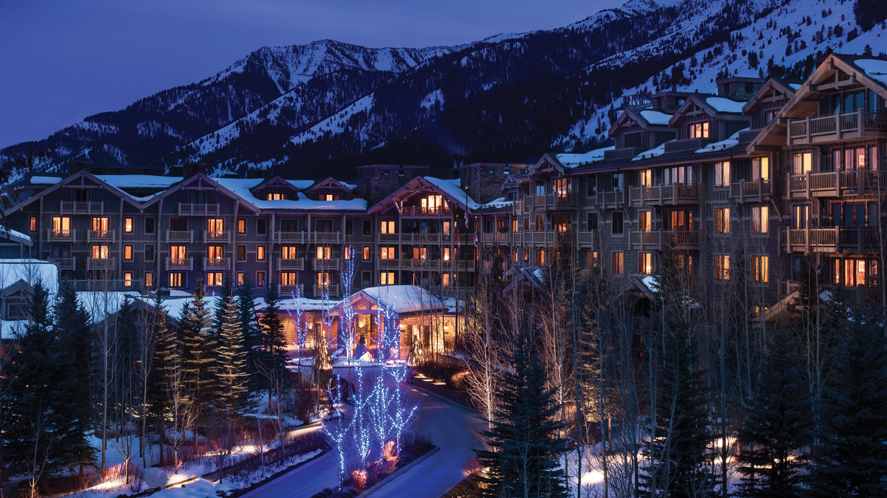 | February 7, 2023, Jackson Hole, U.S.A.  Four Seasons Resort and Residences Jackson Hole Named Best Hotel in Wyoming in 2023 U.S. News & World Report Best Hotel Rankings  https://publish.url/jacksonhole/hotel-news/2023/best-hotel-in-wyoming.html
January 23, 2023, Jackson Hole, U.S.A.
Acclimate This Winter with New Slope-Side Oxygen Bar, IV Therapy at Four Seasons Resort and Residences Jackson Hole
https://publish.url/jacksonhole/hotel-news/2023/new-elevate-oxygen-bar.html

PRESS CONTACTS

Kim Cole APR
Director of Public Relations
7680 Granite Loop Road, PO Box 544
Teton Village
USA
kim.cole@fourseasons.com

+1 480 980 8773

Jordan Ben-Hanania
Digital Marketing Manager, Sales & Marketing
7680 Granite Loop Road, PO Box 544
Teton Village
USA
jordan.ben-hanania@fourseasons.com

+1 307 732 5617

