Four Seasons Hotel Gresham Palace Budapest Welcomes Thibaut Drege as General Manager

March 23, 2023, Budapest, Hungary

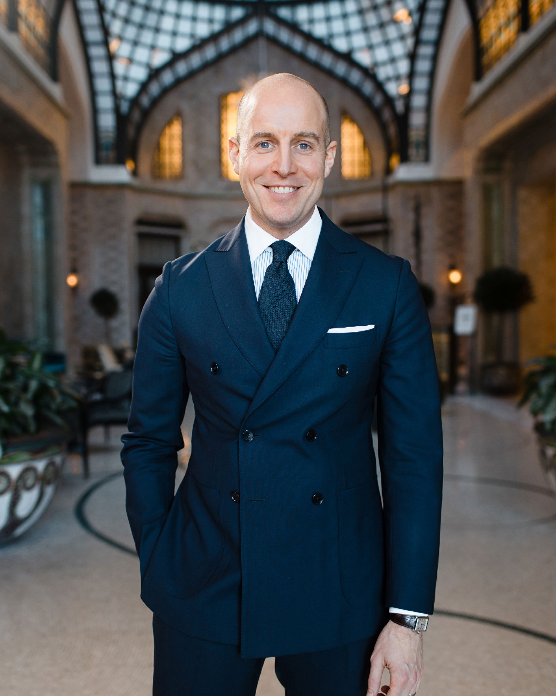
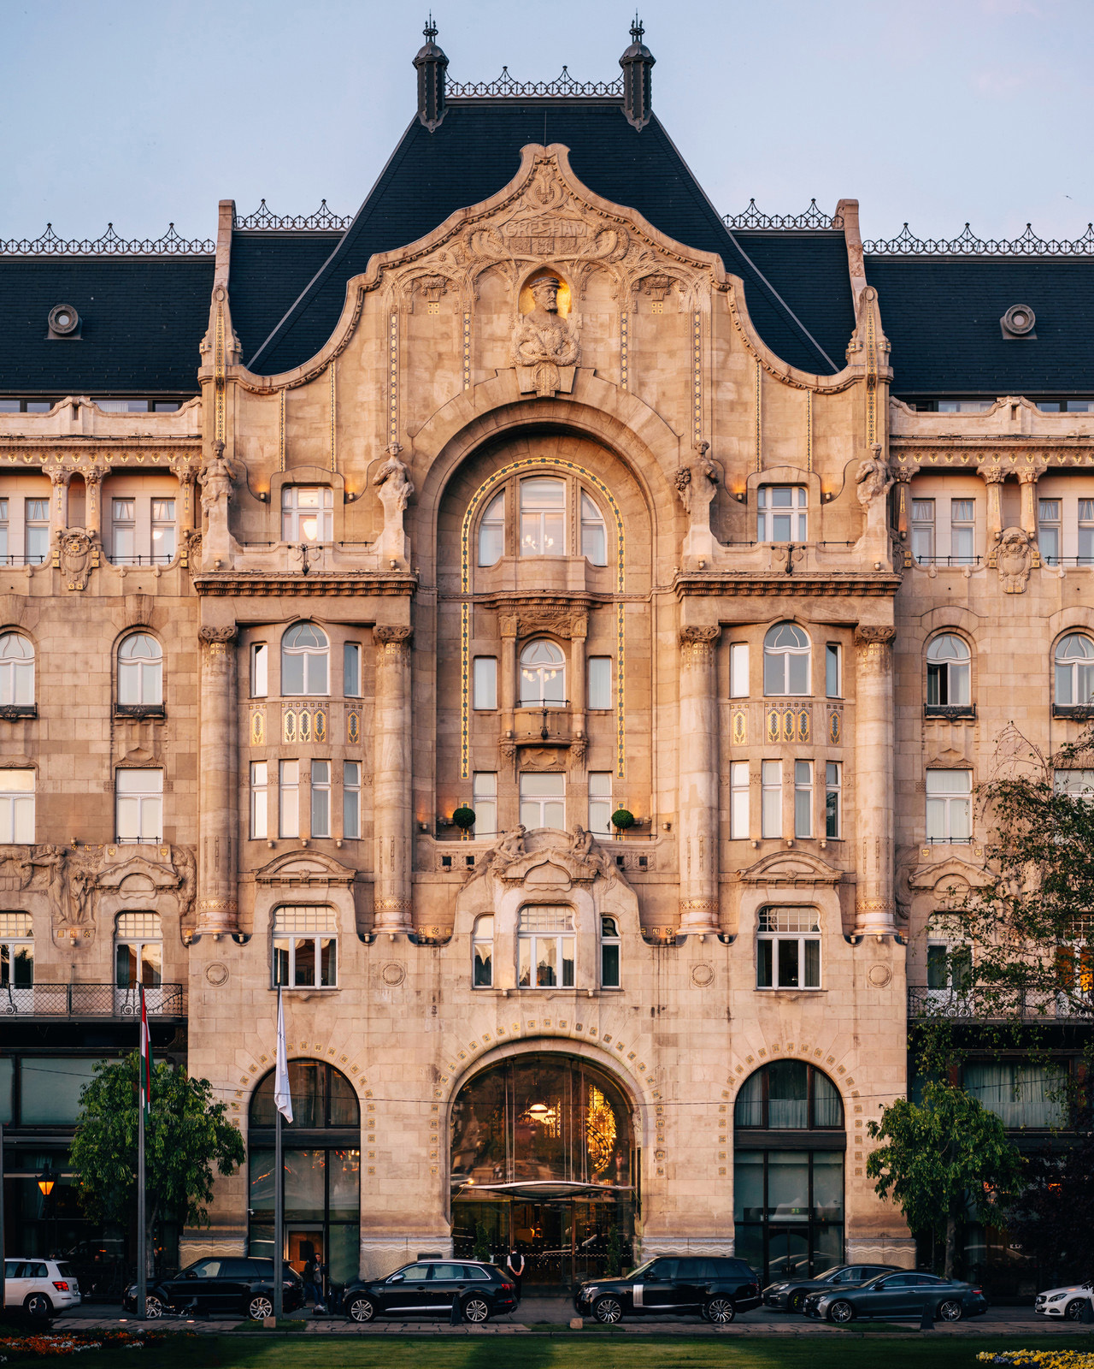
With an experience spanning across almost two decades in the luxury hospitality industry, Thibaut Drege brings new inspiration and a drive for excellence to Four Seasons Hotel Gresham Palace Budapest as new General Manager.
Drege joined Four Seasons in 2018 as Hotel Manager at Four Seasons Hotel George V, Paris. “From the first day of my career I always told myself, the day Four Seasons will call me, I’d stop whatever I’d been doing and I’d join this amazing company.” After five successful years in Paris, he was appointed to take the helm at Four Seasons Hotel Gresham Palace Budapest. “I feel honoured and proud, having the opportunity to be the General Manager of one of the most beautiful hotels on the planet.”
His leadership philosophy is inspired by the passion of craftsmen and fine artisans, who put all their heart in their work and creations, and never stop striving for excellence. This passion translates for him to an admiration of great food and cooking, considering gastronomy a genuine way of caring for people. Carrying on the celebration of exceptional dining experiences, Four Seasons Hotel George V maintained its unique, prestigious position under his lead, being the only hotel in Europe housing a total of five Michelin stars within three restaurants, a world leader in culinary experiences.
He considers sharing feedback, sharing knowledge and mentoring is crucial in bringing the best out of each individual and helping them to reach their own potential.
Highly dedicated to Budapest and the Gresham Palace, Drege will build on his global experience and the vast expertise of his team to ensure the worldwide community of sophisticated travellers discover what the city and the Hotel have to offer.

RELATED

March 23, 2023, Budapest, Hungary
Új vezérigazgató a Four Seasons Budapest Gresham Palota élén
https://publish.url/hu/budapest/hotel-news/2023/new-general-manager-thibaut-drege-2.html

March 14, 2023, Budapest, Hungary
Four Seasons Hotel Gresham Palace Budapest Has Been Awarded with Five Stars in Forbes Travel Guide 2023 for the Seventh Consecutive Year
https://publish.url/budapest/hotel-news/2023/forbes-five-star-hotel-and-spa.html

PRESS CONTACTS

Judit Esküdt
Director of Public Relations and Communications
Széchenyi István tér 5-6.
Budapest
Hungary
judit.eskudt@fourseasons.com

+36 1 268 5452

Fruzsina Otto
Assistant Public Relations Manager
Széchenyi István tér 5-6.
Budapest
Hungary
fruzsina.otto@fourseasons.com

+36 1 268 5419

