Freshly Baked with a New Menu at Fresca Café and Bakery at Four Seasons Hotel Alexandria

Chefs Patrick and Giuseppe collaborate to bring the freshest in the culinary scene to the table
October 6, 2020, Alexandria, Egypt

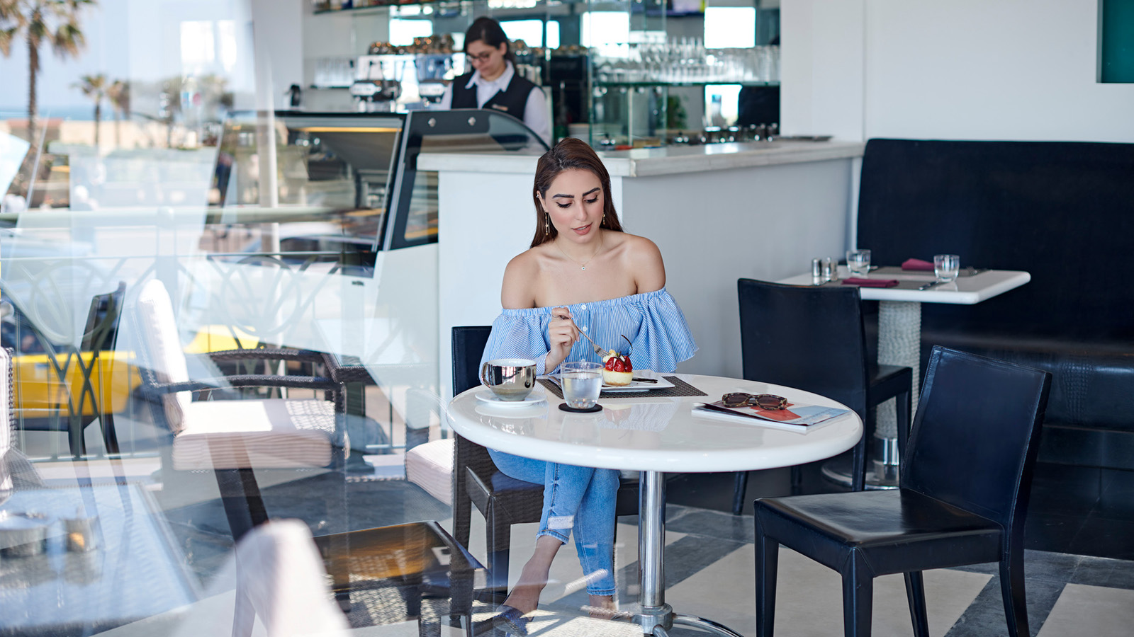
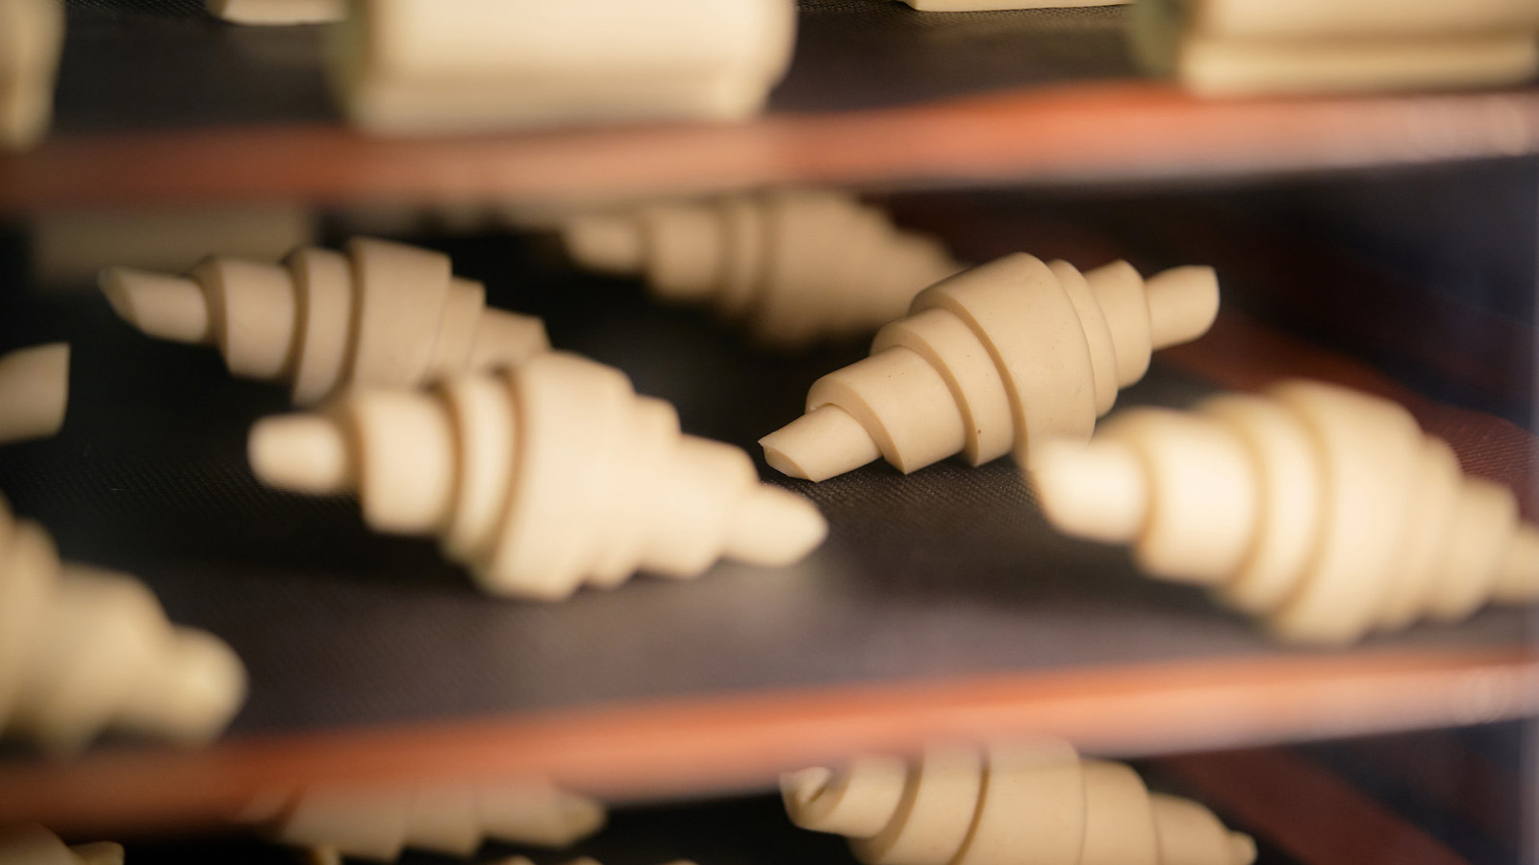 | 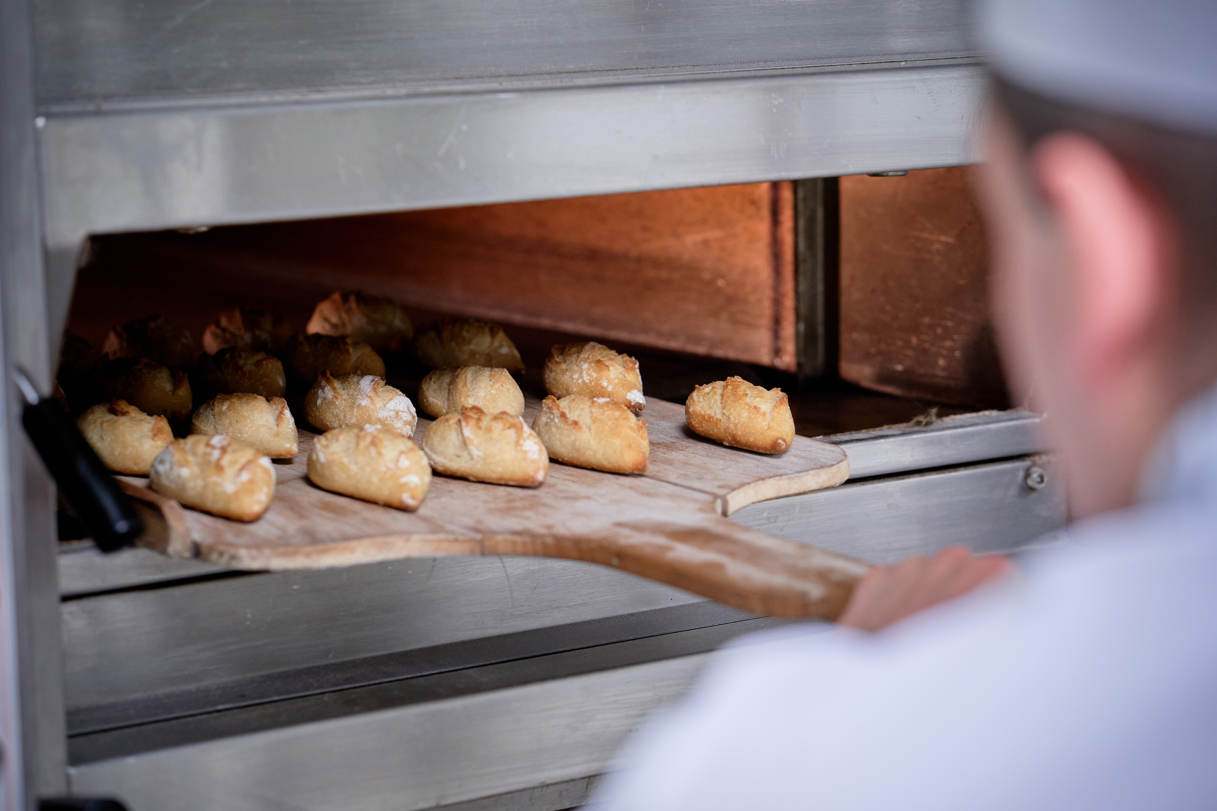 | 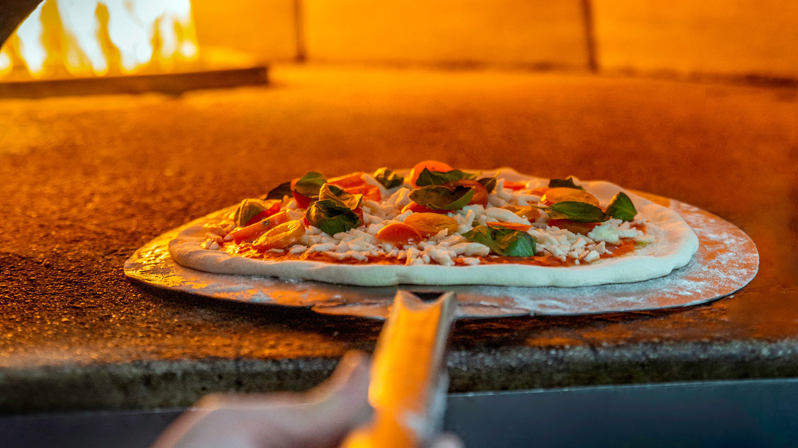

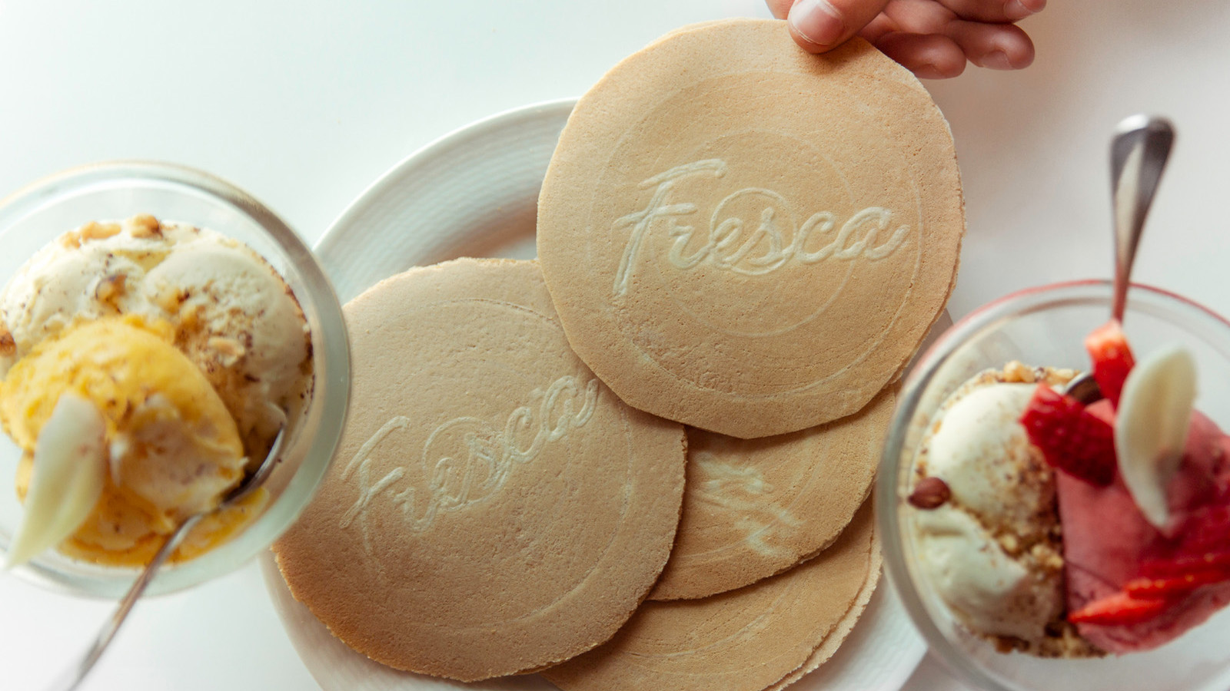

RELATED

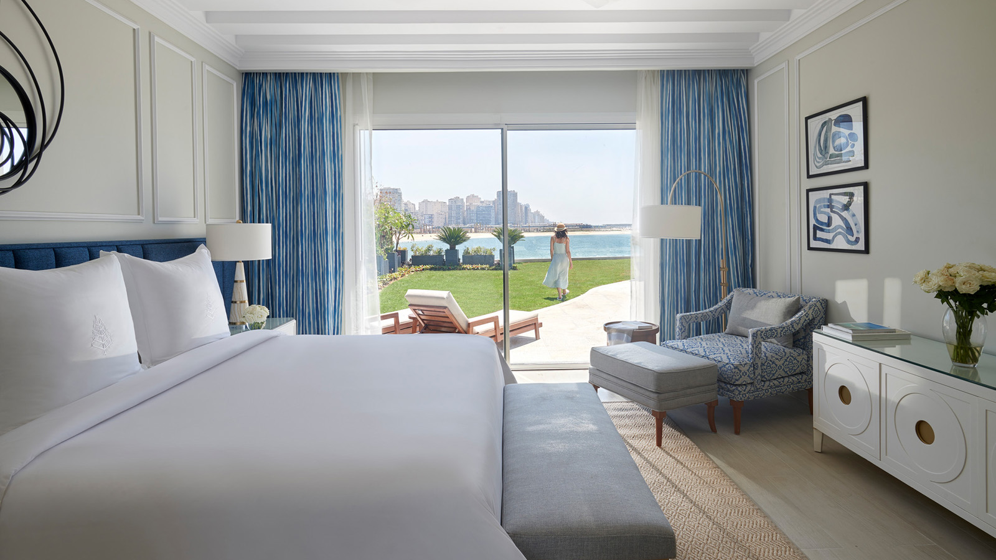 | August 4, 2020, Alexandria, Egypt  New Beach Villas with Pools at Four Seasons Hotel Alexandria  https://publish.url/alexandria/hotel-news/2020/new-beach-villas.html
June 10, 2020, Alexandria, Egypt
From Sea to Table: A Fresh, Local Fish Market Experience at the Beach Restaurant at Four Seasons Hotel Alexandria
https://publish.url/alexandria/hotel-news/2020/fish-market-at-beach-restaurant.html

PRESS CONTACTS

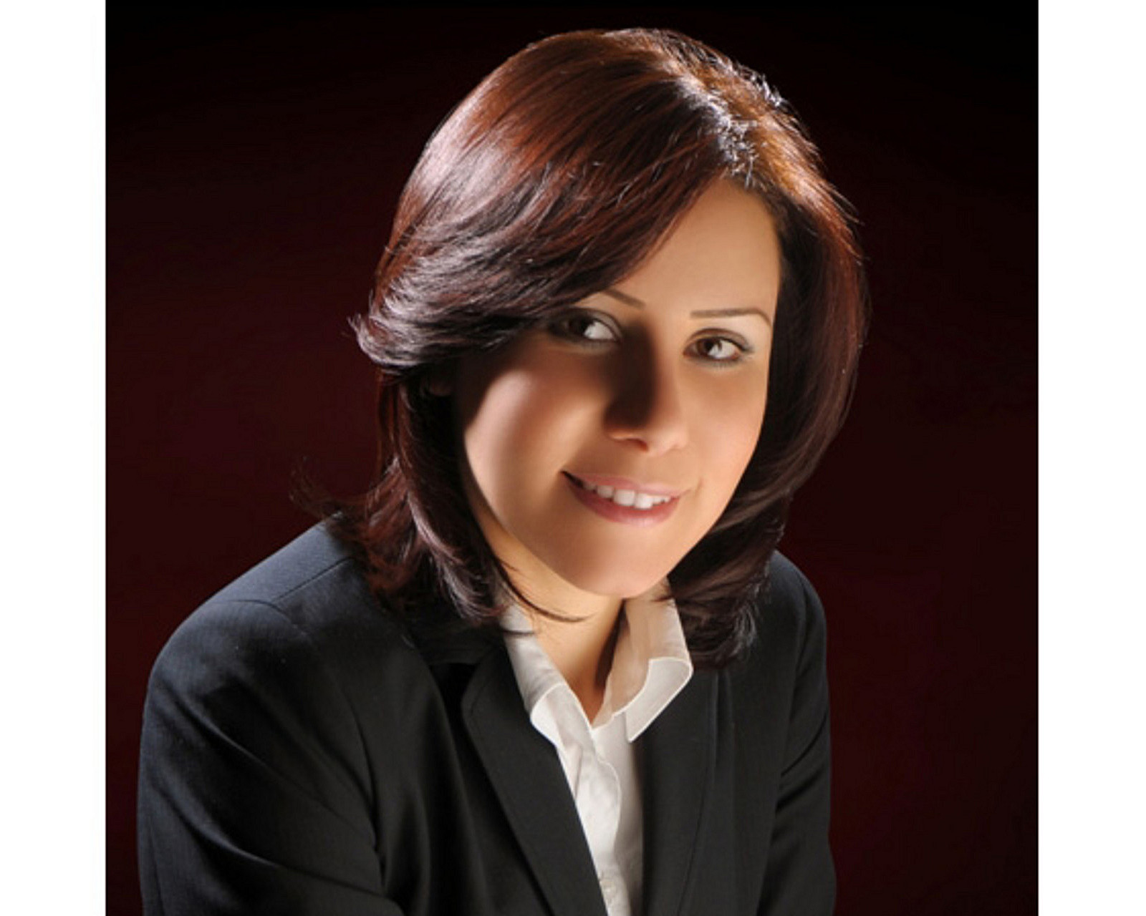 | Sarah Nabil  Director of Public Relations  399 El Geish Road  Alexandria  Egypt  sarah.nabil@fourseasons.com  20 3 581 8000

