Find Your Music Muse in Austin

March 27, 2018, Austin, U.S.A

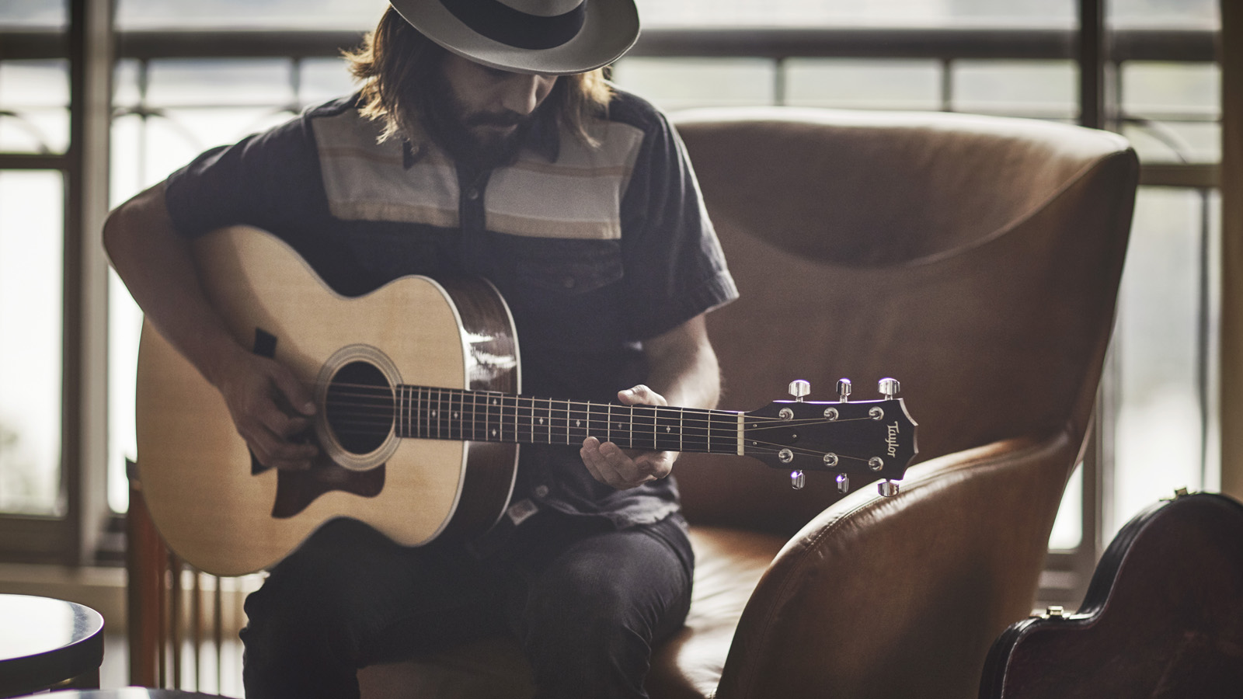
Known for its thriving music scene and reputation as the “Live Music Capital of the World,” Austin is the perfect stage for one of the most unique Four Seasons in-room amenities.
Thanks to a partnership with Taylor Guitars, music-loving guests can borrow premium guitars throughout their visit to strum, riff and dog ear to their heart’s content in the comfort of their guest room, on the scenic back lawn at
Four Seasons
Hotel Austin, or at another inspiring Austin locale.
For a truly one-of-a-kind experience – and souvenir – guests can also sign up for a one-on-one song writing session with a local musician who’s worked with the likes of Lyle Lovett and other Texas legends. Perched above picturesque Lady Bird Lake for inspiration, guests will get a crash course in musical composition and theory before penning their own take-home tune.

RELATED

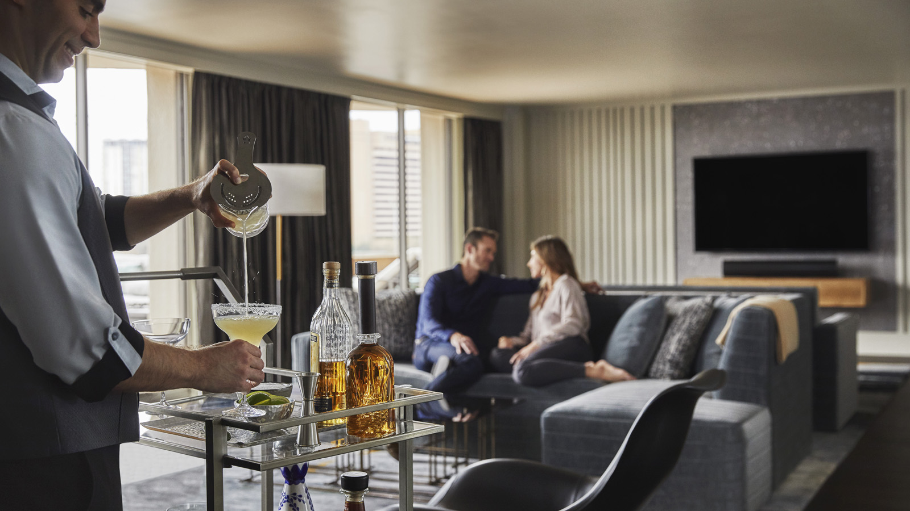 | March 6, 2018, Austin, U.S.A  On-Demand Margarita Cart Coming to Four Seasons Hotel Austin  https://publish.url/austin/hotel-news/2018/in-room-bar-service.html
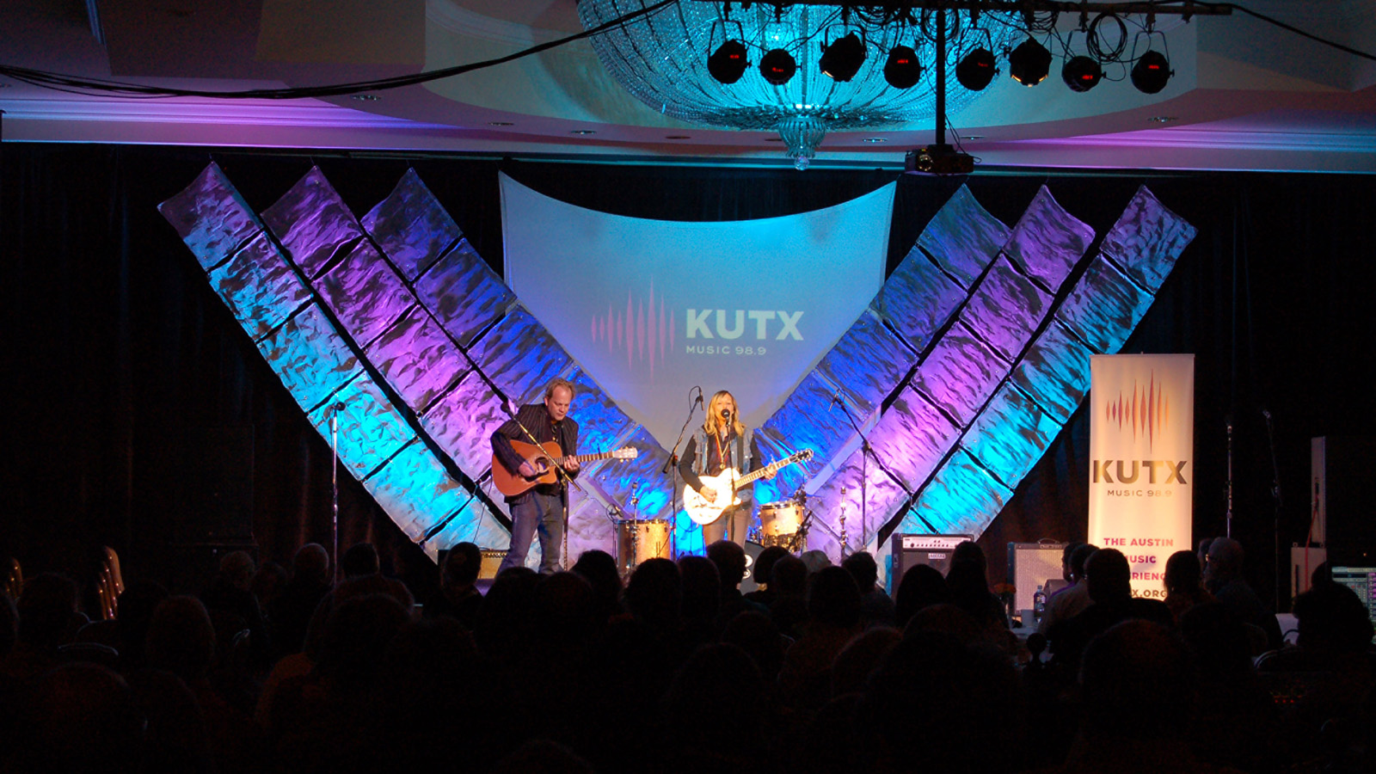 | February 21, 2018, Austin, U.S.A  South-by-Southwest Music Series Returns at Four Seasons Hotel Austin  https://publish.url/austin/hotel-news/2018/south-by-southwest-music-series.html

PRESS CONTACTS

Kerri Sholly
Senior Director of Public Relations - Americas
98 San Jacinto Boulevard
Austin
U.S.A.
kerri.sholly@fourseasons.com

1 (512) 685-8058

