Camp Manitou Features Hawaii Island-Inspired Programming and Family Experiences at Four Seasons Resort Hualalai

One of the nation’s foremost overnight camps for children partners with Five-Star, Five-Diamond Resort for exclusive activities and experiences
June 29, 2022, Hawaii, Hualalai, U.S.A.

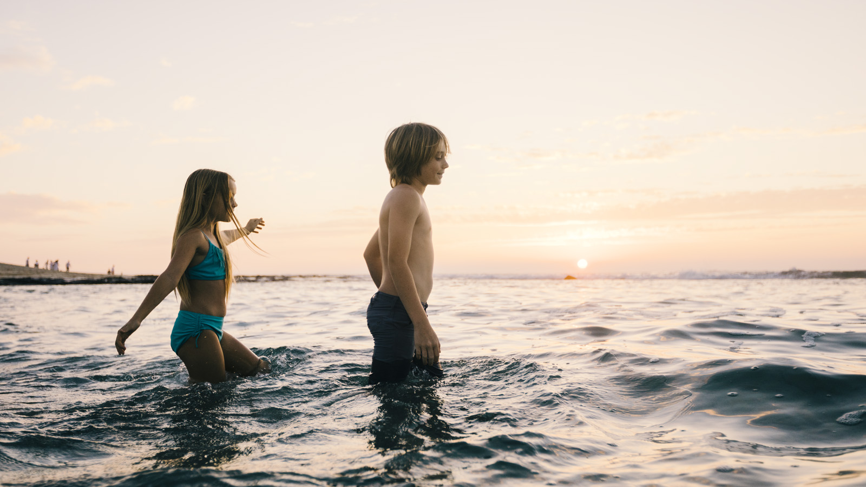 | 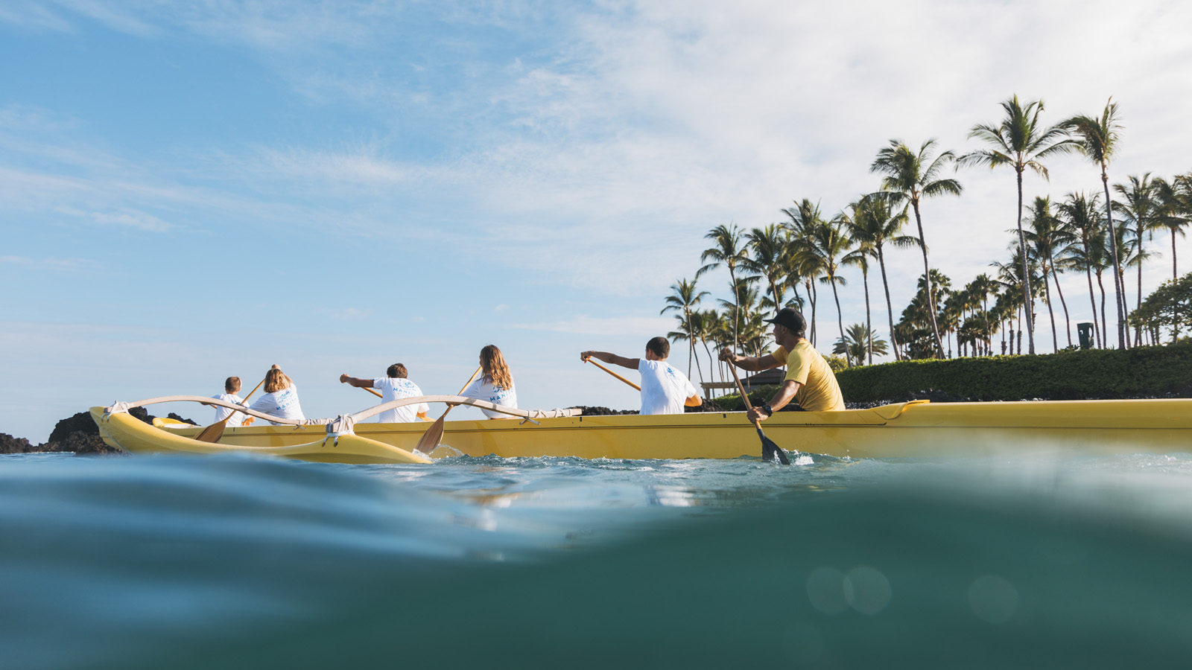 | 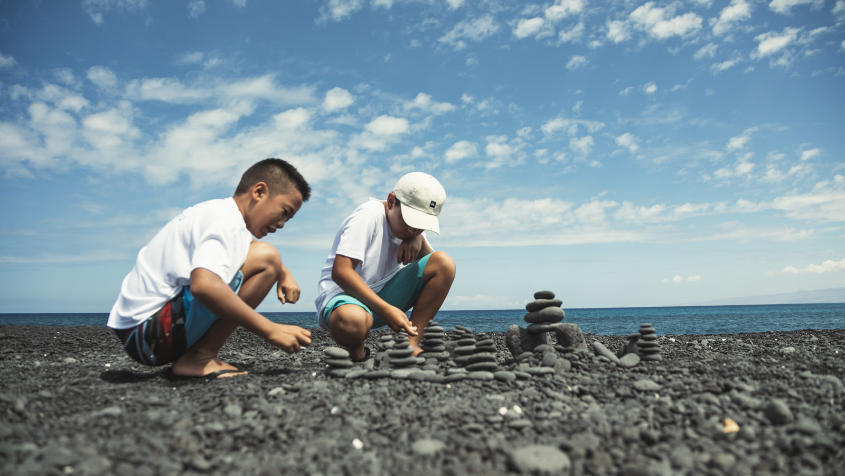
Camp Manitou at Four Seasons Resort Hualalai offers guests distinct activities and programs designed to connect children and families to the destination and each other. Camp Manitou, a well-known summer camp in Maine founded in 1947, hosts two camps for kids at the award-winning Resort during the summer, and festive seasons.
The all-inclusive experience for children ages 9 through 17 will feature the outstanding programs and staff Camp Manitou is known for, focusing on group bonding through an array of cultural, recreational, and explorative activities. Daily activities take campers to explore throughout the Resort and Hawaii Island, with single and multi-day programming. Memorable off-site activities include visiting secret beaches, exploring lava tubes and waterfalls, kayaking and snorkelling at Kealakekua Bay, and stargazing at Mauna Kea.
In addition to the keiki experiences, Camp Manitou at Four Seasons Resort Hualalai offers Family Day Adventures, a full day adventure created by the Camp Manitou team for the entire family. Each Family Day Adventure is private and full customized to the guest, with a unique itinerary for exploring magical Hawaii Island. From swimming in a lava tube in Kiholo Bay to hiking in the Pololu Valley, the day will be filled with the experiences that make an unforgettable vacation.
The Camp Manitou summer experience currently runs through August 21, 2022 costs USD 225 per child per day for the full day. Additional fees may apply for optional excursions. For more information, inquire about festive dates, or to make a reservation please visit click here or call 808 325 8000.

RELATED

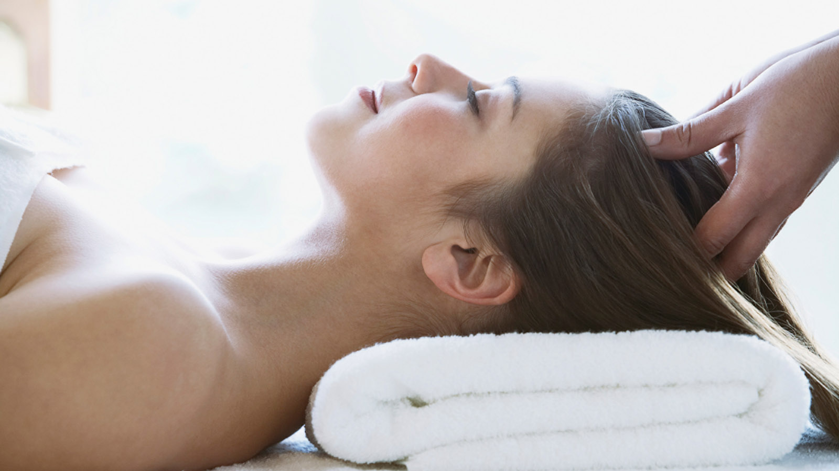 | June 27, 2022, Hawaii, Lanai, U.S.A.  Hawanawana Spa at Four Seasons Resort Lanai Introduces New Ayurvedic Treatments  https://publish.url/lanai/hotel-news/2022/new-ayurvedic-spa-treatments.html
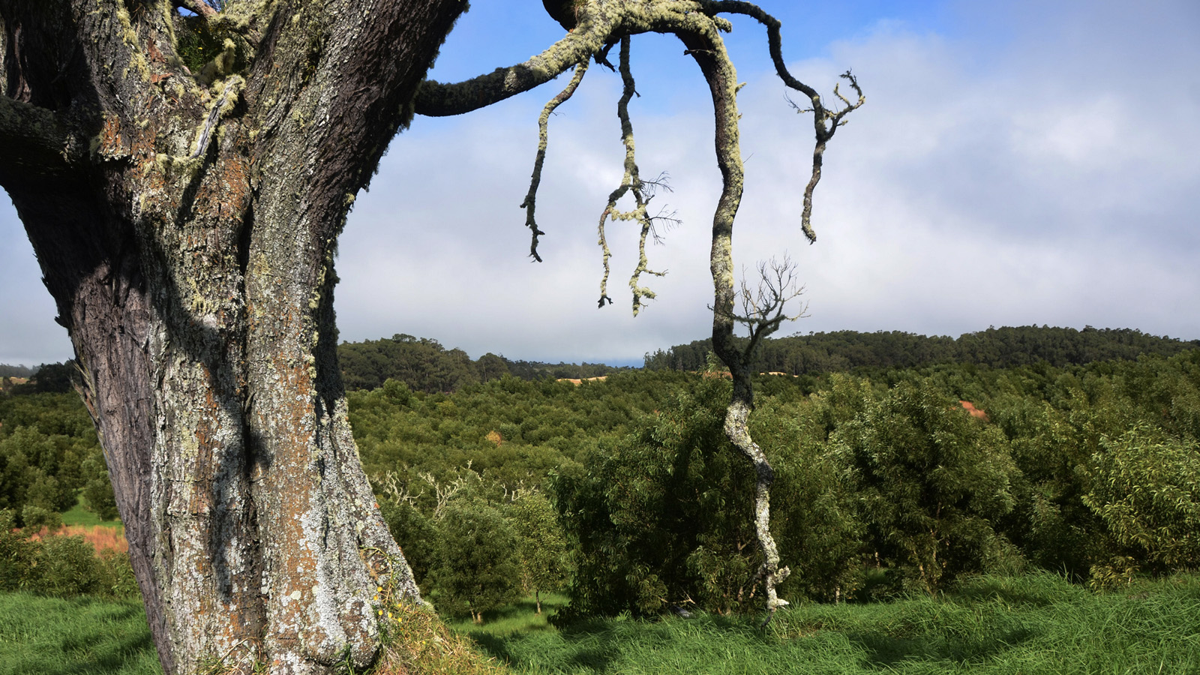 | June 21, 2022, Hawaii, Hualalai, U.S.A.  Four Seasons Resort Hualalai Plants 50,000th Legacy Tree on Hawaii Island  https://publish.url/hualalai/hotel-news/2022/legacy-forest-50000-trees-planted.html

PRESS CONTACTS

Morgan Suzuki
Regional Director of Public Relations and Communications
72-100 Ka'upulehu Drive
Kailua Kona
USA
morgan.suzuki@fourseasons.com

1 808 557 5909

