The Spa at Four Seasons Hotel Seattle Sparkles with Diamond Anniversary Specials

Trio of treatments celebrate the 10-year anniversary of the Spa and Hotel
November 1, 2018, Seattle, U.S.A.

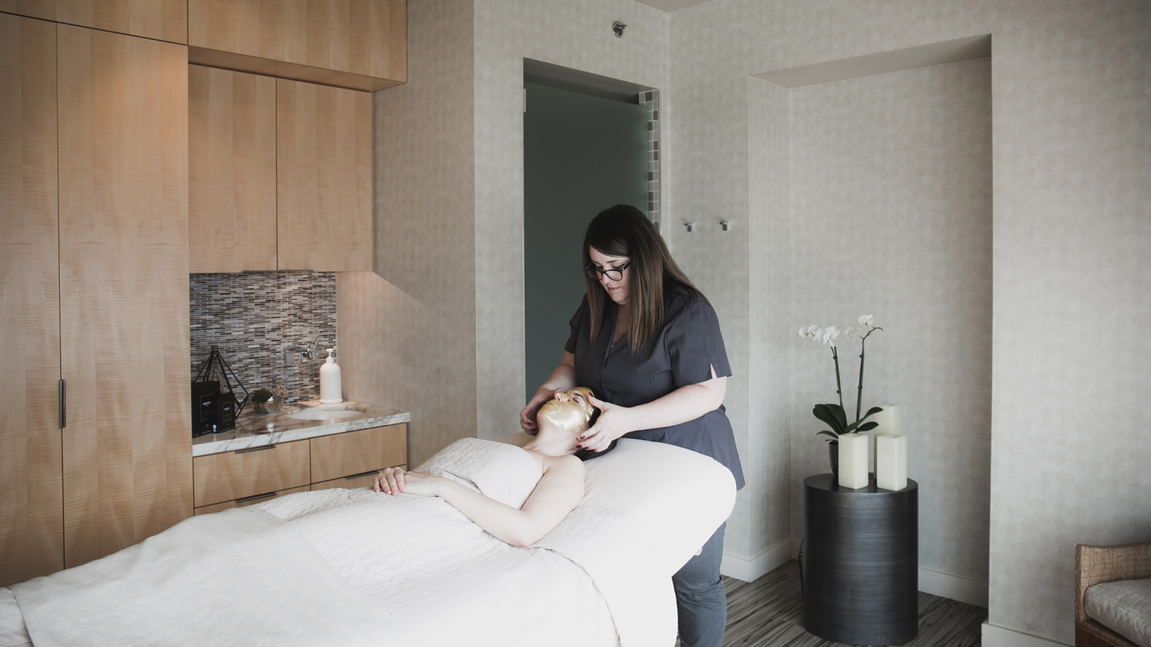
The Spa at Four Seasons Hotel Seattle launches three special treatments in celebration of its 10-year anniversary. Available now through December 30, 2018, they highlight the 10-year anniversary gemstone, diamonds, harnessing its healing properties.
“The Hotel and Spa’s anniversary are on November 3, 2018, and these treatments are a combination of The Spa’s most luxurious treatments, enhancing natural beauty through the power of diamonds,” says Trina Wood, Director of Spa at The Spa at Four Seasons Hotel Seattle.
Just like no two diamonds can ever be the same, the Diamond Package is unique to The Spa featuring the Diamond Anniversary Facial, the River Rock Massage and the Lux Manicure and Pedicure. With head-to-toe relaxation and the latest in skin- and body care technology these treatments offer the total spa experience with results addressing anti-ageing and day-to-day stresses to our bodies and minds.
Focusing on decades of experience from the Spa team, the Ultimate Unwind Diamond Body Treatment showcases the craftsmanship and knowledge the therapists bring to each treatment. The body is prepped with a dry brushing to increase circulation, and to help aid in the elimination of toxins. Next, a refining body scrub is applied to polish the skin to perfection and prepare it to receive a decadent shea butter hydration.
“My favourite part is when the body is cocooned in a warm wrap while the therapist focuses on the feet and scalp, and the eyes are treated to a luxurious diamond eye mask upgrade,” continues Wood. “As guests emerge from the cocoon, they enjoy a relaxing massage utilising illuminating finishing cream.”
The Spa at Four Seasons Hotel Seattle is the only Forbes Travel Guide Four-Star spa in the state and features eight treatment rooms. Guests are pampered with all the extra luxuries, from the Relaxation Lounge and Couple’s Suite with views of Elliott Bay, to the eucalyptus steam and sleek changing rooms.
Of the 36 employees who are celebrating their 10-year anniversary with Four Seasons Hotel Seattle, two are in the Spa.
“My favourite part about the Hotel is that it's like a sanctuary and a scene, all at the same time. You can look out at the infinity pool deck and you have beautiful nature and the water, and then you can turn around and it's the bustling city. I think that's really unique for this property and for our location,” says Megan Perry, a Spa therapist who has been with The Spa since opening in 2008. “I’m really excited about the Diamond Anniversary Facial, as it’s a treatment I helped create.”
The Diamond Anniversary Facial begins with a tailored deep exfoliation and ultimate oxygen hydration, finishing with a transformative Diamond Mask. The diamonds deliver unprecedented luminosity and encourage deep skin replenishment.
“I help people all the time for weddings and events, or birthdays and celebrations, and what I feel is the most fulfilling part of my job is that I can help make people feel good,” says Perry. “Even if it's just an hour out of their day, they just feel so great. It's the little things that make them feel amazing that I feel good about.”
Treatments are bookable by calling The Spa at +1 206 749 7000.

RELATED

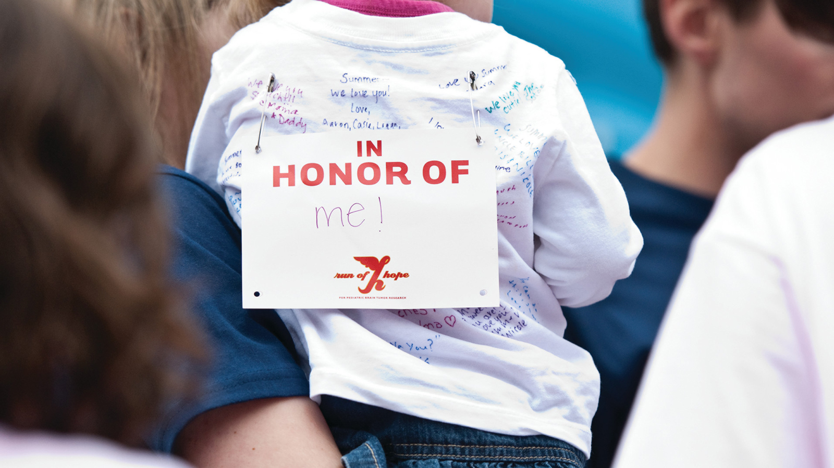 | September 7, 2018, Seattle, U.S.A.  Run of Hope Seattle Impacts Seattle Pediatric Brain Cancer Community  https://publish.url/seattle/hotel-news/2018/run-of-hope.html
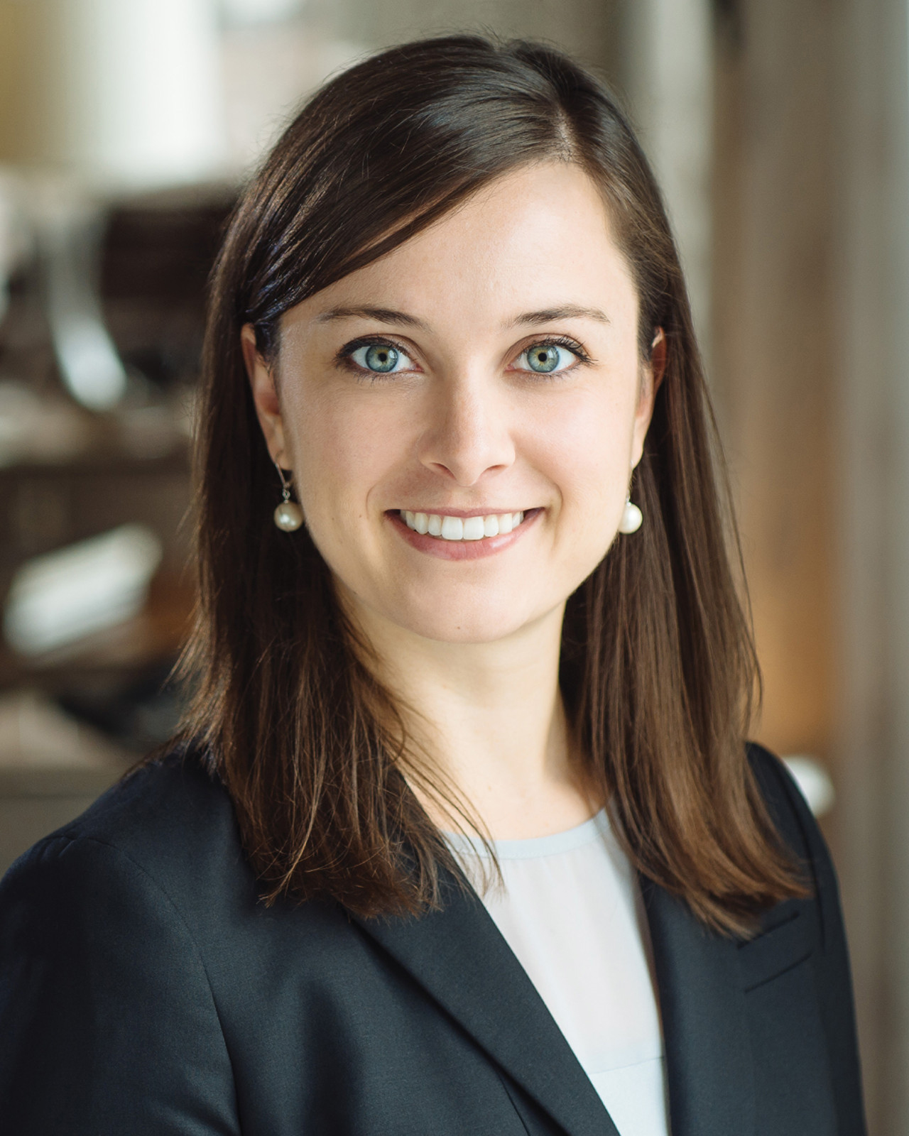 | July 16, 2018, Seattle, U.S.A.  Four Seasons Hotel Seattle Announces New Director of Marketing  https://publish.url/seattle/hotel-news/2018/new-director-of-marketing-tori-boos.html

PRESS CONTACTS

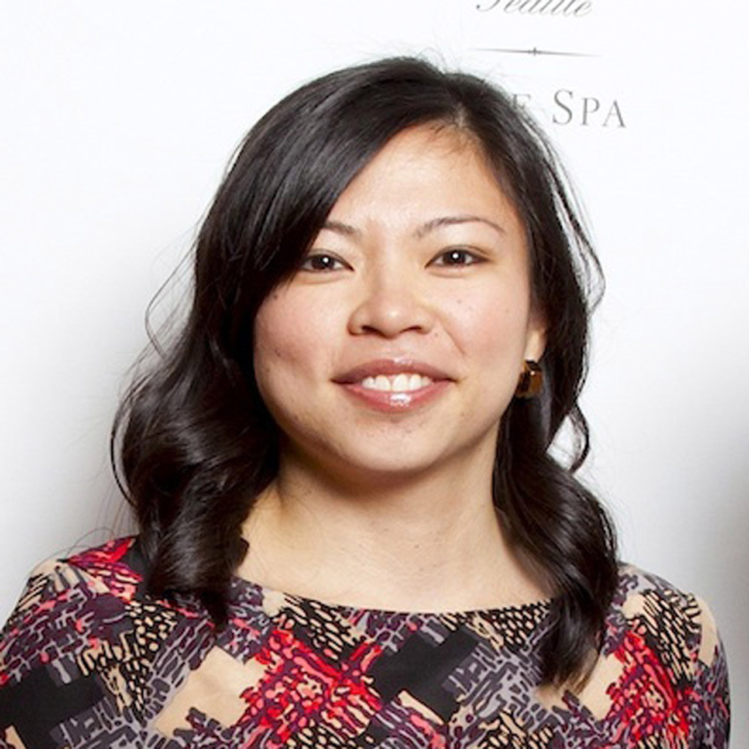 | Meg Paynor  PR Consultant  99 Union Street  Seattle  U.S.A.  meg@paynorpr.com  1 (206) 913-3848
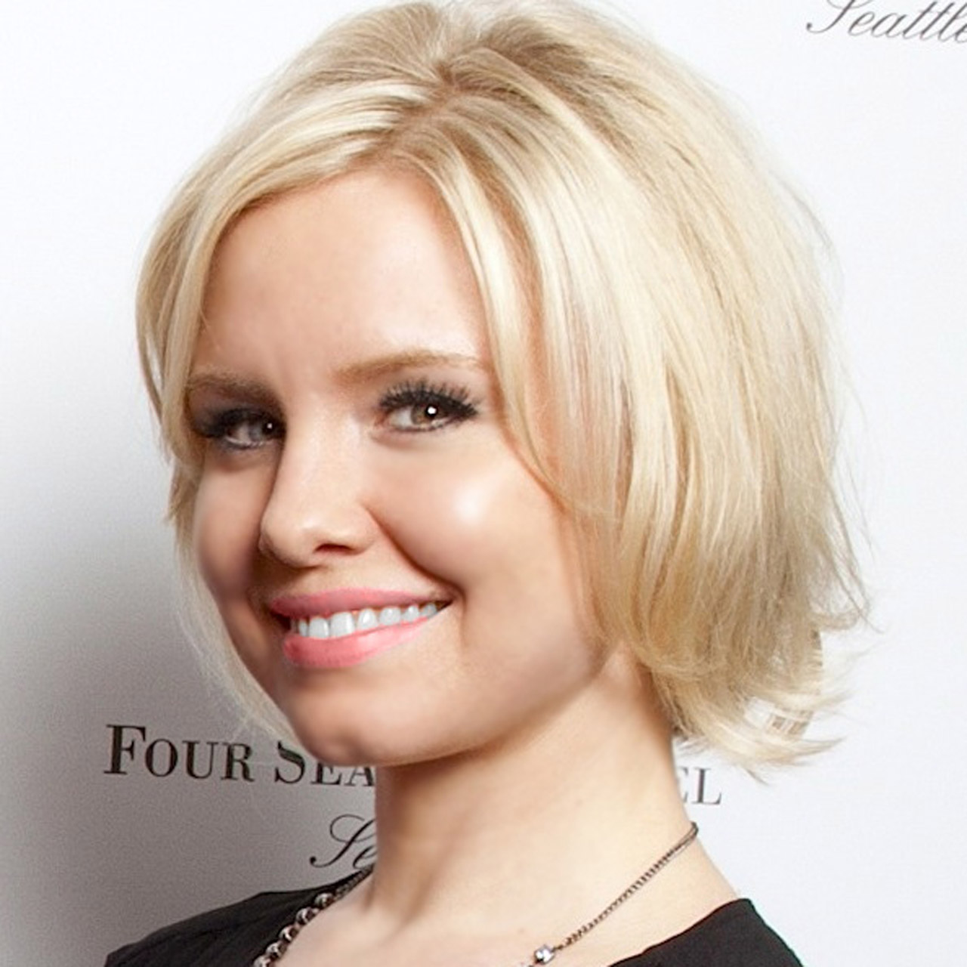 | Crystal Southcote  Digital Media Manager  99 Union Street  Seattle  U.S.A.  crystal.southcote@fourseasons.com  +1 (206) 749-3909

