Toast to the Holiday Season at Four Seasons Hotel Philadelphia at Comcast Center

December 18, 2019, Philadelphia, U.S.A.

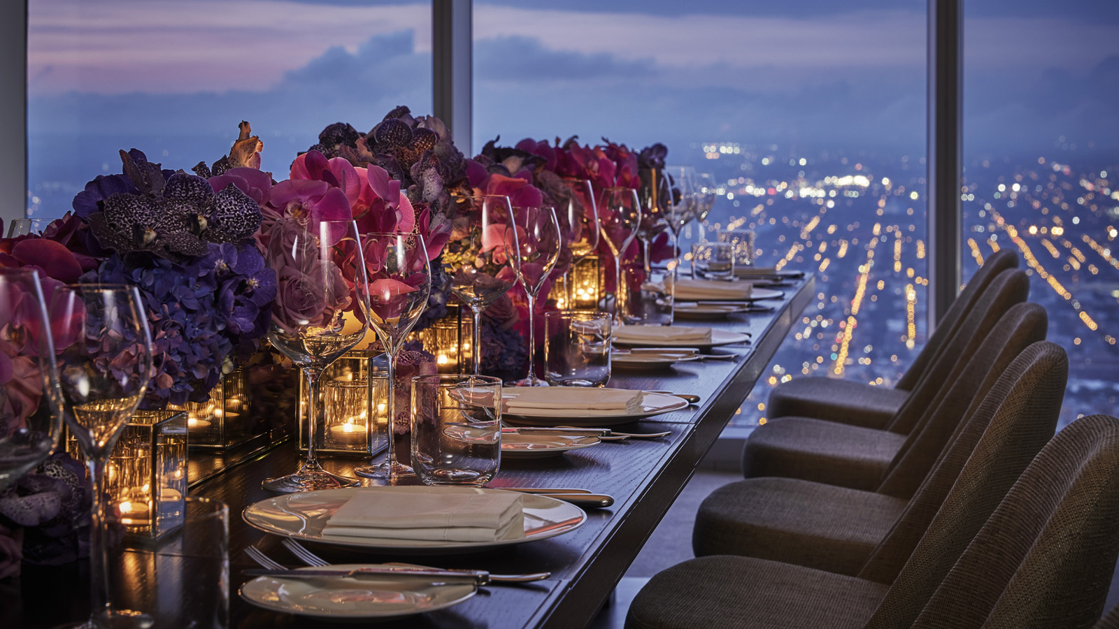
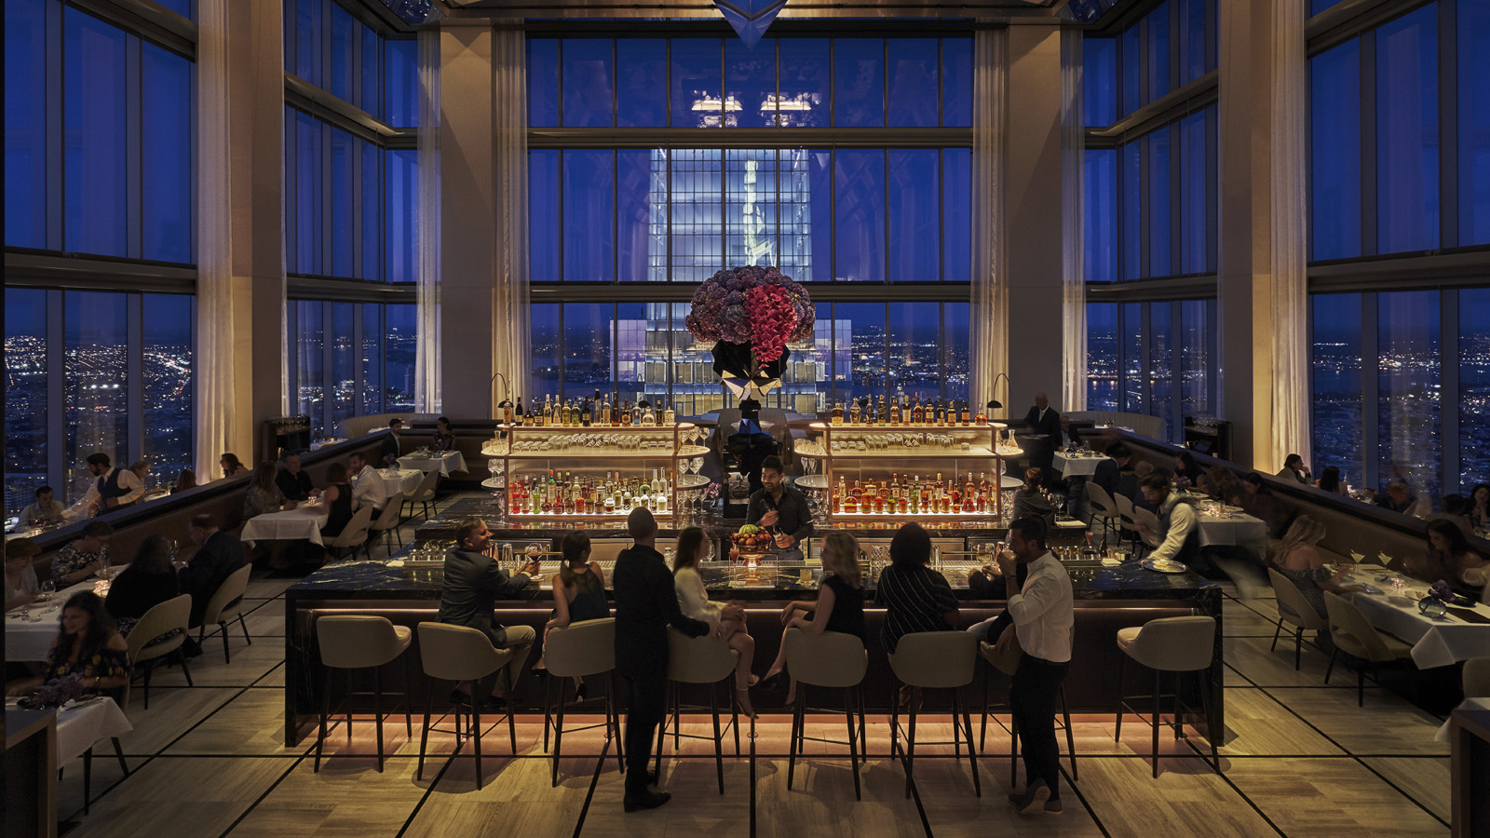 | 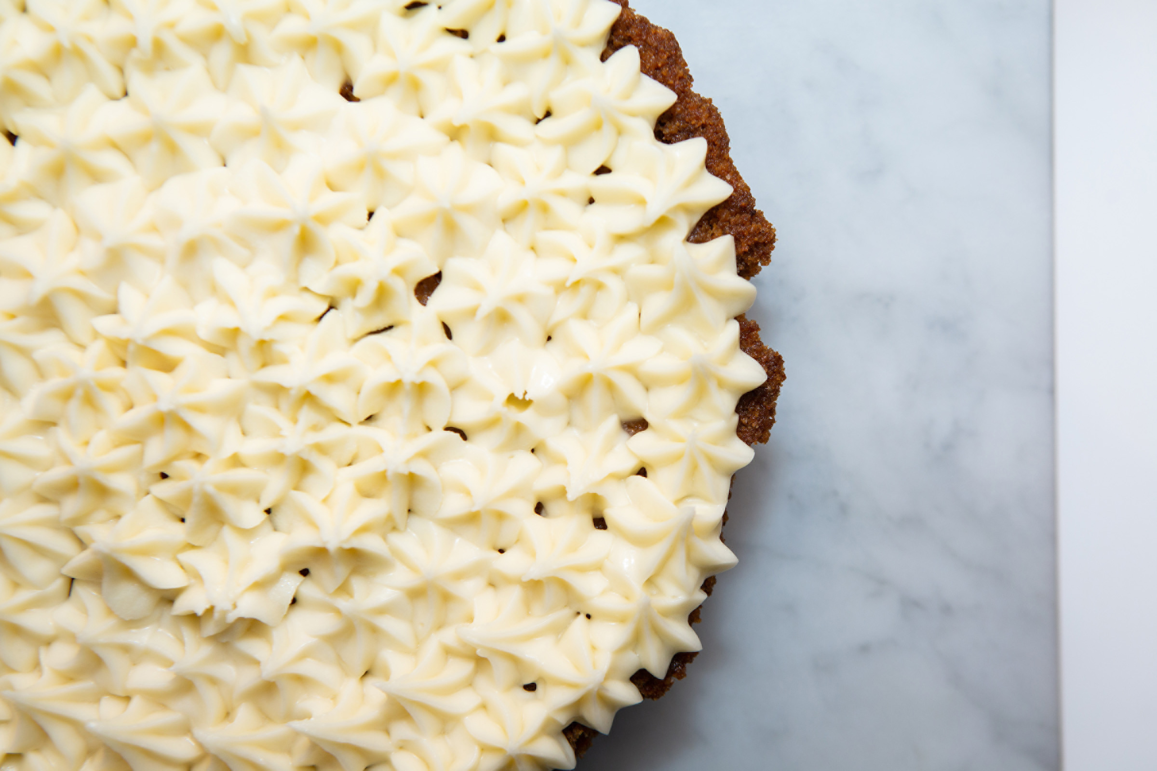
Create new holiday traditions at Four Seasons Hotel Philadelphia at Comcast Center.
Guests are invited to enjoy festive décor from world-renowned Artistic Director Jeff Leatham and a variety of dining experiences from James Beard Award-winning Chef Greg Vernick and Michelin-starred Chef Jean-Georges Vongerichten.
Experience the holidays from new heights and toast to 2020 with a series of limited programming, menus and offerings fit for the whole family.
The Holidays, Jeff Leatham Style
Four Seasons Hotel Philadelphia has transformed into a festive holiday oasis thanks to the magic of the Jeff Leatham team. The floral journey begins in the lower lobby with a mirrored reindeer display and continues 60 stories above in the Sky Lobby with an immersive display that includes Christmas tree, blooming florals, and a trail of baby’s breath trees.
Weekly Music
Guests looking to get into the holiday spirit can set their sights on JG SkyHigh, soaring 60 stories above the clouds. Every Wednesday night, dazzling performances by way of live jazz can be enjoyed with signature cocktails and casual Jean-Georges cuisine, including the Ginger Margarita and wagyu cheesesteak spring rolls. DJ sets curated by Bellosound pair perfectly with the sky-high views on Friday and Saturday evenings.
Christmas Tasting Menu
For those looking to create lasting family memories, Four Seasons Hotel Philadelphia at Comcast Center invites everyone to experience an elevated Christmas Tasting Menu on December 24 and 25 2019, a seven-course extravaganza courtesy of Jean-Georges Philadelphia. Begin with ossetra caviar followed by slivers of yellowfin tuna, risotto with peekytoe crab, crispy skin black sea bass, Maine lobster and more. Be sure to save room for one of the delectable desserts crafted by the pastry team. Dinner is served between 5:30 and 10:00 pm.
New Year’s Dinner
Toast to a new decade with a New Year’s dinner to remember at Jean-Georges Philadelphia. Elevating Philadelphia’s culinary scene, Michelin-starred chef Vongerichten presents a 59th-floor destination. On this special occasion, an indulgent five-course dining experience will be presented alongside sweeping views of fireworks over the Delaware River.
Vernick Fish will also be offering dinner reservations to ring in the New Year featuring the full a la carte menu as well as special holiday additions. The evening will continue with live music in the restaurant lounge and a toast will be poured for the countdown at midnight.
New Year’s Party
Ring in the New Year atop Philadelphia’s tallest tower! This New Year's Eve Experience will highlight five of Jean-Georges' favourite bites, including caviar, scallops, truffles and a sparkling toast at midnight. Personalise the evening and pre-order a favourite bottle of bubbly or wine.
Live jazz can be enjoyed from 9:00 to 11:00 pm followed by a DJ performance that will carry the party into the New Year, from 11:00 pm to 2:00 am.
For the Family
Take a trip to the lower lobby for access to the Comcast Center Campus where families can find the perfect gift in the marketplace, live performances, and other activities including:
The Holiday Spectacular - A must-see holiday tradition in Philadelphia
- Through January 1, 2020
- 10:00 am – 8:00 pm - top of every hour (the show is not presented on weekdays at 5:00 pm)
Visits with Santa - Share a holiday wish list or request with St. Nick
- Saturdays and Sundays
- 11:00 am – 4:00 pm
For the Table
Vernick Coffee Bar serves up a menu of expertly prepared dishes and in-house baked goods all with high impact, global flavour combinations. Bring a taste of Four Seasons home for the holidays and pre-order holiday-inspired offerings including: bûche de Noël, carrot cake pie, gingerbread cookies, and panettone. Orders can be placed by calling the café at 215 419 5052, or by visiting in person. Subject to availability.

RELATED

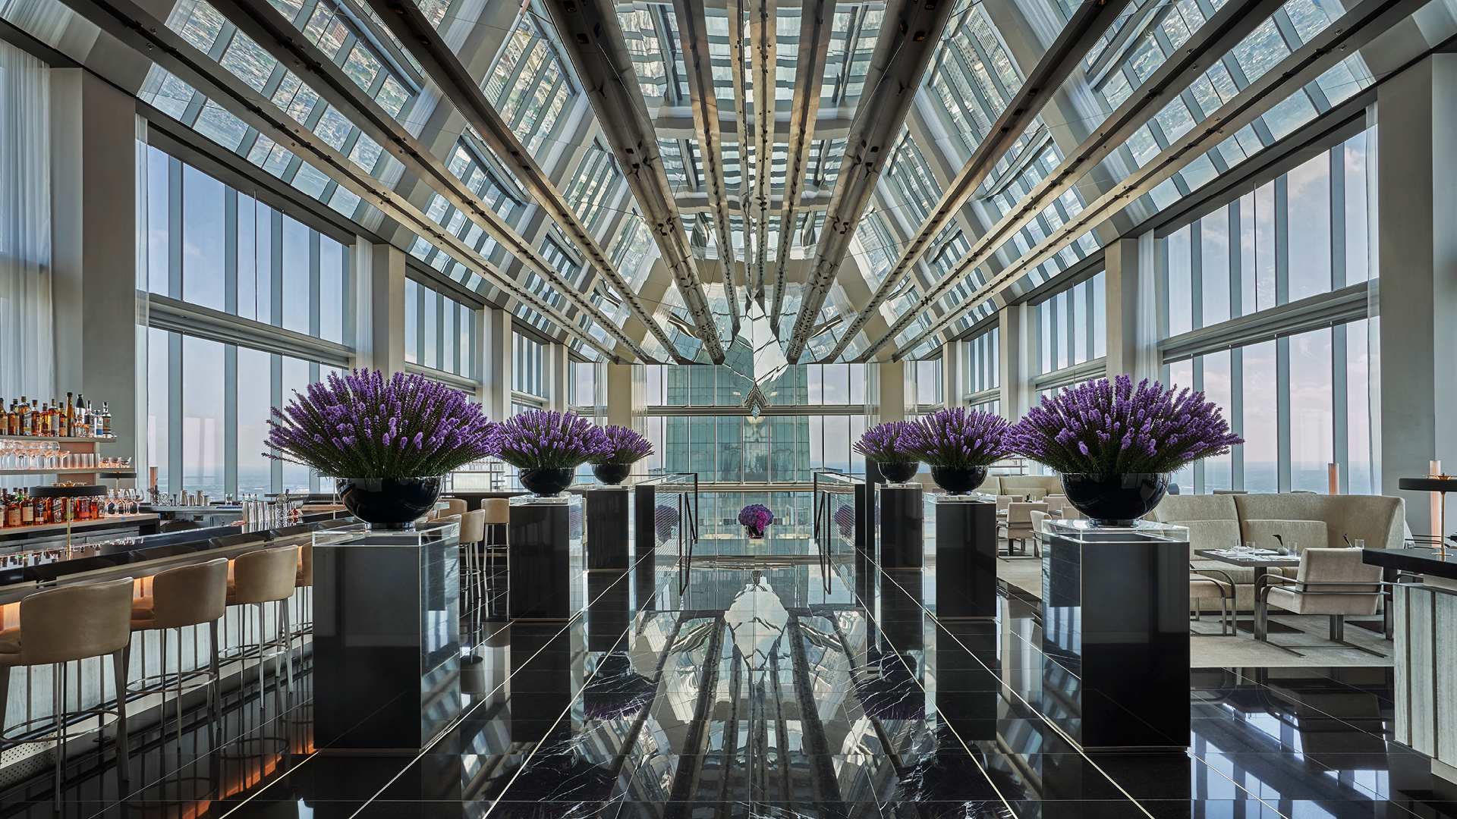 | August 12, 2019, Philadelphia, U.S.A.  فورسيزونز تفتتح أعلى فندق في أمريكا الشمالية في برج كومكاست سنتر بفيلادلفيا  https://publish.url/ar/philadelphia/hotel-news/2019/now-open-4.html
August 12, 2019, Philadelphia, U.S.A.
Bem-vindo ao futuro: o novo Four Seasons Hotel at Comcast Center abre as portas no prédio mais alto da Filadélfia
https://publish.url/br/philadelphia/hotel-news/2019/now-open-2.html

PRESS CONTACTS

Melissa Quinones
Director of Public Relations
One North 19 Street
Philadelphia
U.S.A.
melissa.quinones@fourseasons.com

+1 (215) 419-5033

