Four Seasons Hotel New York Recognised with Prestigious Forbes Travel Guide 2021 Five-Star Award

Four Seasons Hotel New York earns Forbes Travel Guide’s annual Five-Star designation for the 28th consecutive year
September 4, 2020, New York, U.S.A.

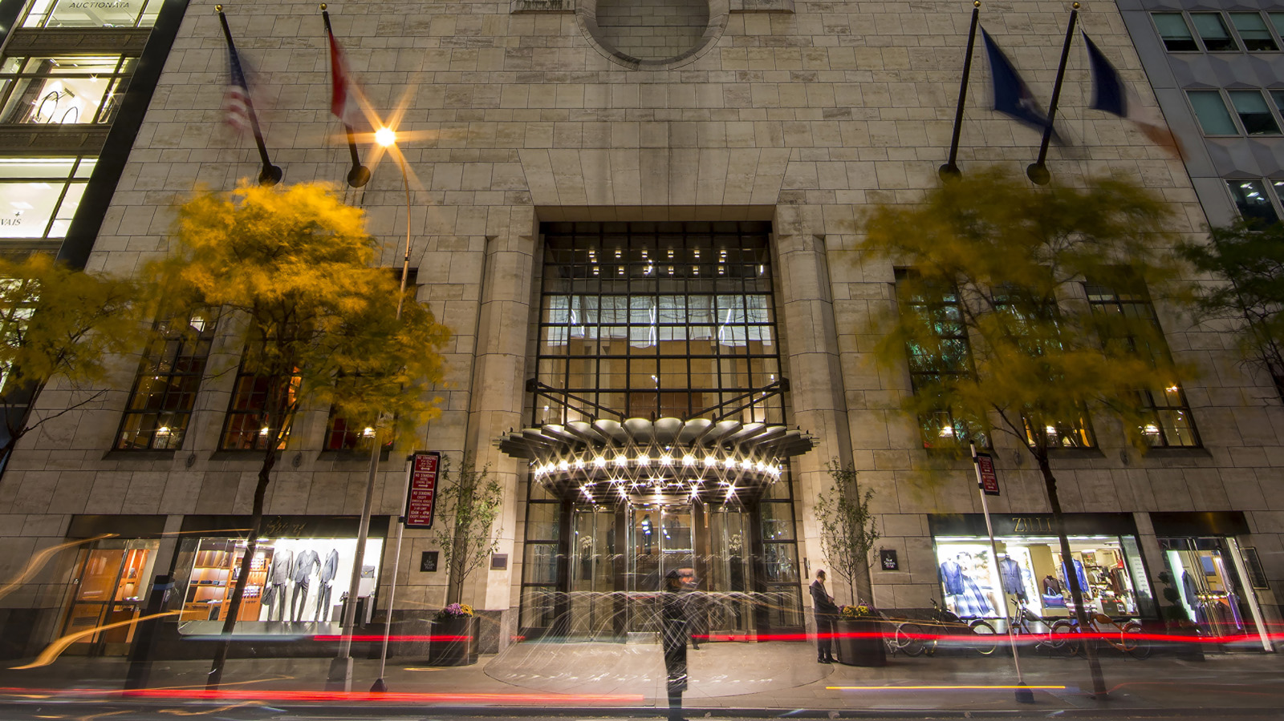
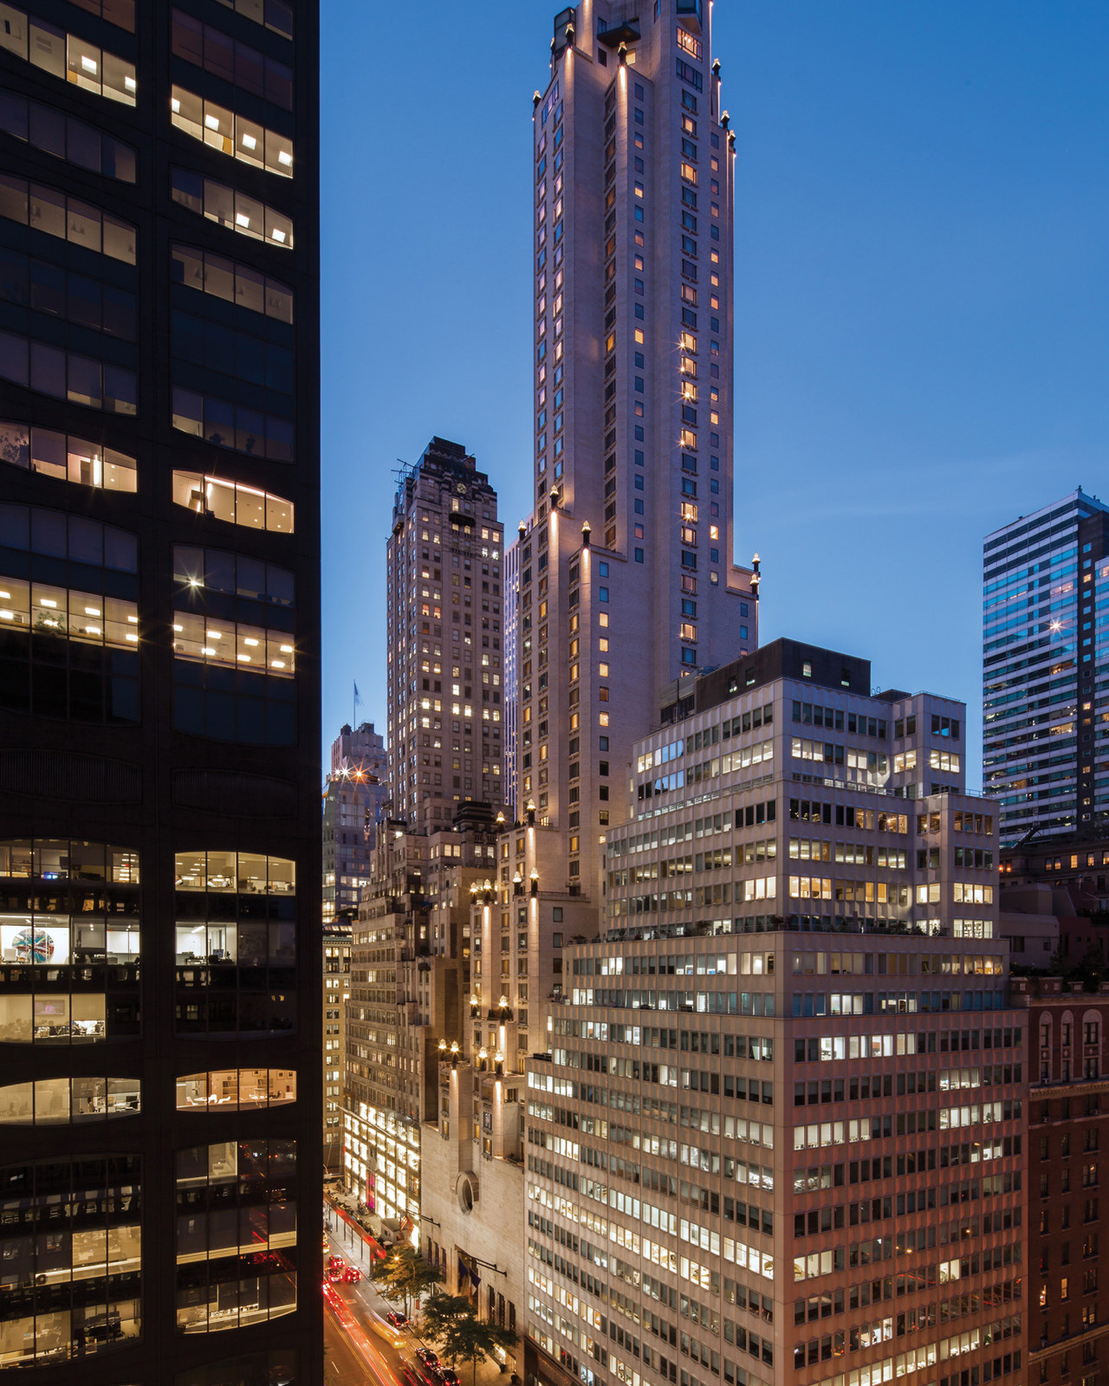 | 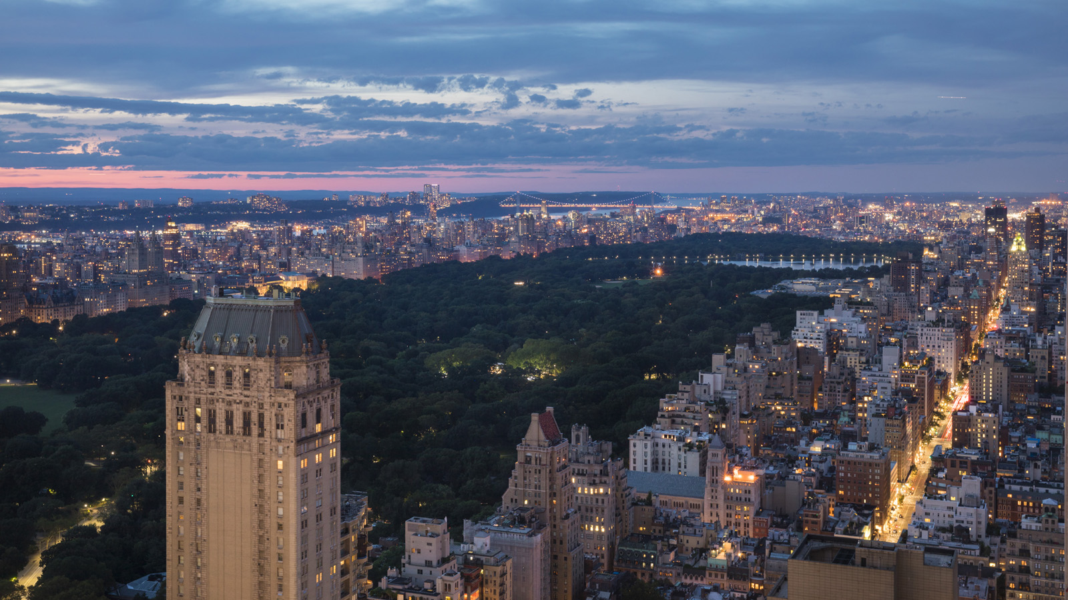 | 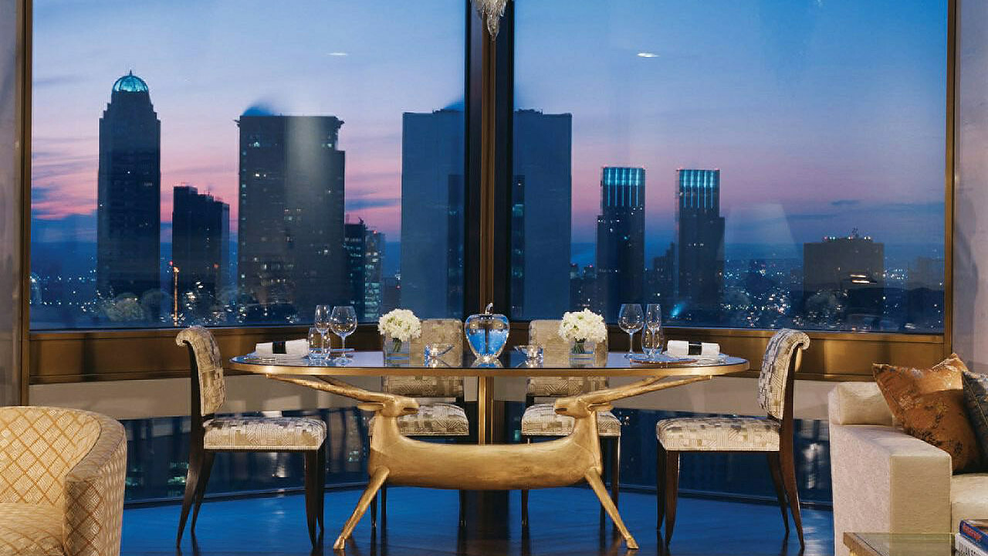
Four Seasons Hotel New York has been recognised by the world-renowned Forbes Travel Guide, the only global rating system for luxury hotels, restaurants, and spas, with a prestigious 2021 Five-Star Hotel Award, marking the 28th consecutive year the Hotel has been honoured with this designation.
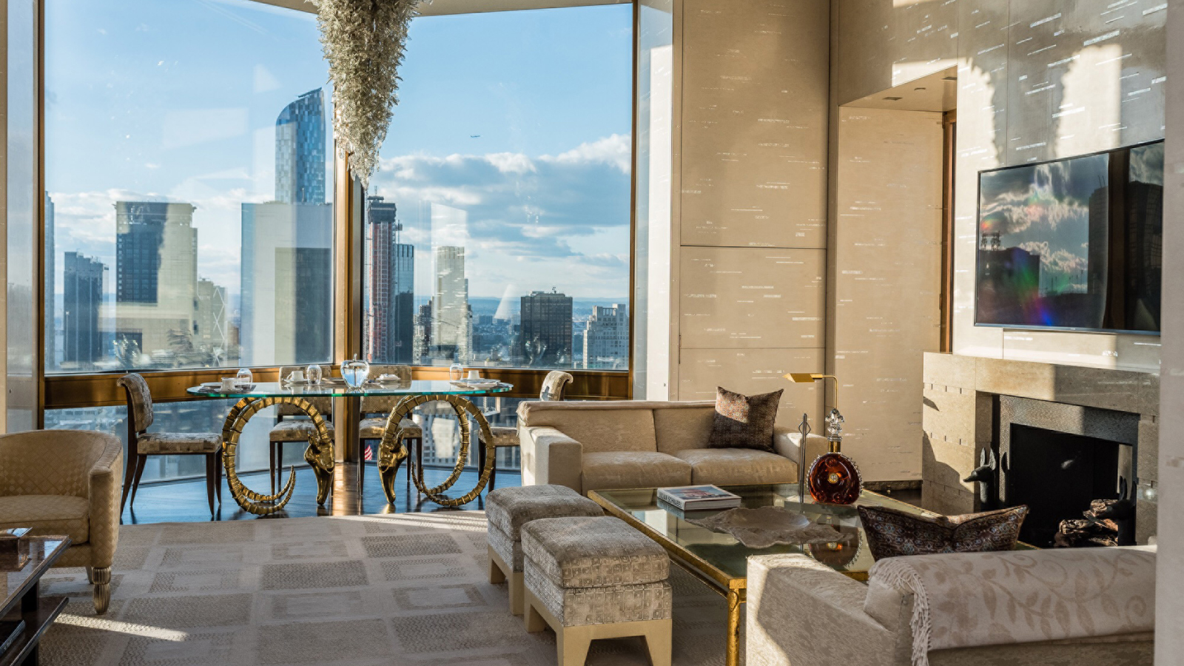 | 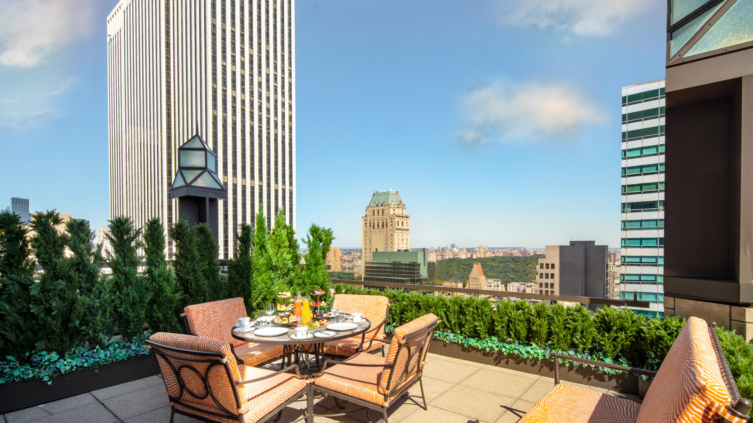
“We are humbled to receive this honour again,” says Rudy Tauscher, General Manager of Four Seasons Hotel New York. “Forbes Travel Guide is the global expert on genuine Five-Star service, and this award is truly a testament to our team members and their steadfast commitment to service that exceeds excellence for Four Seasons Hotel New York guests.”
Located just steps from Central Park in the vibrant heart of Midtown Manhattan, the illustrious I.M. Pei-designed Four Seasons Hotel New York is one of the most iconic hotels in the world. A beacon of luxury just steps from the world-leading businesses and high-end boutiques of Fifth and Madison Avenues, the landmark Four Seasons Hotel New York is a glamorous art deco oasis with its soaring architecture, elite concierge team, and 368 unparalleled luxury suites and studios, including the spectacular Ty Warner Penthouse, the world’s most expensive one-bedroom suite, priced at USD 50,000 per night. The Hotel is also home to The Garden, a restaurant with a locally-sourced menu; and Ty Bar, an art-deco cocktail lounge overlooking the Hotel’s grand lobby. The Hotel also features a 24-hour fitness centre, award-winning L.RAPHAEL Beauty Spa and more than 15,000 square feet (1,400 square metres) of event space, including FIFTY7, a premier wedding venue designed by Pierre-Yves Rochon.
While the Hotel remains temporarily closed, it looks forward to welcoming employees and guests upon reopening, and delivering an unmatched level of intuitive service, bespoke experiences, and luxury accommodations through the Four Seasons enhanced health and safety program, Lead With Care.

RELATED

June 7, 2022, Toronto, Canada
四季酒店推出“风光之路”旅行路线，欧洲慢行生活全新启程
https://publish.url/news-releases/2022/scenic-routes-in-europe-3.html

June 7, 2022, Toronto, Canada
Four Seasons apresenta Rota Cênica pela Europa com experiências exclusivas e inéditas em oito hotéis
https://publish.url/news-releases/2022/scenic-routes-in-europe-2.html

PRESS CONTACTS

Four Seasons Press Room

prsm@fourseasons.com

