Four Seasons Leads Asia’s 50 Best Bars 2022 List with Five Ranked Bars Plus Four Special Awards of Distinction

Keith Motsi named Altos Bartenders’ Bartender Award 2022; Bar Trigona wins Siete Misterios Best Cocktail Menu Award; newcomers to the list BKK Social Club and ARGO earn the Michter’s Art of Hospitality Award and Disaronno Highest New Entry Award respectively
April 28, 2022, Bangkok, Thailand

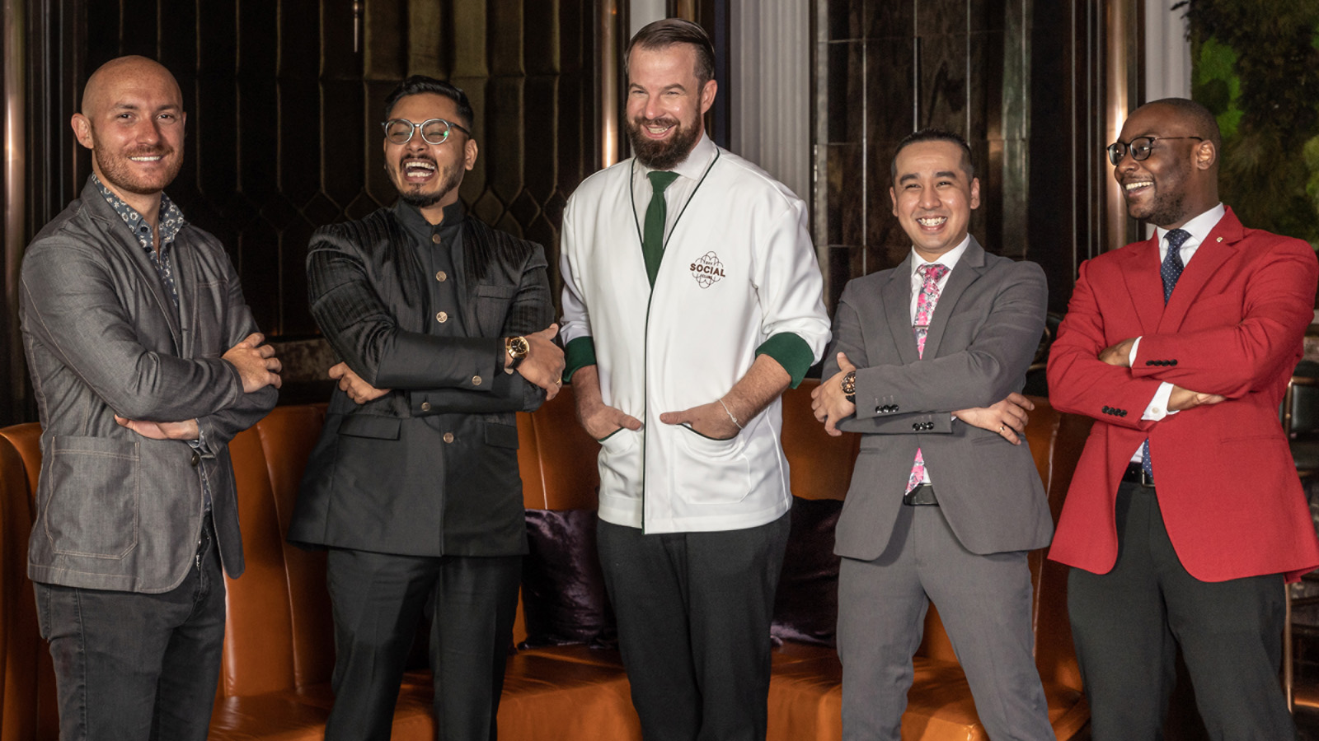
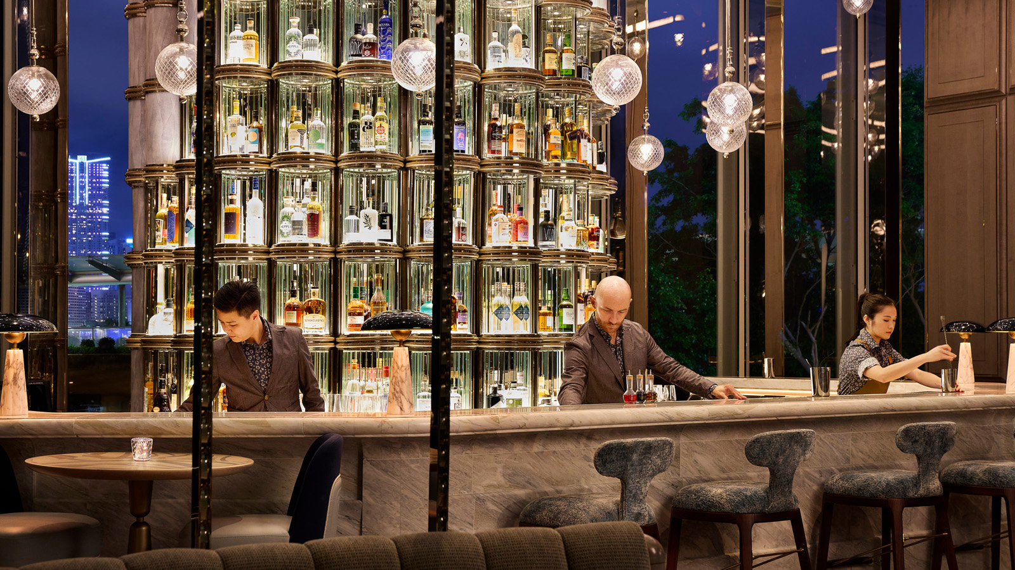 | 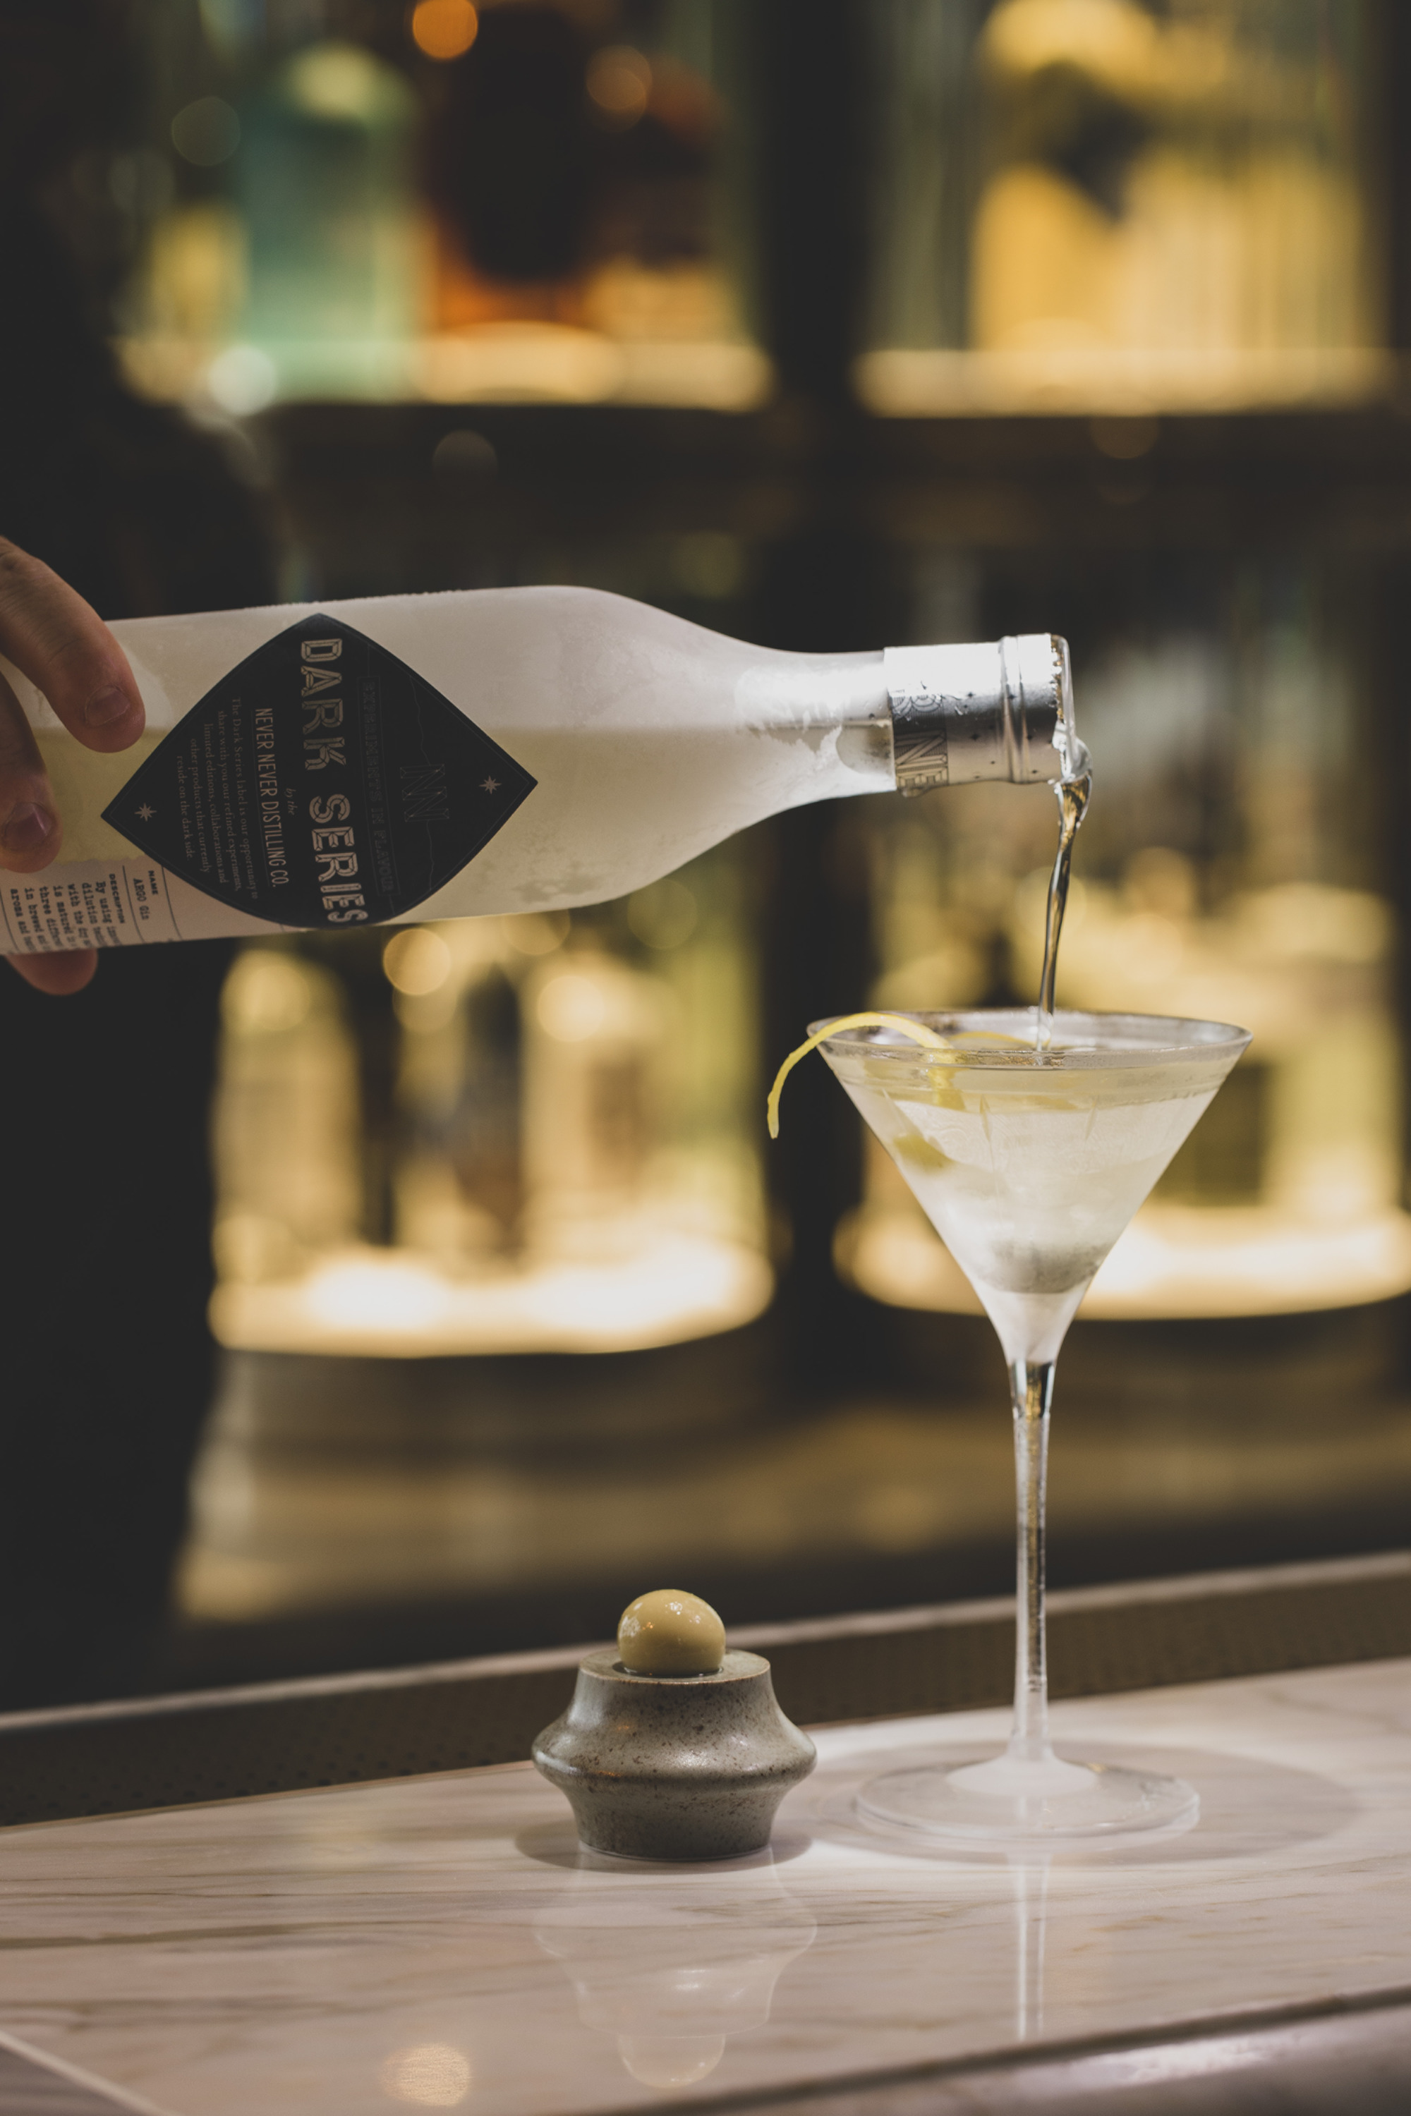 | 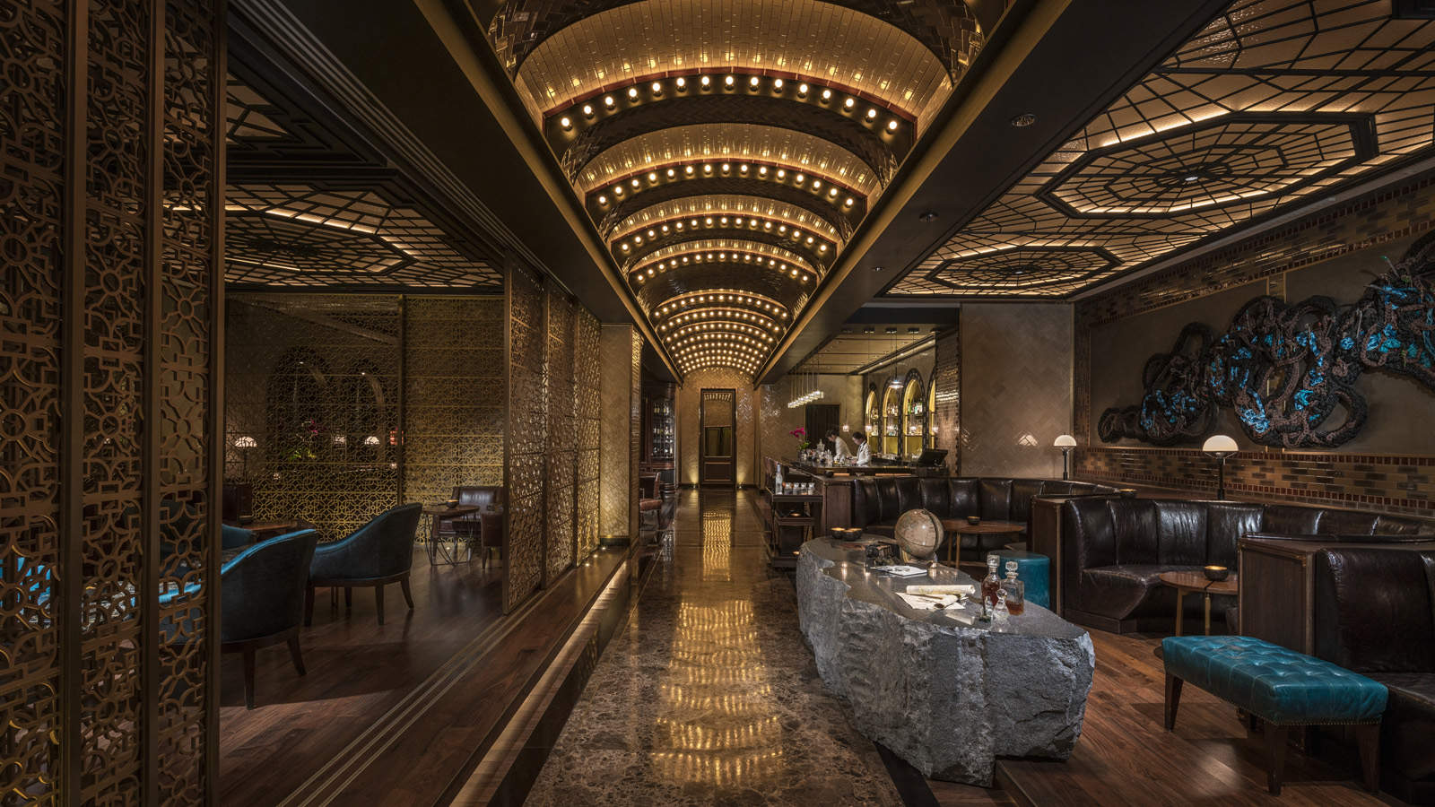
Five bars across Four Seasons portfolio have earned placement among the finest drinking establishments in the world as ranked by Asia’s Best Bars Academy. Announced on April 28, 2022 in Bangkok, the prestigious Asia’s 50 Best Bars list includes two perennial favourites, and three establishments making their debut on the list: ARGO at #3, Charles H. at #7, BKK Social Club at #10, Bar Trigona at #29 and Copitas at #44.
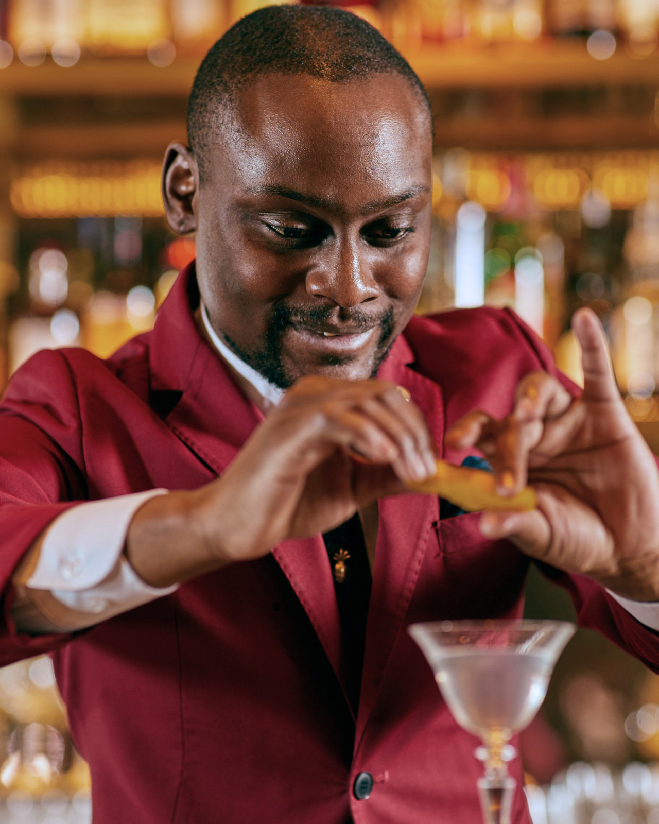 | 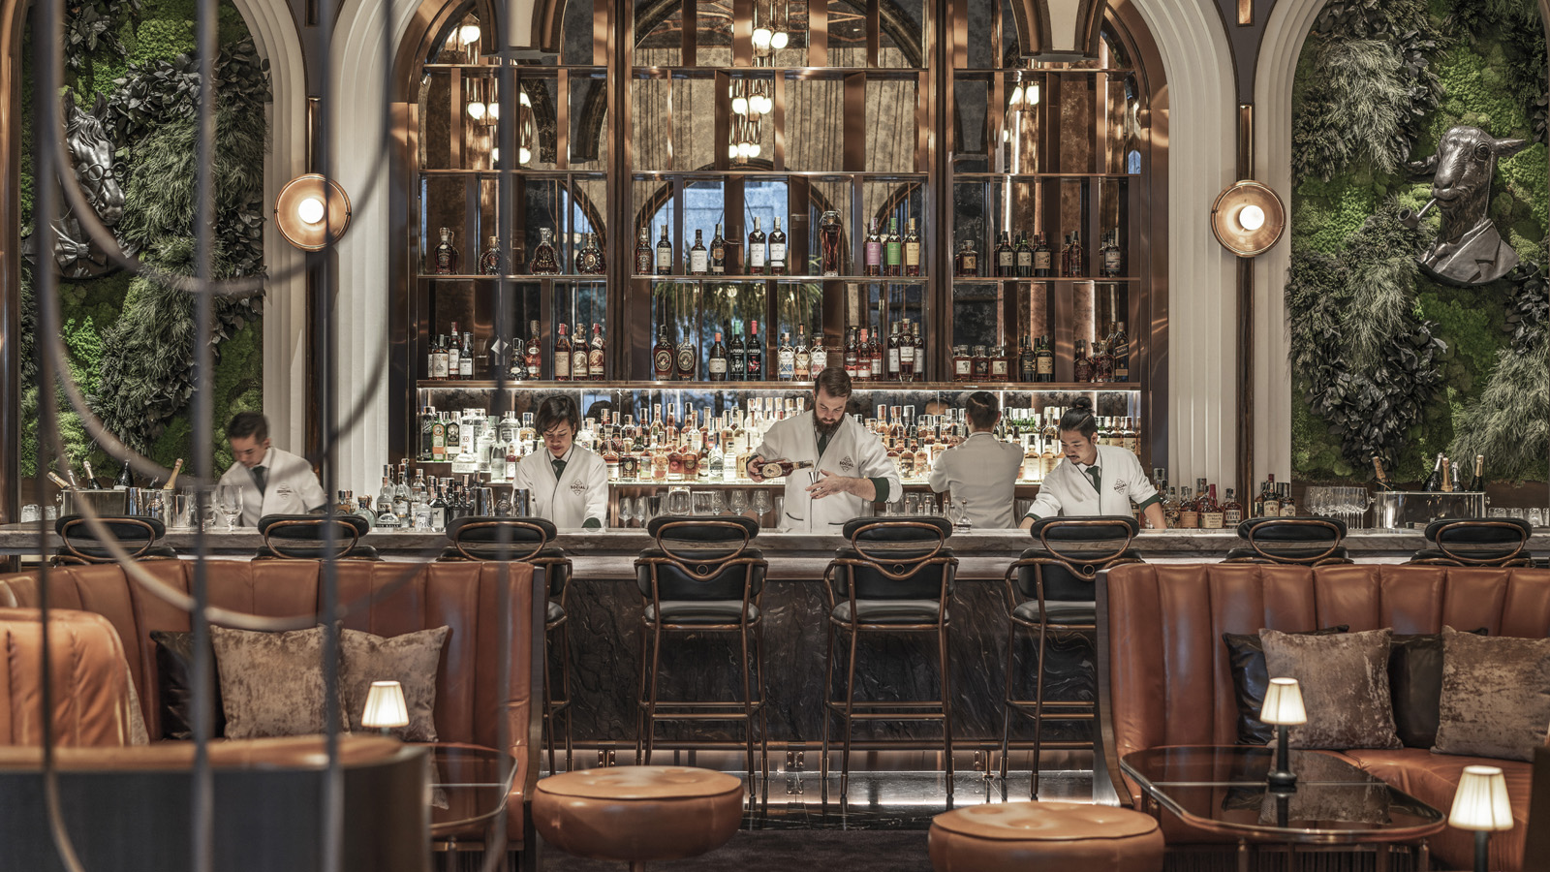 | 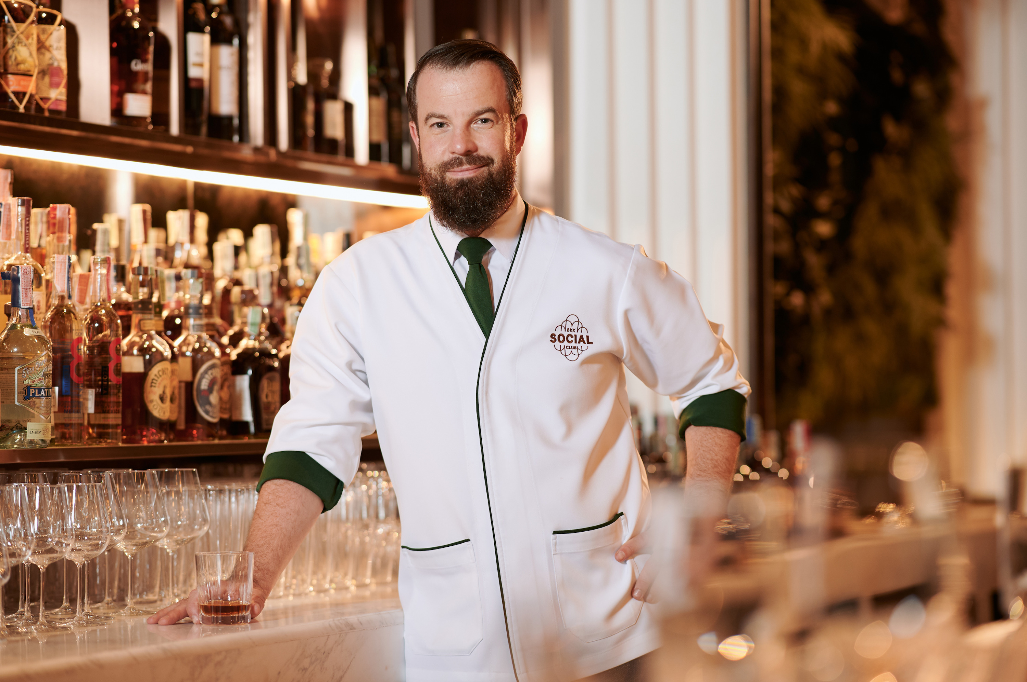
In addition, the Asia’s Best Bars Academy has bestowed four very special awards: BKK Social Club has been further distinguished in its first year on the list with the Michter’s Art of Hospitality Award 2022; ARGO, also in its first year, won the Disaronno Highest New Entry Award; Bar Trigona received the Siete Misterios Best Cocktail Menu Award; and Keith Motsi, who leads the team at Charles H., has been selected by his peers as Altos Bartenders’ Bartender 2022.
“These are exceptional honours for our teams – passionate beverage craftspeople who push creative boundaries and drive innovation,” says Kimberly Grant, Global Head of Restaurants and Bars, Four Seasons Hotels and Resorts. “Our bars are dynamic showcases of artistry, each unique and embedded within the local fibre of the markets they operate in. These accomplishments validate our mission to continue to deliver category-defining concepts that are bold, exciting and relevant. We are grateful for the industry recognition and I applaud our teams’ unwavering dedication to their craft that made this all possible.”
#3 Bar in Asia: ARGO at Four Seasons Hotel Hong Kong
Launched less than a year ago, ARGO is the latest addition to the Hotel’s food and beverage offering, which also includes seven Michelin stars across four Forbes Five-Star restaurants. With this stellar debut, ARGO also won the Disaronno Highest New Entry Award.
Inspired by the Greek myth of Jason and the Argonauts and their journey of discovery and exploration, ARGO at Four Seasons Hotel Hong Kong is a celebration of innovation in the world of fine drinking. Every cocktail has a story, with the bar’s own Field Guide to the World’s Most Innovative Spirits offering a treasure trove of history, provenance and production methods. Ingredients are carefully sourced, and a rotating “Canvas” menu features seasonal creations and collaborations led by celebrated mixologist Lorenzo Antinori, who is also Beverage Ambassador for Four Seasons Asia Pacific.
#7 Best Bar in Asia: Charles H. at Four Seasons Hotel Seoul
Charles H. has ranked among Asia’s 50 Best Bars since 2018, and maintains its position as the #1 Bar in Korea for four consecutive years.
What began as an homage to the travels and writings of legendary cocktail connoisseur and bon vivant Charles H. Baker has become a destination for drinks afficionados the world over who seek out this hidden speakeasy tucked away inside Four Seasons Hotel Seoul. Along with stellar renditions of classic and contemporary cocktails, the Charles H. team is continually adding new concoctions to its repertoire, as well as its signature beer labels.
Special Award: Altos Bartenders’ Bartender Award 2022, Keith Motsi
The always affable Keith Motsi believes that the success of any bar depends on its understanding that people come for the experience as much as the cocktails. “People anticipate something serious at a luxury five-star hotel, so we need to bring an element of fun,” he laughs. Like the bar’s namesake Charles H. Baker, Keith looks back on his travels in creating drinks lists, as well as local inspirations including Korean fermentation techniques, herbs and fruits, and the local spirit baiju. A team player who involves his colleagues in all aspects of cocktail menu development, he notes that “if one place gets recognition in Korea, we’re all going to get recognition. We want to be the bar that Koreans are proud of.”
#10 Best Bar in Asia: BKK Social Club at Four Seasons Hotel Bangkok at Chao Phraya River
BKK Social Club makes its debut on the list as the #1 Bar in Thailand, adding to a growing list of accolades including earning #90 on the World’s Best Bars list in late 2021. The bar also earned the Michter’s Art of Hospitality Award 2022.
No stranger to Asia’s 50 Best Bars thanks to his stellar turn at the globally-acclaimed Manhattan bar in Singapore, Beverage Manager Philip Bischoff arrived in Bangkok during the pre-opening of Four Seasons Hotel Bangkok at Chao Phraya River with a mission to both put BKK Social Club on the map for international visitors to the city, and “create a big living room for the local community.” He adds with a smile, “and this being Four Seasons, everyone expects a little glamour and luxury too.” Indeed, both the space and its cocktail menu are inspired by the style of the golden age of Argentina, with an eclectic cocktail list that includes top drawer versions of the classics, twists on the trendy, and radical innovations born in the creative minds of the bar team.
#29 Best Bar in Asia: Bar Trigona at Four Seasons Hotel Kuala Lumpur
Bar Trigona has ranked among Asia’s 50 Best Bars since 2019, and is a two-time winner of the Ketel One Sustainable Bar Award. This year, it won Siete Misterios Best Cocktail Menu Award at the World’s 50 Best Bars event late last year, and again today at Asia’s 50 Best Bars. It remains the #1 Bar in Malaysia for the third year in a row.
Known for its sustainable practices and imaginative use of homegrown Malaysian herbs, Bar Trigona at Four Seasons Hotel Kuala Lumpur continues to partner with local growers, including an ambitious reforestation initiative called Tree-volution, and its popular Adopt a Beehive program, which is inspired by its namesake the trigona bee, whose honey is prized for its sweet and sour notes. “Root to shoot” is the mantra as the team aims for zero waste in extracting every drop of flavour from indigenous fruits, herbs and spices.
#44 Best Bar in Asia: Copitas at Four Seasons Hotel Bengaluru at Embassy One
In its first year on Asia’s 50 Best Bars list, Copitas is also the top-ranked bar in Bengaluru.
Opened just three years ago on the 21st floor of Four Seasons Hotel Bengaluru at Embassy One, the stylish Copitas is known for its always lively scene as much as its creative cocktail list, highlighted by a menu of four different G&Ts and more than a dozen different gins, perfect for warm nights on the outdoor terrace. The accompanying snacks menu is a tour of spicy Asian flavours. Notes Bar Manager Sarath Nair, “India’s cocktail scene is brimming with energy now. Forever a melting pot of ideas, there has been a recent coming of age of the beverage landscape.”
Salud, Kanpai, Å’kålè Ma’luna, Chok Tee and Cheers! at Four Seasons
To discover more award-winning dining and drinking experiences at Four Seasons hotels and resorts around the world, click here. For the latest news from Four Seasons cocktail lounges, wine rooms, beach bars and lobby lounges, click here.

RELATED

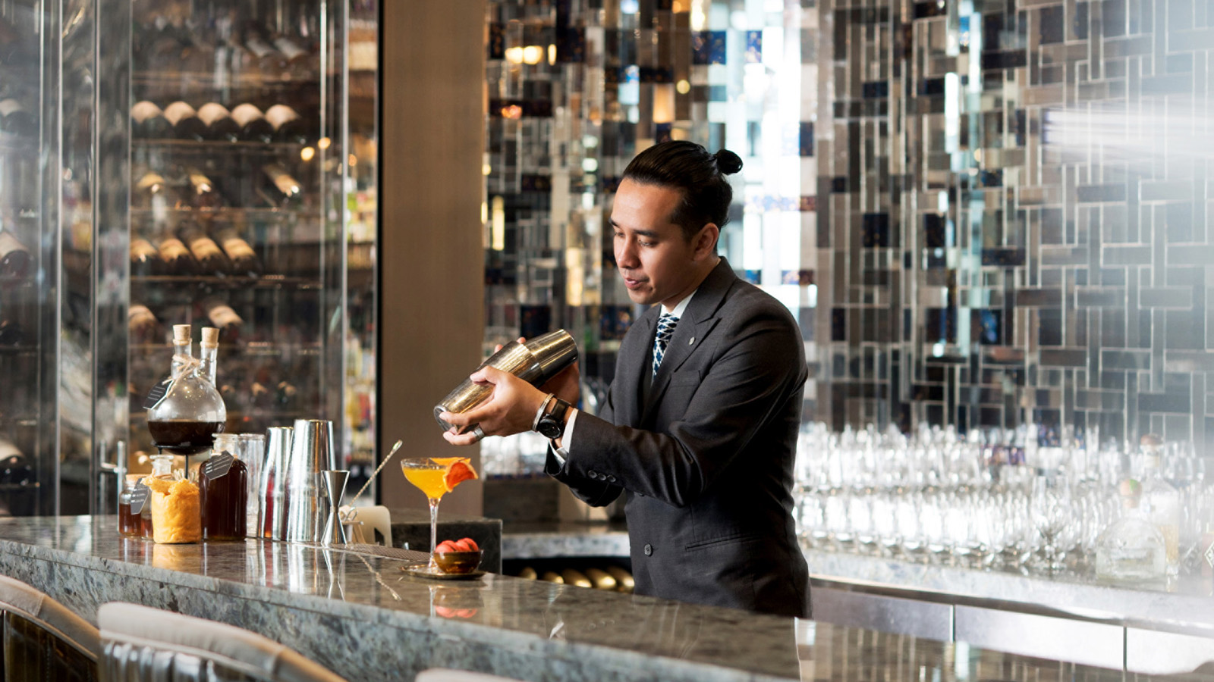 | April 28, 2022, Kuala Lumpur, Malaysia  Bar Trigona at Four Seasons Hotel Kuala Lumpur Wins Best Cocktail Menu Award  https://publish.url/kualalumpur/hotel-news/2022/asias-50-best-bars.html
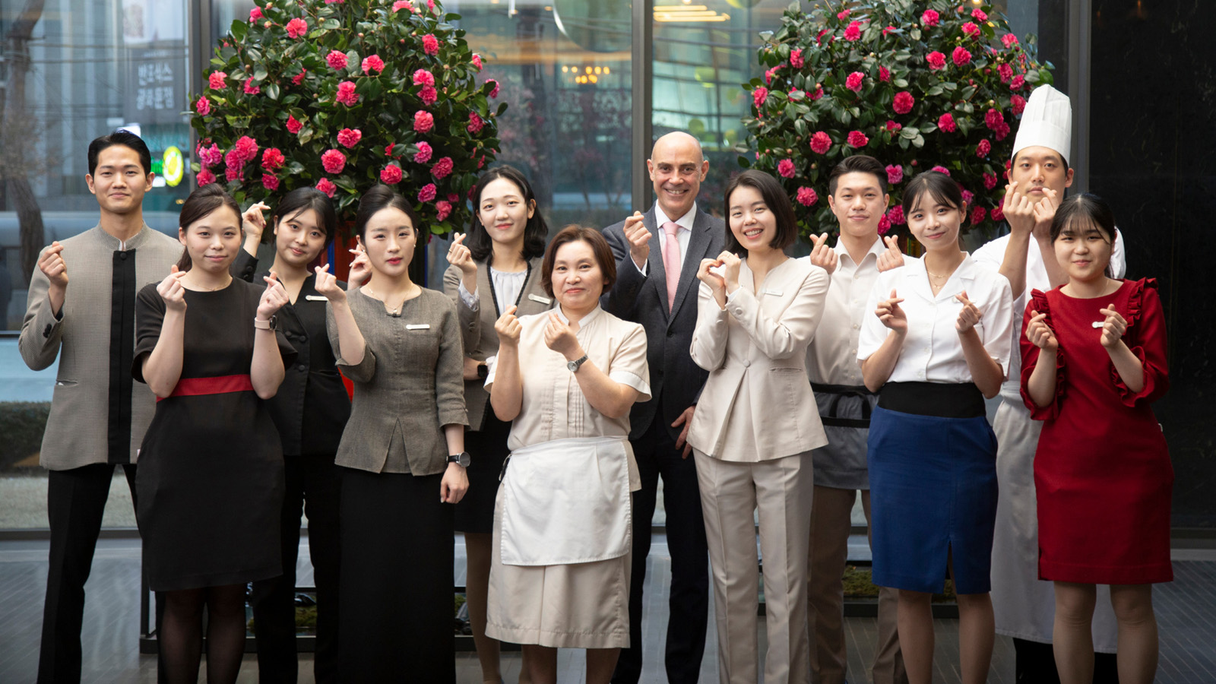 | April 27, 2022, Seoul, Korea  Four Seasons Hotel Seoul – Korea’s Luxury City Haven – Secures Third Consecutive Forbes Five Star Rating  https://publish.url/seoul/hotel-news/2022/forbes-five-star-hotel.html

PRESS CONTACTS

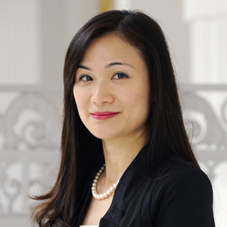 | Vivian Koh  Director, Public Relations and Content, Asia-Pacific  Tourism Court, 1 Orchard Spring Lane #04-01  Singapore  Singapore  vivian.koh@fourseasons.com  +65 6739 5806

