Celebrity Floral Artist Jeff Leatham to Join Four Seasons Hotel Philadelphia at Comcast Center

Leatham expands his collaboration with Four Seasons at the new landmark hotel in downtown Philadelphia, set to open in 2019
August 22, 2018, Philadelphia, U.S.A.

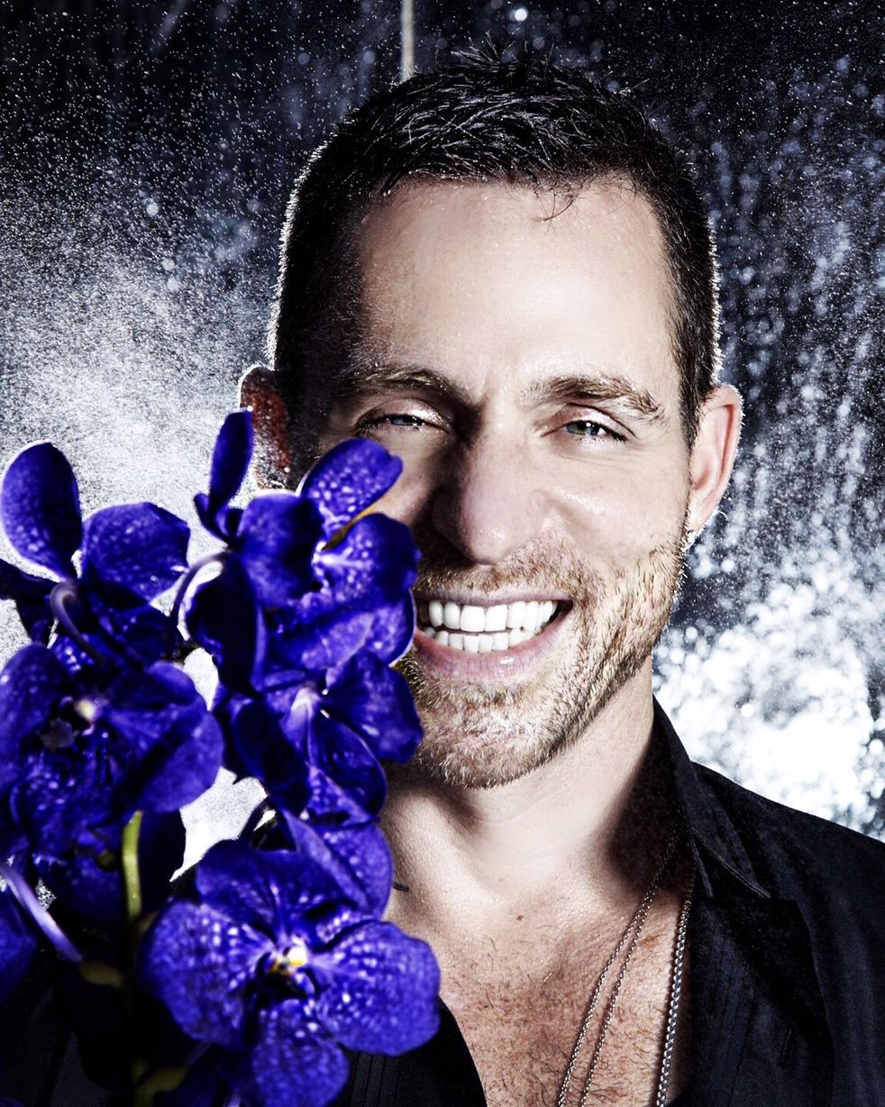
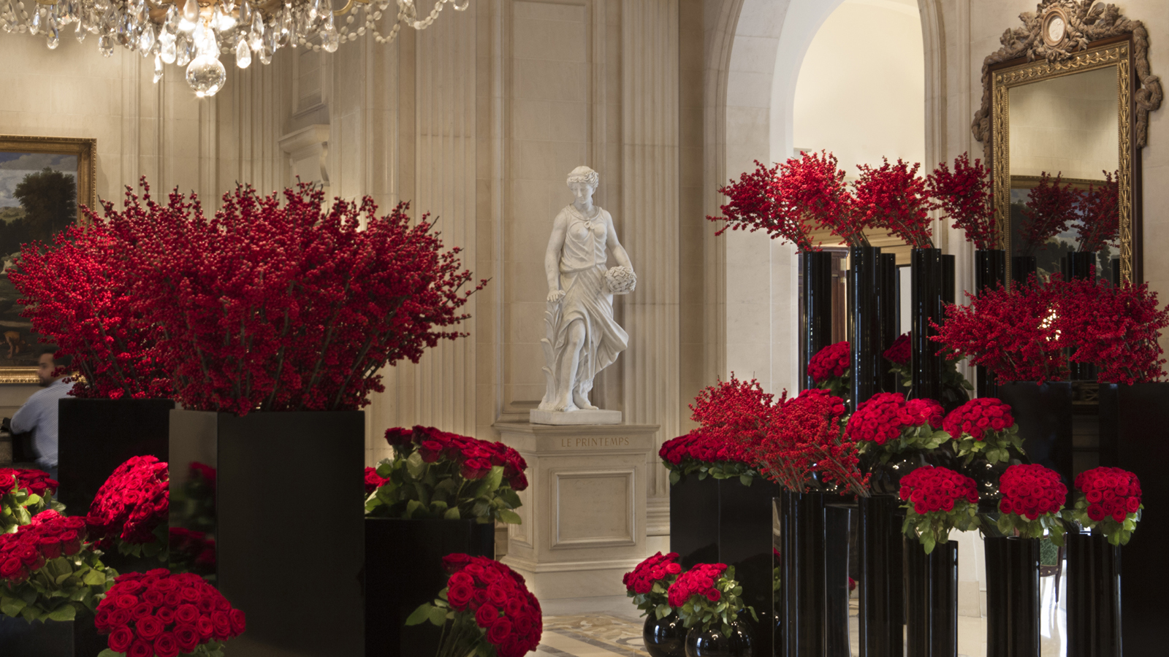 | 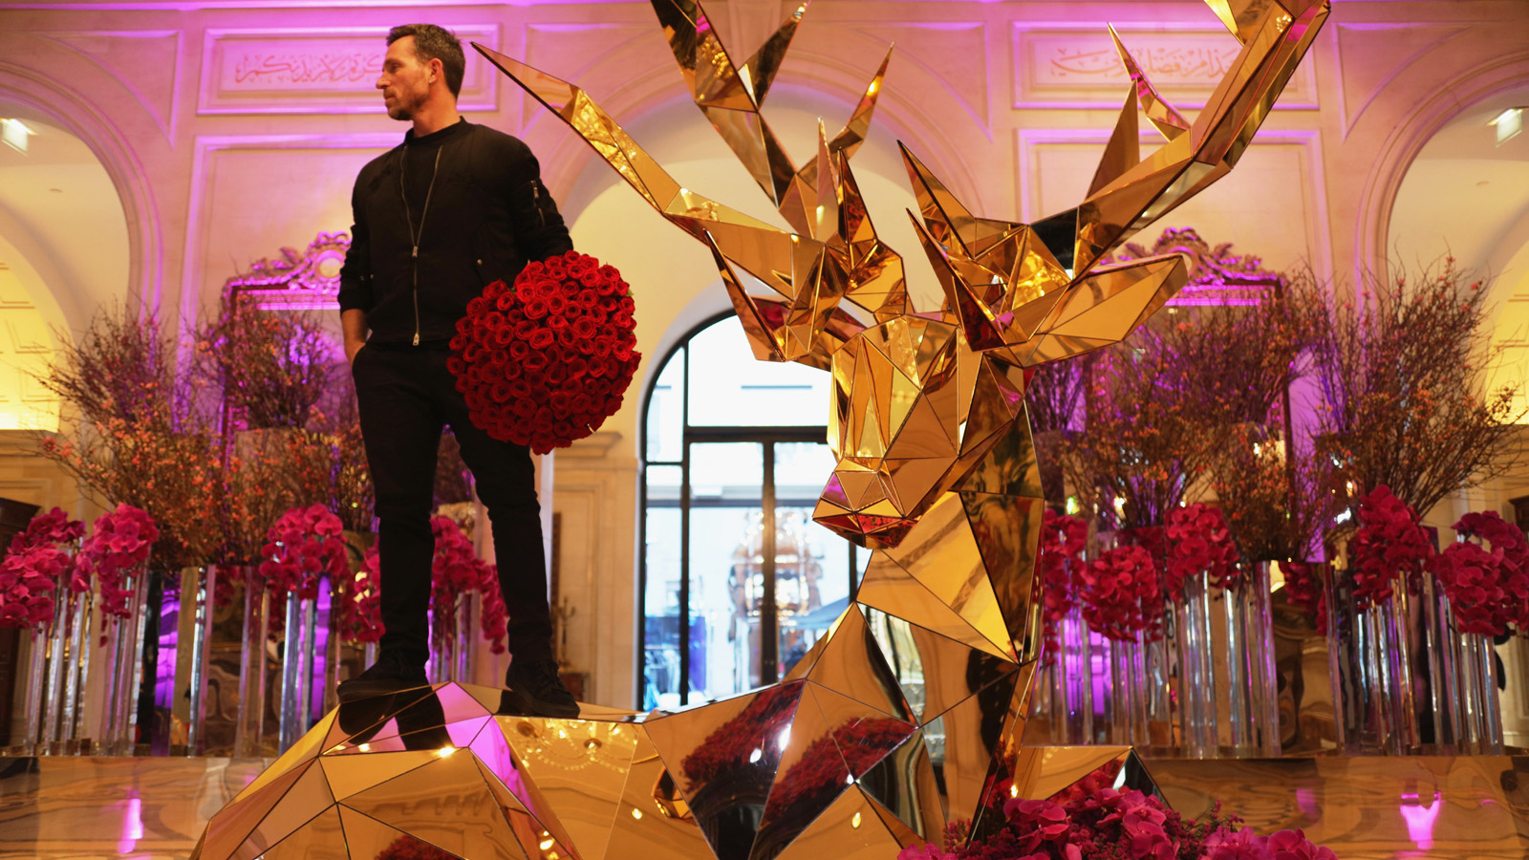 | 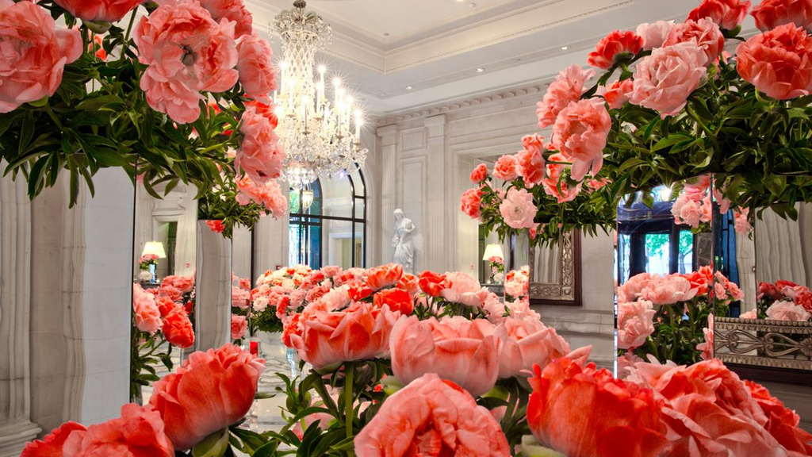
Master floral designer Jeff Leatham is bringing his signature style to Four Seasons Hotel Philadelphia at Comcast Center as Artistic Director overseeing floral concepts and displays throughout the Hotel. It will be the first Four Seasons property on the east coast of the US to showcase Jeff Leatham florals. Guests, clients and locals can look forward to seeing his unique vision comes to life in living, breathing artistic installations throughout the Hotel’s public spaces, spa, restaurants and lounges. In addition, event planners and wedding couples will have the opportunity to work with the Leatham team.
“We are very excited to welcome Jeff to our team as we elevate the guest experience to an entirely new – and beautiful – level with his artistic floral creations,” says Ben Shank, General Manager of Four Seasons Hotel Philadelphia. “As we look ahead to our opening next year, we have been very focused on innovation and establishing the ultimate experience for our guests, two principles to which Jeff is also deeply committed.”
Leatham began his relationship with Four Seasons Hotels and Resorts nearly 25 years ago at Four Seasons Hotel Los Angeles at Beverly Hills, where he continues to oversee the Hotel’s floral style. In 1999, while it was still under renovation, he joined the team at the soon-to-be Four Seasons Hotel George V, Paris, where, as Artistic Director, Leatham conceived what was to become the Hotel’s signature style with its bold and innovative floral concepts. His ground-breaking style continues to set the standard for floral art on a global scale.
“I’m very excited by this opportunity to work with a hotel that promises to be cutting edge in its service and technology, and to be able to provide the important elements of nature and beauty found in floral art,” says Leatham. “I can’t wait to share my passion for floral design with both visitors to the city, and the people of Philadelphia.”
Joining Leatham on the Philadelphia team is Eduardo Verdi, who will be the Resident Floral Designer at Four Seasons Hotel Philadelphia as they collaborate on designs for the Hotel. A special focus for the Leatham floral designers will be consulting with clients on corporate and social events at the Hotel.
With more than 15 years of experience working with many of the world’s leading designers, Eduardo Verdi is one of the country’s top floral experts, having brought his deep knowledge and love for design from his native Brazil. A key member of the Leatham team since 2014, Verdi has collaborated in high profile events such as Sofia Vergara’s wedding and Kardashian-Jenner family celebrations.
To learn more about the new Four Seasons Hotel Philadelphia at Comcast Center, follow the latest news here.
About Jeff Leatham
Jeff Leatham is the owner and visionary behind Jeff Leatham Flowers, whose creations have defined numerous high profile weddings and special events; luxury brand installations and events for Balenciaga, Alexander McQueen, Dom Pérignon and Chanel to name but a few; and floral elements for private homes and the world’s leading hotels. Leatham’s celebrity clients have included Oprah Winfrey, the Kardashian family, the Clinton family including the wedding of Chelsea Clinton and Marc Mezvinsky, as well as the weddings of Sofia Vergara and Joe Manganiello, Tina Turner and Erwin Bach, and many more.
He is the author of three bestselling books, Flowers by Jeff Leatham, Flowers by Design, and Jeff Leatham - Visionary Floral Art and Design, and creator of the documentary series Flowers Uncut. His passion for design expands and continues to advance in product lines with his own JL Home, Fine Fragrance collection, as well as two collections Fleurology and Jeff Leatham for Waterford Crystal.
Among many accolades, in 2014 he was awarded the prestigious Chevalier de l'Ordre des Arts et des Lettres, the highest honour for artists who have made a significant contribution to French culture given by the Minister of Culture.
Since 1999, Leatham has been the Artistic Director of Four Seasons Hotel George V, Paris and he continues to work closely with his original Four Seasons home at Four Seasons Hotel Los Angeles at Beverly Hills. Leatham is the Artistic Director of the new Four Seasons Hotel Philadelphia at Comcast Center, set to open in 2019.

RELATED

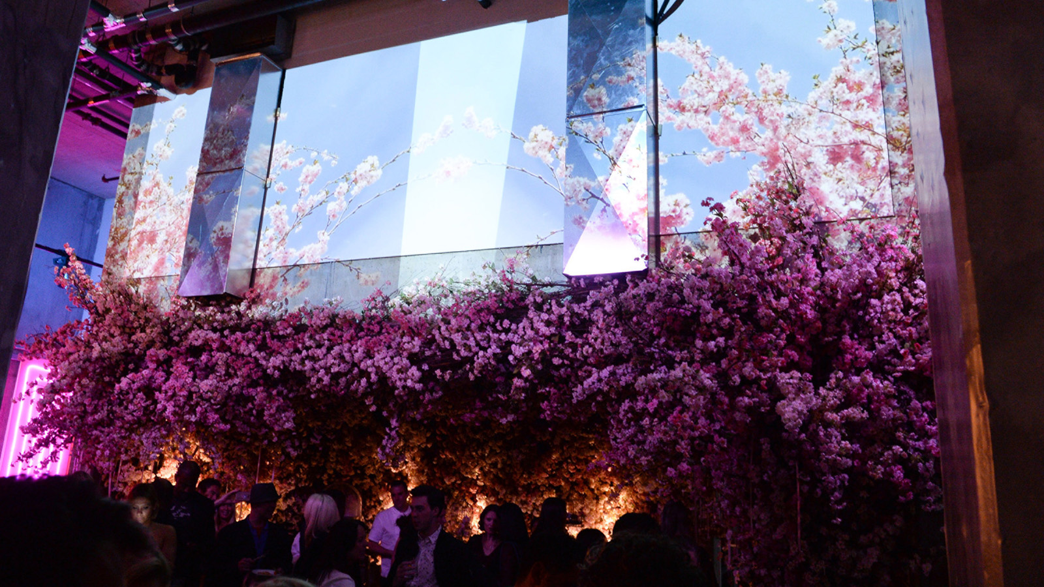 | June 27, 2018, Toronto, Canada  فيلادلفيا على موعد مع مفهوم فورسيزونز المبتكر "بوب داون" في سبتمبر القادم  https://publish.url/news-releases/2018/pop-down-philadelphia-miami-hongkong-6.html
June 27, 2018, Toronto, Canada
四季酒店“纵览四季”系列活动将于九月在“友爱之城”——费城举行
https://publish.url/news-releases/2018/pop-down-philadelphia-miami-hongkong-7.html

PRESS CONTACTS

Melissa Quinones
Director of Public Relations
One North 19 Street
Philadelphia
U.S.A.
melissa.quinones@fourseasons.com

+1 (215) 419-5033

