Four Seasons Hotel New Orleans Celebrates Thanksgiving with Sumptuous Dining Options

Enjoy 15% off and complimentary valet parking with seasonal Papa Noel package
November 8, 2022, New Orleans, U.S.A.

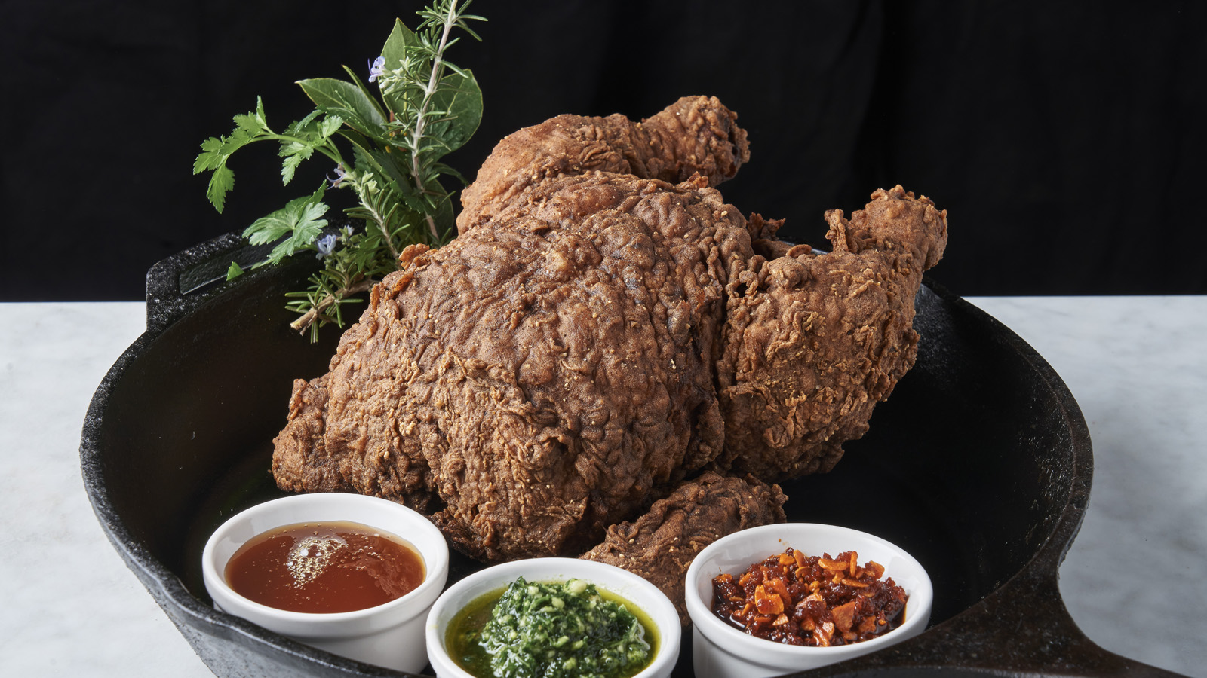
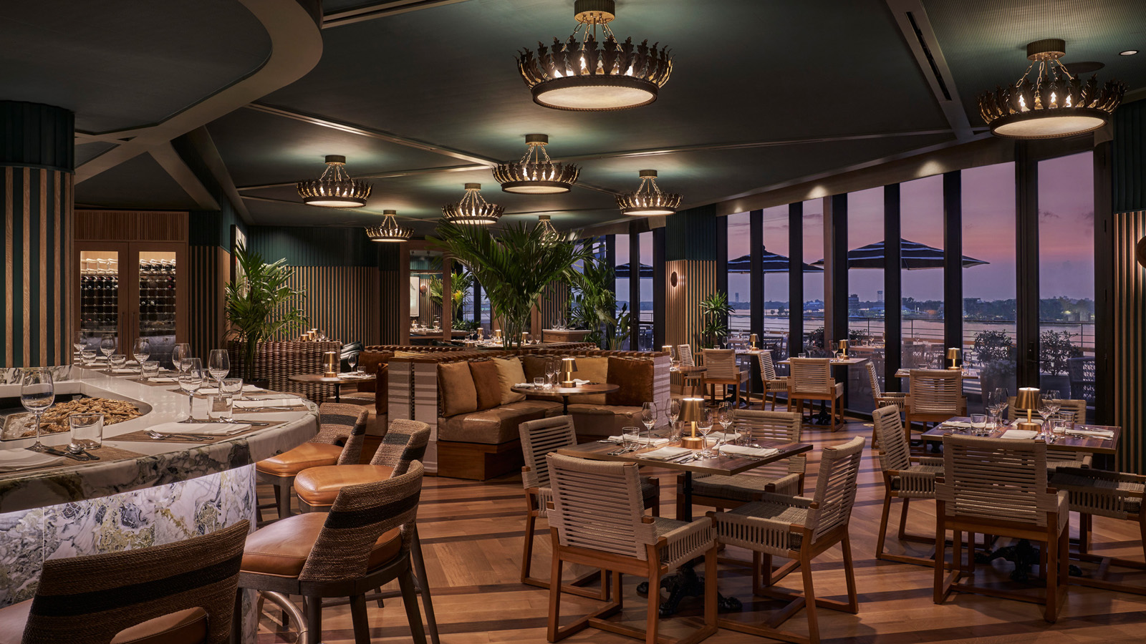 | 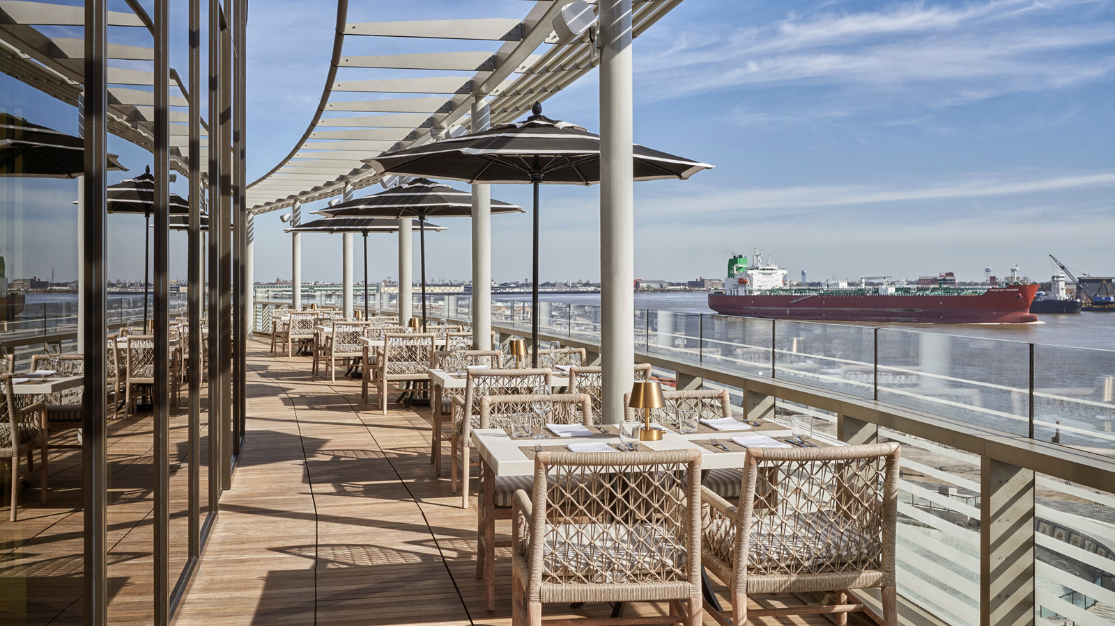 | 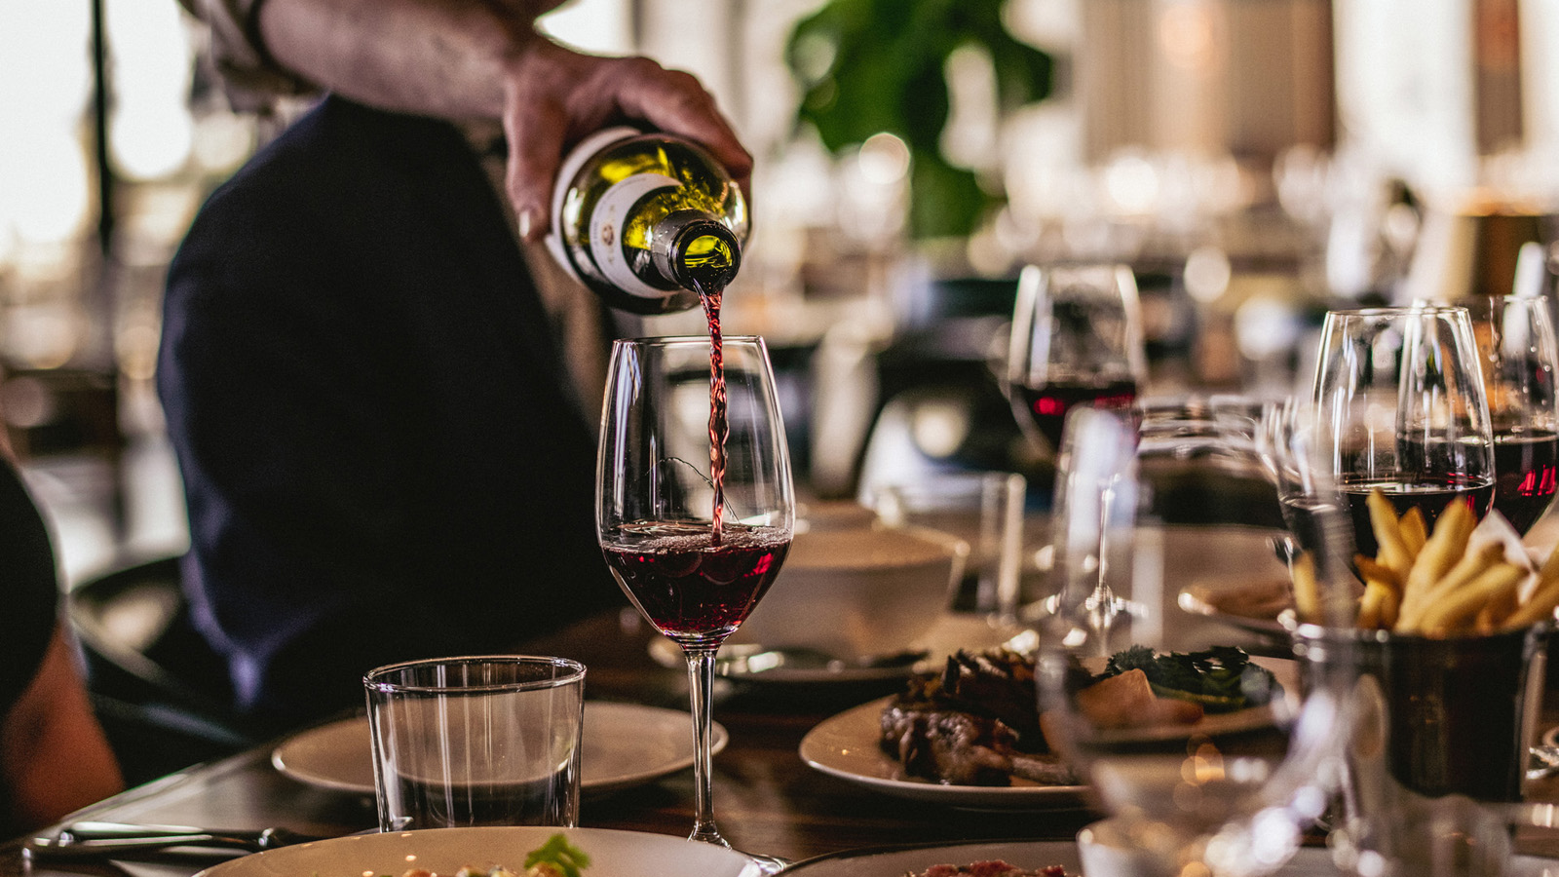
The holiday season is a time for gathering around the table with friends and family from near and far. This Thanksgiving, Four Seasons Hotel New Orleans invites guests to celebrate the holiday with decadent meals in its two signature restaurants.
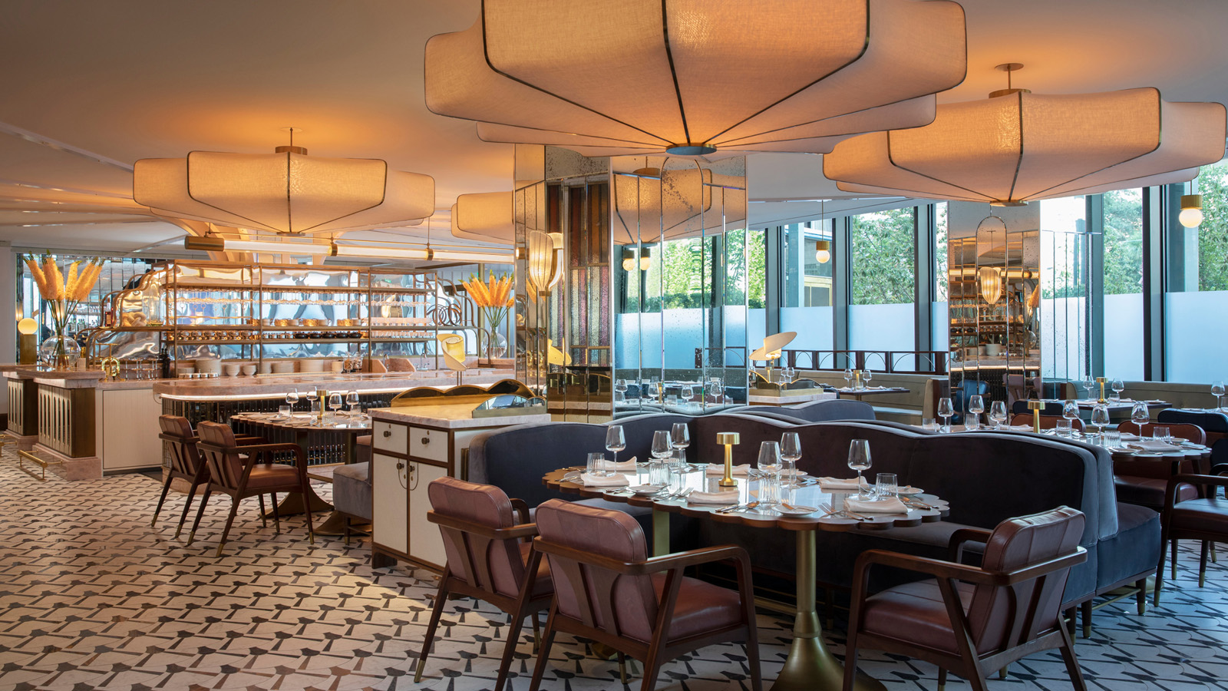 | 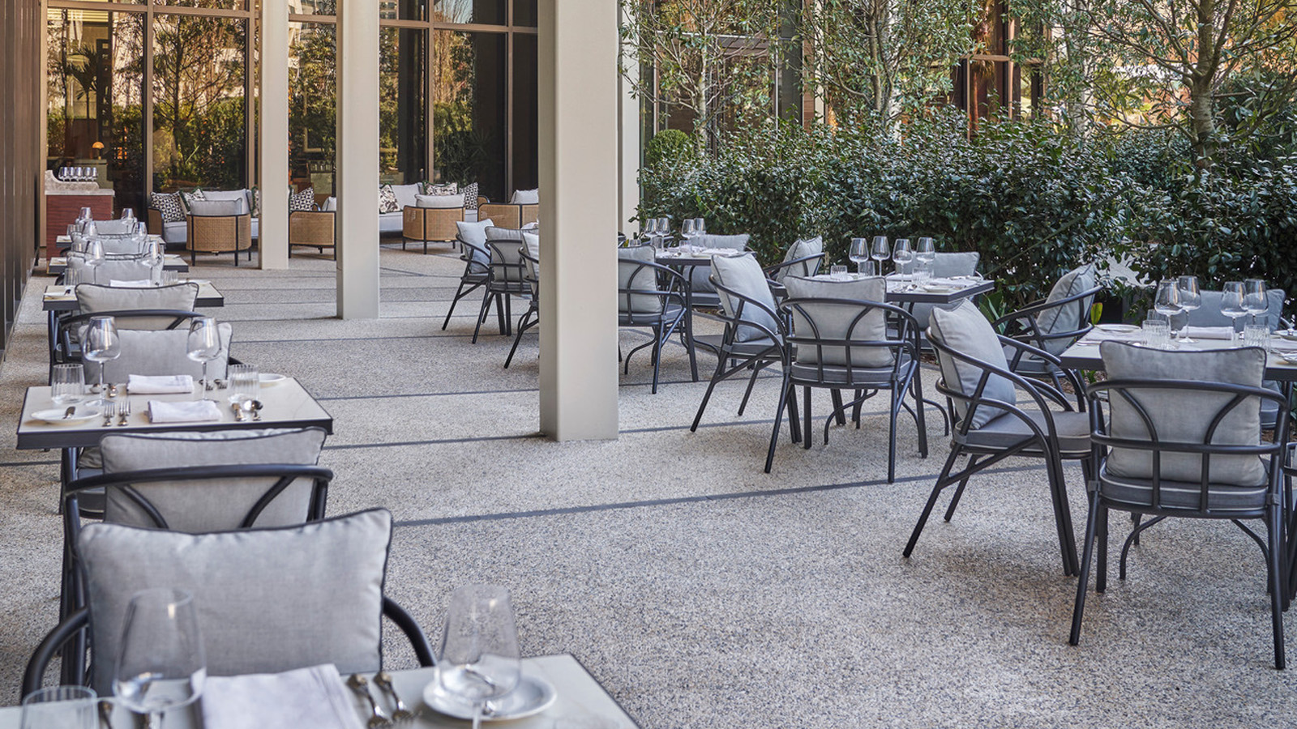 | 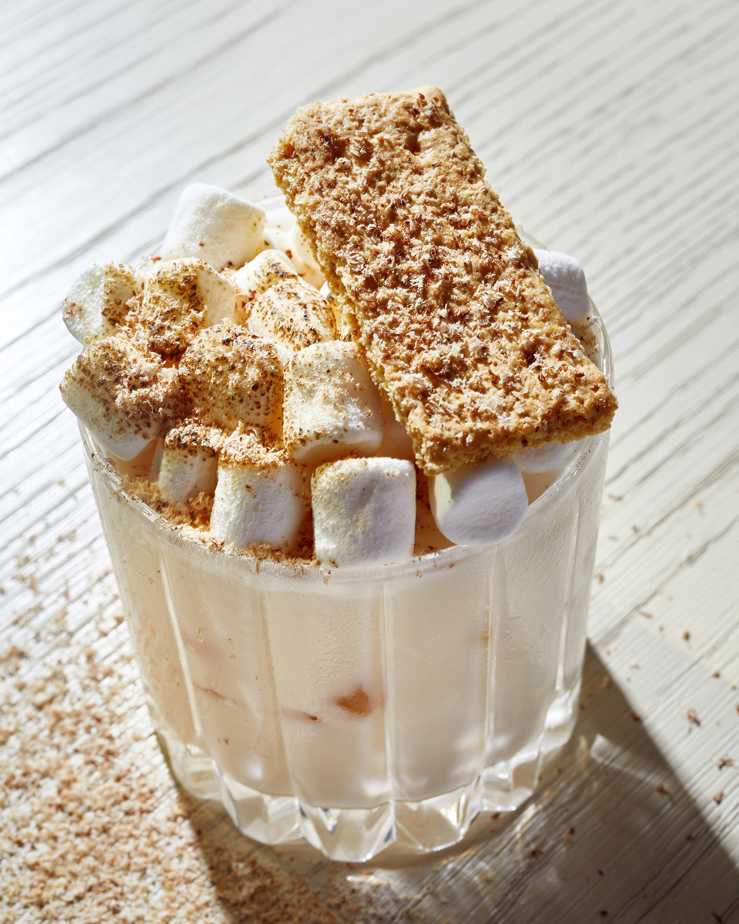
The traditional Southern menu at Chemin à la Mer features several of Partner Chef Donald Link’s favourite holiday dishes he serves for his own family at home. The highlight of the three-course tasting menu is a turkey roulade stuffed with house made boudin from Cochon Butcher. The menu, which is skillfully prepared by Executive Chef Justin Koslowsky, also includes a savoury turkey and andouille sausage gumbo, mashed potatoes with gravy, greens beans, cornbread dressing, and cranberry sauce. No feast is complete without dessert and this one pulls from Chef Link’s family recipes – a satsuma buttermilk pie that incorporates Louisiana citrus, adding brightness to this Southern staple. Chemin à la Mer Sommelier Emily Kitzmiller has brought in special wines to complement holiday dining, including Chef Link’s favourite Vieux Télégraphe Châteauneuf du Pape, and other special occasion bottles such as the 2018 Chappellet Pritchard Hill Cabernet Sauvignon from Napa and the Domaine Roumier Morey-Saint-Denis 1er cru Clos de la Bussière.
Located on the Hotel’s fifth floor, Chemin à la Mer offers an outdoor terrace with unparalleled views of the Mississippi River, lush décor and regional artwork to set the backdrop for a warm and memorable holiday gathering. Chemin à la Mer’s Thanksgiving menu is available for USD 85 per person and will be offered from 12:00 noon to 8:00 pm. Reservations are essential and can be made by calling 504 434 5898.
Partner Chef Alon Shaya welcomes guests to Miss River with signature dishes perfect for sharing across the table. A playful interpretation of the traditional Thanksgiving feast, the menu features a whole buttermilk-fried chicken that is brined for 16 hours, then, battered, breaded and deep fried, resulting in a perfectly golden, crunchy exterior and tender, juicy interior. The succulent fried chicken can be accompanied by crowd-pleasing Thanksgiving sides, including mashed potatoes and gravy, green beans almondine, sweet potato, oyster dressing, and cranberry sauce. Miss River’s regular menu will also be available, featuring inventive takes on beloved New Orleans dishes, such as clay pot dirty rice, seafood on the half shell, blackened snapper, and redfish court bouillon, prepared by Executive Chef Aleksandre Nadirashvili.
Ideal for a mild Louisiana Thanksgiving, Miss River offers patio seating overlooking the Hotel’s Garden in addition to a grand dining room. Miss River will be open all day on Thanksgiving from 11:30 am to 10:00 pm. Reservations are essential and can made though OpenTable or by calling 504 434 5701.
For guests welcoming friends and family to town, the glamorous Chandelier Bar has quickly become the centre of New Orleans’ social scene and the ideal setting for pre- and post-dinner drinks. The highlight of the seasonal menu is a S’mores Milk Punch that is both bold and decadent and topped with toasted marshmallows and graham cracker.
For guests interested in staying at the Hotel for Thanksgiving and through the holiday season, Four Seasons is now offering a Papa Noel Package through December 31, 2022. The package offers guests 15 percent savings on the room rate and complimentary valet parking.
Offer is subject to availability at the time of booking. Offers are not valid in conjunction with any other offer or contract and do not apply to groups. Rates are per room, per night, vary by arrival date and/or length of stay, and do not include applicable taxes, service charges, or surcharges unless otherwise noted. Early departure fees may apply. Rates are subject to change.

RELATED

October 11, 2022, New Orleans, U.S.A.
Four Seasons Hotel New Orleans Invites Guests to Celebrate in the Crescent City This Fall with Special Culinary Offer
https://publish.url/neworleans/hotel-news/2022/experience-more-culinary-offer.html

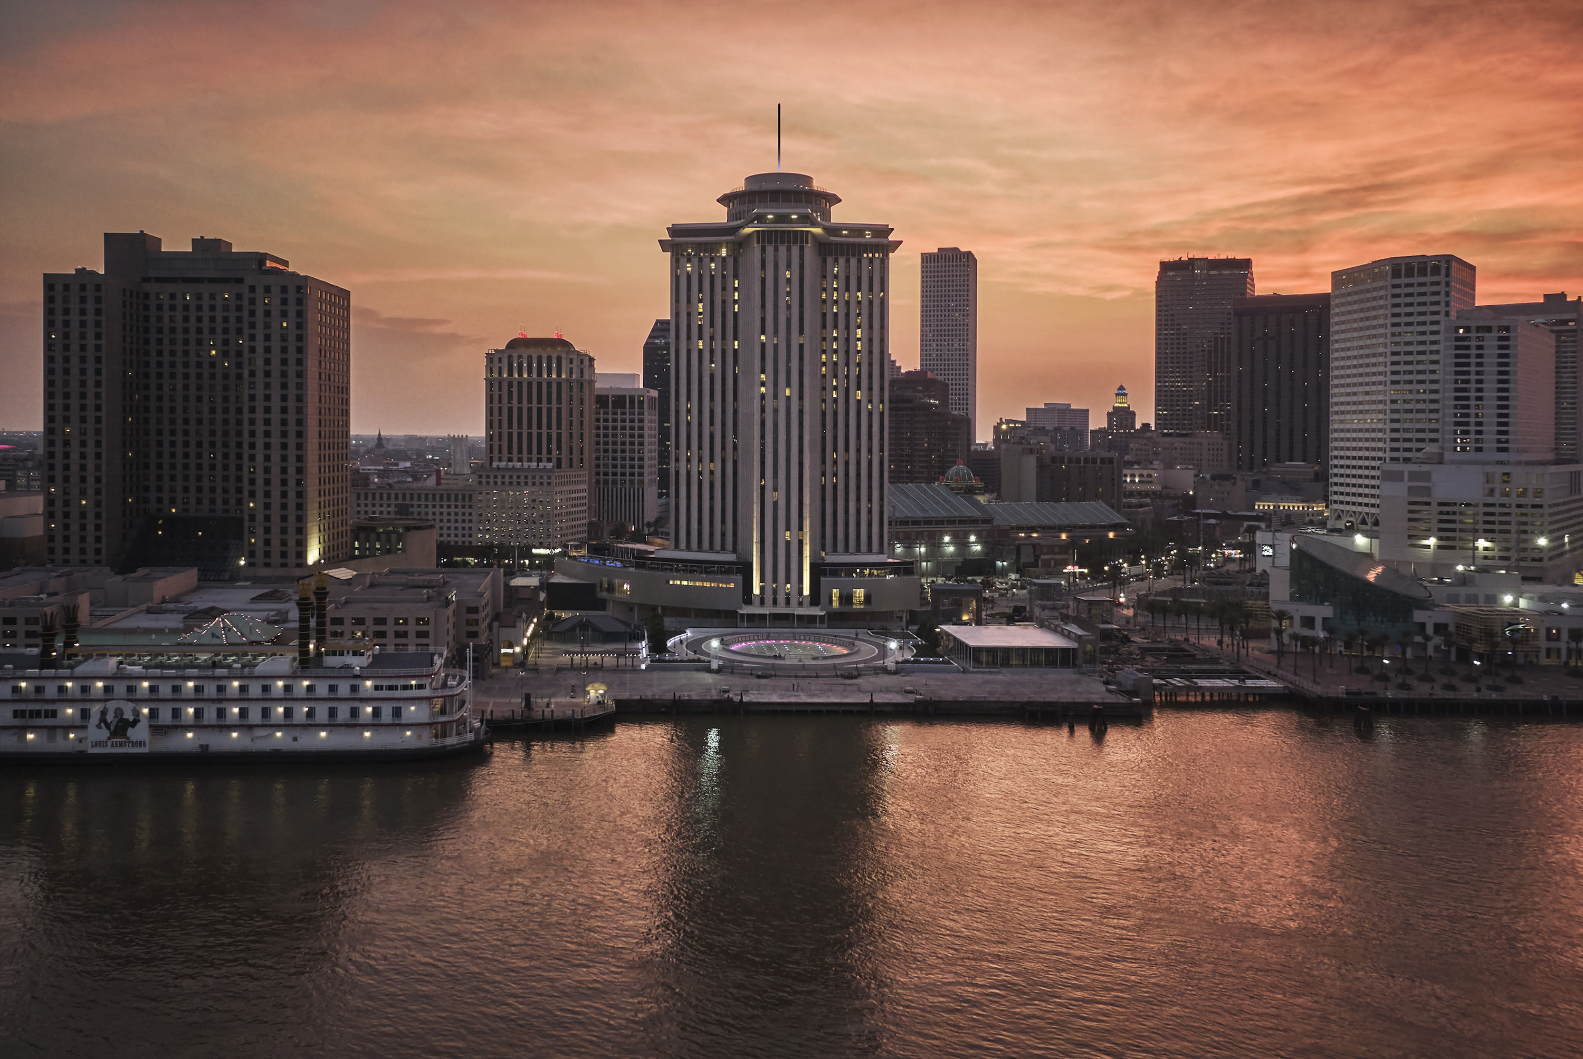 | October 6, 2022, New Orleans, U.S.A.  Four Seasons Hotel New Orleans Goes Positively Pink for October  https://publish.url/neworleans/hotel-news/2022/pink-october.html

PRESS CONTACTS

Vicki Bristol
Director of Public Relations and Communications
2 Canal Street
New Orleans
USA
vicki.bristol@fourseasons.com

+1 504 434 7012

