Let It Snow! Even in Warmer Climates, Four Seasons Offers Fresh Reasons to Get Cosy This Winter

The après lifestyle evolves with here-and-now experiences at a rooftop skating rink, champagne ice bar, private chalets and a snow globe, with gentle dustings of fluffy snow (in California!)
November 4, 2019, Toronto, Canada

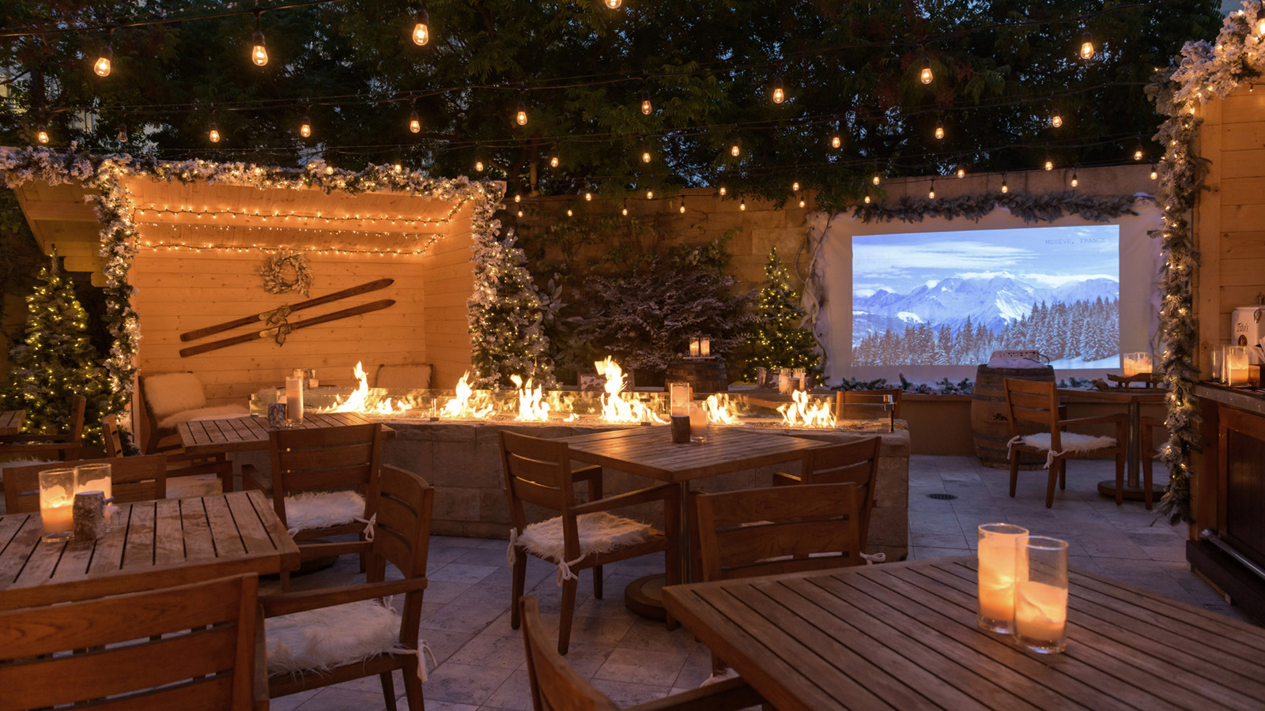
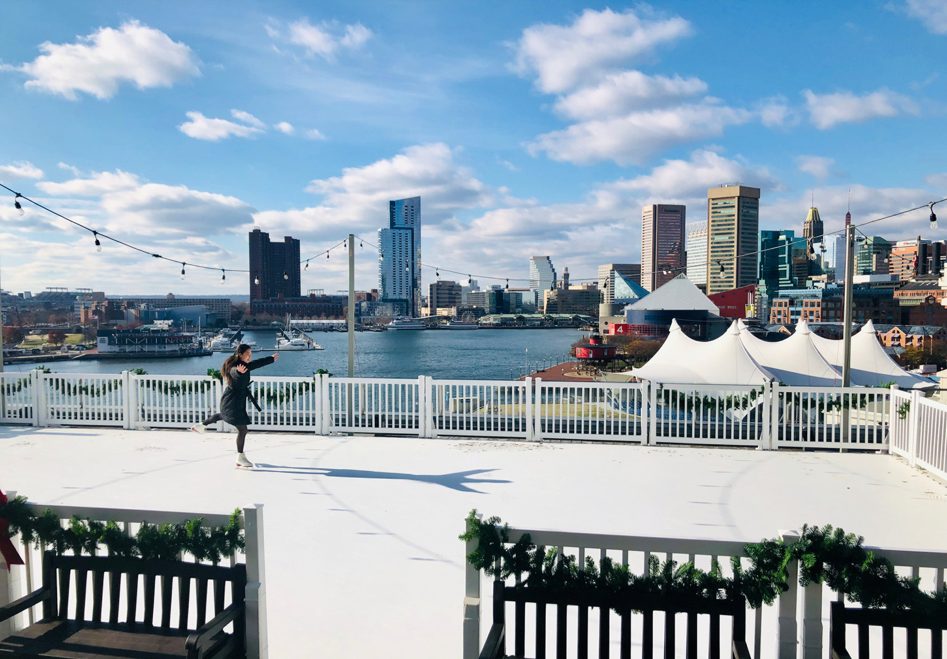 | 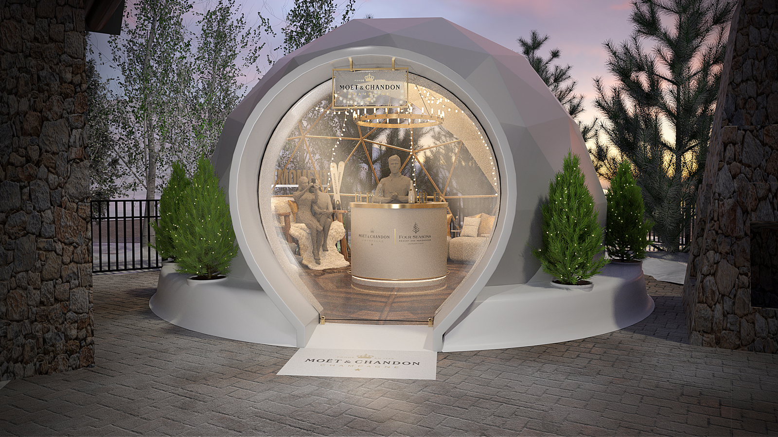 | 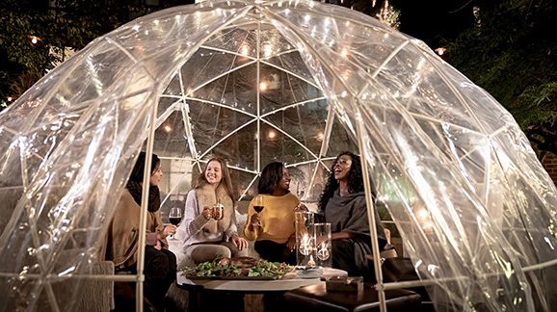
This winter, bundle up and embrace the fresh cold air, then cuddle up with friends and family for skating parties, movie nights under the stars and more innovative offerings from Four Seasons.
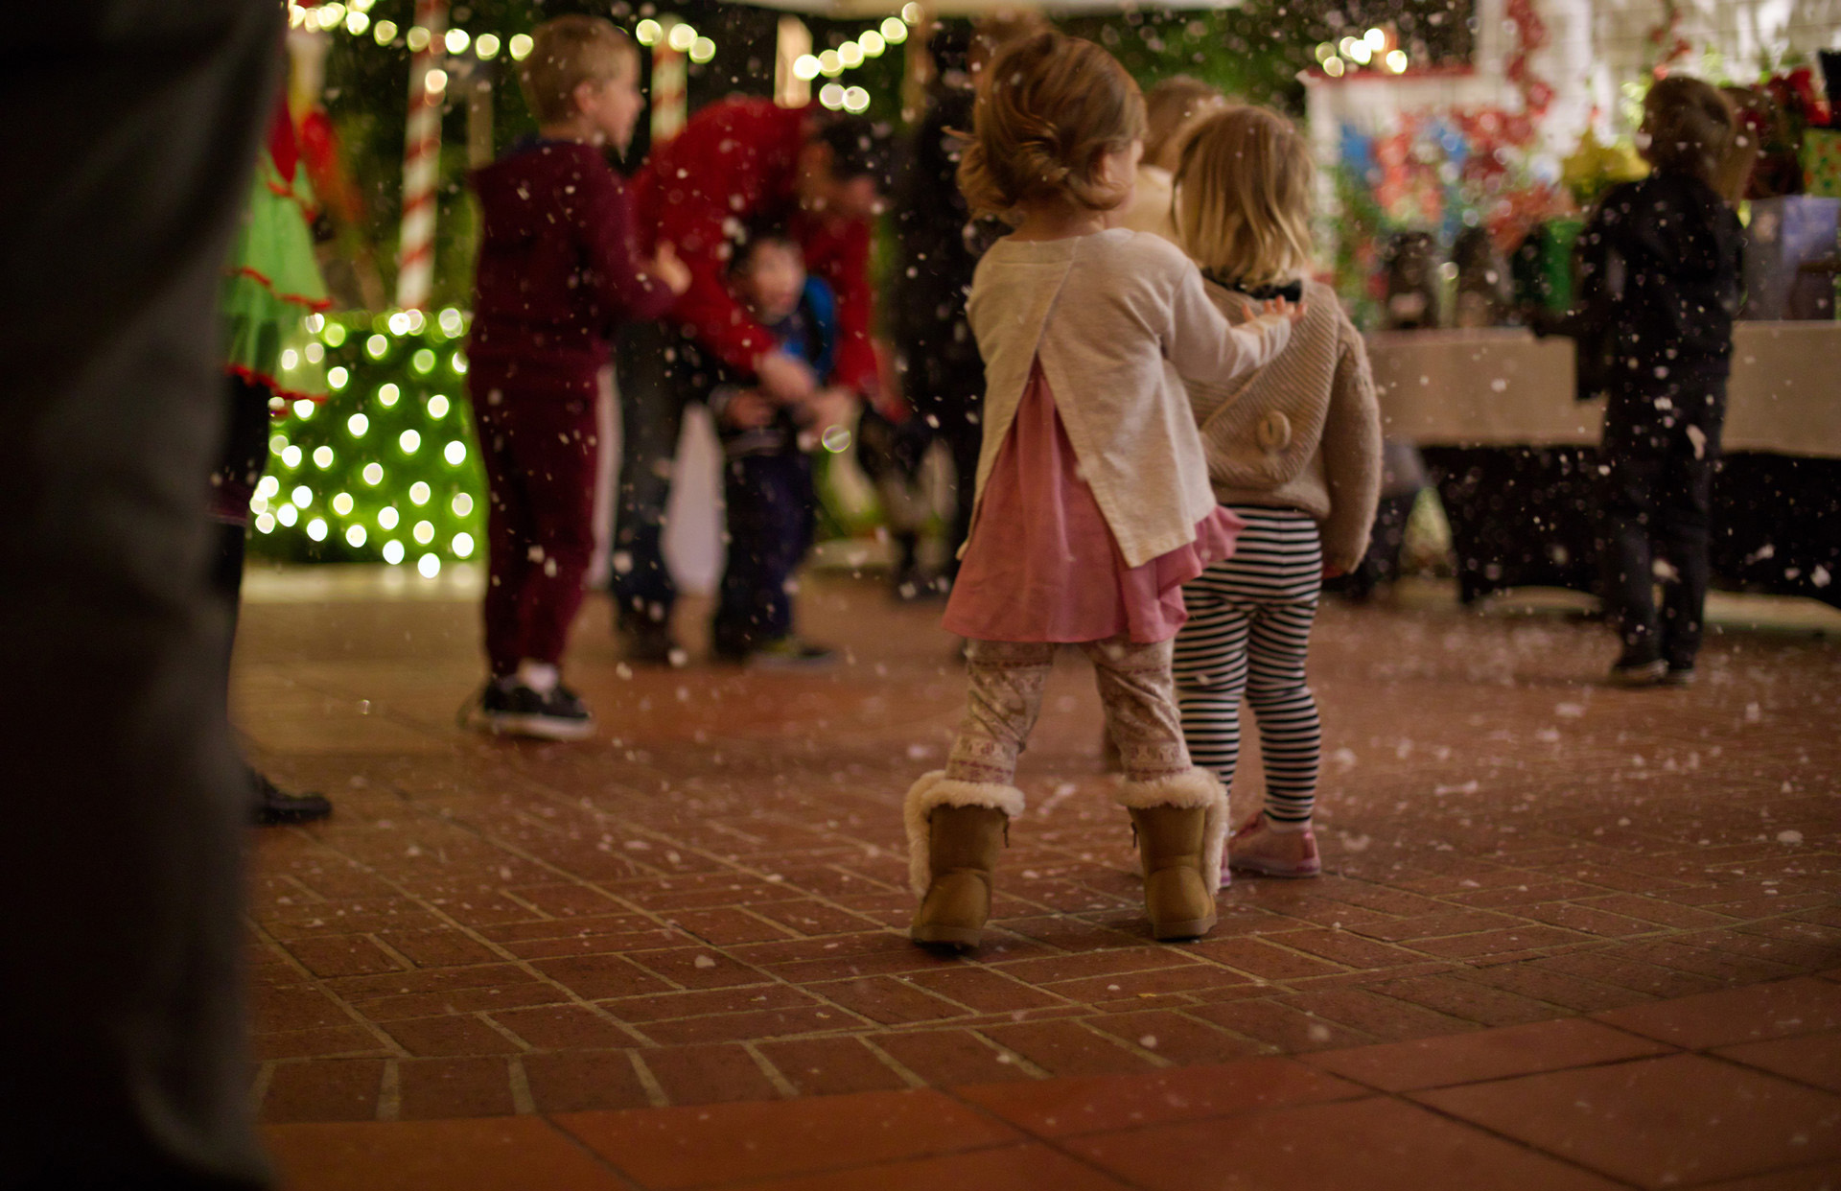 | 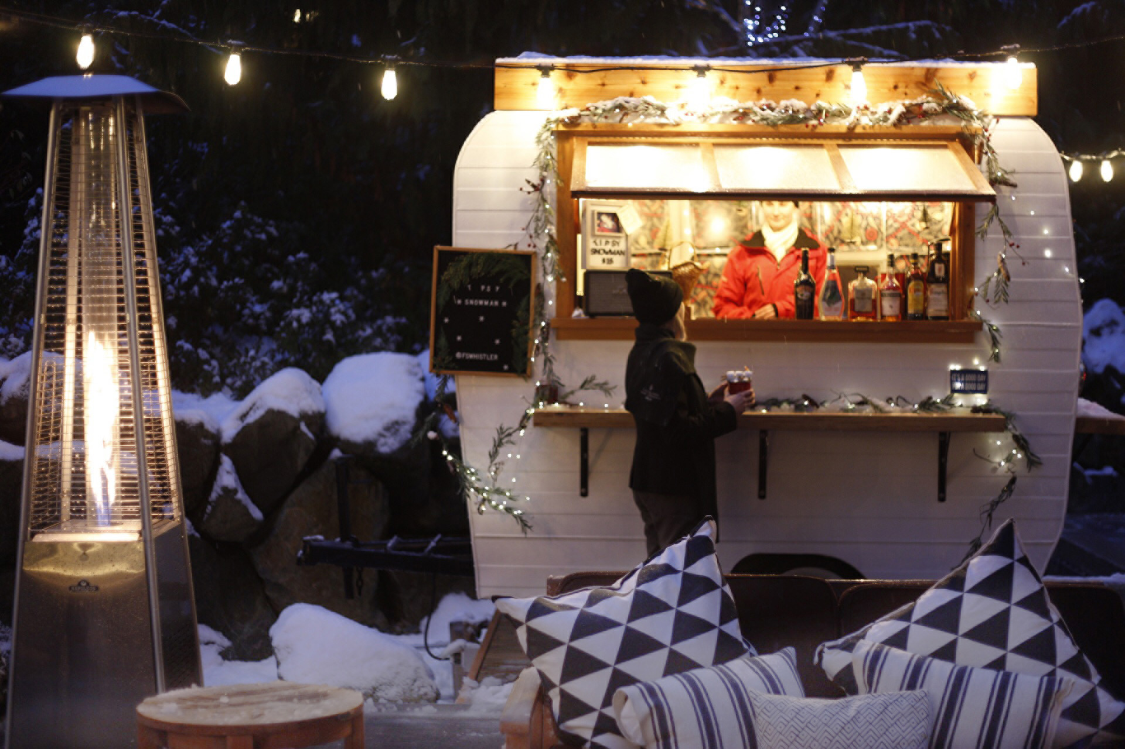
Here are some of the winter pop ups that travellers and local guests can look forward to at Four Seasons hotels and resorts from coast to coast:
The Après Winter Lounge
- Four Seasons Hotel Silicon Valley at East Palo Alto: Now featuring an array of luxurious “Tahoe Chalets” and outdoor movie screenings ranging from holiday classics to first-run blockbusters, the annual Après Winter Lounge pop up transforms the terrace of Quattro restaurant into a mountain fantasy complete with cocktails, alpine fare, and nightly “snowfall.” Daily from November 1 to January 5, with movie nights every weekend; family friendly.
The Rooftop Skating Rink
- Four Seasons Hotel Baltimore: Overlooking the historic Inner Harbor and festooned with twinkling lights, a skating party is literally taken to new heights with festive décor, lively music and luxe versions of hot chocolate for the kids and hot toddies for the adults. Weekends from November 29 to January 5, family friendly.
Fahrenheit 47
- Four Seasons Resort and Residences Jackson Hole: Located slopeside, the intimate, igloo-shaped Fahrenheit Forty-Seven pop up bar offers panoramic mountain views from its cosy domed interior, which opens to a fully furnished outdoor lounge with fireplace and firepits. While sipping Moët & Chandon (47 degrees is the ideal temperature to serve champagne after all), it’s an indulgent way to warm up and chill out after a day on the slopes. Daily from November 28 throughout the winter season, family friendly.
- Also at Four Seasons Resort Jackson Hole, Westbank Grill introduces an après menu including fondue and raclette on its newly renovated outdoor terrace. Daily throughout the winter season, family friendly.
Hotel on Ice
- Four Seasons Hotel Washington, DC: Book one of the BOURBON STEAK DC’s “Champagne Bubbles” for a private dining experience like no other in the Nation’s Capital, featuring stellar choices from the Hotel’s acclaimed steakhouse washed down with bottles of Krug, Ruinart or Dom Pérignon. Glow-in-the-dark outdoor lawn games along with hot chocolate and s’mores add to the fun. November 6 to March 1; family friendly.
- Also at Four Seasons Hotel Washington, Georgetown’s popular ENO Wine Bar is transforming into an après ski (or after work, post shopping, your choice!) bar with an inspired menu of raclette, fondue and charcuterie paired with wine selections. November to March, adults only.
Winter Wonderland
- Four Seasons Hotel Westlake Village, California: Minutes from Malibu beach, this popular annual event features holiday express train rides, cookie decorating, menorah lighting, special character appearances and much more – including the opportunity to enjoy festive treats as the “snow” falls. An overnight Winter Wonderland package is also offered as part of this event for those who wish to make a weekend of it. December 20-22, family friendly.
Party on the Patio
- Four Seasons Resort and Residences Whistler: The Resort’s retro patio camper is serving up cheesy fondue with freshly baked pretzel baguettes and other treats, along with the notoriously Instagrammable – and deliciously drinkable - Tipsy Snowman. Daily from November 23 throughout the winter season, family friendly.

RELATED

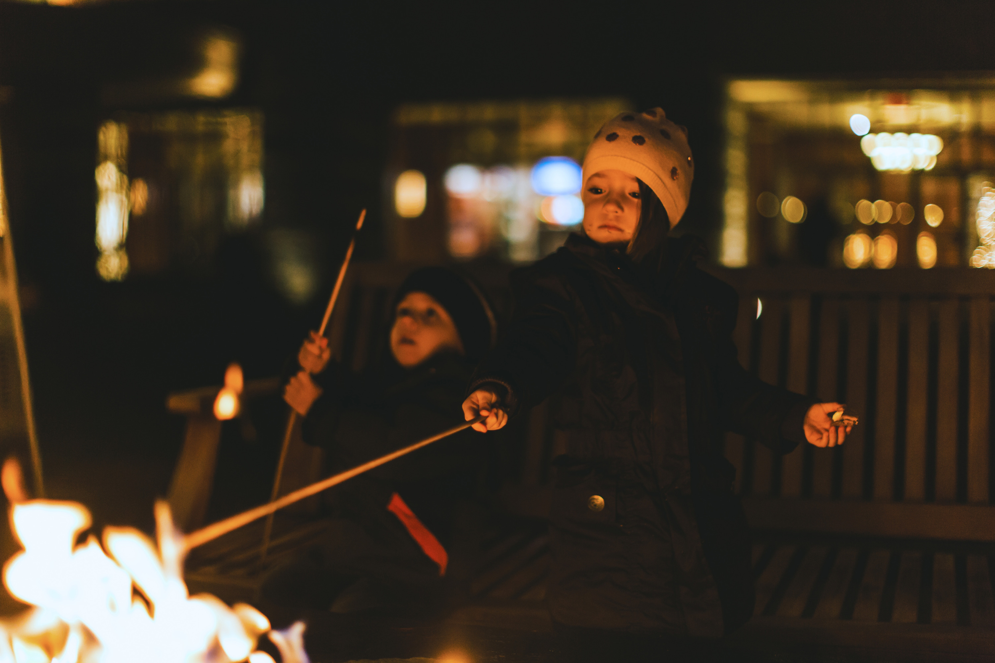 | February 21, 2020, Whistler, Canada  Take a Leap and Make the Most of Gifted Hours at Four Seasons Resort and Residences Whistler This Leap Day  https://publish.url/whistler/hotel-news/2020/take-your-time.html
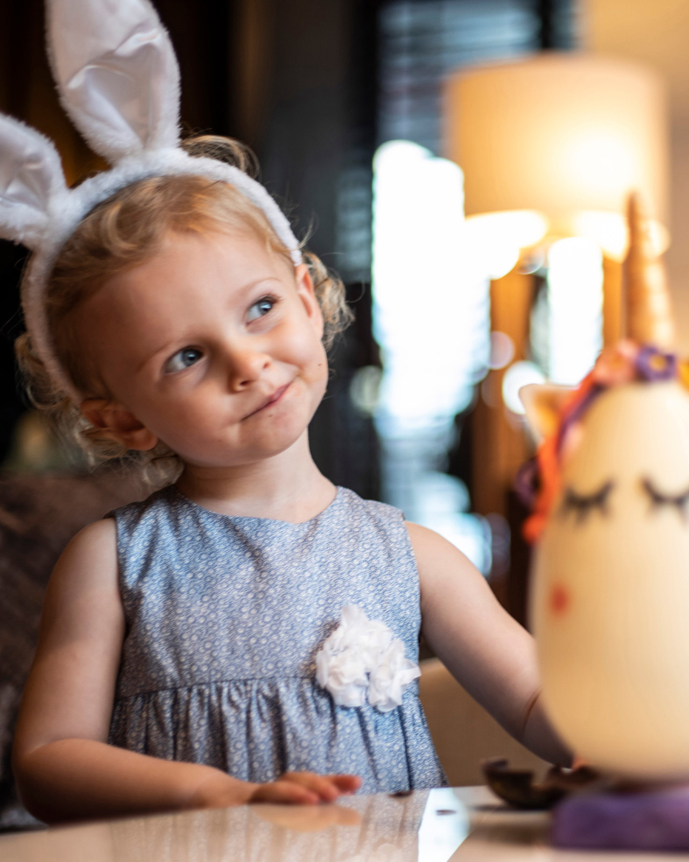 | February 19, 2020, Baltimore, U.S.A.  Celebrate Easter with an Eggstravagant Brunch in the Ballroom at Four Seasons Hotel Baltimore  https://publish.url/baltimore/hotel-news/2020/easter.html

PRESS CONTACTS

Malia O'Connor
Public Relations and Communications Manager
2050 University Avenue
East Palo Alto
USA
malia.oconnor@fourseasons.com

+1 650 470 2810

Christina Criss
Public Relations Manager
200 International Drive
Baltimore
USA
christina.criss@fourseasons.com

+1 (410) 223-1343

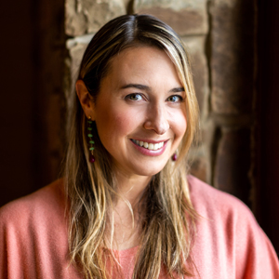 | Nina Braga  Public Relations Director  7680 Granite Loop Road, PO Box 544  Teton Village  USA  nina.braga@fourseasons.com  +1 307 732 5062
Anina Belle Giannini
Director of Public Relations
2800 Pennsylvania Avenue N.W.
Washington
U.S.A.
aninabelle.giannini@fourseasons.com

+1 202 944 2074

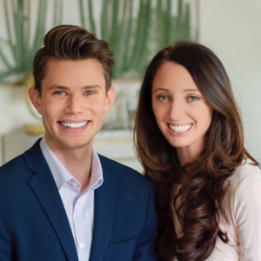 | Jacqueline Kerns and Harley Potter  Public Relations & Communications Team  Two Dole Drive  Westlake Village  USA  publicrelations.westlakevillage@fourseasons.com  +1 818 575 3089
Eleanor Gilkes
PR Executive
4591 Blackcomb Way
Whistler
Canada
eleanor.gilkes@fourseasons.com

+1 604 966 2666

