Bar Trigona at Four Seasons Hotel Kuala Lumpur Ranks in Top 5 for Best Cocktail Menu Award

Bar Trigona’s “Herb Garden in Your Glass” menu is recognised by The World’s 50 Best Bars 2021
December 8, 2021, Kuala Lumpur, Malaysia

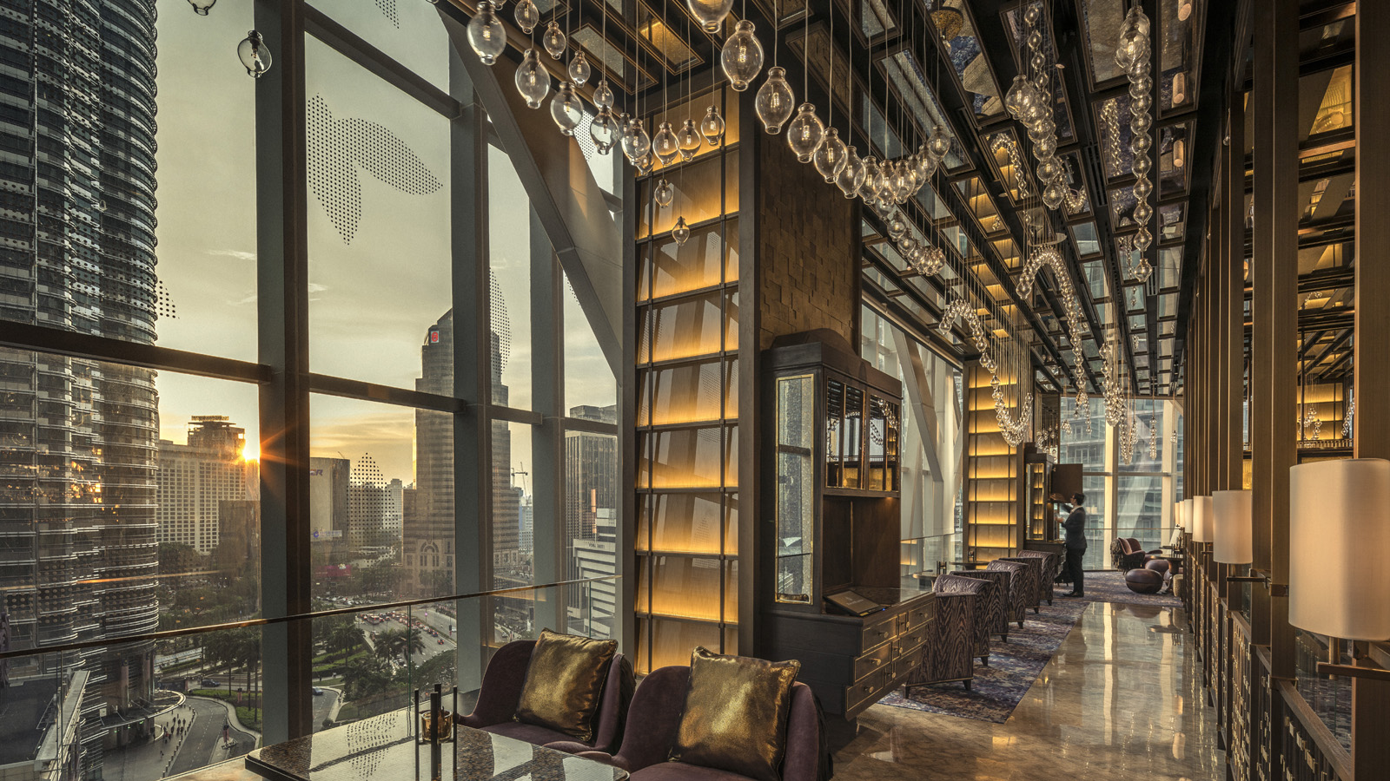
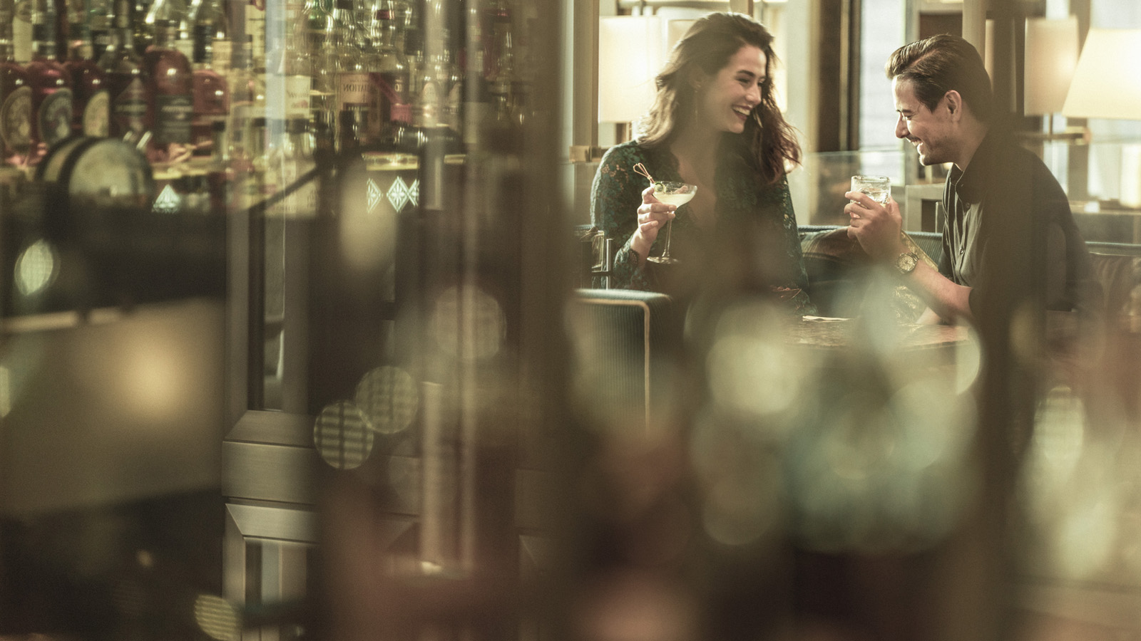 | 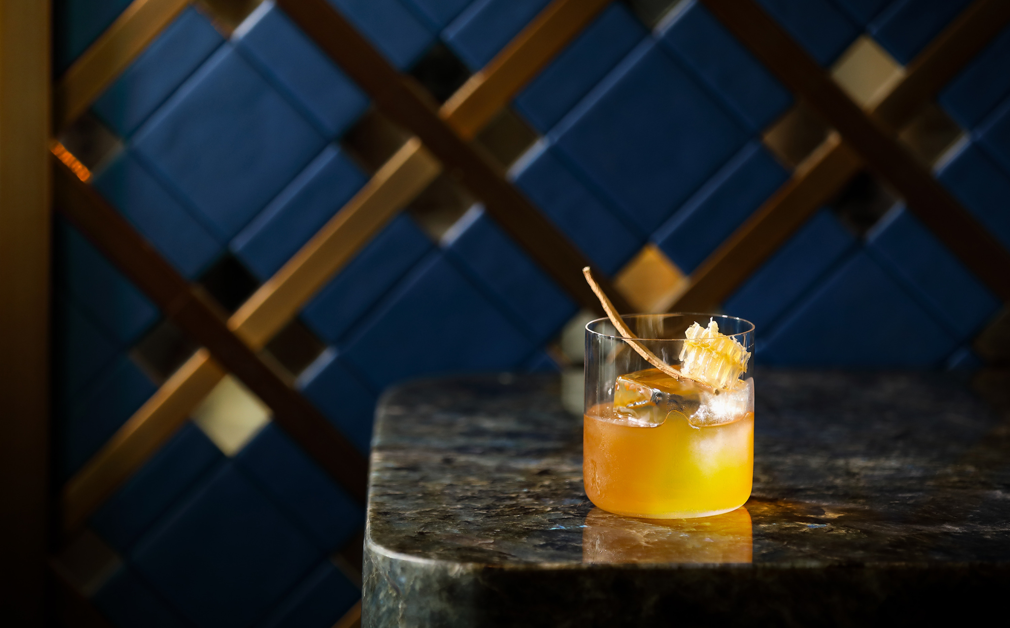 | 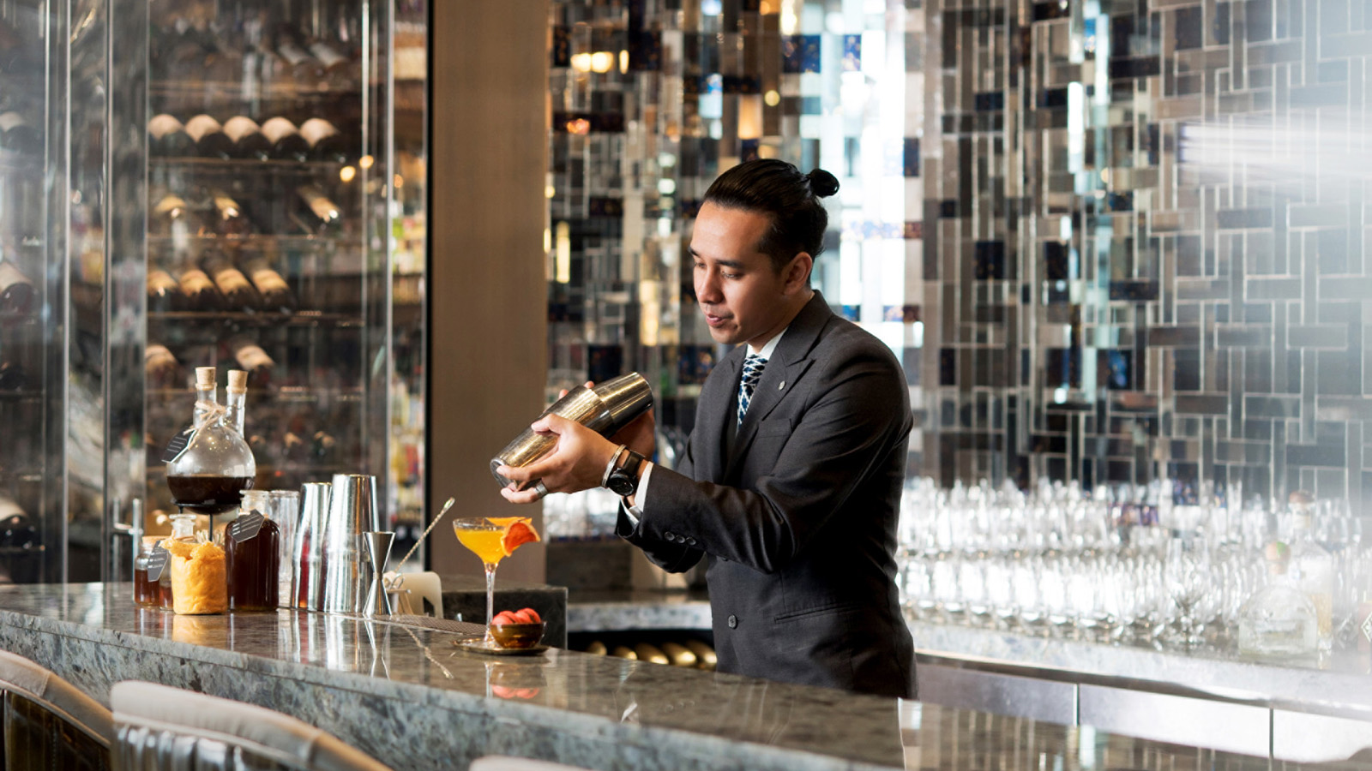
Bar Trigona at Four Seasons Hotel Kuala Lumpur has emerged among the top five contenders for the inaugural Siete Misterios Best Cocktail Menu Award, announced on December 7, 2021 at The World’s 50 Best Bars 2021 ceremony.
Based on an assessment of 190 bars across 43 countries, this prestigious title celebrates the brilliance of an individual bar’s cocktail menu, evaluating aspects such as storytelling, innovation and sustainability. Bar Trigona has been recognised for its exceptional Herb Garden in Your Glass menu, which puts the spotlight on Malaysian herbs used in kitchens across the country.
“We are thrilled to be shortlisted for this prestigious award in its very first year. On behalf of the entire team, I would like to thank all those who have supported us on this journey, especially our loyal guests and the local farmers we are proud to partner with,” says Assistant Bar Manager Julian Benjamin. “We promise to continue redefining luxury beverages by showcasing the best of Malaysian farms, gardens and forests.”
Herb Garden in Your Glass
Paying homage to homegrown herbs, this storied menu is woven around four Malaysian staples – pandan (screwpine), pegaga (Asiatic pennywort), bunga kantan (torch ginger), and lemongrass.
Featured in culinary recipes and healing concoctions for centuries, these herbs are now used by the Bar Trigona team in myriad ways to extract their full range of flavours and textures. Not only does this root-to-shoot approach help to maximise creativity but it also to minimises food wastage.
Guests can sample signature creations such as Serenity, an intense blend of aged and dark rums with candlenut osmanthus orgeat and lemongrass falernum, and Honey Bloom, a refreshing medley of white rum and bunga kantan honey with elements such as citrus, elderflower and ginger. In Black & Gold, taste blended scotch and prosecco elevated by pandan cordial and epsuma.
At the Forefront of Sustainability
As a previous winner of the Ketel One Sustainable Bar Award, Bar Trigona is a pioneer in sustainable cocktail-making. “We have to look at the entire lifecycle of ingredients. What can we reuse, recycle, repurpose? We are passionate about exploring different ways to protect our planet,” says Julian.
The bar draws ongoing inspiration from its namesake – the trigona honeybee. Native to Malaysia, these tiny, stingless bees produce a honey prized for its sweet and sour notes. The team sources its artisanal honey from a farm in Negeri Sembilan, a collaboration that has flowered into a hive of eco-friendly initiatives over time, including the popular Adopt a Beehive programme.
“For us, a big part of sustainability means working with local communities,” explains Julian, noting that their hyperlocal approach is founded on long-standing partnerships with Malaysian farmers.
The team’s latest project is Tree-volution, an ambitious reforestation initiative that is planting fruit trees around local farms. Proceeds from selected cocktails fund seed collection, planting and protection of the fledgling forest. Alongside with providing employment, the goal is to refortify the soil and restore biodiversity.
Award-Winning Hospitality
Celebrated by patrons and industry alike, Bar Trigona claimed a coveted spot among The World’s 50 Best Bars 2020, making it the first-ever bar in the country to receive this recognition. It was also named 12th Best Bar in Asia by Asia’s 50 Best Bars 2021.
Stylish yet authentic, Bar Trigona embodies the true art of personalisation – from tailored cocktails to personalised service. “Everyone who walks through our doors is met with a warm welcome and treated with genuine care. That’s who we are,” says Julian.
Ready to sip a herb garden in a glass? Chat with Bar Trigona via the Four Seasons App for reservations.

RELATED

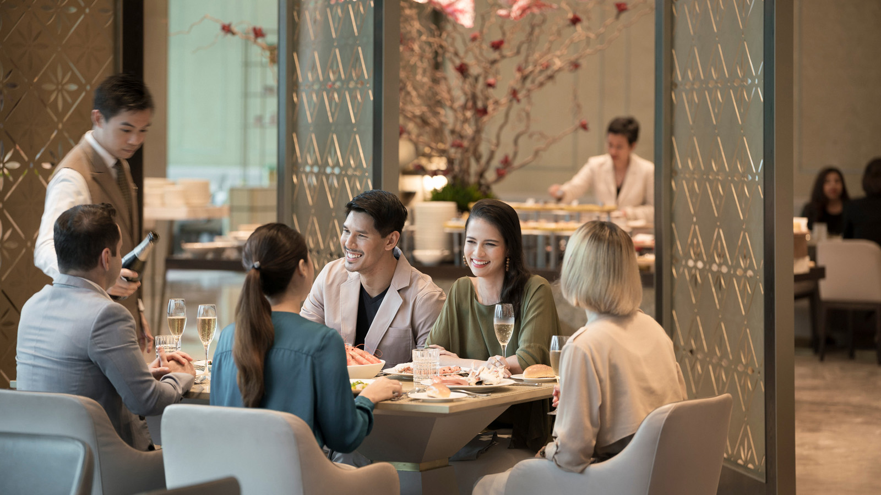 | November 23, 2021, Kuala Lumpur, Malaysia  Joys of the Seasons: Discover a Gastronomic Wonderland at Four Seasons Hotel Kuala Lumpur  https://publish.url/kualalumpur/hotel-news/2021/festive-season.html
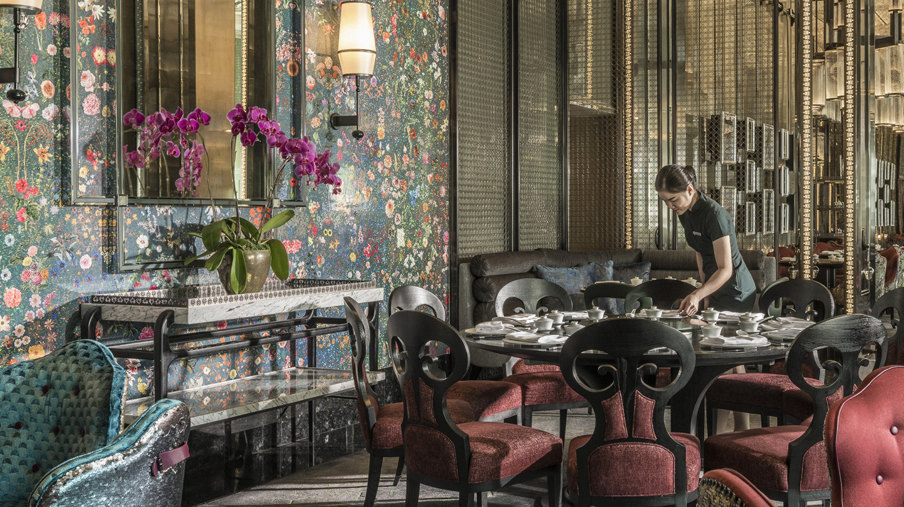 | November 15, 2021, Kuala Lumpur, Malaysia  Ready, Set, Play! Yun House at Four Seasons Hotel Kuala Lumpur Redefines Cantonese Dining with Fresh Flair  https://publish.url/kualalumpur/hotel-news/2021/yun-house-relaunch.html

PRESS CONTACTS

Kanchana Ganglani
Director of Public Relations
145 Jalan Ampang
Kuala Lumpur
Malaysia
kanchana.ganglani@fourseasons.com

+6(03) 2382 8740

