Four Seasons Hotel Denver Unveils Enticing Culinary Events and Special Dinners

Calling all foodies: EDGE to debut chic new dining series, pool events, holiday dining and more
March 12, 2018, Denver, U.S.A.

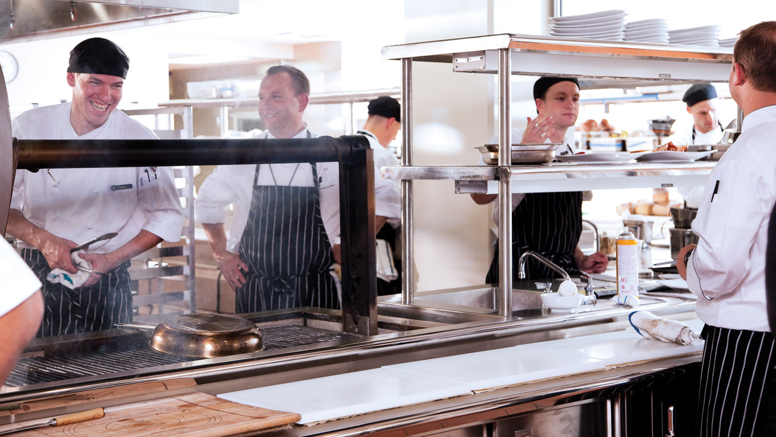
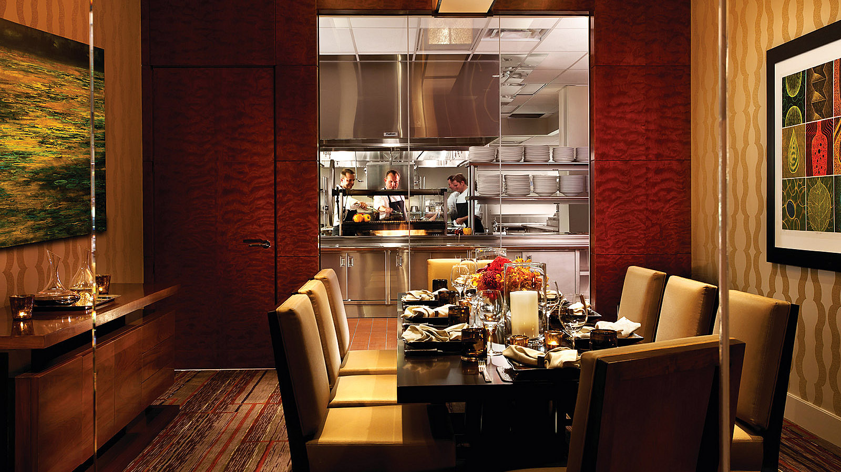 | 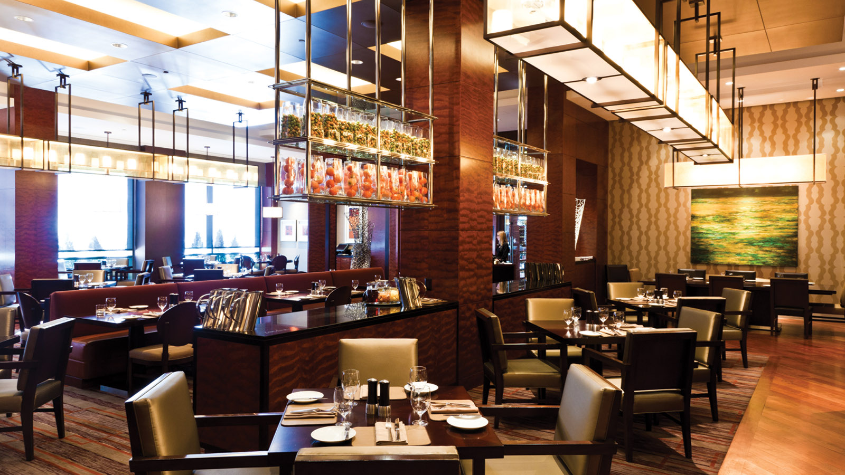
With a new season around the corner in the Mile-High City, the team at
Four Seasons
Hotel Denver and EDGE Restaurant and Bar is celebrating by announcing a calendar of restaurant and bar events sure to excite any foodie or experience-seeker.
“I’m thrilled about the upcoming events planned for EDGE,” says Director of Food and Beverage Loic Thomas. “We are honoured to partner with outstanding wine and spirits companies, participate in local community events and shine a light on the culinary talent at the Hotel.”
Save the dates below for the special happenings at EDGE Restaurant and Bar:
March 2018
- March 17 - St. Patrick’s Day at EDGE Bar: This St. Patrick's Day, join EDGE Bar and Tullamore Dew for a celebration sure to bring the luck of the Irish. Beginning at 2:00 pm, enjoy live Irish music, prize giveaways, and Irish-themed food and drink specials throughout the evening.
April 2018
- April 1 - Easter Brunch at EDGE: EDGE Restaurant is celebrating Easter with an expansive brunch buffet, featuring a variety of breakfast options, seafood raw bar, live action pasta and carving stations, and activities for the entire family. Easter Brunch seatings are available from 10:00 am to 3:00 pm for USD 85 per adult and USD 35 per child 12 and under.
- April 11 - Kentucky Derby Hat Happy Hour: In partnership with Mariel Boutique, join as EDGE Bar hosts a Hat Happy Hour on Wednesday, April 11 from 5:30 to 7:30 pm. Enjoy Southern-inspired cocktails and a Derby hat trunk show to shop the latest fashions for the Running of the Roses viewing parties.
- April 14 - Louis Roederer Cristal Dinner: As the official kick off for the new EDGE dining series, the restaurant will host an exclusive five-course champagne dinner with Louis Roederer on Saturday, April 14 at 6:30 pm. Guests will enjoy a five course meal prepared by Executive Chef Simon Purvis paired with champagne from Louis Roederer, highlighting Cristal and Cristal Rosé. The intimate dinner is limited to 20 seats and available for USD 300 per person, inclusive of tax and gratuity.
- April 18 - Don Julio Tequila Dinner: On Wednesday, April 18 at 6:30 pm, EDGE Restaurant welcomes Don Julio for a tequila pairing dinner. Guests will enjoy five courses prepared by the culinary team paired with Don Julio tequila, including favourites such as Don Julio 1942 and Don Julio Real. Seating for this dinner is limited to 20 people and can be reserved for USD 175 per person, inclusive of tax and gratuity.
May 2018
- May 5 - Kentucky Derby Party & Brunch: The annual Kentucky Derby Day party and brunch returns to the third-floor rooftop pool terrace at the Hotel, welcoming guests to celebrate the Running of the Roses with a viewing party and live DJ entertainment on Saturday, May 5 from 2:00 to 7:00 pm. Before the races begin, enjoy a brunch buffet at EDGE Restaurant or on the Hotel's sought after rooftop pool terrace, both available for USD 84 per person, inclusive of tax and gratuity.
- May 17 - "Flavors" American Liver Foundation Dinner: Executive Chef Simon Purvis will be a highlighted chef for this event at The Hangar at Stanley, alongside local culinary talent in Denver. Participating chefs will cook a signature dish for a multi-course dinner, benefitting the American Liver Foundation.
June 2018
- June 10 - 303 Magazine Pool Party: In partnership with 303 Magazine, enjoy live DJ entertainment, drink specials and a day to enjoy the great outdoors on the Hotel’s third-floor rooftop pool terrace beginning at 4:00 pm.
- June 21 - Do at the Zoo: Executive Chef Simon Purvis will participate in this annual event at the Denver Zoo. Proceeds benefit science education, local and global conservation of wild animals and world-class animal care.
- June 28 - Top Taco: EDGE Restaurant Chef Zachary Rozanski and the EDGE Bar team will compete alongside dozens of local Denver restaurants for "Top Taco" and best cocktail in partnership with Patron Tequila on Thursday, June 28 at the River North Festival Grounds in Denver.
To make a reservation for the Louis Roederer or Don Julio dinner, contact Sarah McHugh at sarah.mchugh@fourseasons.com or call 303 389 3149. For all other dining reservations, call 303 389 3050.

RELATED

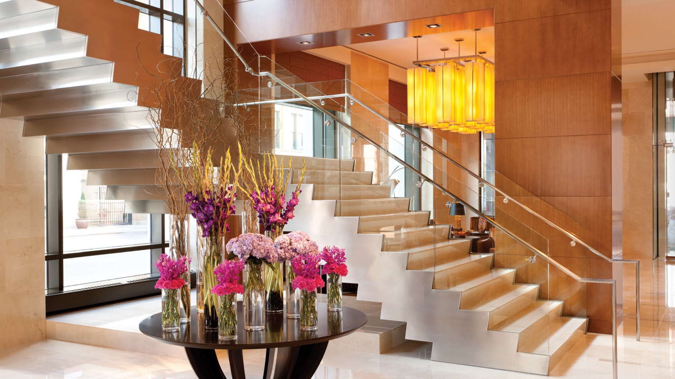 | April 9, 2018, Denver, U.S.A.  Treat Mom to a Mile-High Mother’s Day at Four Seasons Hotel Denver  https://publish.url/denver/hotel-news/2018/mothers-day.html
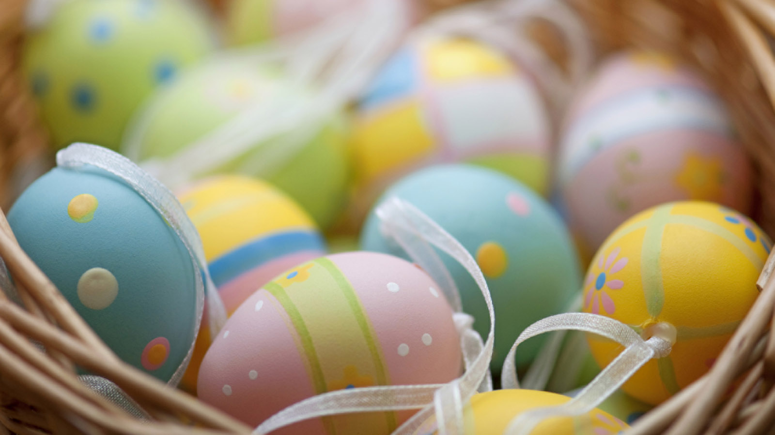 | March 5, 2018, Denver, U.S.A.  Hop Over to EDGE Restaurant at Four Seasons Hotel Denver to Celebrate Easter  https://publish.url/denver/hotel-news/2018/easter.html

PRESS CONTACTS

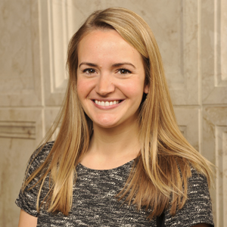 | Sally Mjoseth  Public Relations Manager  1111 14th Street  Denver  U.S.A.  sally.mjoseth@fourseasons.com  +1 (303) 389-3000

