The Spa at Four Seasons Resort Orlando Introduces New, Results-Oriented Treatments

Cryotherapy and exclusive Biologique Recherche now offered
December 3, 2019, Orlando at Walt Disney World Resort, U.S.A.

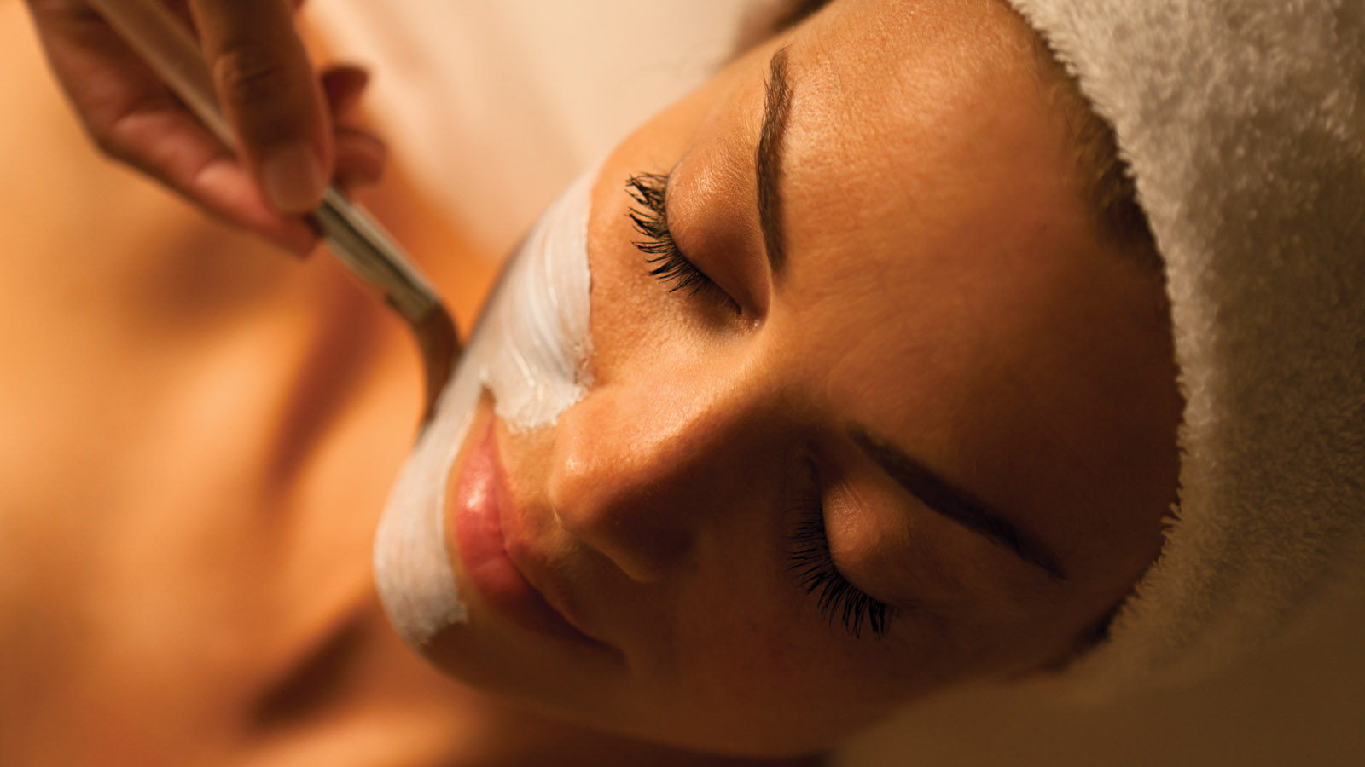
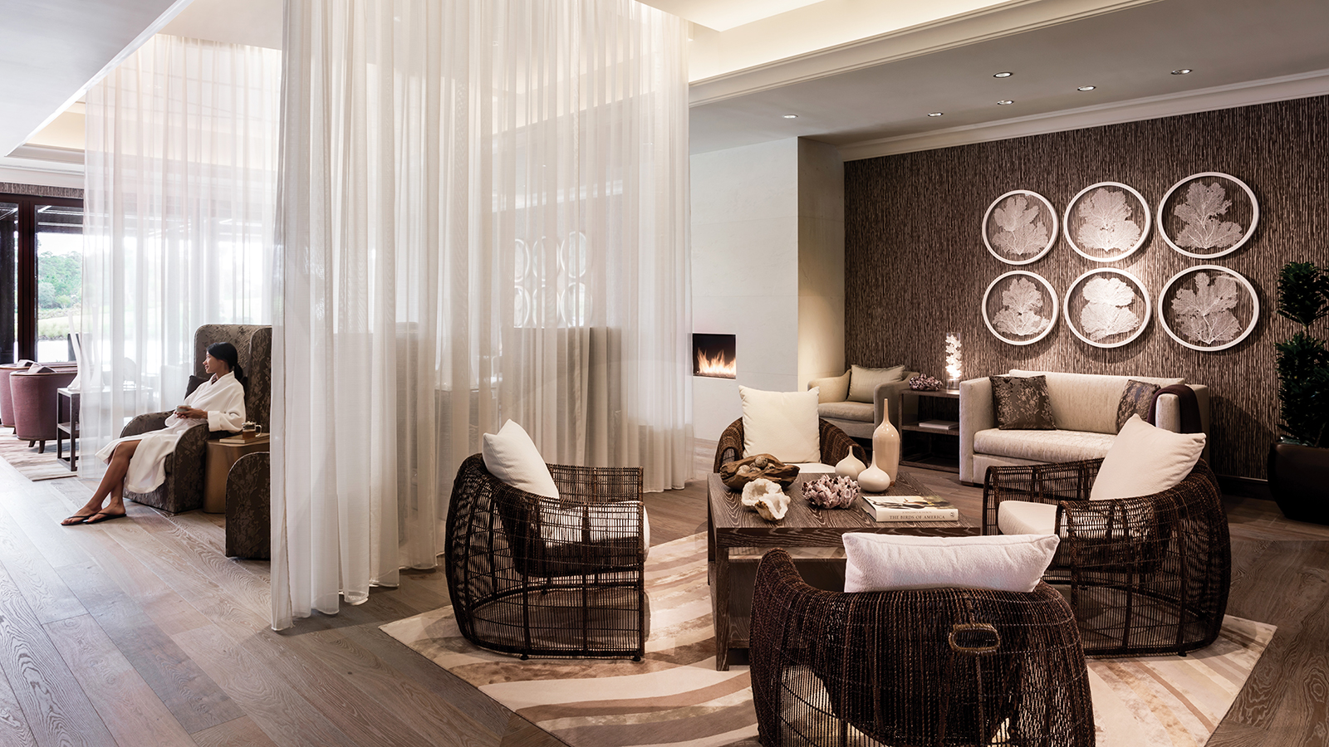
The Spa at Four Seasons Resort Orlando at Walt Disney World Resort is Central Florida’s premier spa offering both high-tech, innovative results-driven therapies, combined with traditional body and facial therapies, for the ultimate in rejuvenation and restoration. Exclusive in Central Florida to Four Seasons Orlando, The Spa now offers the Parisian line Biologique Recherche and its array of remarkably effective facials. Additionally, The Spa is now offering several cryotherapy treatments for body contouring, using a high-tech Cryoskin machine.
“The Spa at Four Seasons offers full body and facial regimens, catering to all areas of interest, from age-defying and hydrating to contouring and slimming,” says Derek Hofmann, Senior Director of Spa for Four Seasons Resort Orlando. “For guests who wish to recharge with a spa service, The Spa is always an incredible experience, however for guests who are seeking advanced therapies and results-oriented procedures, I am pleased that our spa therapists are able to produce noticeable results by offering many new high-tech treatments, such as the Micro-Puncture Facial and Cryo Slimming.”
Hofmann notes many of The Spa’s introductory clients of these new procedures have purchased multi-treatment packages to return for additional sessions, since results are intensified with frequency.
Biologique Recherche
Esteemed skin care line Biologique Recherche of France is known for its high concentrations of botanical, marine and biological extracts. Cold-made formulations that preserve the structure of active ingredients are applied to “recondition” the skin and help activate regeneration properties and balance the skin. The Spa now has the Biologique Recherche Remodeling Face Machine, a non-invasive machine that uses electrical currencies at three different frequencies, aimed to stimulate tissue, plump the skin, and create a radiant, refreshed look. The following new treatments are offered incorporating this premium line:
- Hyper Customised Facial – 50 minutes, USD 210; 80 minutes, USD 310 - A bespoke facial designed to show instant results for all ages and skin types, this facial includes a thorough skin consultation, deep cleanse, exfoliation, delightful and effective lifting and contouring facial massage, and a curated skin cocktail of serums and masks.
- Lift & Remodel Facial – 80 minutes, USD 395 - Define and sculpt facial contours while stimulating underlying tissue with three currents. Galvanic, medium and high frequency are utilised to lift the face, neck and décolleté. Remodeling Face Machine revitalises the skin, restores elasticity and reduces puffiness around eyes while improving the penetration of active ingredients for the ultimate anti-ageing experience.
- Regenerating Micro Puncture Facial – 50 minutes, USD 350; 80 minutes, USD 445 - This facial is an intensive treatment that increases collagen production through intra-epidermal micro stimulation combined with a serum skin cocktail of highly active amino acids and vitamins. Micro Puncture Lab activates the skin’s natural repair and regenerative process. A remarkably effective treatment to illuminate the complexion, improve firmness and elasticity and combat premature signs of ageing. The 80 minute treatment includes cocktails d’actifs and specialty collagen mask.
Biologique Recherche Touch Therapies for the Body
- Tone & Lift – 50 minutes, USD 190; 80 minutes USD 285 - A restorative body treatment featuring an exfoliating session followed by a bio-reflex massage using a moisturising and dermo-protecting complex, followed by the application of firming cream that prevents against skin slackening. This treatment offers a full body toning of the epidermis while refining skin’s texture.
- Detox & Slim – 80 minutes, USD 285 - This treatment aims to improve circulation, blood flow, eliminate toxins and fats responsible for localised weight gain and help to regenerate body tissue. This treatment is ideal for combating water retention and bloating while naturally encouraging slimming.
Cryotherapy
Exclusive to Four Seasons Resort Orlando in Central Florida, the cryotherapy treatments involve a technique to slim the body with a three-phase thermal shock system that destroys fat cells, followed by a lymphatic massage. The Spa uses the Cryoskin machine, in which the therapist uses a wand to apply temperatures of negative four degrees Celsius to four degrees Celsius, to trigger the death of fat cells and achieve results. An immediate slimming in the targeted area, such as the stomach, thighs, arms, or back, is often experienced as a result of localised exposure to sub-zero temperatures. Longer lasting results will be seen at the end of three to five sessions.
Cryo toning sessions aim to eliminate cellulite, slow the skin’s ageing process and improve tone and appearance to areas lacking elasticity. This cold therapy treatment advances oxygenated blood flow, speeds up cellular metabolism and helps to yield higher collagen production.
- Cryo Slimming – USD 350 for a 50 minute treatment; USD 325 per treatment for a series of three; or USD 300 per treatment for a series of five - Naturally slim the body with this remarkable treatment consisting of a three-phase thermal shock to destroy fat cells and lose inches on the stomach, thighs, arms, and back. Results are immediate after one session and best results occur between three and five sessions.
- Cryo Toning – USD 350 for a 50 minute treatment; USD 325 per treatment for a series of three; or USD 300 per a series of five - Eliminate cellulite, slow the skin’s ageing process and improve tone and appearance with this cold therapy treatment that improves microcirculation, speeds up cellular metabolism and helps to yield higher collagen production.
- Cryo Facial – USD 250 for a 50 minute treatment; USD 225 per treatment for a series of three; or USD 200 per treatment for a series of five - For the face, cryo techniques can also assist with diminishing fine lines, boosting collagen production, improving elasticity, and feeling a tightening of the skin with advanced oxygenated blood flow from cold therapy. Immediate enhancements in the tone and appearance of skin, as well as a refreshing lift and firmness, are experienced after one session. The Cryo Facial stimulates major collagen production for a firmer, more radiant glow.
With all cryo therapies, optimal results are seen with multiple sessions. Cryo Toning benefits are not permanent and are cumulative with regular sessions and healthy lifestyle choices. Cryo treatment results can last for several weeks after the treatment, and best results are typically seen between fifteen days and three weeks.
About The Spa at Four Seasons
The 18-treatment room Spa at Four Seasons is a sanctuary of wellness, offering exclusive body and facial treatments such as the Vibrational Sound Therapy, detoxifying cupping, a hydrating oxygen facial, plus many traditional facial and body therapies and a full hair and nail salon. The Spa’s two relaxation lounges, plus separate solarium with zero-gravity loungers and spacious men’s and women’s locker rooms with experience shower, steam room and whirlpool, provide the ultimate opportunity to relax and de-stress. For appointments, call 407 313 6160.

RELATED

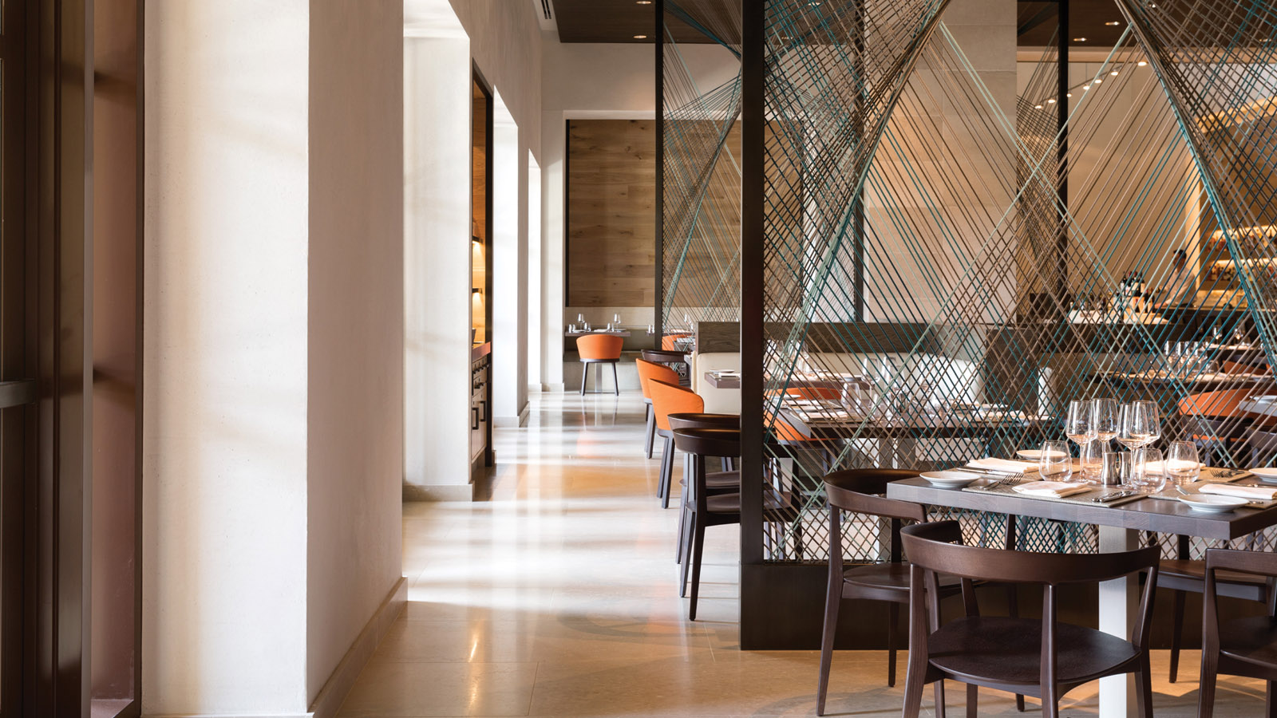 | November 11, 2019, Orlando at Walt Disney World Resort, U.S.A.  Four Seasons Resort Orlando Hosts James Beard Foundation Dinner for 5th Year  https://publish.url/orlando/hotel-news/2019/james-beard-dinner.html
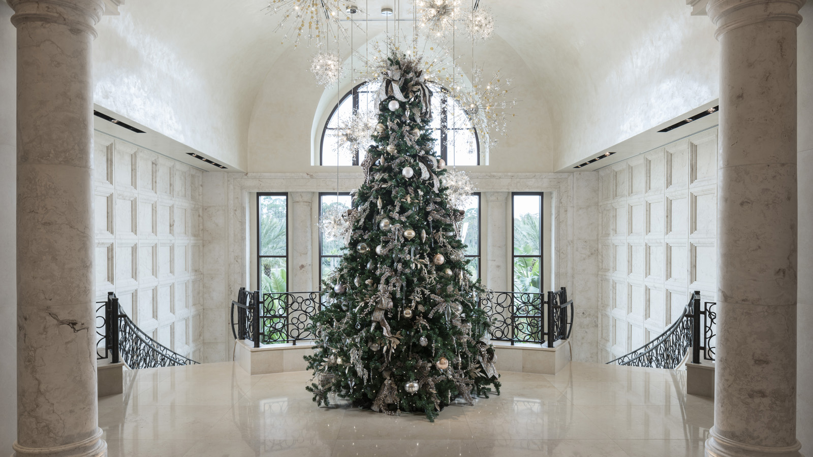 | October 3, 2019, Orlando at Walt Disney World Resort, U.S.A.  Rejoice with a Festive Season Vacation Under the Sun at Four Seasons Resort Orlando at Walt Disney World Resort  https://publish.url/orlando/hotel-news/2019/festive-season.html

PRESS CONTACTS

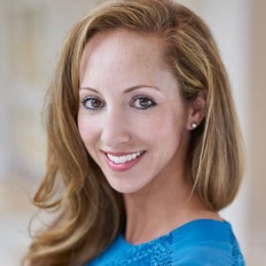 | Dana Berry  Director of Public Relations  10100 Dream Tree Boulevard  Orlando  U.S.A.  dana.berry@fourseasons.com  1 (407) 313-7777

