Take a Leap and Make the Most of Gifted Hours at Four Seasons Resort and Residences Whistler This Leap Day

February 21, 2020, Whistler, Canada

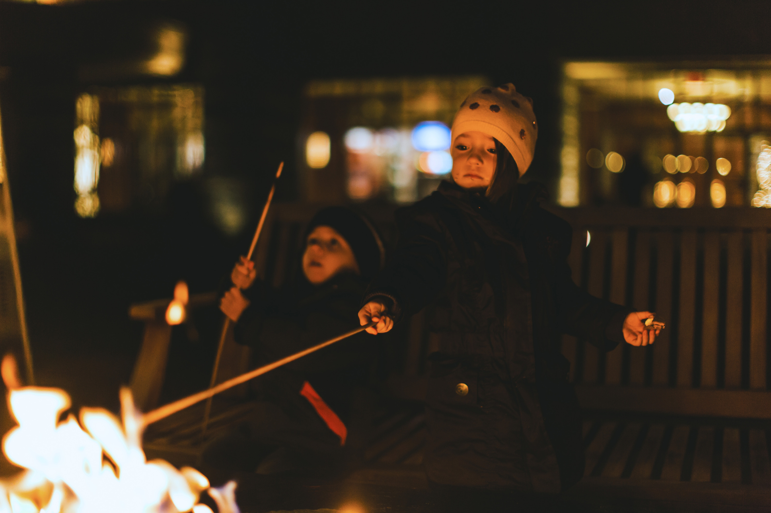
2020 has gifted us all with an extra day and the team at Four Seasons Resort Whistler is making it easier to seize every moment from sunrise to sunset. Inspiring guests to take their time, a series of unique experiences have been crafted to make the most of this Leap Day. Take time to reconnect while immersed in local culture at sunrise, receive extra time at The Spa with a signature Sea to Sky treatment, go back in time with the exclusive 1908 cocktail at SIDECUT Bar or celebrate the end of extra hours with a sunset party at the infamous Vintage Patio Camper.
Sunrise Yoga at the Squamish Lil'wat Cultural Centre
Take time to reconnect surrounded by local First Nation art and history with an exclusive Four Seasons Resort Whistler sunrise yoga class held at Whistler’s Squamish Lil'wat Cultural Centre. Conveniently located adjacent to the Resort, the SLCC celebrates the joint history of Squamish and Lil’wat First Nations, past and present, by showcasing their histories, creative works and cultures in an interactive format. Guests can prepare for the coming day while enjoying the stunning views of the northerly mountain ranges and Lost Lake Woods.
Extra Time at The Spa
Enjoy a luxurious journey up the Sea to Sky with a Signature Treatment from The Spa at Four Seasons Resort Whistler. The experience begins with a Canadian maple syrup and brown sugar scrub followed by a warm clay and algae nourishing body wrap. While wrapped, hair and scalp are treated to a Moroccanoil massage and conditioning treatment. The journey is completed with a deep moisturising, full-body massage using organic detoxifying body butter. Signature Treatments booked on Leap Day will receive a complimentary 10 minutes of additional massage.
Subtle Thyme Stories at SIDECUT Bar, Four Seasons Resort Whistler
Introducing 1908, a cocktail taking us back to a leap year that saw the first-ever ball-drop in Times Square. SIDECUT Bar's 1908 combines the unique flavour of 1908 Empress gin with a house-made syrup of honey, vanilla and the subtle reference of thyme. Balance is added with a touch of citrus, changing the hue to a delicate purple.
Head Bartender at Four Seasons Resort and Residences Whistler Robert Kharazmi, speaks of his creation: “When you receive the gift of additional time it always feels like magic, it gives you that uplifting feeling I wanted to re-create in this cocktail. Using a colour-changing botanical, I have added a touch of magic and, through the syrup, I wanted to hint of the bonus ‘thyme’ a leap year brings - because I can never resist a little pun.”
Celebratory Sunset Party at the Vintage Patio Camper
Seize the final hours of Leap Day while watching the winter sun fall behind a snow covered peak while dancing to smooth tunes by local Whistler legen, DJ Foxy Moron at the ever-Instagrammable Vintage Patio Camper. Snack on time-themed nibbles, Canadiana s’mores and Tipsy Snowman signature hot chocolates.
Take the leap and make a mountain of memories this Leap Day. All #FSTakeYourTime activities are exclusive to guests staying at the Four Seasons Resort and Residences Whistler on February 29, 2020.

RELATED

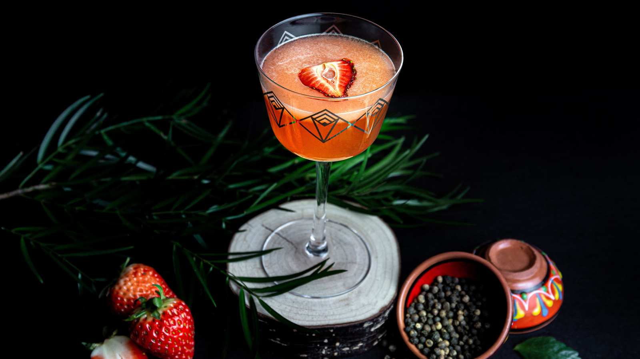 | February 19, 2020, Whistler, Canada  New Names Join Lauren Mote for the Third Volume of the Spirit of the Mountains Cocktail Program at Four Seasons Resort and Residences Whistler  https://publish.url/whistler/hotel-news/2020/new-spirit-of-the-mountains-cocktails.html
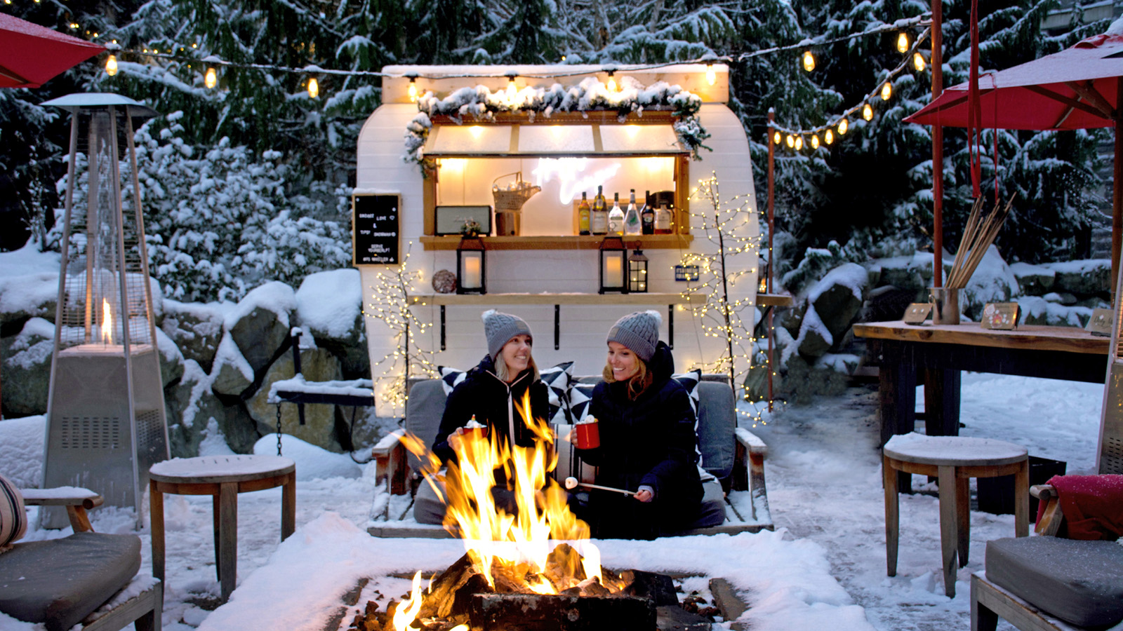 | January 22, 2020, Whistler, Canada  With Fresh Snow Comes Fresh Experiences at Four Seasons Resort and Residences Whistler  https://publish.url/whistler/hotel-news/2020/winter-experiences.html

PRESS CONTACTS

Eleanor Gilkes
PR Executive
4591 Blackcomb Way
Whistler
Canada
eleanor.gilkes@fourseasons.com

+1 604 966 2666

