A Season of Festive Fun at Four Seasons Resort Sharm El Sheikh

December 16, 2018, Sharm El Sheikh, Egypt

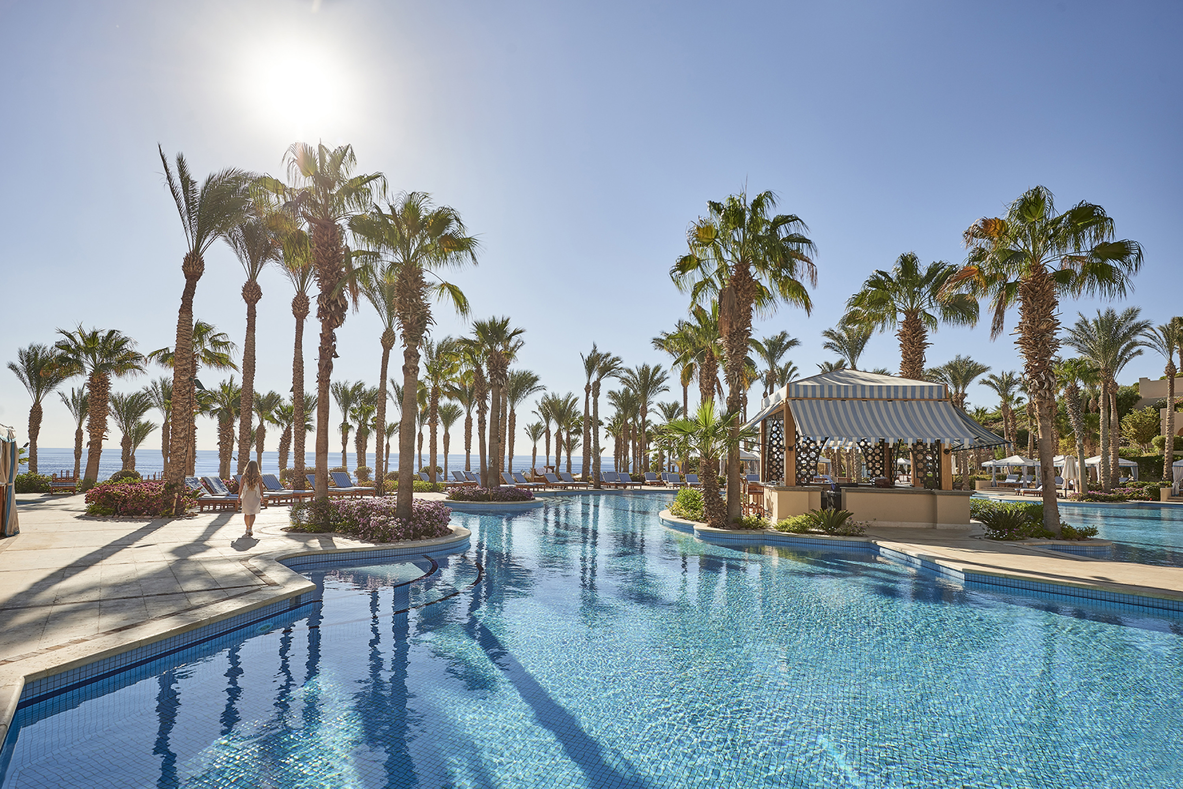
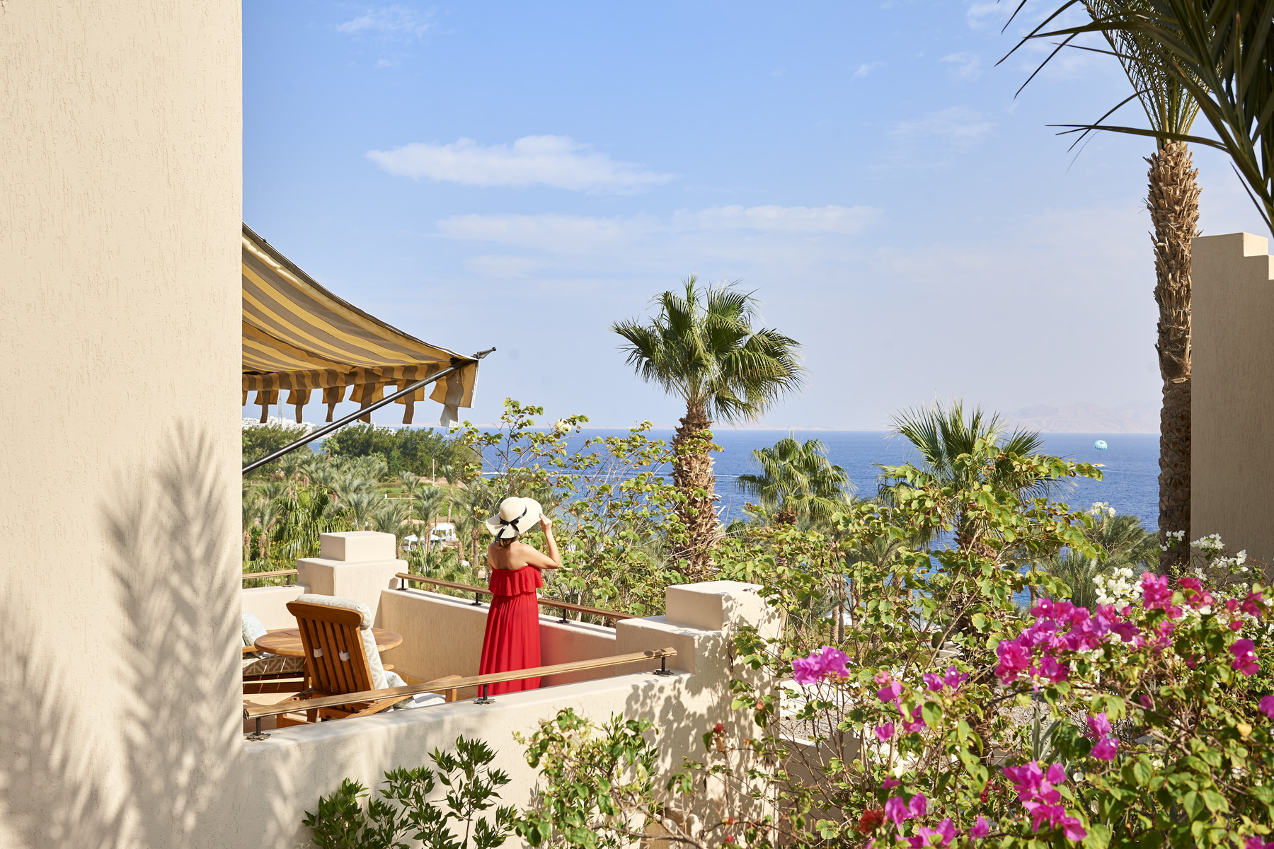
Escape the winter days into the all-year-around warm haven of Four Seasons Resort Sharm El Sheikh, a desert-and-sea hideaway. Whether looking for a romantic New Year break or a family festive celebration, the Resort's masterful team will ensure a magical stay in the exotically enchanting Red Sea resort.
Kick off the holiday season with a magnificent journey far away to the charming city of Sharm El Sheikh and immerse in an intimate ambiance with an exclusive program of indoor and outdoor activities, with celebratory gastronomic experiences that will satisfy every appetite and help every guest embrace the best of the merry season.
As 2018 comes to an end, dance the night away and party with the live band, special DJ tunes, and a wide selection of selectively crafted cocktails by the talented mixologists.
And because this is the time of the year to spend rekindling with family, Four Seasons Resort Sharm El Sheikh has thought about the “littlest” details of all. The Kids for All Seasons team will be ready with lots of entertainment activities and fun-filled themed programs for the little ones to engage in recreational activities of their choice, setting the tone for a true festive celebration.
The Resort’s coveted location, with an easy on-site access to 70 must-experience Red Sea dive sites, makes it a world-class diving destination. Together with various accommodation options inspired by oriental art and Moorish architecture, in addition to an authentic spa experience, nine dining options, four swimming pools and the impeccable Four Seasons hospitality, guarantee a wonderful winter wonderland.
For a spectacular start to 2019, stay a little longer to breathe in the warm Red Sea breeze and experience the stunning New Year’s Eve celebrations at Four Seasons Resort Sharm El Sheikh.
Book the perfect festive season holiday now.

RELATED

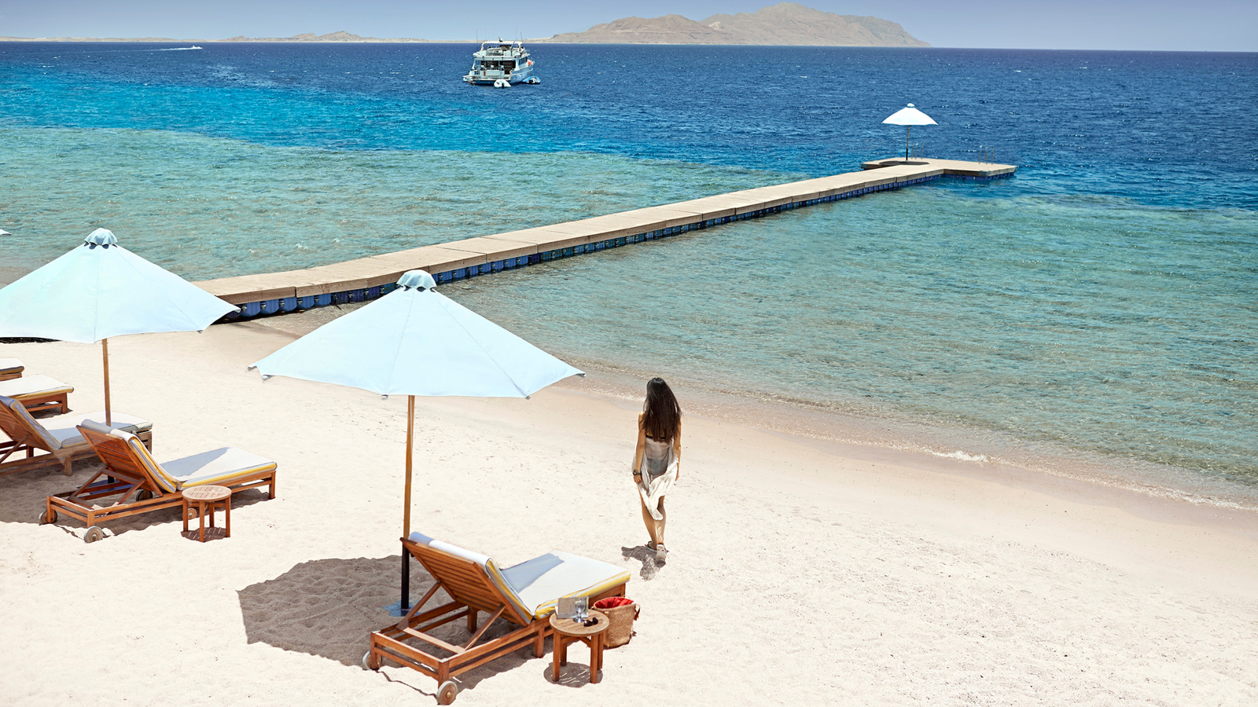 | August 13, 2018, Sharm El Sheikh, Egypt  Ultimate Eid Getaway at Four Seasons Resort Sharm El Sheikh  https://publish.url/sharmelsheikh/hotel-news/2018/eid-getaway.html
June 7, 2018, Sharm El Sheikh, Egypt
Four Seasons Resort Sharm El Sheikh Celebrates Global Wellness Day
https://publish.url/sharmelsheikh/hotel-news/2018/global-wellness-day.html

PRESS CONTACTS

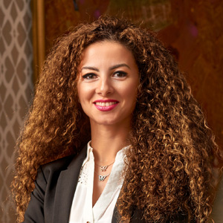 | Sherry Adel  Senior Director of Public Relations and Marketing Communications - Egypt  1089 Corniche El Nil, P.O. Box 63 Maglis El Shaab  Garden City 11519, Cairo  Egypt  sherry.adel@fourseasons.com  +20 (2) 2791 7000
Sally Hamdy
Public Relations Manager
1089 Corniche El Nil, P.O. Box 63 Maglis El Shaab, Garden City
Cairo
Egypt
sally.hamdy@fourseasons.com

+20 (2) 2791 7788

