A Season of Romance at Four Seasons Hotel Kuala Lumpur

Four Seasons rolls out the red carpet for Kuala Lumpur’s lovebirds
February 2, 2021, Kuala Lumpur, Malaysia

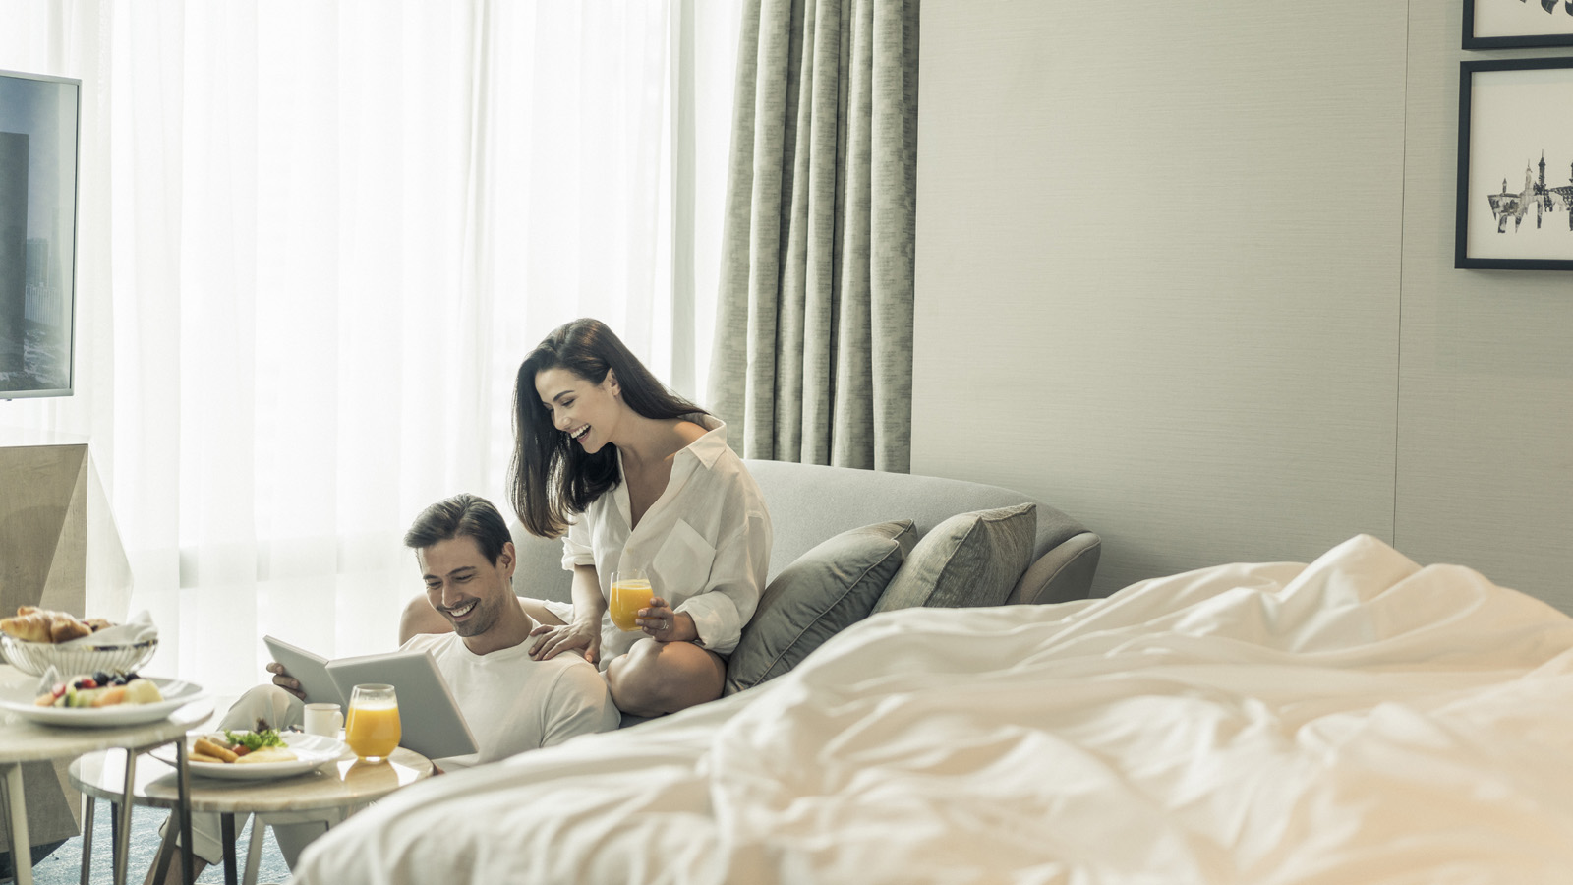
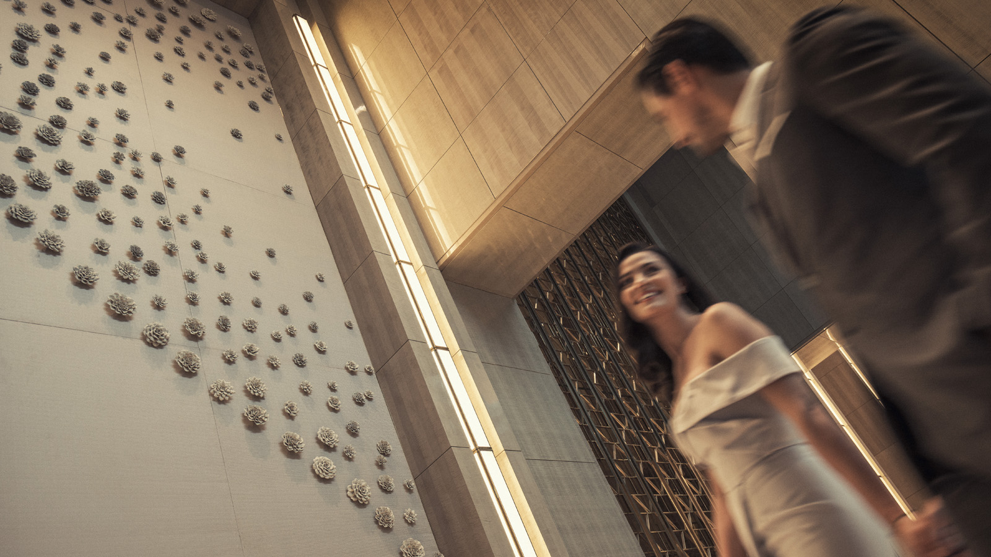
This February, fall in love all over again at Four Seasons Hotel Kuala Lumpur with Valentine’s Day offers, whether staying over or bringing the romance home.
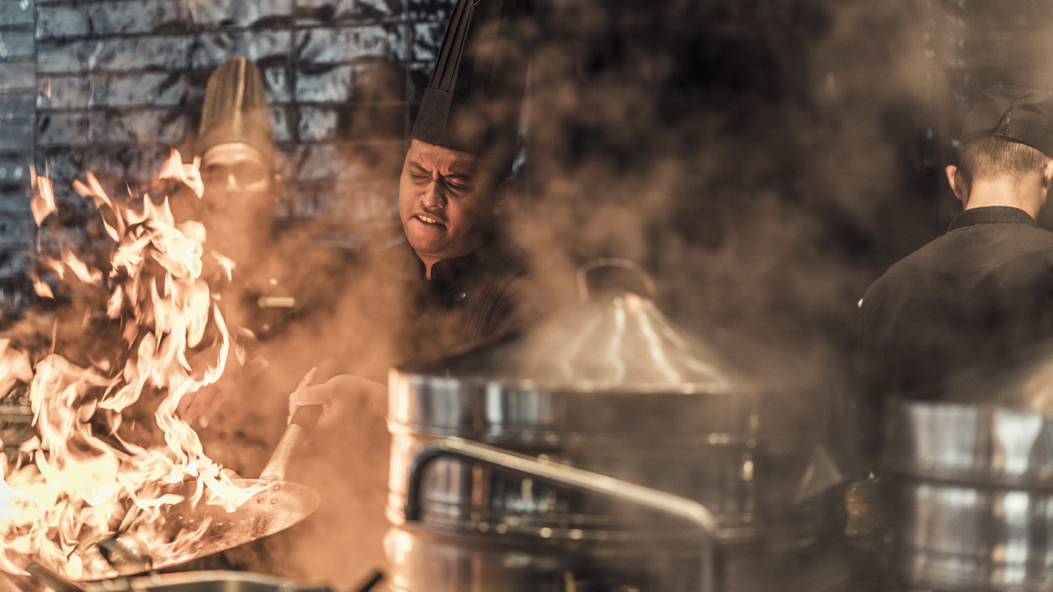
Escape to this glamorous lifestyle sanctuary to celebrate the season of love with an intimate staycation. Four Seasons staff plays Cupid, creating a magical love-is-all-around ambience and pampering the couple with special treats – perfect for reigniting that precious romantic spark.
“This has been a year when the world paused and reflected on what really matters. The answer is clear – nothing is more important than our loved ones,” smiles Alex Porteous, General Manager. “Our Valentine’s Day experiences are the perfect way to spoil your sweetheart and show them how much they mean to you.”
Romantic Getaway Package
Get cosy with a luxurious staycation for two, filled with romantic offerings – available all through February 2021. Lovebirds can choose to stay in their own exclusive bubble throughout the stay, wrapped in indulgence and world-class Four Seasons care.
Wake up to stunning vistas of the city or the greenery of KLCC park, then linger over a leisurely gourmet breakfast. Each stylish guest room or suite comes with expansive window walls, offering an array of day-to-night views. As the setting sun paints the sky with vibrant hues, raise a toast to love with crafted cocktails from the award-winning team at Bar Trigona.
After dark, the glittering skyline forms a dramatic backdrop for "Love @ First Bite" – a swoon-worthy culinary journey. Reconnect and savour each moment over this three-course dinner, with luscious ingredients such as oysters, wagyu beef and lobster, paired with tantalisers such as caviar, aromatic prawns and coconut crème fraiche.
Guests can elevate the evening further with optional add-ons. Choose from a selection of fines wines and gift boxes featuring fresh flowers, pralines and more. Afterwards, the signature Four Seasons Bed promises a night of bliss.
Inclusions:
- Daily breakfast for two
- Nightly dinner for two (three-course set menu, includes a rose and box of pralines)
- Pre-dinner drinks for two (happy hour menu)
- Overnight self-parking
- Available until February 28, 2021
From MYR 1,320 nett per night for a double room, this offer can be booked here.
With Love, From Four Seasons
Bring home the Four Seasons magic with signature Valentine’s Day deliveries.
Transform a quiet night into a memorable occasion with "Love @ First Bite," a feast tailored for lovers. The seductive menu is filled with prized ingredients such as lobster, salmon and prawns, enhanced with elegant touches such as Italian cheese, sakura floss and fresh greens. A blooming rose and box of pralines add to the feeling of indulgence. KL residents can also pamper their sweethearts with curated gift boxes, featuring floral bouquets, delectable pralines, wellness goodies and more.
- Available from February 12 to 14, 2021
- Love @ First Bite at MYR 399 nett per couple (three-course set menu, includes a rose and box of pralines)
- Gift boxes from MYR 99 to MYR 599 nett
Rediscover romance with an unforgettable Valentine’s celebration this February. Chat with the Hotel via the Four Seasons App for reservations or enquiries.

RELATED

January 13, 2021, Kuala Lumpur, Malaysia
Innovative Virtual Events at Four Seasons Hotel Kuala Lumpur
https://publish.url/kualalumpur/hotel-news/2021/virtual-meetings-and-events.html

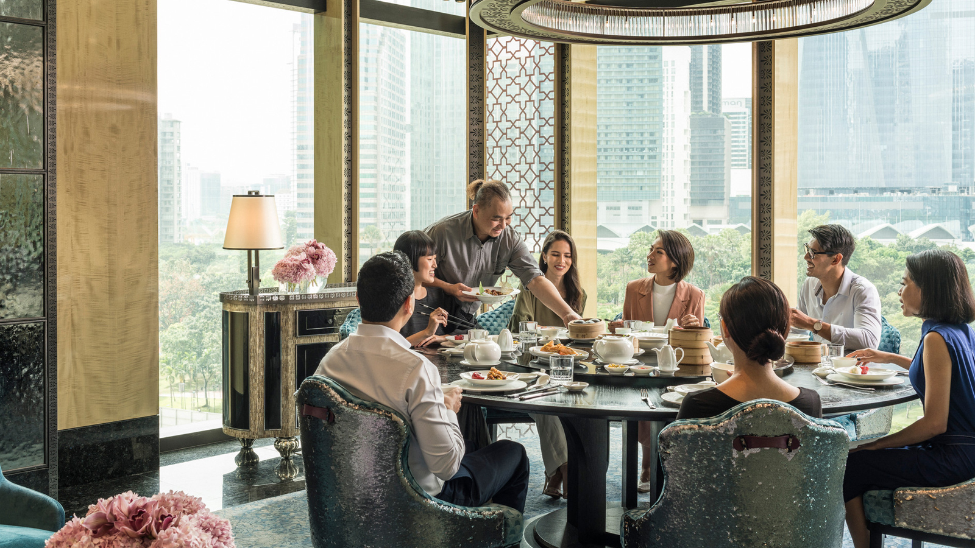 | January 4, 2021, Kuala Lumpur, Malaysia  Celebrate Chinese New Year with Festive Delights at Four Seasons Hotel Kuala Lumpur  https://publish.url/kualalumpur/hotel-news/2021/lunar-new-year.html

PRESS CONTACTS

Kanchana Ganglani
Director of Public Relations
145 Jalan Ampang
Kuala Lumpur
Malaysia
kanchana.ganglani@fourseasons.com

+6(03) 2382 8740

