Four Seasons Hotel Bahrain Bay Recognised with Condé Nast Traveller’s Readers’ Choice Award

Bahrain’s leading island resort awarded as Favourite Hotel in Bahrain 2021
December 7, 2021, Bahrain Bay, Bahrain

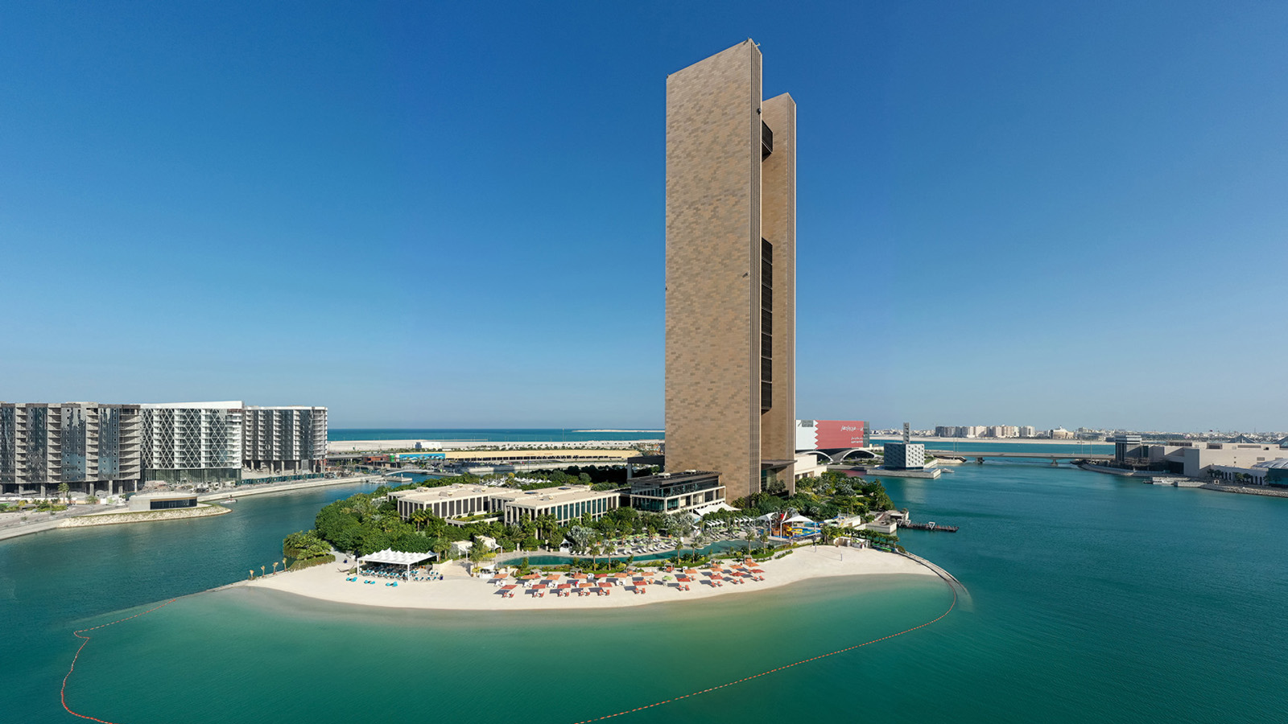
As the world slowly begins reopening, readers from across the world came together to share the travel experiences and destinations they love the most in the Condé Nast Traveller Middle East Readers’ Choice Awards.
Four Seasons Hotel Bahrain Bay was honoured to be recognised as Bahrain’s Favourite Hotel 2021, adding to its outstanding achievement received earlier this year in The Gold List 2021.
Now in its eighth year, the awards celebrate the world’s best destinations, hotels, resorts, airlines and cruises across the Middle East and beyond, as chosen by discerning readers. The Condé Nast Traveller Readers’ Choice Awards are the longest-running and most prestigious recognition of excellence in the travel industry and are commonly known as “the best of the best of travel.”

RELATED

November 17, 2021, Bahrain Bay, Bahrain
تألق في موسم الأعياد في فندق فورسيزونز خليج البحرين
https://publish.url/ar/bahrain/hotel-news/2021/festive-season-2.html

November 17, 2021, Bahrain Bay, Bahrain
A Magical Winter Wonderland at Four Seasons Hotel Bahrain Bay
https://publish.url/bahrain/hotel-news/2021/festive-season.html

PRESS CONTACTS

Clare Bromilow
Director of Public Relations and Communications
P.O.Box 1669, Bahrain Bay
Manama
Bahrain
clare.bromilow@fourseasons.com

+973 1711 5000

