Enjoy La Dolce Vita at Home: A Social Media Series Will Help People to Recreate the Experience of Four Seasons Italy

April 16, 2020, Florence and Milan, Italy

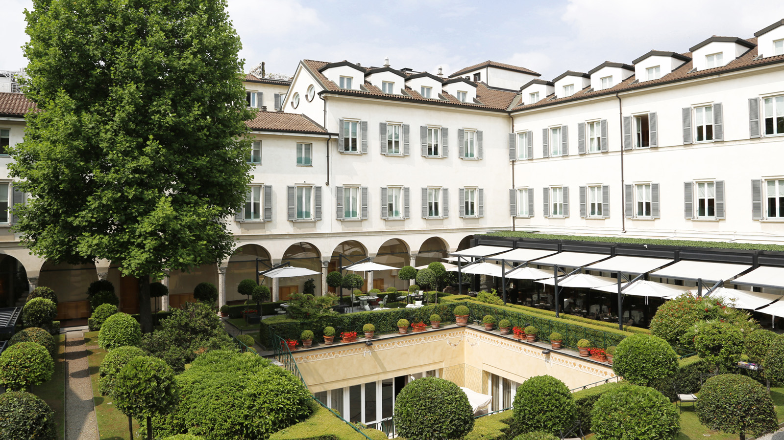
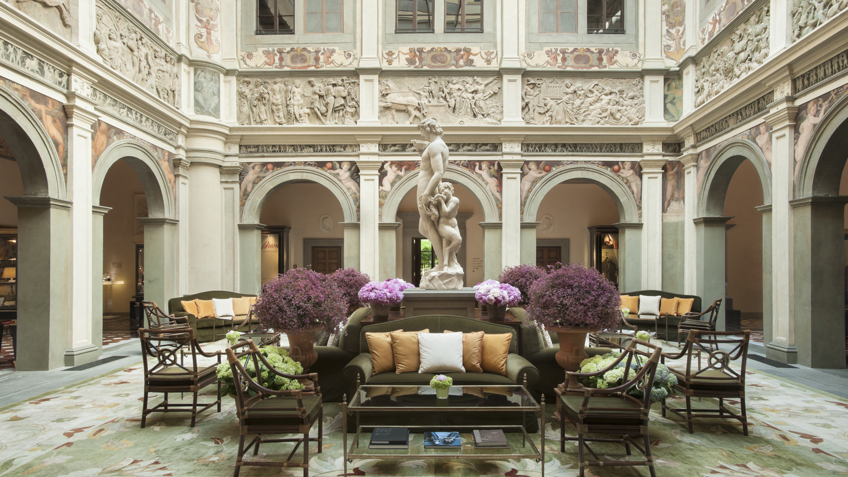 | 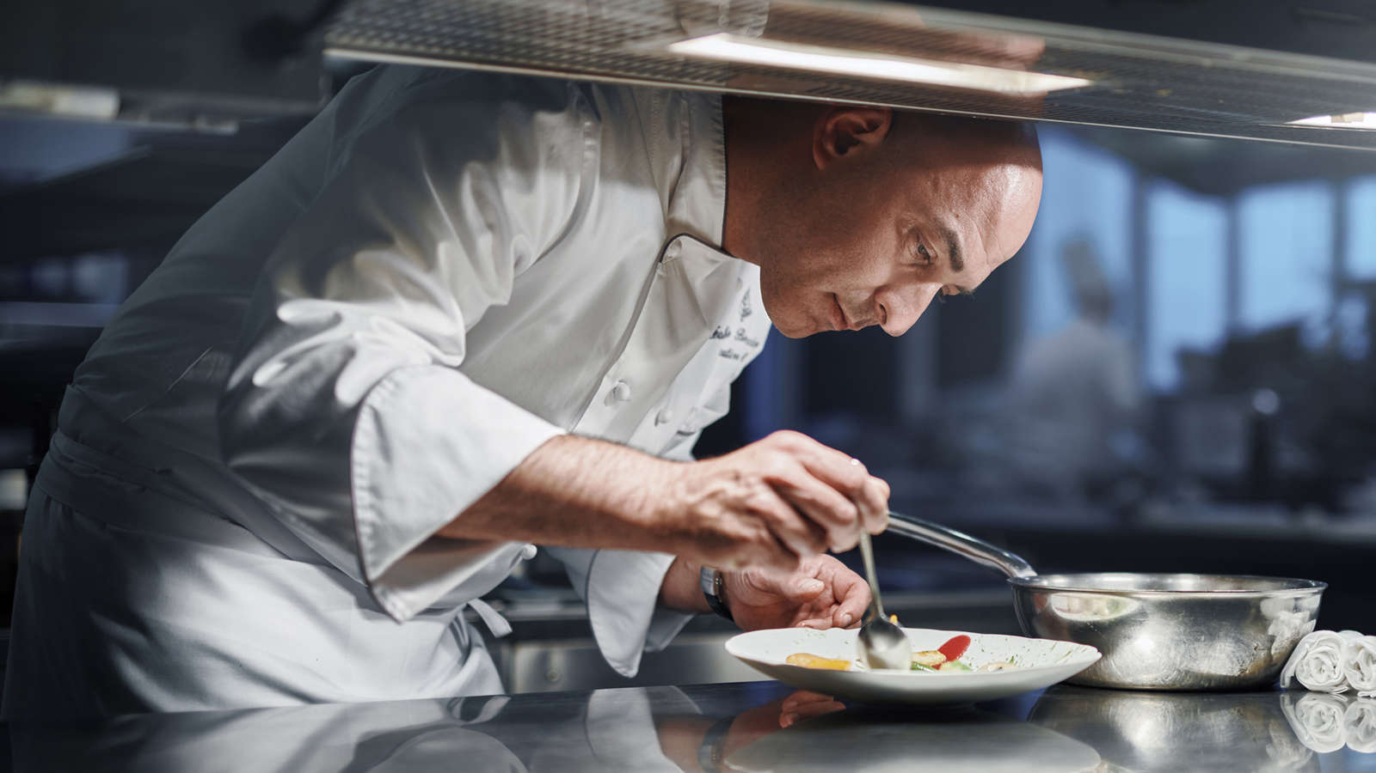 | 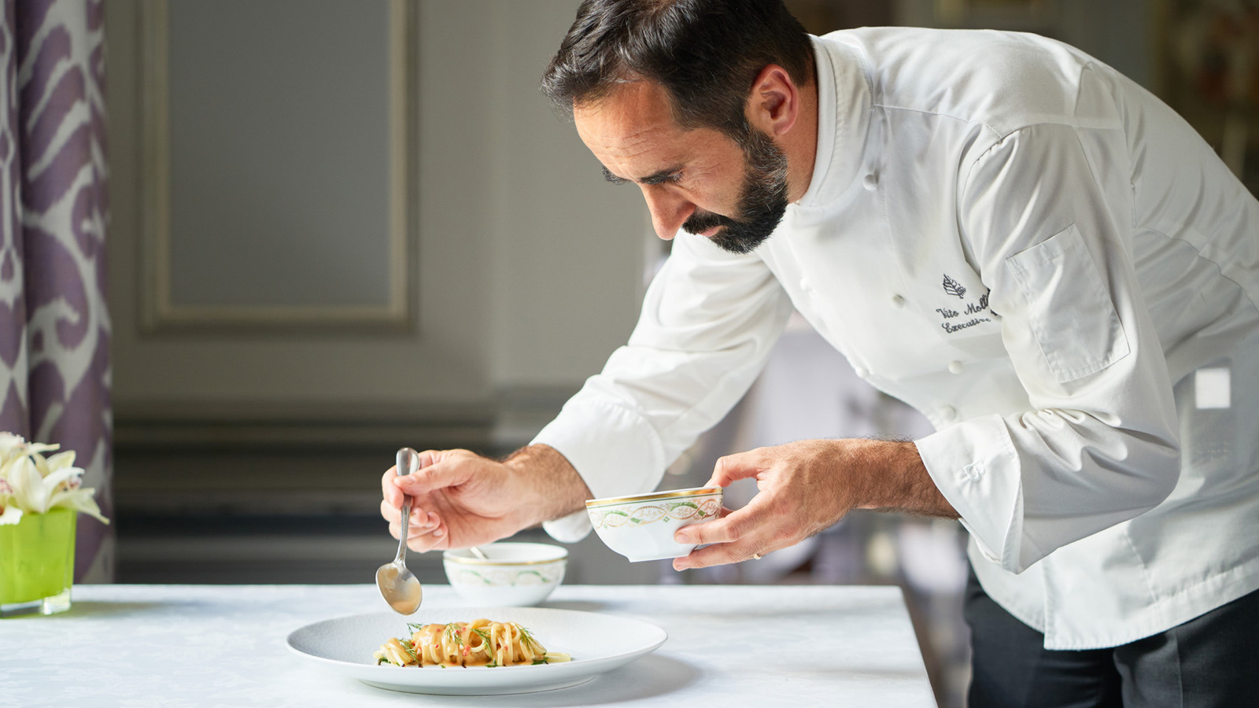
During these hard times for everyone, the teams at Four Seasons Hotel Firenze and Four Seasons Hotel Milano want to help their community to recreate at home a little bit of that dolce vita spirit that makes Italy so special.
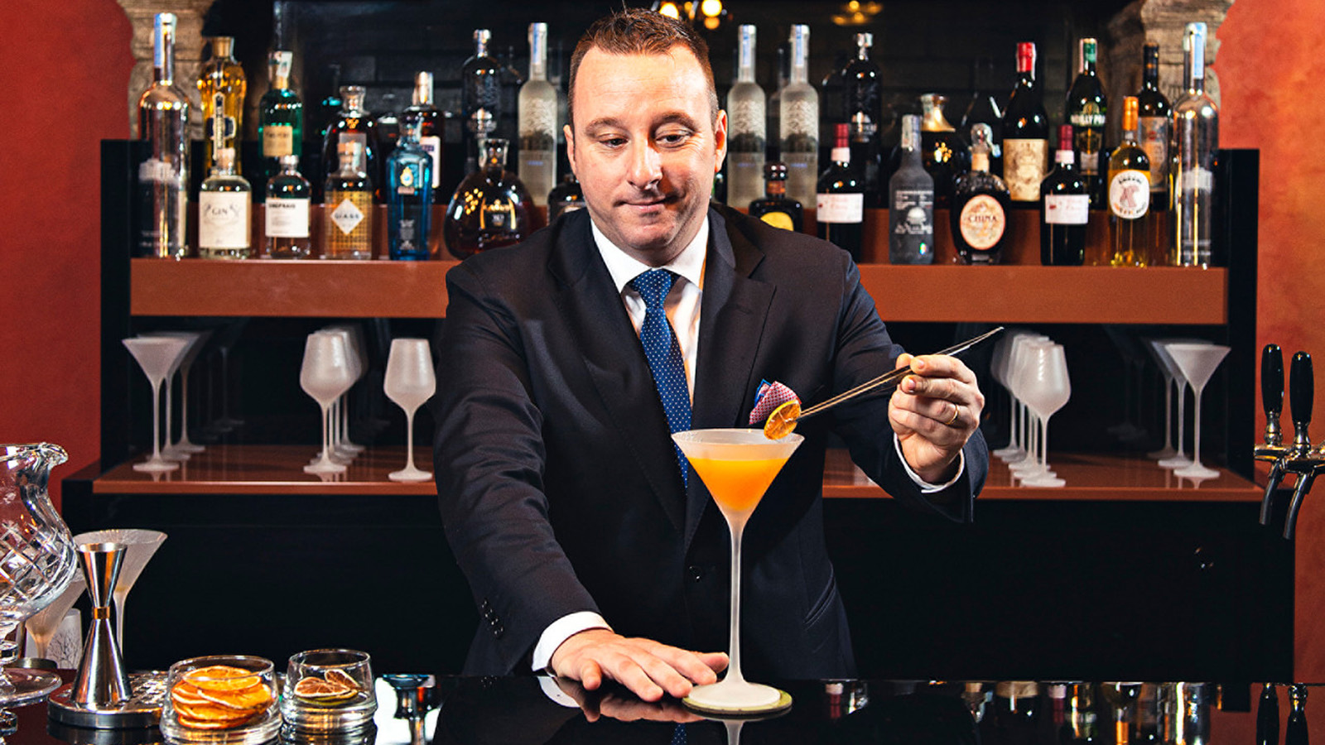 | 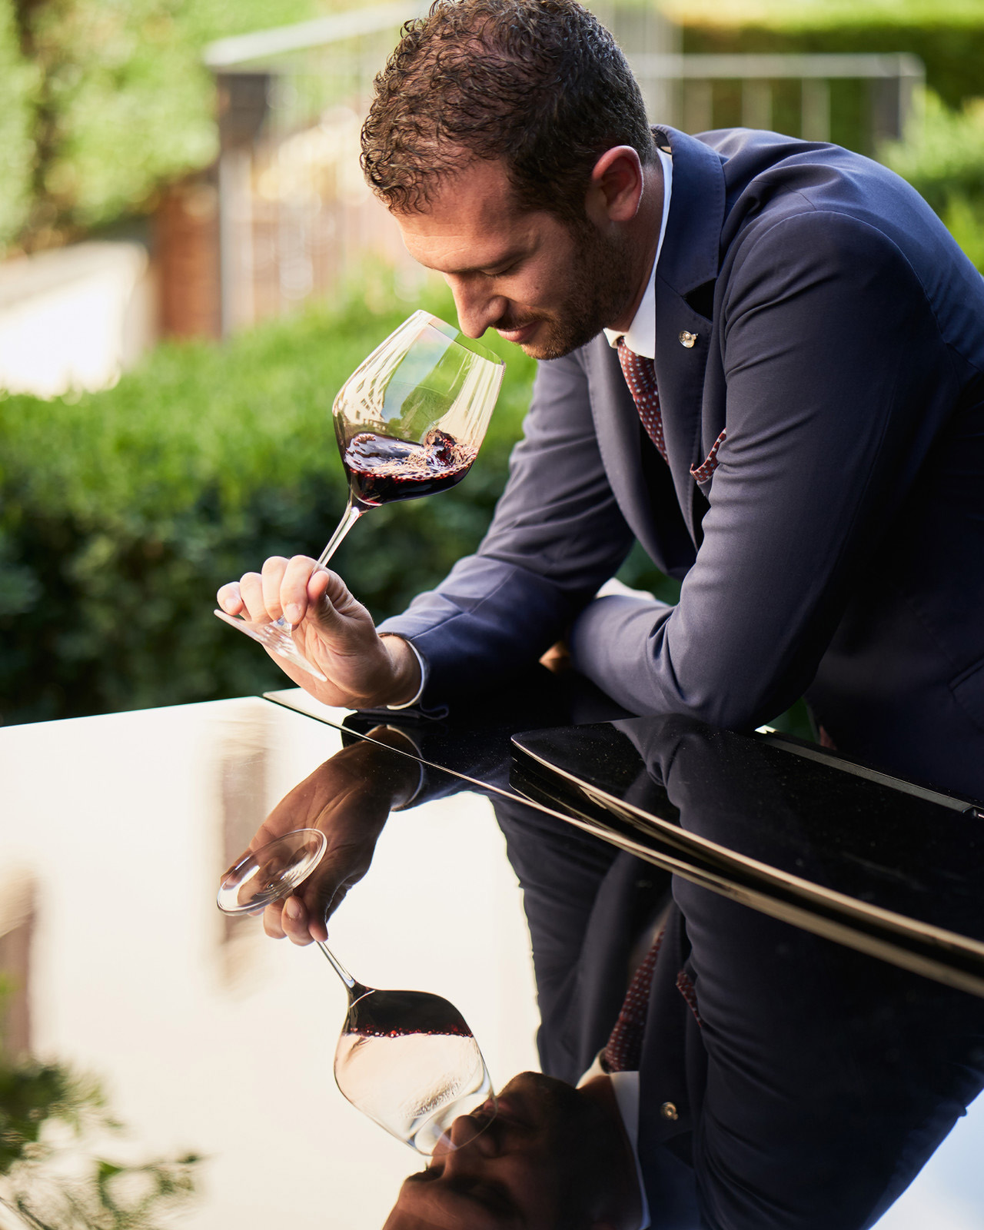 | 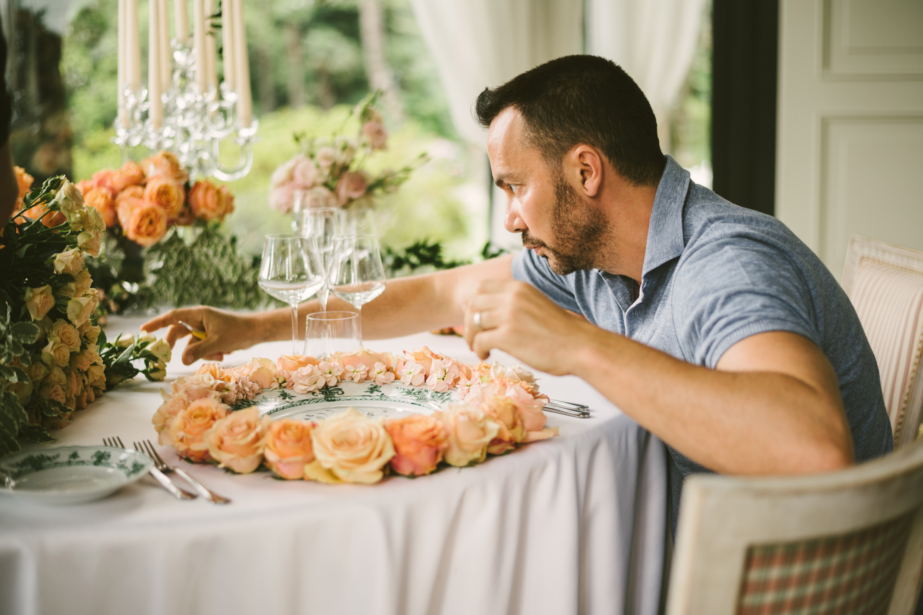
Four Seasons Italy launched “Four Seasons Dolce Vita at Home” on April 12, 2020, a social media series hosted live by the property’s talents and partners
- Instagram: @fsmilan @fsflorence
- Facebook: FSMilan FSFlorence
Over the following weeks, @fsflorence and @fsmilan will share video tips from some of their staff on many different topics, to make life at home a little bit sweeter.
For a one of a kind do-it-yourself culinary creation with a Michelin-starred twist, Four Seasons Hotel Firenze Chef Vito Mollica offers his Italian recipes. With his legendary sparkling energy and passion, he will share basic steps to create his traditional giardiniera di verdure. From Four Seasons Hotel Milan, Executive Chef Fabrizio Borraccino will share his love for Italian terroir and nature, teaching everyone how aromatic herbs can be used as a healthy alternative to enhance a dish. For desserts, the Junior Sous-Chef Matteo Omarini shares his tips on the creation of the traditional Colomba cake, while the Executive Pastry Chef Domenico di Clemente from Four Seasons Hotel Firenze will guide everyone in the preparation of the traditional taralli Pugliesi.
For those who want to use this time to learn the secrets behind wine tasting, the Hotels’ Head Sommeliers Lorenza Panzera and Walter Meccia will be walking everyone through the art of degustation, sharing their tips to understand the characteristics of a wine. The aperitivo time is saved by bar managers Luca Angeli and Edoardo Sandri, who will explain the best way to prepare the Cheesecake à la Maison cocktail and the Moscow Mule.
On the beauty side, to continue to look our very best while staying at home, Four Seasons Hotel Firenze Spa Director Lucia Papalini and her team will teach everyone how to take care of the body and skin, including special care for the hands and hair during this long period at home.
The social media series will also host some special cultural and craft sessions with partner guests. The Artistic Director Vincenzo Dascanio will show how to enhance the dining table with amazing decorations; the award-winning textile designers Margherita Pandolfini and Ernst Karl Jorns will host a textile painting lesson to decorate home fabrics; and the Director of Pinacoteca di Brera, James Bardburne, will share his thoughts on how to make the best of this lockdown time to indulge into culture.
By following Four Seasons Hotel Firenze and Four Seasons Hotel Milan social media accounts, everyone will be able to create their personal dolce vita at home.
- April 12 - @fsmilan: Junior Sous-Chef Matteo Omarini on the creation of the traditional Colomba cake
- April 15 - @fsflorence: Head Bartender Edoardo Sandri explains the preparation of a Moscow Mule
- April 19 - @fsmilan – Bar Manager Luca Angeli hosts a Cheesecake à la Maison preparation lesson
- April 22 - @fsflorence: Executive Chef Vito Mollica prepares the traditional giardiniera di verdure
- April 26 - @fsmilan – Director of the Pinacoteca di Brera James Bradburne’s personal cultural insights
- April 29 - @fsflorence Spa Director Lucia Papalini shares her tips on how to take care of body and skin
- May 3 - @fsmilan – Head Sommelier Lorenza Panzera and her best tips on wine tasting
- May 6 - @fsflorence Head Sommelier Walter Meccia unveils his tips on wine tasting
- May 10 – @fsmilan Executive Chef Fabrizio Borraccino’s recipe of the traditional risotto alla Milanese
- May 13 - @fsflorence Award-winning textile designers Margherita Pandolfini and Ernst Karl Jorns host a lesson on textile painting
- May 17 - @fsmilan Artistic Director Vincenzo Dascanio teaches how to enhance the dining table at home
- May 20 – @fsflorence - Executive Pastry Chef Domenico di Clemente shows how to prepare the traditional taralli Pugliesi
- May 27 - @fsflorence – The Spa team’s beauty tips to take care of the hair, hands and face during these times at home

RELATED

April 16, 2020, Florence and Milan, Italy
La Dolce Vita Four Seasons a casa: Four Seasons Italy lancia una serie di masterclass sui Social Media per ricreare l’esperienza Four Seasons tra le mure domestiche
https://publish.url/it/florence/hotel-news/2020/four-seasons-at-home-series-2.html

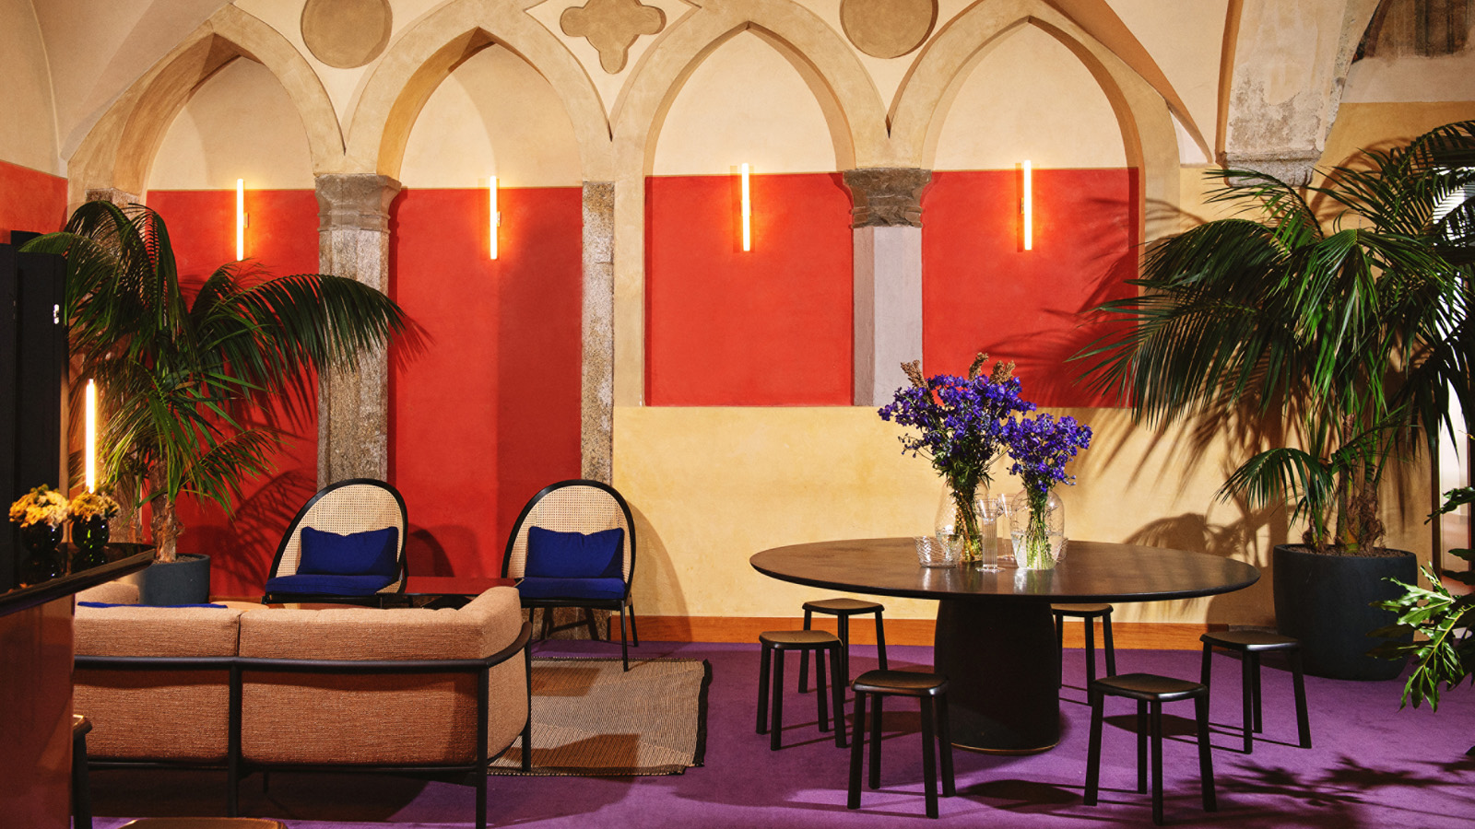 | February 25, 2020, Milan, Italy  Four Seasons Hotel Milano Presenta “NEST,” l’Esclusivo Design Pop-Up Bar & Lounge Progettato dalla Designer Chiara Andreatti  https://publish.url/it/milan/hotel-news/2020/nest-pop-up-bar-and-lounge-2.html

PRESS CONTACTS

Martina Nesti
Public Relations and Marketing Communications Coordinator
Borgo Pinti, 99
Firenze
Italy
martina.nesti@fourseasons.com

+39 055 2626222

Anita Ruozzi
Public Relations and Marketing Communication Coordinator
Via Gesu, 6/8
Milano
Italy
anita.ruozzi@fourseasons.com

+39 02 7708 1123

