51 hours in DC by Meron Kassahun

July 31, 2020, Washington, DC, U.S.A.

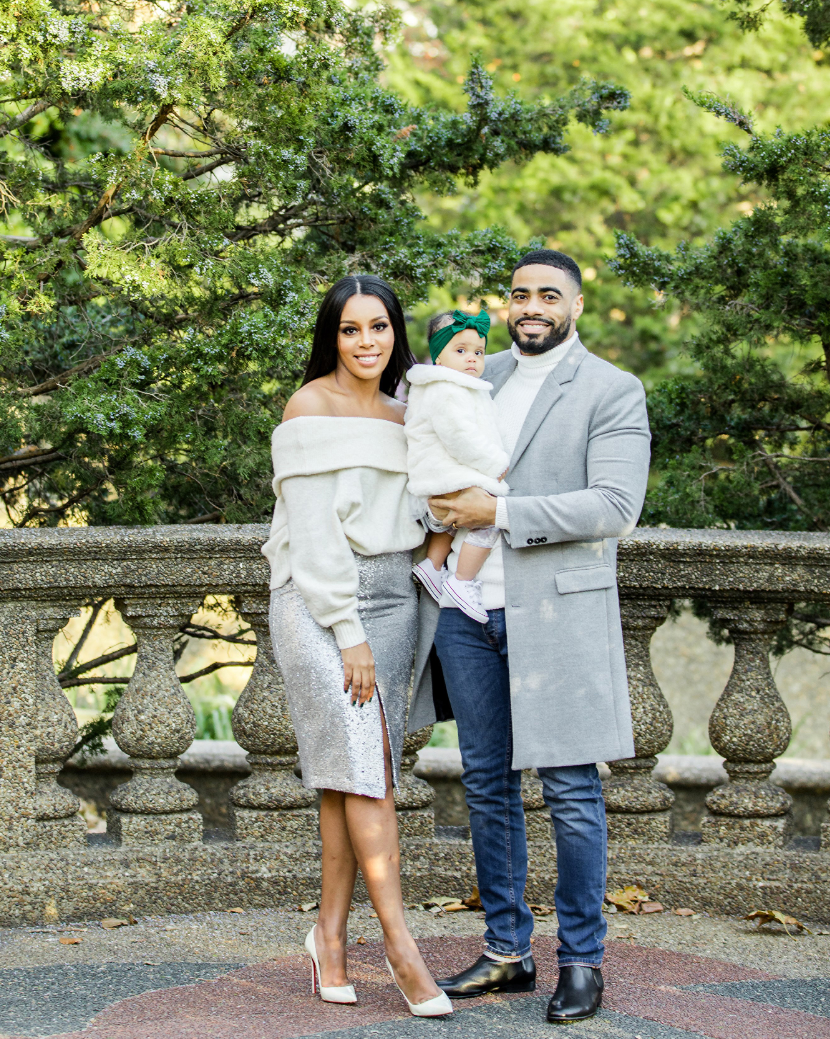
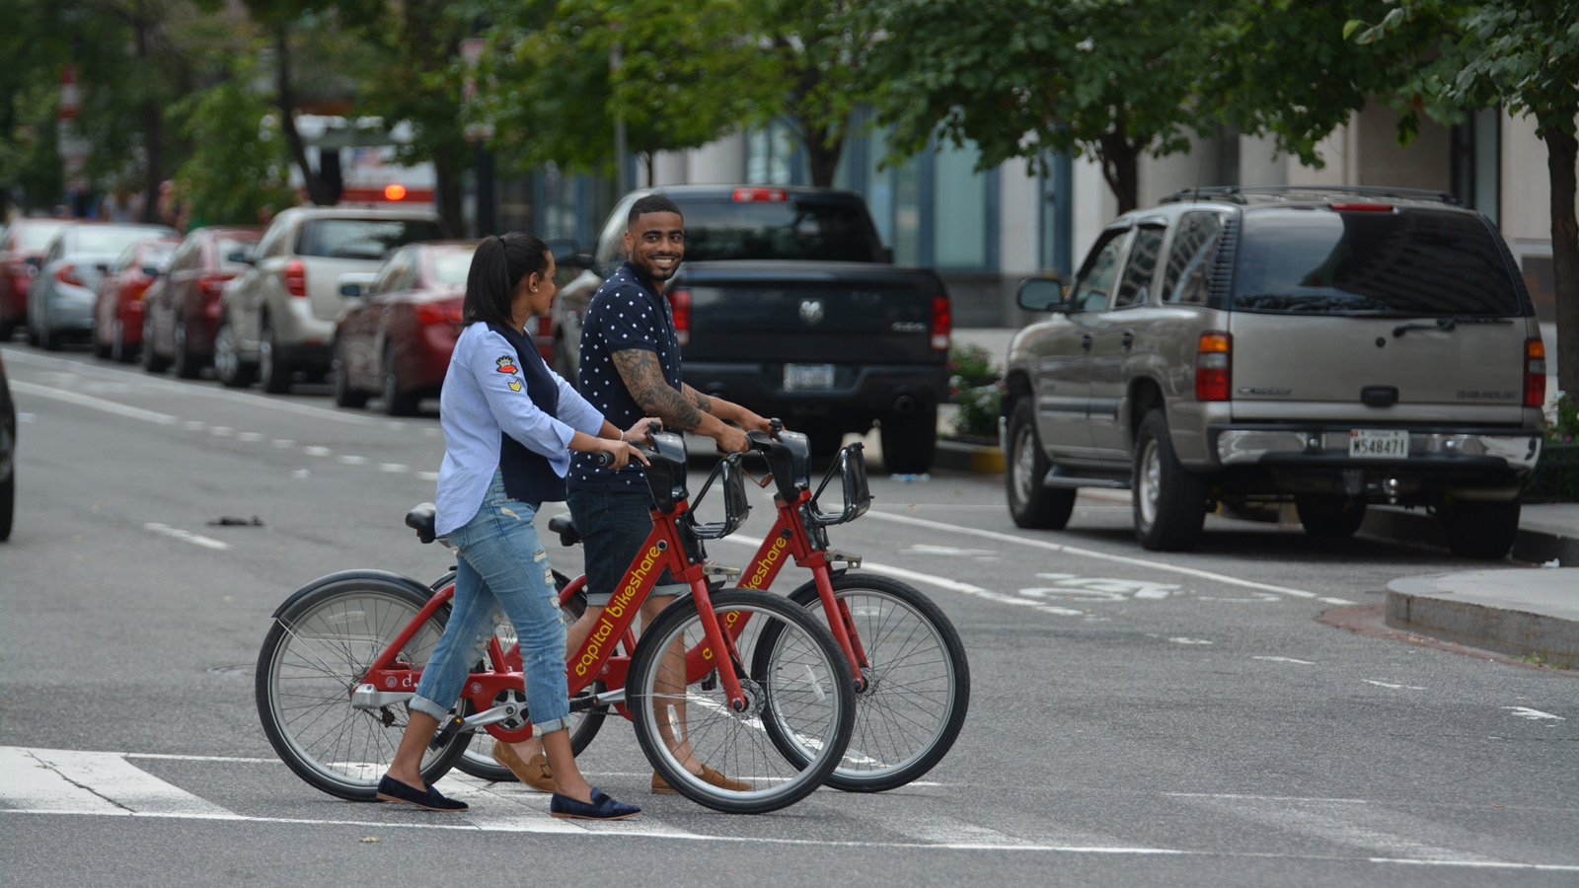 | 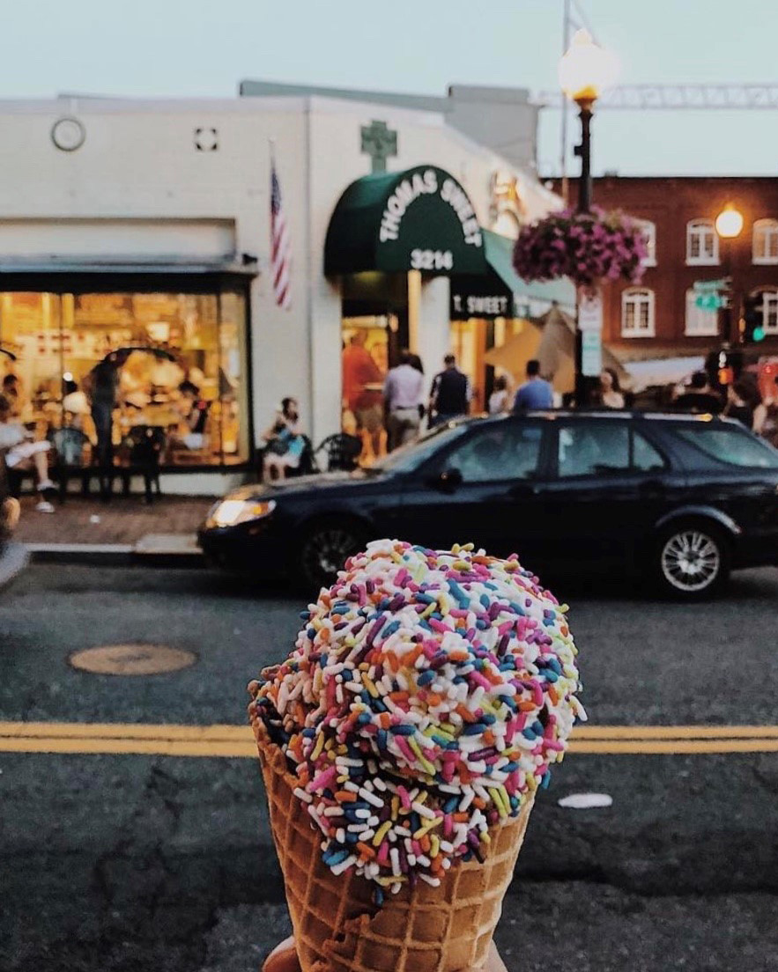 | 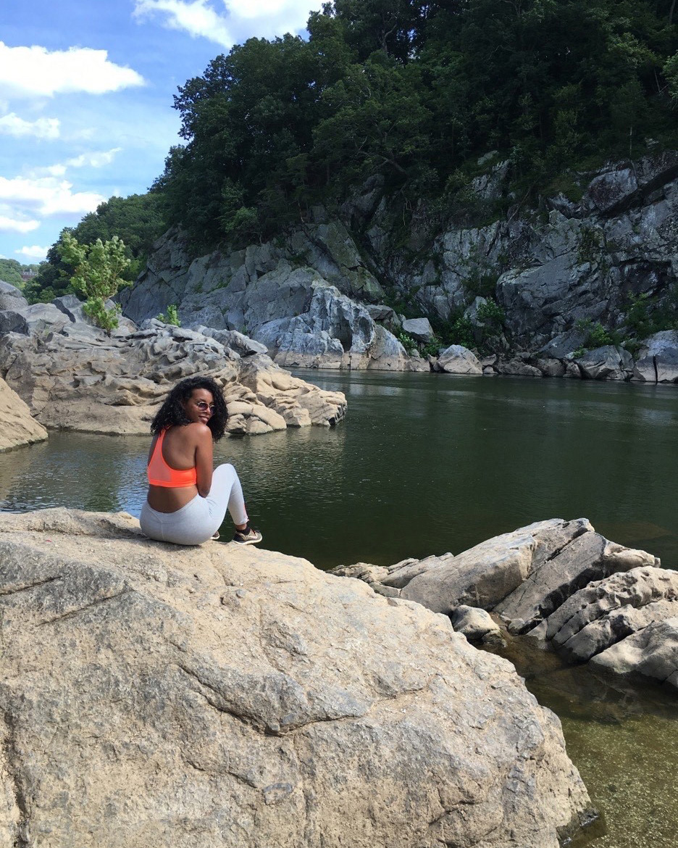
51 Hours in DC is a series highlighting the richness and diversity of the Nation’s Capital through the eyes of the employees of Four Seasons Hotel Washington, DC.
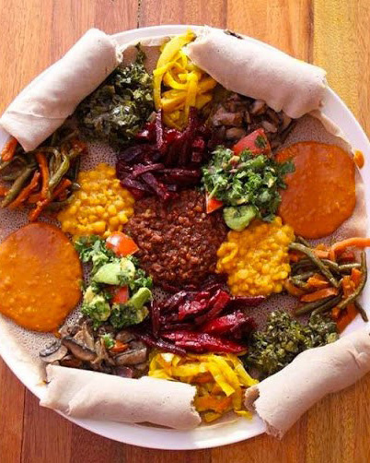 | 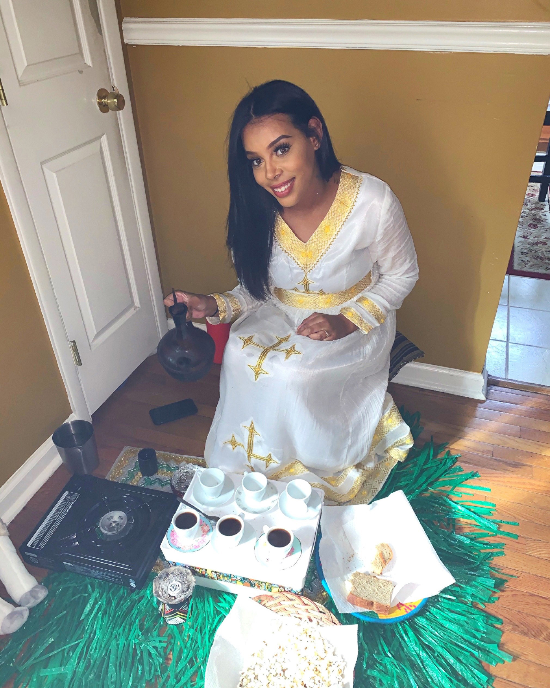 | 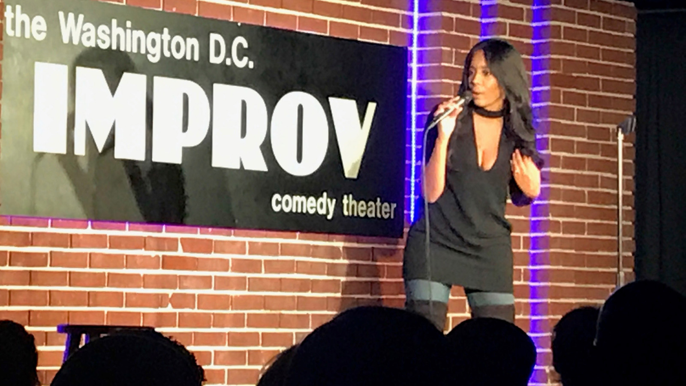
This edition is brought to you by Reservations Manager Meron Kassahun. Meron was born in Ethiopia but has lived in the DC/Maryland (Takoma Park) area for 25 years. Together with her husband Reshad Favors, a labour attorney, and her daughter Laila, Meron loves to explore the neighbourhoods of DC. On weekends Meron and her family like to hike the trails around DC as well.
Read below for how Meron and her family would spend a fun weekend in DC, including some recommendations for cool cocktail bars and the best places for Ethiopian and Indian food. We hope that this will inspire your own travels to the Nation’s Capital.
51 Hours in DC by Meron Kassahun
Friday Afternoon
- Kitsuen
H street was hit the heaviest during the 1968 riots that resulted from MLK’s assassination. It did not start to really see signs of recovery till the early 2000s. It is now home to some of the coolest bars in the city and music venues such as Kitsuen.
Here I love to enjoy a handcrafted cocktail and hookah with some 90s music playing. The bar is owned by DC locals and nightlife gurus Wayne and Tony, and has great ramen and cocktails.
Friday Evening
- Chicken + Whiskey
The Peruvian chicken and yucca fries are amazing - it's hands down the best Peruvian chicken in DC.
Friday Night
- Chicken + Whiskey

RELATED

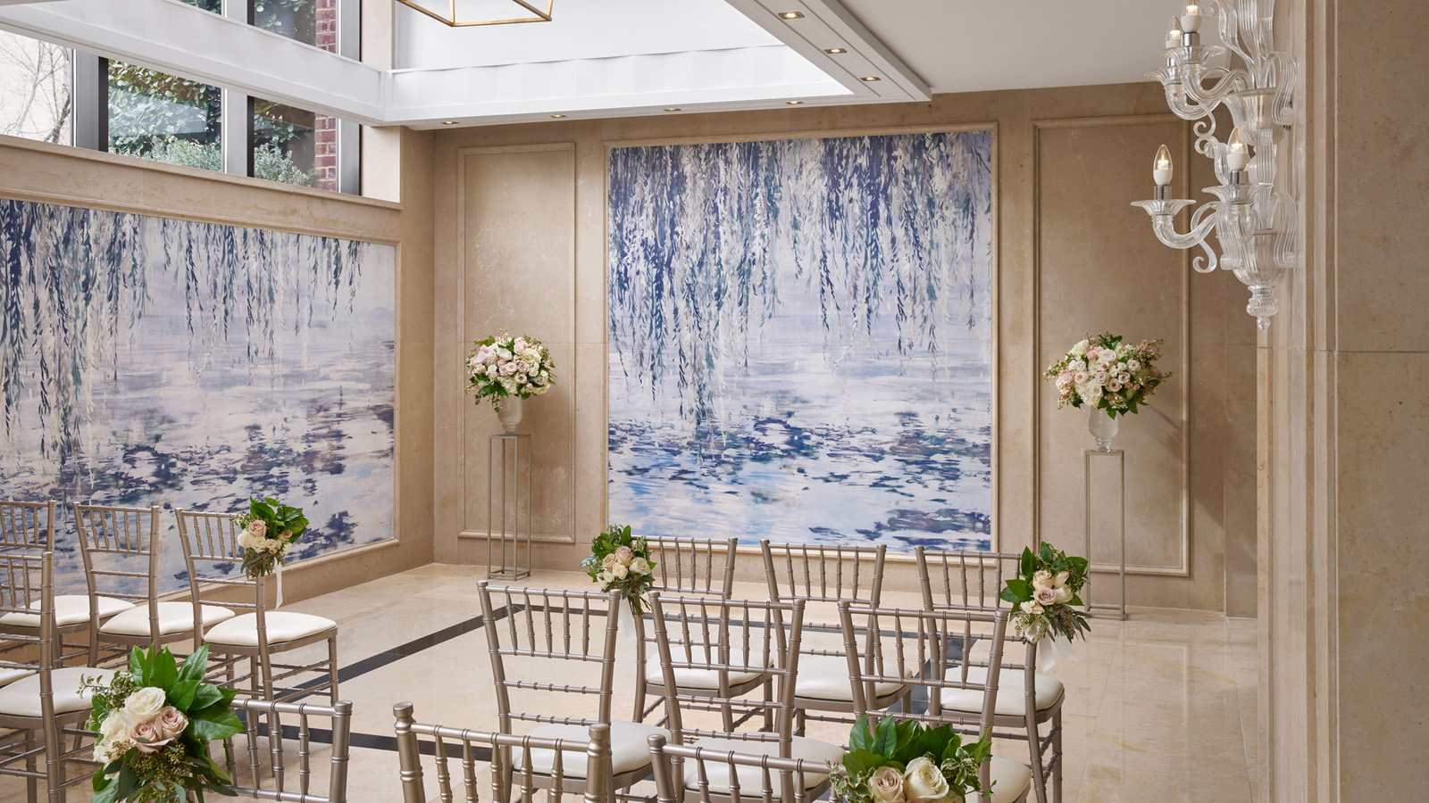 | July 13, 2020, Washington, DC, U.S.A.  Bespoke, Intimate Weddings Shine in the Newly Renovated Events Spaces of Four Seasons Hotel Washington, DC  https://publish.url/washington/hotel-news/2020/renovated-wedding-venues.html
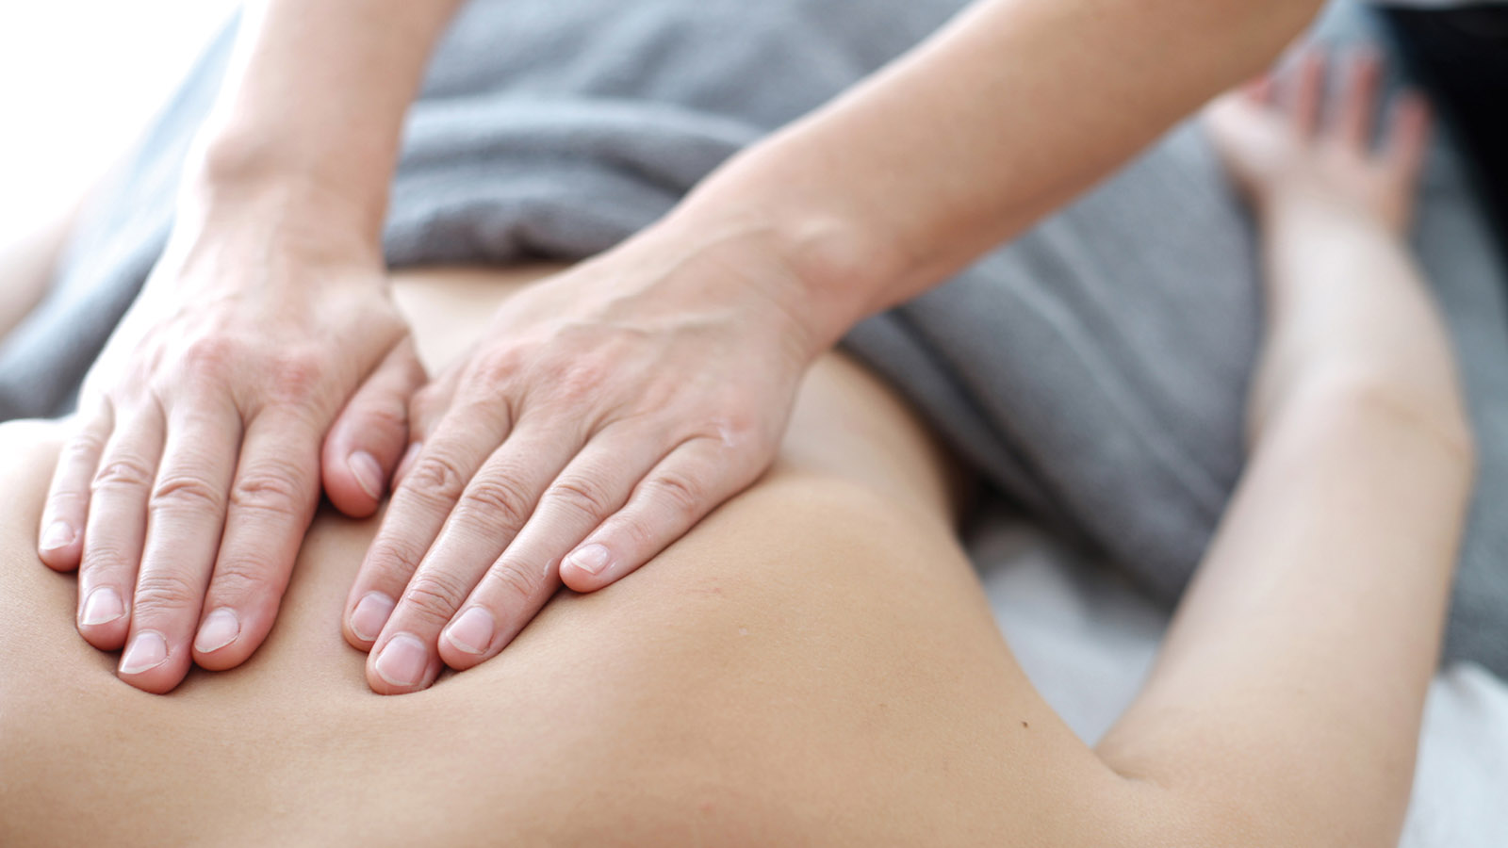 | June 30, 2020, Washington, DC, U.S.A.  Four Seasons Hotel Washington, DC Reopens The Spa and Fitness Club  https://publish.url/washington/hotel-news/2020/spa-reopening.html

PRESS CONTACTS

Anina Belle Giannini
Director of Public Relations
2800 Pennsylvania Avenue N.W.
Washington
U.S.A.
aninabelle.giannini@fourseasons.com

+1 202 944 2074

