Two Hearts Intertwined at Four Seasons Hotel Hong Kong

July 8, 2020, Hong Kong, China

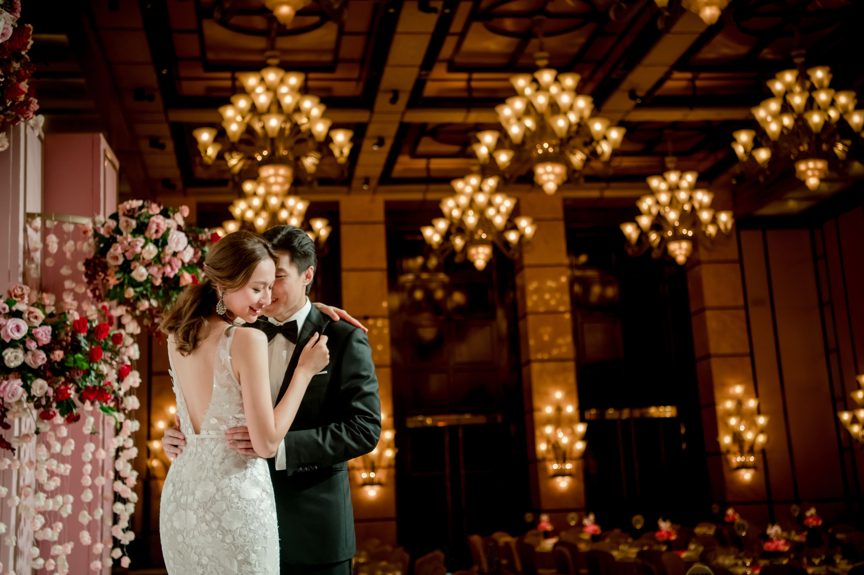
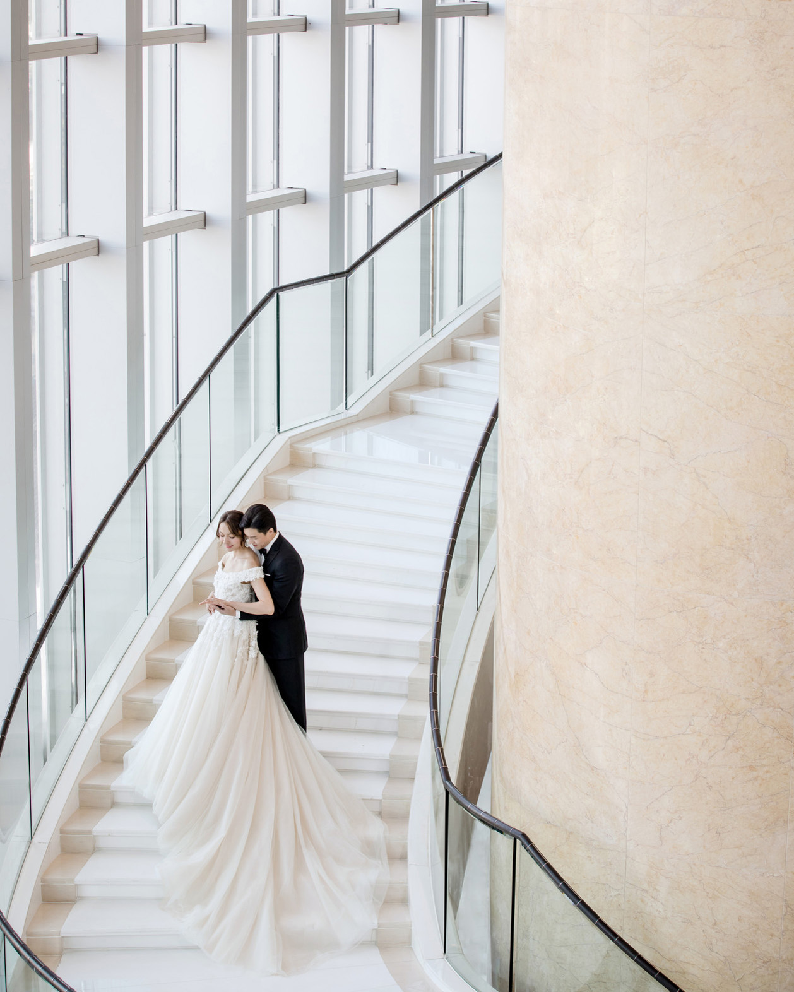 |  | 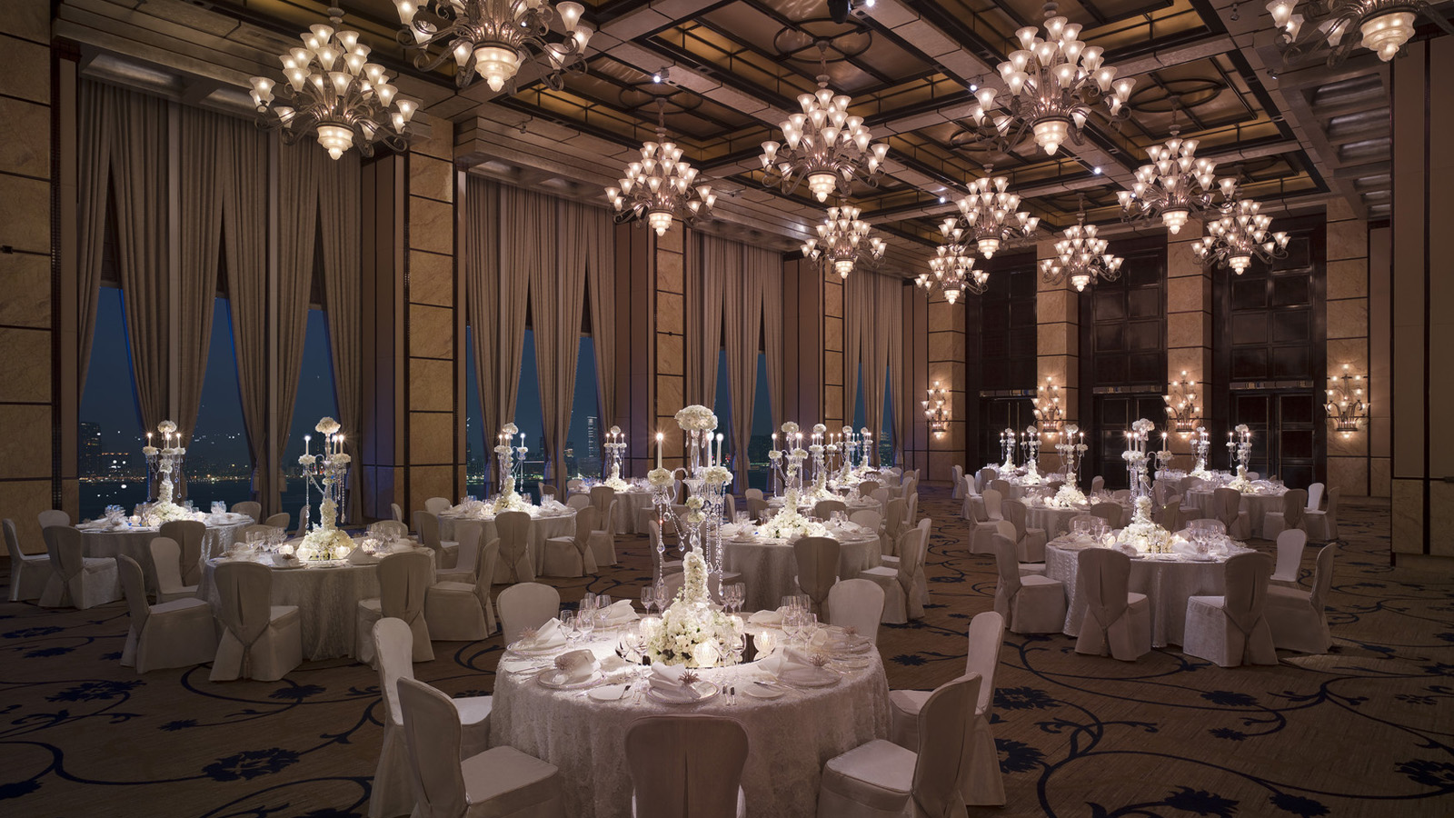
From July 25 to August 2, 2020, Four Seasons Hotel Hong Kong will launch a contemporary wedding pop up, offering limited time offers for big celebrations and intimate weddings. The elegant affair will take place at the Hotel lobby from 12:00 noon to 7:00 pm daily and is admission-free.
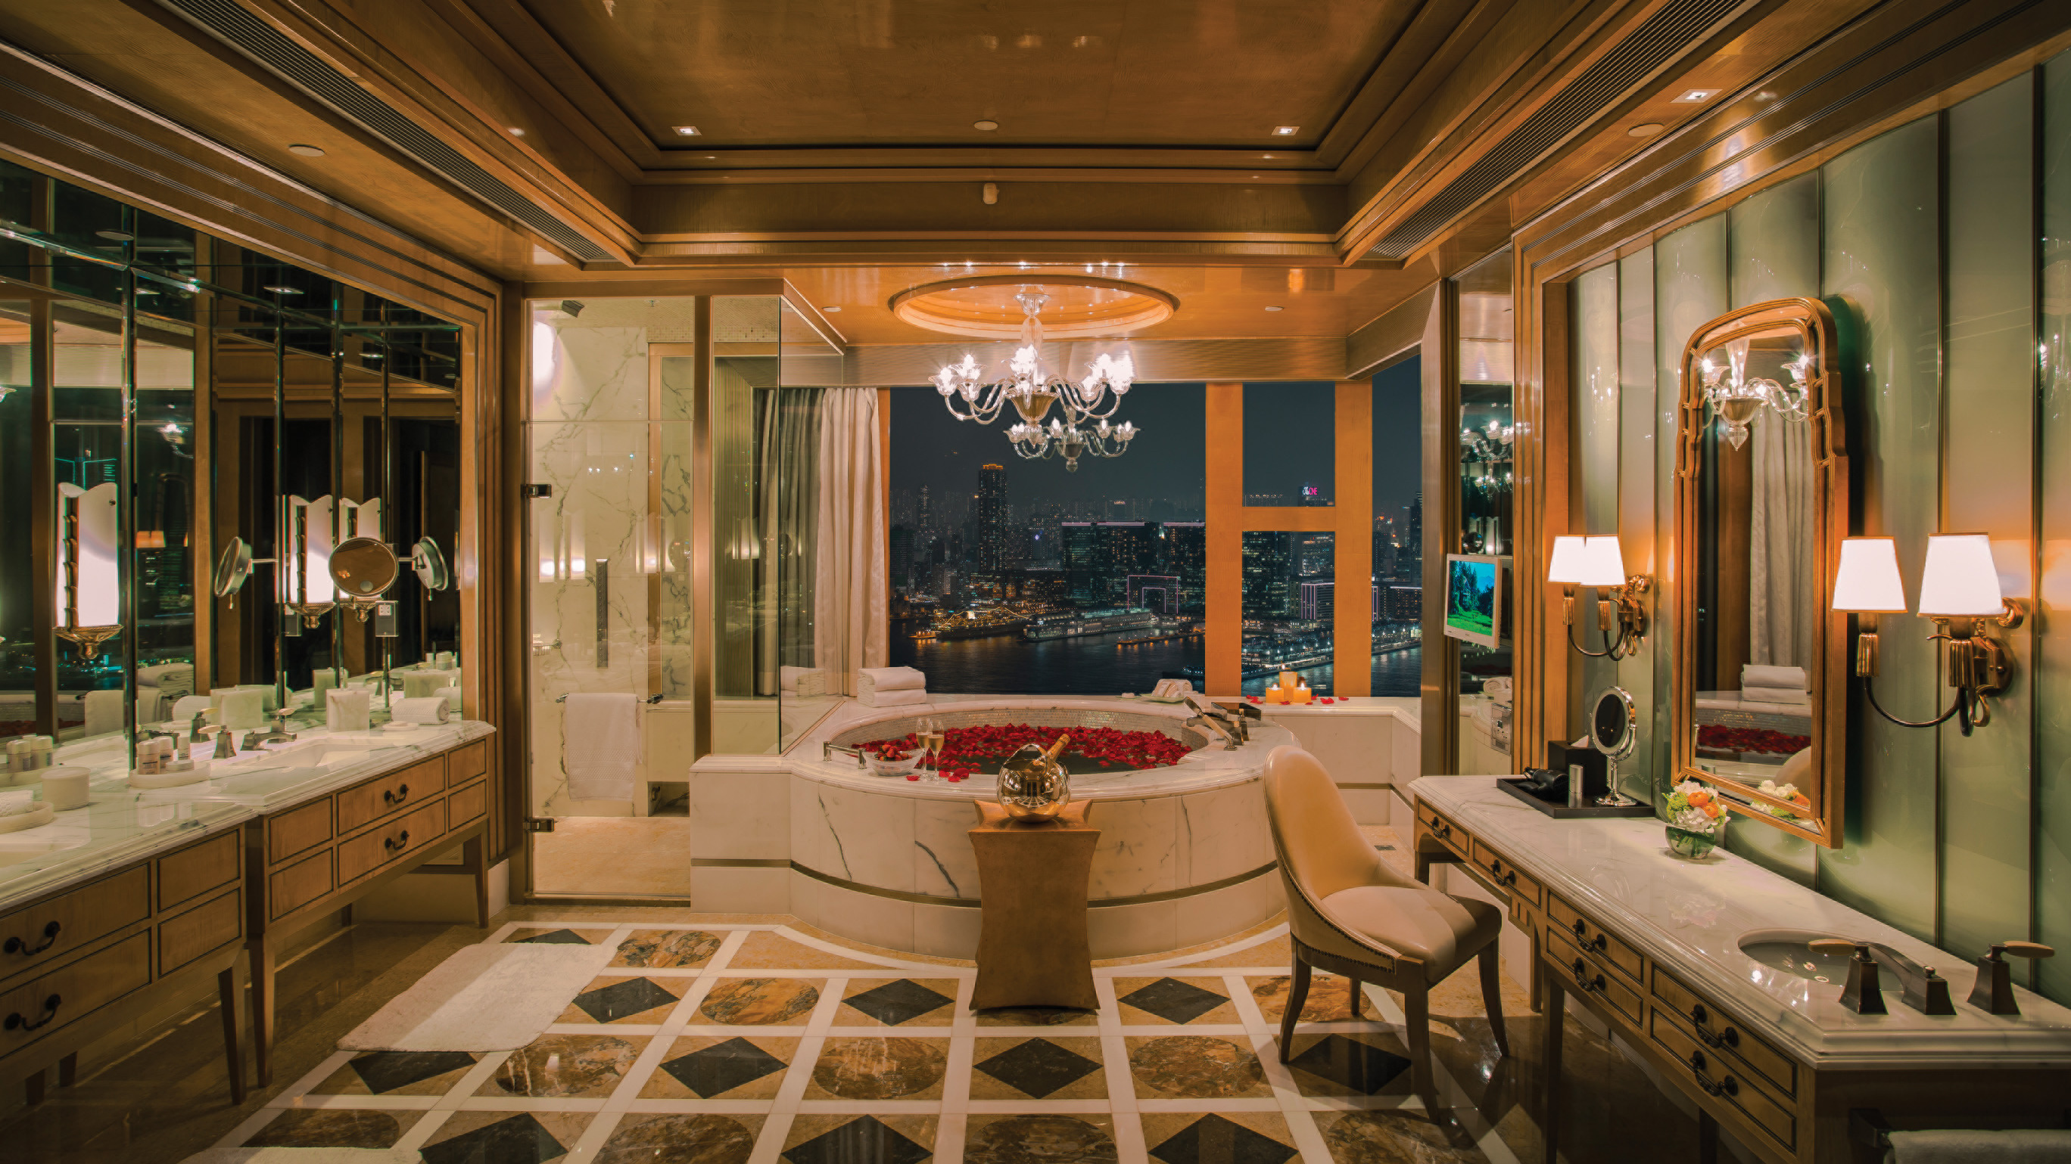
Couples can envision how their wedding will come together with expert advice from the Hotel’s consultants. Partnering with David Yurman, The LOFT Bridal and The Symphony Designer cakes, wedding guests will gain access to the Presidential Suite to explore nuptial set ups, new collections of high-end jewellery and an exclusive experience in finding the wedding dress of one’s dreams and everything needed for the big day and beyond.
Journey of a Lifetime
Four Seasons Hotel Hong Kong takes delight in bringing each couple’s dream wedding to life while keeping wedding planning easy and efficient. Guests can sit back at the wedding pop up and discover exclusive wedding packages.
The Hotel features breath-taking venues at the Grand Ballroom that can accommodate more than 400 banquet guests; the Harbour View Ballroom that is ideal for medium-sized weddings; and the Presidential Suite that is perfect for an intimate wedding reception of up to 30 guests, as well as other versatile spaces. Banquet menus are designed by Michelin-starred chefs in the Hotel.
Host a quintessential Hong Kong culinary experience with Chinese menus curated by renowned Chinese Executive Chef Chan Yan Tak of Lung King Heen, or entertain guests with intercontinental menus by Executive Chef Dirk Haltenhof. Lung King Heen is first Chinese restaurant in the world to have received three Michelin stars in 2008 with longstanding recognition of 12 consecutive years, whereby Chef Chan oversees the operation of the coveted Chinese restaurant and keeps a close eye on food quality at wedding banquets. Chef Haltenhof from Germany adds flair to traditional European cooking with influences from various cultures in Europe, Middle East and Asia.
Four Seasons Hotel Hong Kong wedding packages start from HKD 14,988 per table for lunch and HKD 17,388 per table for dinner. Both packages are inclusive of beverage selection (unlimited house white and red wine, fresh-squeezed orange juice and soft drinks). For a wedding reception in the Presidential Suite, packages start from HKD 50,000.
Prices are subject to 10 percent service charge and are available during the wedding pop up for weddings held in 2020.
Celebrating a Union
For a dream wedding to happen, it is imperative to be in good company to orchestrate a seamless event. Four Seasons Hotel Hong Kong has carefully curated an incredible selection of top-notch industry veterans at the Presidential Suite, who demonstrate finesse and refinement through their work.
Guests can enjoy interactions with:
- Jacqueline Au, founder of The LOFT Bridal and style maven for modern brides: brides-to-be can enjoy the opportunity to be personally styled for their wedding day or special event by the fashion expert and get first dibs on the latest arrivals available only at the pop up (only by appointment)
- David Yurman: wedding couples can explore their bridal and high-end jewellery collections; the New York brand’s iconic cable rings where two elements intertwine, creating a harmonious tension akin to love and marriage
- Ms. Melody, founder of The Symphony Designer Cakes: their custom-made masterpieces translate personal style and taste into tangible details at the wedding
Every bride will receive exclusive offers from wedding vendors and gifts from David Yurman and Amorepacific, a premium Korean skincare brand, as a token of appreciation.
For reservations and enquiries, email catering.hkg@fourseasons.com or contact +852 3196 8338.
David Yurman
David Yurman is a timeless model of inspiration, innovation and consummate craftsmanship. America’s foremost luxury jewellery and timepiece brand, the company was founded in New York City by David, a sculptor, and his wife Sybil, a painter, and built on a passion for art and design. When they began collaborating, their intention was not to start a business but to make beautifully designed objects to wear.
In 2003, their son Evan Yurman joined the company. Drawing inspiration from natural textures, antiquities and cutting-edge materials, he has played an integral role in the design direction of the Men’s, Wedding and High Jewellery Collections. Today, Evan collaborates with David and Sybil on every aspect of the business.
Jacqueline Au, Founder of The LOFT Bridal
Jacqueline Au is a fashion buyer, entrepreneur, and brand consultant. After stints in powerhouse designer brands Givenchy, Celine & Lane Crawford as buyer, Au made her name in retail as founder and creative director of The LOFT Bridal, an award-winning luxury bridal destination in Hong Kong. Named by Vogue HK as “The Style Maven for Modern Brides,” Jacqueline is recognised for her refined, high-fashion approach to bridal wear, providing bespoke access, brand discovery on designers brides won't find anywhere else and unparalleled expertise in empowering her brides to create their own fairy tales down the aisle.
The Symphony Designer Cakes
Divine custom couture cakes created with artisan hands. For any momentous life event, The Symphony Designer Cakes can craft beautiful cakes with finesse and expertise to meet precise requirements.

RELATED

July 8, 2020, Hong Kong, China
情意交织于香港四季酒店
https://publish.url/zh/hongkong/hotel-news/2020/wedding-pop-up-3.html

July 8, 2020, Hong Kong, China
情意交織於香港四季酒店
https://publish.url/zh_hant/hongkong/hotel-news/2020/wedding-pop-up-2.html

PRESS CONTACTS

Chu Wong
Director of Public Relations
8 Finance Street, Central
Hong Kong
China
chu.wong@fourseasons.com

(852) 3196 8306

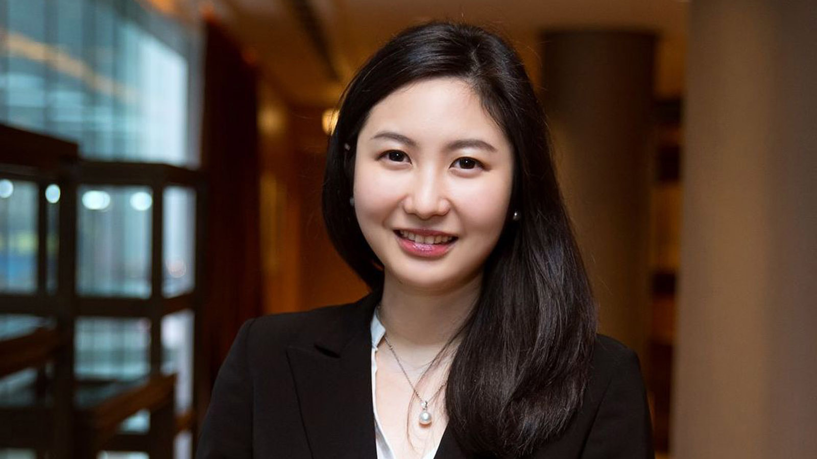 | Priscilla Chan  Assistant Public Relations Director  8 Finance Street, Central,  Hong Kong  China  priscilla.chan@fourseasons.com  (852) 3196 8307

