Shaken Not Stirred: The Martini Bar at The Ocean Club, A Four Seasons Resort Launches New Mixology and Epicurean Experiences

The Ocean Club’s iconic lounge offers experiences fit for James Bond himself
April 29, 2021, Paradise Island, Bahamas

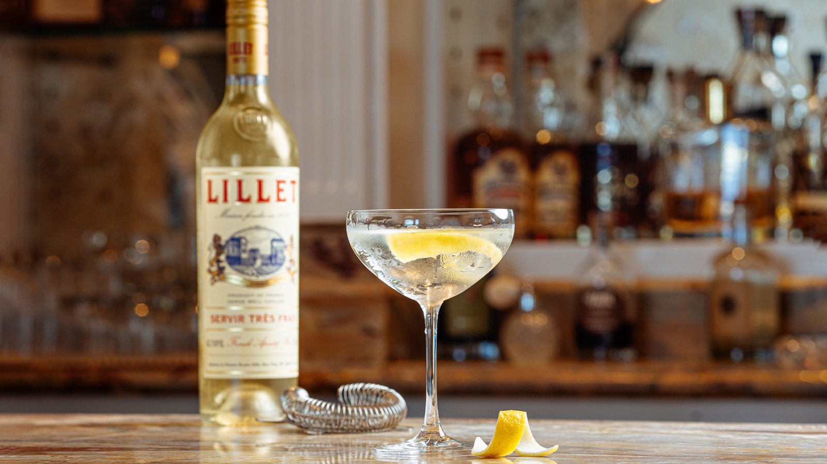
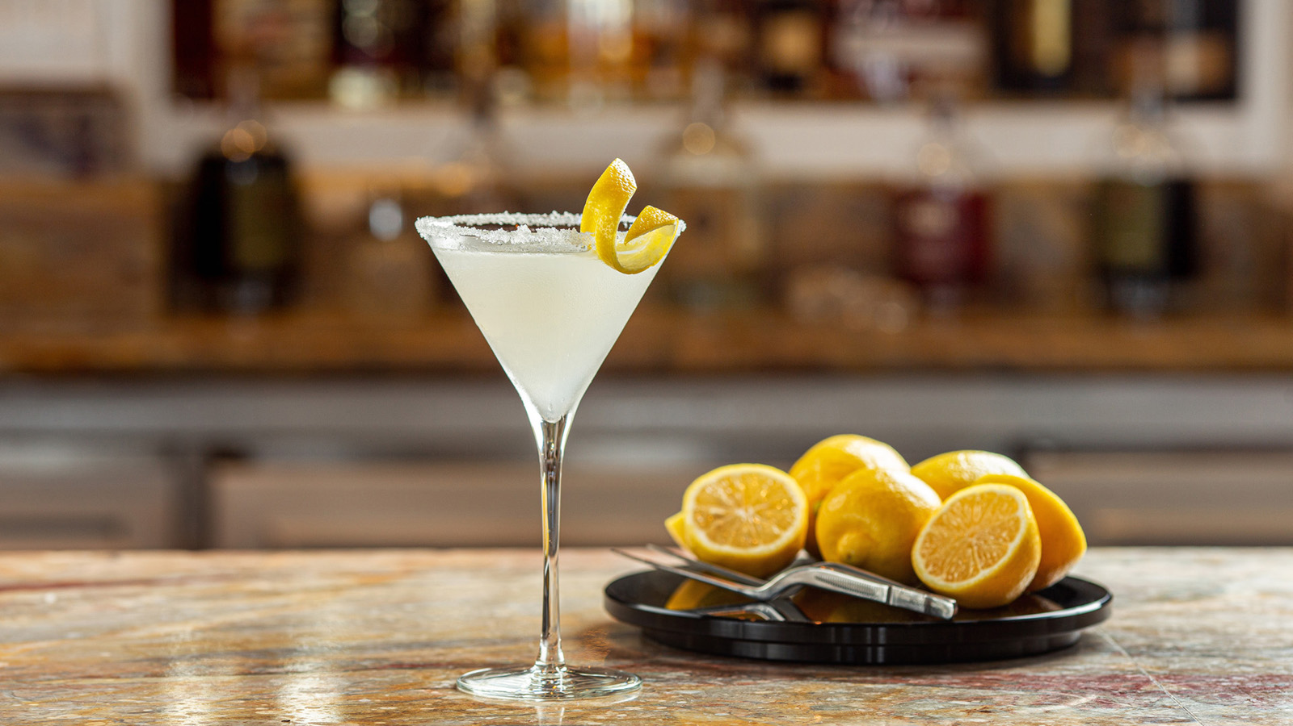 | 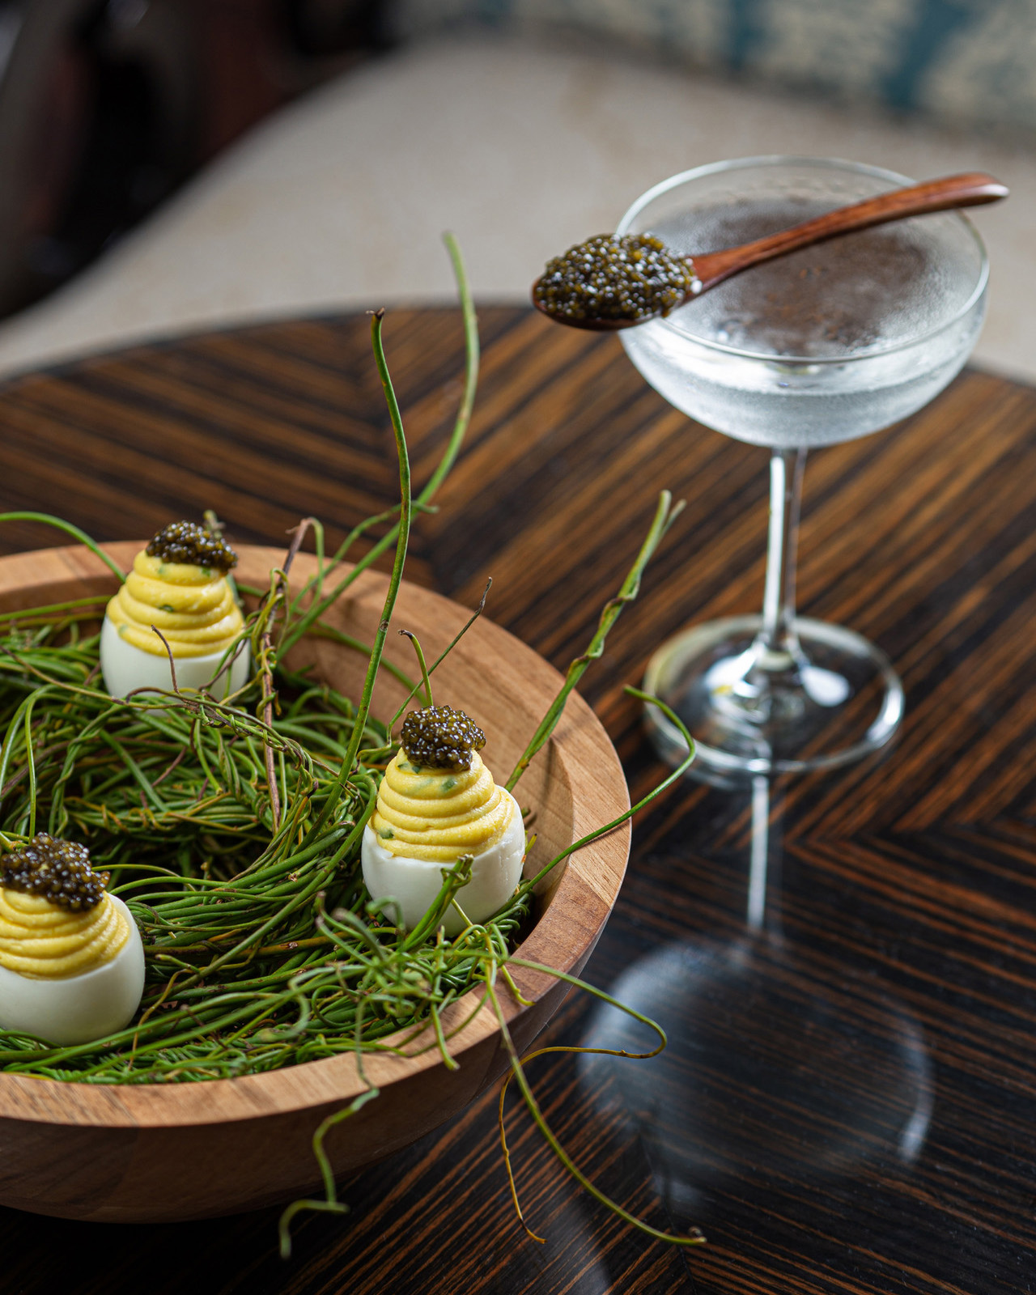
A nod to its glamorous and star-studded legacy, The Martini Bar at The Ocean Club, A Four Seasons Resort, Bahamas has recently announced the launch of a new and decadent mixology and culinary experience for the spring 2021 season. Known best as the backdrop for the 2006 remake of the Casino Royale film where James Bond can be seen sipping his famous Vesper Martini, this limited seat Living Room Bar transports guests into the scenes of their very own movie. Whether sipping on a classic Vesper or indulging in the new ultra-luxe Caviar Martini, it’s an unforgettable experience.
Master mixologist Keith Cash has helmed the bar at The Ocean Club serving up cocktails to celebrities and discerning travellers for more than three decades. Sourcing every premium spirit and special ingredient featured on the cocktail menu, Cash’s expertise and passion can assure guests that each sip is special. Guests can choose from a sparkling, citrus Clementine Martini, a zingy Passion Fruit Chili Martini or a more classic yet sweet French version with hints of vanilla and champagne. For the ultimate celebrator, the Caviar Martini priced at USD 110 is The Ocean Club’s version of the ultimate classic cocktail. Stirred, not shaken, this creation is served with a mother of pearl spoon full of ossetra caviar. Looking ahead, a new globally inspired menu showcasing seven of the most popular Martinis from Four Seasons hotels and resorts around the world will be introduced this summer.
While cocktails are the heart of The Martini Bar signature experience, unique culinary creations are presented with suggested Martini pairings. Guests can indulge in the likes of wagyu beef “hot patties” with truffle jus, mango relish and a house-made hard grape soda, or west end pickled conch served with burnt toast, goat pepper EVOO and a Kalik Beer Shandy. Free range devilled eggs topped with even more caviar are paired with an exquisite Caviar Vodka Martini by the master mixologist to complete the ultimate Martini Bar experience.
For James Bond enthusiasts – and those looking for a one-of-a-kind epicurean experience - the newly reimagined Martini Bar offers the best Bond life while on Paradise Island.
Martini Bar and Lounge is open every Friday and Saturday from 6:00 to 10:00. Reservations can be made by calling the Resort +1 242 363 2511 or via OpenTable.
In addition to The Martini Bar, visitors to The Ocean Club can choose from a total collection of five restaurants and bars, ready to tempt one's palate with a variety of menus and specialties. The Ocean Club, A Four Seasons Resort and all of its restaurants and bars continue to strictly enforce health and safety protocols under the guidance of the Four Seasons Lead With Care Advisory Board.

RELATED

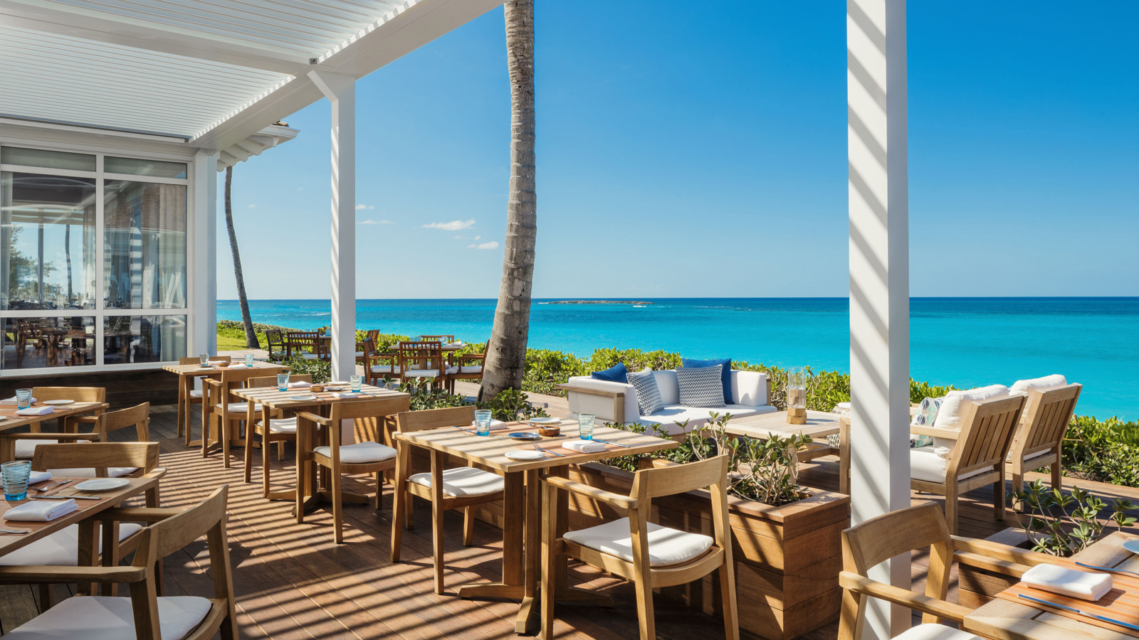 | January 20, 2020, Paradise Island, Bahamas  The Ocean Club, A Four Seasons Resort Launches Nassau’s Finest Sunday Brunch at DUNE by Jean-Georges Featuring Bahamian Cuisine in a Lavish, Mouth-Watering Weekly Ritual  https://publish.url/oceanclub/hotel-news/2020/new-sunday-brunch-at-dune.html
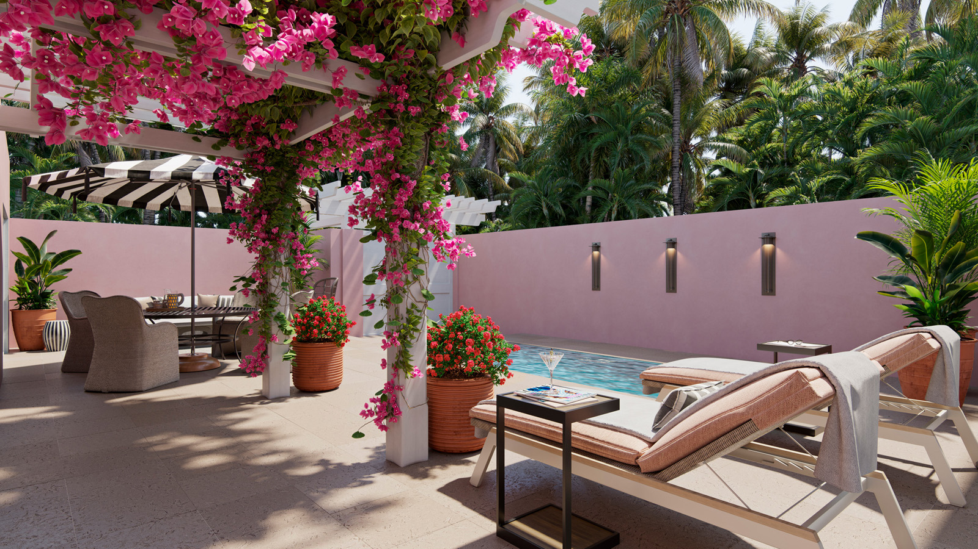 | December 18, 2019, Paradise Island, Bahamas  Unveiling New Two-Bedroom Plunge Pool Villas: The Ocean Club, A Four Seasons Resort, Creates the Ideal Haven for a Retreat to The Bahamas  https://publish.url/oceanclub/hotel-news/2019/new-two-bedroom-plunge-pool-villas.html

PRESS CONTACTS

Viktoria Riley
Director of Marketing
777 Yamato Road, Suite 502
Boca Raton
USA
viktoria.riley@fourseasons.com

+1 561 931 0610

