Celebrate Dad This Father's Day At Four Seasons Hotel St. Louis

An exclusive brunch, hot stone massage and poolside relaxation are the ultimate ways to spoil dad
May 31, 2019, St. Louis, U.S.A.

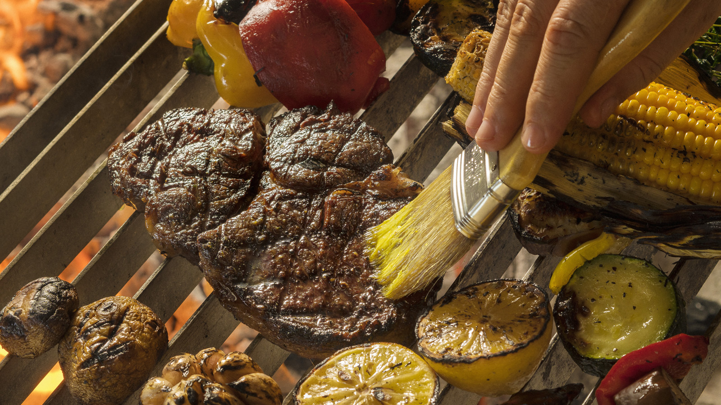
What do you get the man who has everything? Think beyond the traditional tie or latest golf gadget and gift dad with an experience that can only be found at Four Seasons Hotel St. Louis.
Cinder House Restaurant is teaming up with local favorites Pappy’s Smokehouse and Schlafly beer to offer a tap-takeover and extensive brunch buffet that will include the following action stations:
Pappy’s famous ribs – dry-rubbed and slow smoked over apple and cherry wood
- A pig roast and whole-roasted chicken, served with five housemade sauces (chimichurri, hollandaise, aji amarillo, mole and horseradish sauce)
- Ceviche, a selection of the traditional fish dish, cooked in acid and seasoned with fresh herbs and South American spices
- Roasted seasonal local vegetables, cooked over an open flame
- Traditional breakfast items including eggs, bacon, breakfast potatoes and more
- Made-to-order omelette and egg station
- Fresh fruit and a variety of salads
The only thing better than drinking a beer, is drinking a beer with dad. Local craft brewery and a St. Louis favorite, Schlafly will be providing a tap takeover with a Pale Ale, White Lager, Summer Lager and IPA – all available for USD 3 dollar pints at the Cinder House outdoor rooftop bar.
Father’s Day Brunch is available from 10 a.m. through 3 p.m. on Sunday, June 16th. Reservations are USD 54 per adult, USD 25 per child plus tax and gratuity. Children under age four are complimentary and valet parking is included. Limited seating is available. Please contact Cinder House at 314-881-5759 for reservations.
To help dad completely unwind, treat him to a Father’s Day Massage at the Spa where he can enjoy a 50 minute warm stone massage, classic rock playlist (music selection) and a glass of scotch on the rocks for USD 195, during the entire month of June. For bookings and availability call 314-881-5758 or view online.
Extend the relaxation and celebration with an overnight stay. Schedule some time in the sun on Sky Terrace, where dad can relax high above the St. Louis skyline. Lounging by the pool is complimentary and available for overnight hotel guests. Contact the hotel at 314-881-5800 or book an overnight stay online.

RELATED

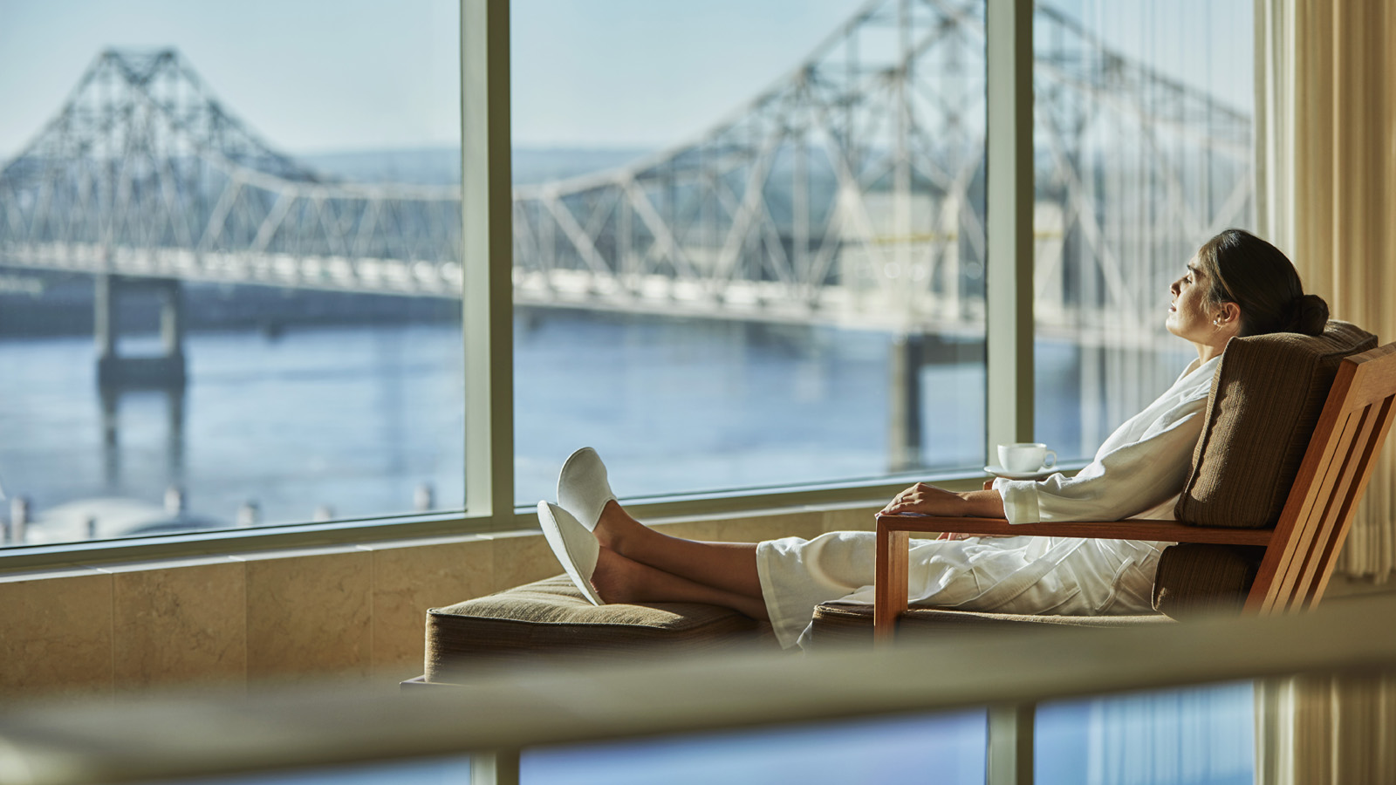 | April 25, 2019, St. Louis, U.S.A.  Treat Mom to the Best: A Mother’s Day Celebration at Four Seasons Hotel St. Louis  https://publish.url/stlouis/hotel-news/2019/mothers-day.html
March 25, 2019, St. Louis, U.S.A.
Spring into Easter with a Bountiful Brunch at Cinder House at Four Seasons Hotel St. Louis
https://publish.url/stlouis/hotel-news/2019/easter.html

PRESS CONTACTS

Chloe Caylor
Director of Public Relations and Communications
999 North 2nd Street
St Louis
USA
Chloe.Caylor@fourseasons.com

+1 (314) 881-2021

