Introducing the Wellness Floor at One Dalton

June 12, 2019, Boston One Dalton, U.S.A.

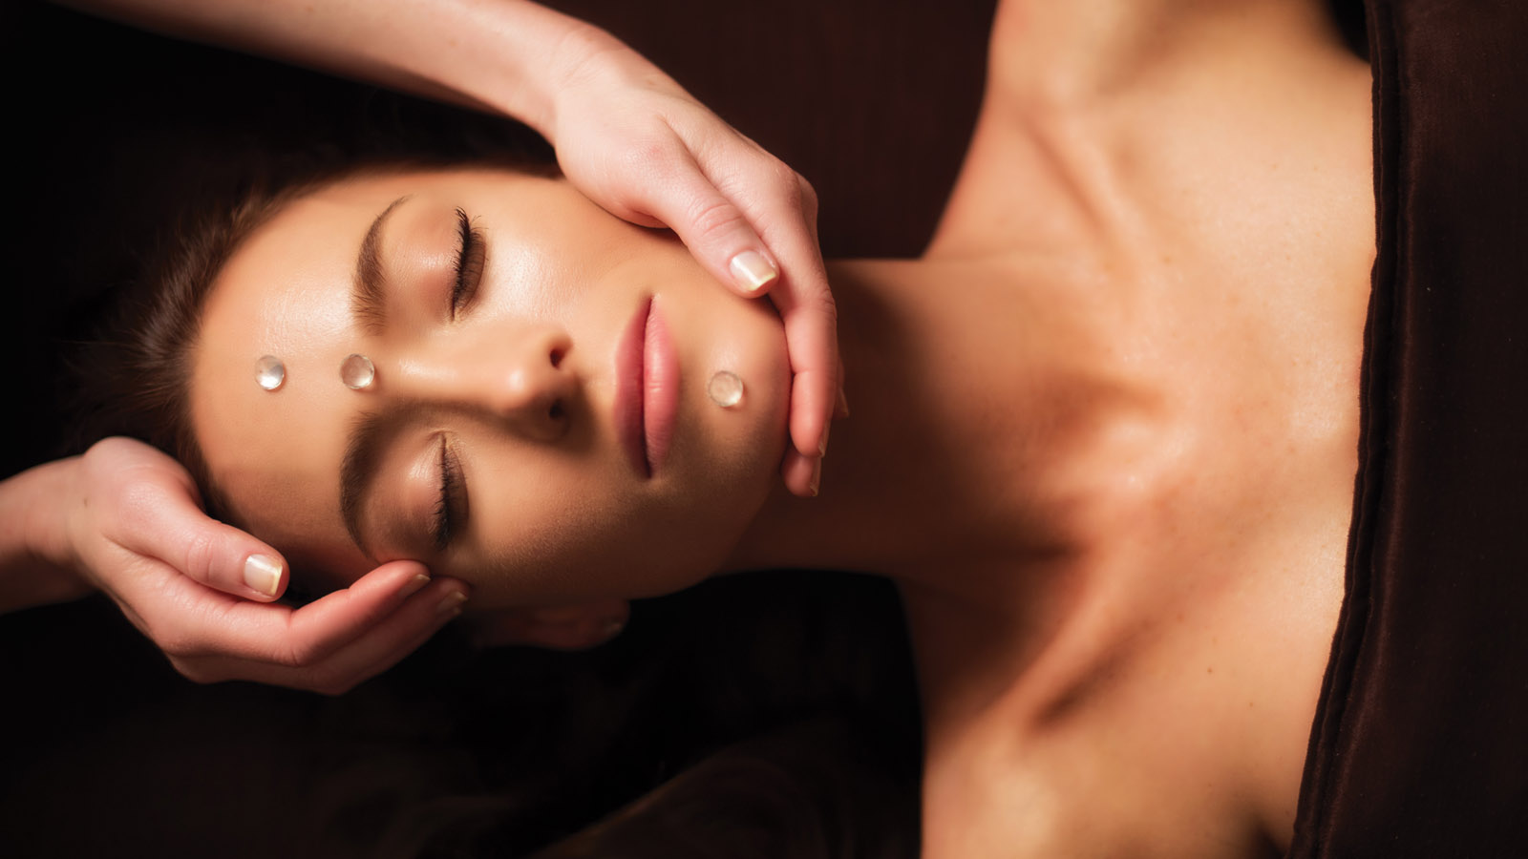
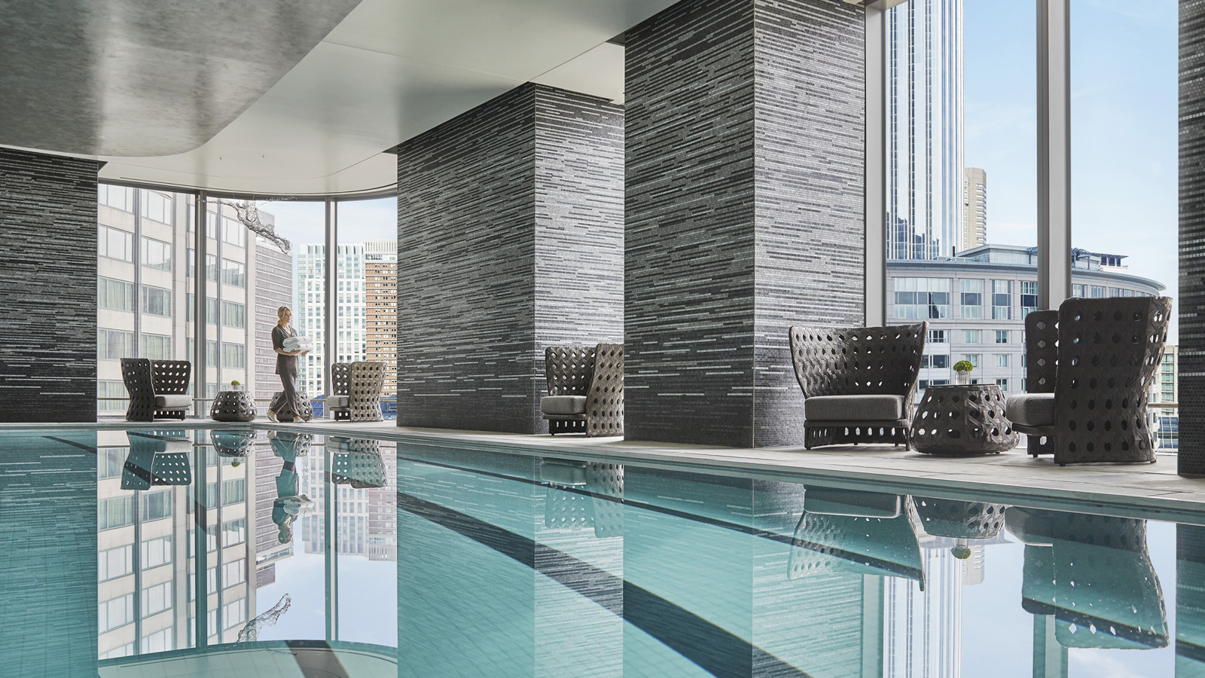
Demonstrating a dedicated approach to holistic wellbeing, Four Seasons Hotel One Dalton Street, Boston introduces The Wellness Floor at One Dalton, offering guests the perfect environment to focus upon rebalancing both body and mind.
The carefully designed menu of spa therapies are skillfully delivered from the sanctuary of five tranquil treatment rooms. Customised wellness journeys are created by an expert team of therapists and aestheticians, harnessing a range of innovative, results-driven beauty brands.
The Wellness Floor at One Dalton also boasts a state-of-the-art fitness centre, utilising the latest Precor equipment chosen by celebrity trainer and Four Seasons Global Fitness Advisor Harley Pasternak. Guests can also exercise in a stunning 64-foot (20 metre) lap pool, which arcs along the building’s curved windows. Tasteful loungers and chairs are positioned all around for relaxation and taking in the city views below.
A comprehensive, well considered range of facial treatments on offer at The Wellness Floor are designed to restore, revitalise and repair all skin types. By harnessing clinically-inspired brands such as 111Skin, as well as the natural and organic range of Alexandra Soveral, The Wellness Floor demonstrates its well-balanced use of international beauty products, which are also available for retail purchase.
Already a firm favourite among regular guests to The Wellness Floor, the Celestial Black Diamond Antioxidant Facial utilises Harley Street, London-based 111Skin to target stubborn signs of aging. This facial is formulated to stimulate collagen production, nourish the skin to minimise fine lines, wrinkles, and pigmentation, and protect against environmental pollutants. In addition to partnering with top international brands, the use of the latest technology is evident through the Cryotherapy Energy Facial, which utilises cold air therapy techniques to encourage a fresher, more youthful look, leaving the skin feeling tight and firm right away without down-time.
A wide range of massages are on offer, with expert therapists curating an experience for every guest’s unique requirements. The Wellness Floor’s beautifully appointed couple’s suite enables guests to book Love Alchemy, and enjoy a side-by-side massage with their loved one. Each guest selects an essential oil to support their personal needs or desired benefits. The two oils will be blended to create a harmonious and memorable massage experience for a couple.
The Wellness Floor at One Dalton adopts a thoughtful approach to the needs of guests with busy schedules. Offering shorter experiences that can be integrated into a demanding travel itinerary, The Express Massage at just 25 minutes is an ideal way to prepare for a busy day or wind down from a hectic one. This massage will help guests escape for a few moments to decompress and refresh.
The team of professionals at The Wellness Floor are passionate about combining treatments for both body and mind, in the crafting of wellness experiences for guests. Perfect as a complement to any treatment, Meditation 22 relaxes and rejuvenates in just 30 minutes through the application of warm and cold touches accompanied by a meditative piano soundtrack that has been especially composed to induce deep relaxation.
To book your wellness experience, contact +1 617 936 4703 or email spa.onedalton@fourseasons.com

RELATED

April 28, 2021, Boston One Dalton, U.S.A.
Four Seasons Hotel One Dalton Street, Boston Launches a Dedicated College Campus Experience
https://publish.url/onedalton/hotel-news/2021/college-campus-experience.html

April 21, 2021, Boston One Dalton, U.S.A.
Celebrate Mom This Mother’s Day at Four Seasons Hotel One Dalton Street, Boston
https://publish.url/onedalton/hotel-news/2021/mothers-day.html

PRESS CONTACTS

Kristi Blake
Senior Public Relations Director
1 Dalton Street
Boston
USA
kristi.blake@fourseasons.com

+1 646 757 0115

Katie Eldemery
Digital Marketing Coordinator
1 Dalton Street
Boston
USA
katie.eldemery@fourseasons.com

