Four Seasons Hotel Boston Announces New Offer to "Work from the Public Garden" at the Luxurious Five-Star Hotel

The new daytime offer invites guests to enjoy a change of scenery for their work day at the storied Five-Star hotel
October 29, 2020, Boston, U.S.A.

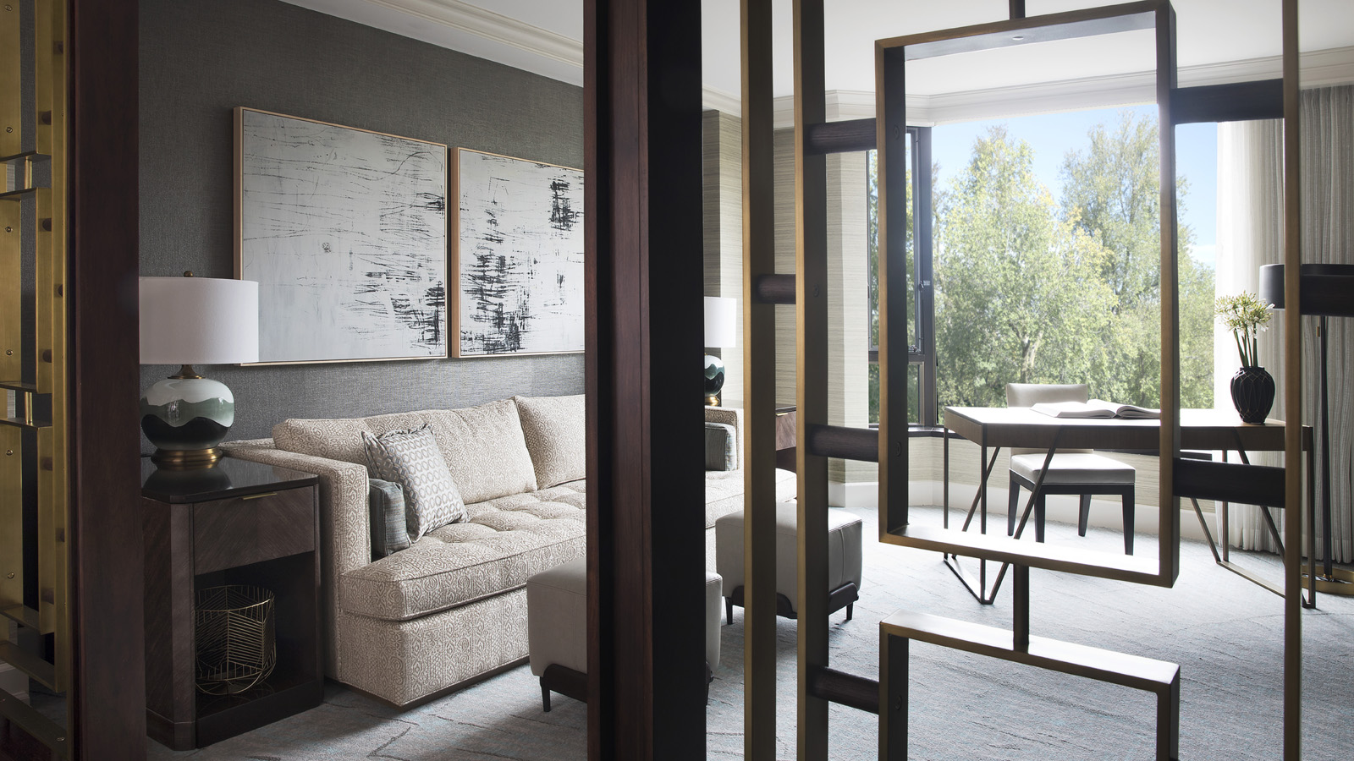
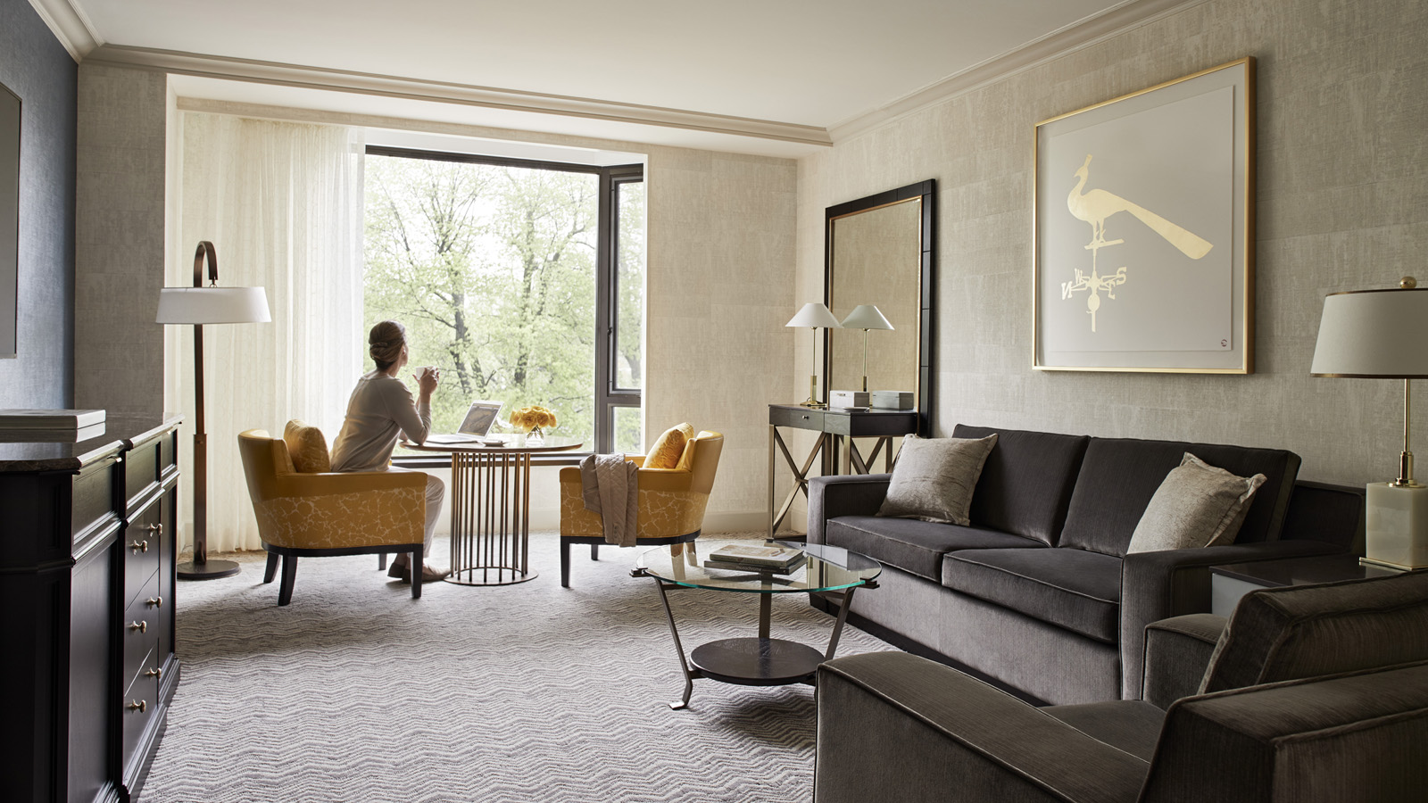 |  | 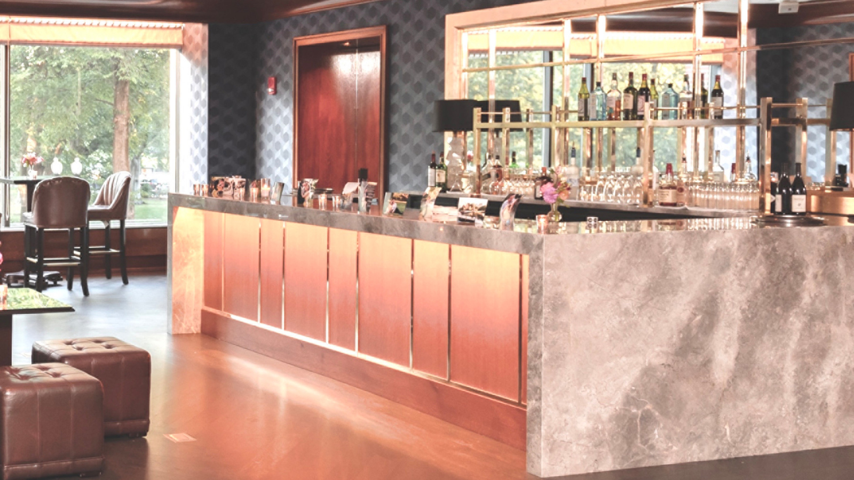
Four Seasons Hotel Boston announces a new offer to elevate guests’ “work from home” experience. With an unmatched setting overlooking the flourishing Boston Public Garden, a glass-enclosed indoor pool, and tempting add-ons to enhance the experience, the legendary Hotel is the perfect oasis to indulge in a change of view for the work day.
The Work from the Public Garden Day Package is USD 395 and offers the following inclusions:
- A luxurious guest room from 9:00 am to 6:00 pm
- Premium Wi-Fi and a high-speed printer, with IT support readily available upon request
- Complimentary artisanal coffee upon arrival, and complimentary snacks in the room
- Access to the indoor swimming pool and fitness centre
- In-Room Dining lunch credit*
- A credit to the Hotel’s lounge for a post-work drink or appetiser*
- Complimentary valet parking
- An option to extend the experience with a dining reservation nearby while Four Seasons holds the guest's car and briefcase
To learn more about this exciting new offer and reserve a private office, call the Hotel at 617 338 4400.

*Note the credit for In-Room Dining lunch is USD 45 and the Hotel lounge drink or appetiser is USD 25. Charges beyond these credits will be applied at check-out.

RELATED

October 20, 2020, Boston, U.S.A.
Celebrate Thanksgiving with Four Seasons Hotel Boston
https://publish.url/boston/hotel-news/2020/thanksgiving.html

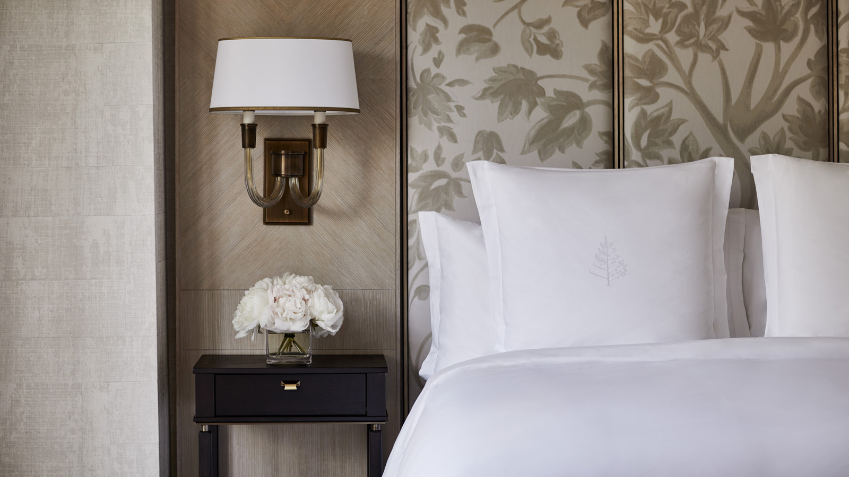 | September 4, 2020, Boston, U.S.A.  Four Seasons Hotel Boston Earns Five Stars in Forbes Travel Guide’s 2021 Star Awards  https://publish.url/boston/hotel-news/2020/forbes-five-star-hotel-2021.html

PRESS CONTACTS

Maggie Lawler
Director of Public Relations and Communications
200 Boylston Street
Boston
USA
maggie.lawler@fourseasons.com

+1 617 351 2161

