A Summer of Sea: Four Seasons Hotel Westlake Village Teams Up with Surf Icon Mary Osborne

Ocean-inspired packages launch at the newly transformed coastal California hotel
June 22, 2021, Los Angeles, Westlake Village, U.S.A.

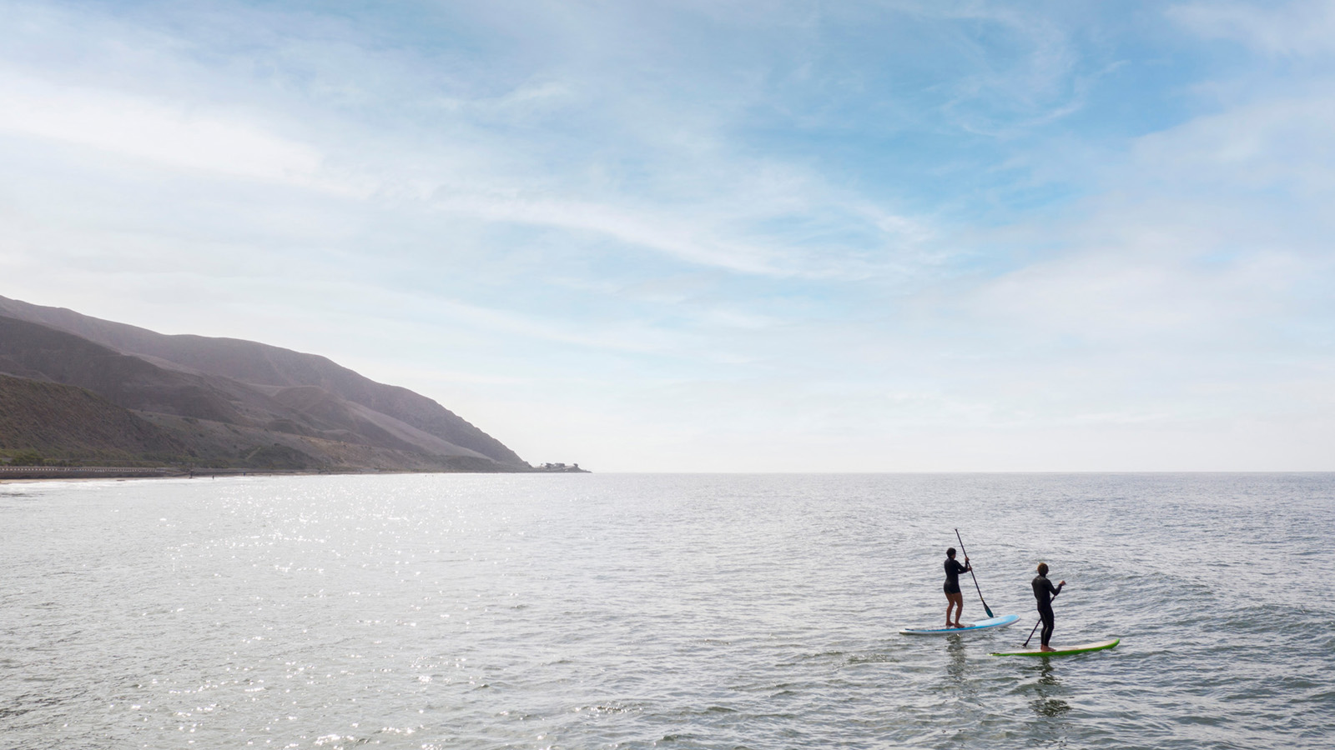 | 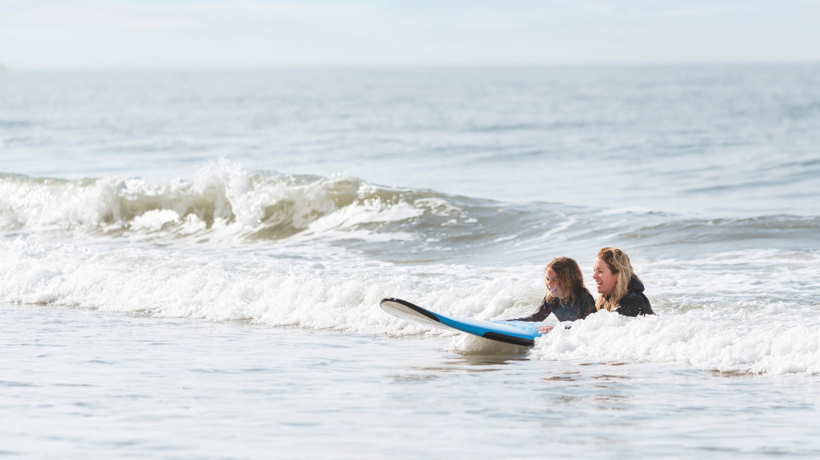
Surf’s up at Four Seasons Hotel Westlake Village, as the AAA Five-Diamond property launches offshore excursions for those seeking activities synonymous with a SoCal summer.
Beginning June 2021, the newly transformed urban retreat Hotel launches its partnership with legend Mary Osborne, bringing guests immersive experiences showcasing the Golden State’s rich surf culture. From one-on-one surf lessons and access to private waves, to stand-up paddle board excursions through sun-kissed harbours, to lesser known, locals only hangouts in the region’s laid back beach towns, summer awaits!
Break for the Beach – Private Surf Package
Travellers of all ages and levels can dive into the adventure of learning to ride a wave. For beginners, this half-day experience takes place on Solimar Beach, offering a picturesque backdrop mixed with the approachability and relaxed environment of this quiet beach community. Intermediate surfers can discover the understated enclaves of Malibu, where some of the most coveted beachfront neighbourhoods are also home to the most ultra-exclusive waves. Price per person USD 250.
The Break for the Beach Package includes:

RELATED

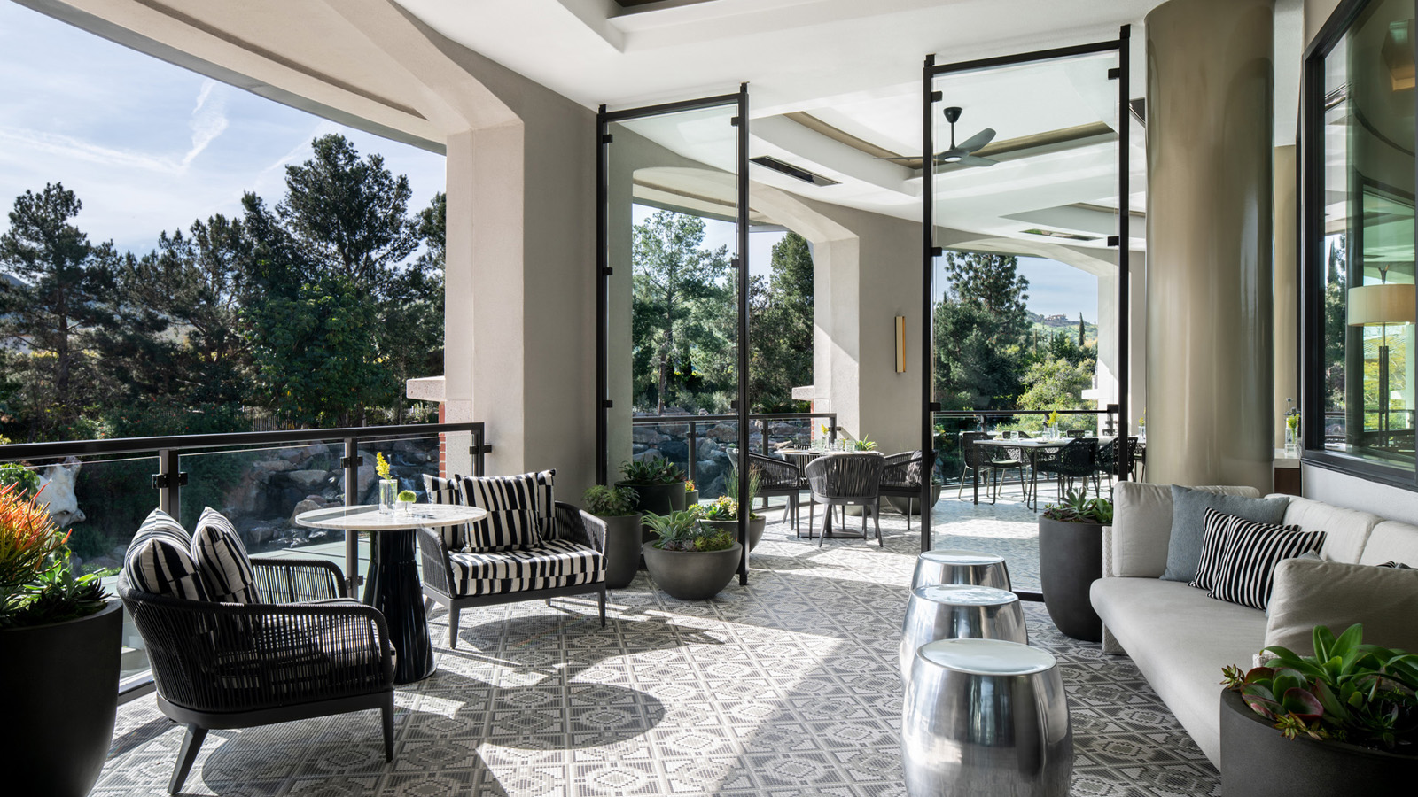 | April 22, 2021, Los Angeles, Westlake Village, U.S.A.  Ingredients for Authenticity: Coin & Candor, the California Brasserie Inside Four Seasons Hotel Westlake Village, Turns Two  https://publish.url/westlakevillage/hotel-news/2021/coin-and-candor-anniversary.html
April 16, 2021, Los Angeles, Westlake Village, U.S.A.
Four Seasons Hotel Westlake Village Presents 5 Ways to Make Mom Smile This Mother’s Day
https://publish.url/westlakevillage/hotel-news/2021/mothers-day.html

PRESS CONTACTS

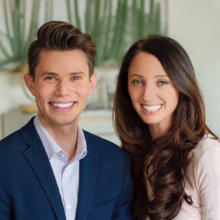 | Jacqueline Kerns and Harley Potter  Public Relations & Communications Team  Two Dole Drive  Westlake Village  USA  publicrelations.westlakevillage@fourseasons.com  +1 818 575 3089

