“Lady Love” Uses Island Charm to Help Couples Create Romantic Memories at Four Seasons Resort Anguilla

February 24, 2020, Anguilla, West Indies

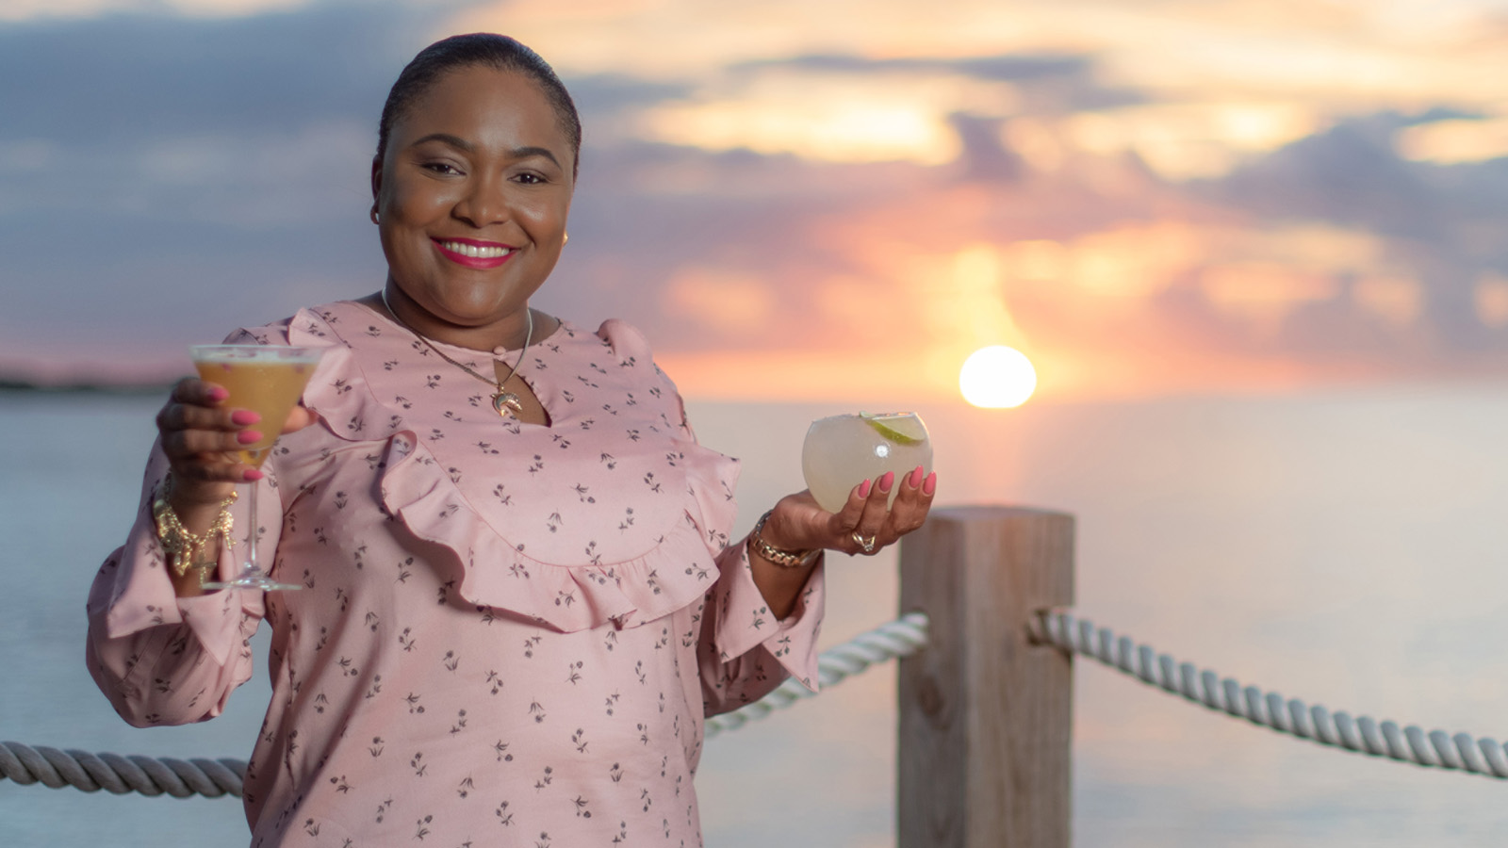
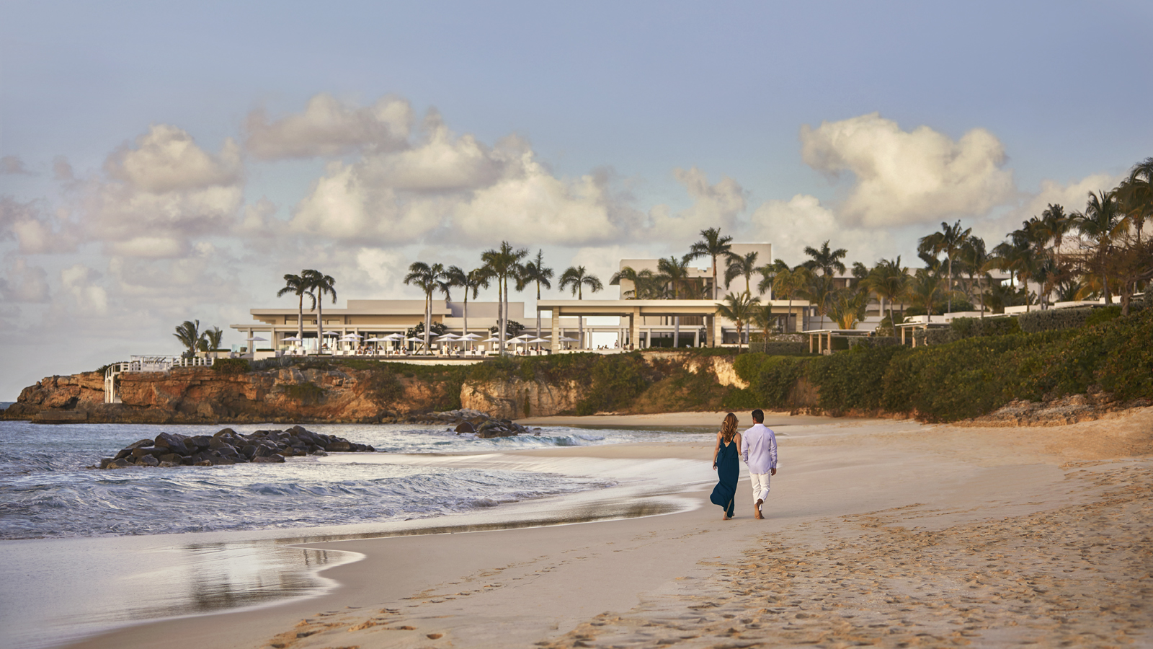 | 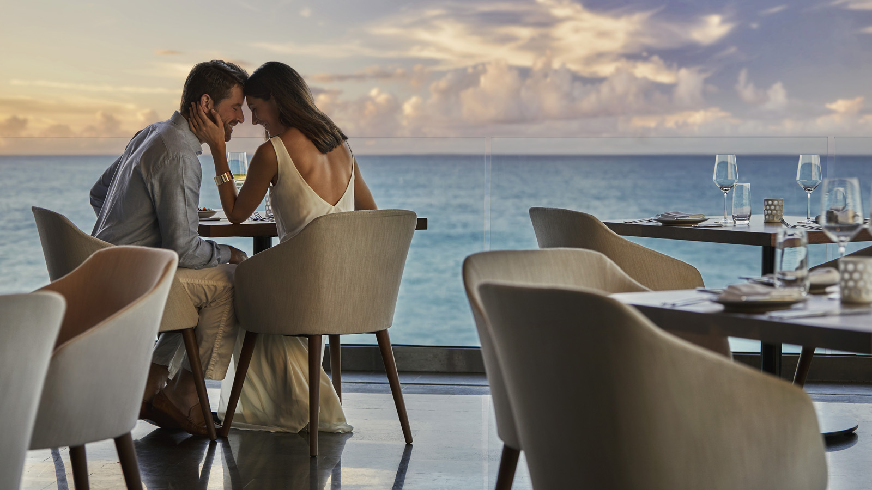 | 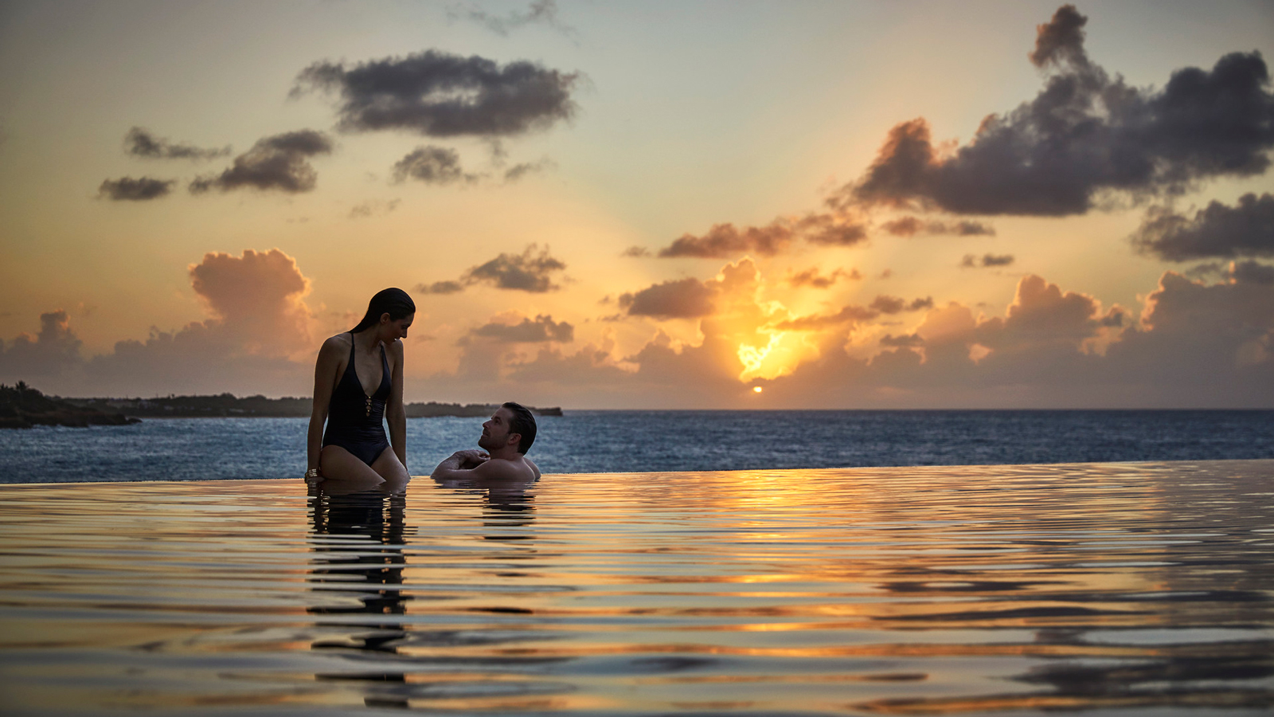
When it comes to romance at Four Seasons Resort and Residences Anguilla, Melisha MacCow-Niles has helped hundreds of couples propose, say their “I dos” and rekindle love. While her official title is Conference Services Manager, this Anguilla native has become known as “Lady Love” by guests because of her ability to foster loving relationships.
Four Seasons Resort Anguilla is an esteemed Caribbean resort known as an ideal destination wedding and honeymoon location. Set atop a bluff overlooking two stunning turquoise bays and sandy white beaches, couples find myriad reasons to celebrate romantic milestones here. Lady Love just makes it easier for them by taking the natural ambiance and collaborating with the couples to set the perfect stage. She thinks of ways to enhance each experience and works with in-house specialists and local vendors to bring their dreams to life. From private yachts to secluded beaches; island entertainers to videographers; rose petals to exotic orchids; Lady Love brings all the parts together to create something unique for each celebration.
One routine she recently incorporated into her initial, in-person consult, and before a wedding, is to begin with an island elixir that she calls her Passionate. This beverage includes fresh Anguilla ingredients believed to bring good luck and love to those who drink it.
Special Packages for Couples
The Anguilla Love is a three-night package and includes:
- Daily breakfast for two
- Spa credit of USD 200
- Luxury pool cabana
The package is available until December 18, 2020.
For those wishing to have their wedding at Four Seasons Anguilla will find a variety of options to create the perfect celebration including:
- Love is Simply Beautiful
- Elegance of a Vow
- Anguilla True Blue
- Romance in Paradise
An incentive to host a wedding at Four Seasons Anguilla includes an offer to return the following year for a complimentary five-night stay, dinner for two and celebratory bottle of champagne.
- Suite Returns
While many island destinations feature cruise ship docks and fast-food chains, Anguilla doesn’t offer either and instead focuses on natural beauty and exceptional, stand-alone restaurants. With more than 33 beaches and 100 restaurants on the 16-mile (26 kilometre) long island of Anguilla, couples find plenty of options for laid-back luxury.

RELATED

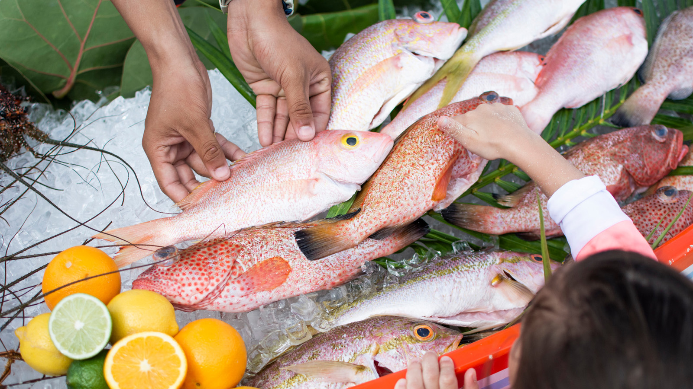 | February 11, 2020, Anguilla, West Indies  New “Take Your Time” Offerings Provide Enriching Travel Experiences at Four Seasons Resort and Residences Anguilla  https://publish.url/anguilla/hotel-news/2020/take-your-time.html
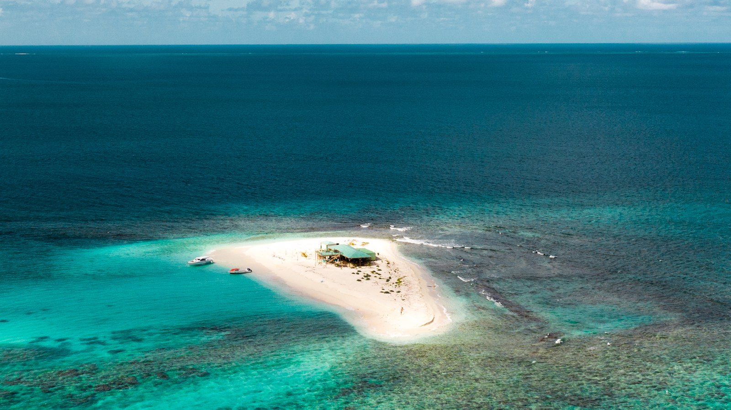 | January 22, 2020, Anguilla, West Indies  Own a Resort and an Island? Yes! “Exclusively Yours” Package Includes a Total Buyout of Award-Winning Four Seasons Resort Anguilla and Nearby Sandy Island  https://publish.url/anguilla/hotel-news/2020/resort-and-island-buyout-package.html

PRESS CONTACTS

Suzanne Willis
Director of Public Relations and Communications
Barnes Bay, P.O. Box 8028
West End
Anguilla
suzanne.willis@fourseasons.com

+1 (239) 287-7070

