Four Seasons Takes Legendary Service to the Roadways of Europe with Beyond by Four Seasons, An Exclusive Driving Journey Through Tuscany

Car enthusiasts are invited to enjoy the splendours of Italy with a customized week-long itinerary unlocking scenic drives, world-class cuisine, and insider access to Tuscany's celebrated sites
April 1, 2022, Toronto, Canada

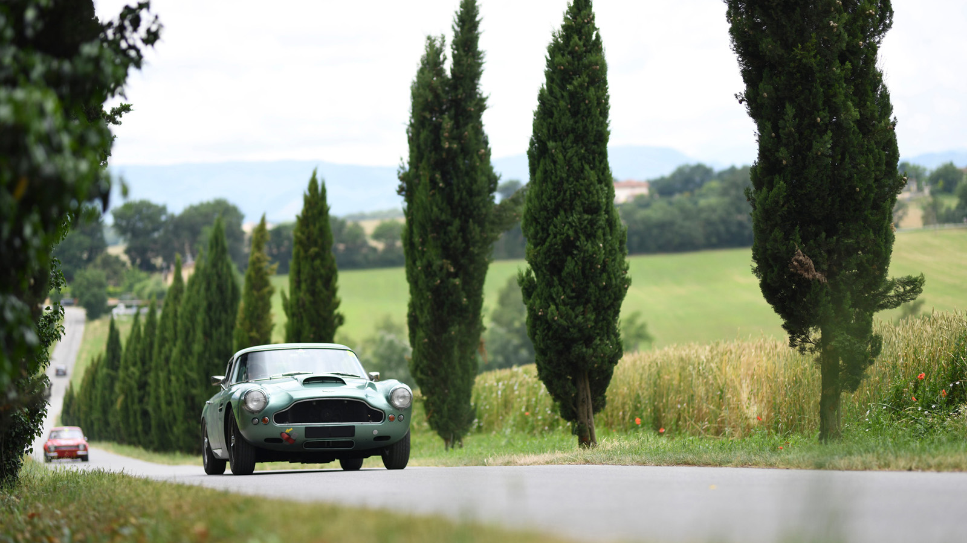
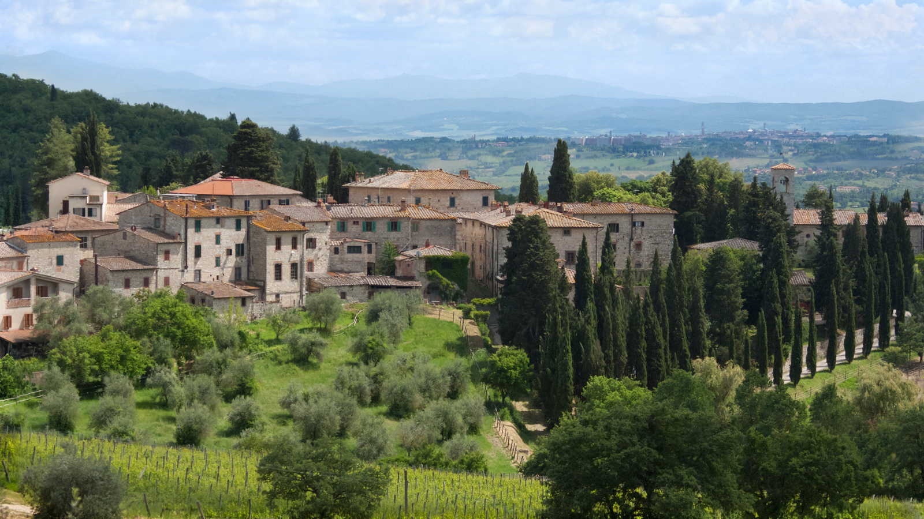 | 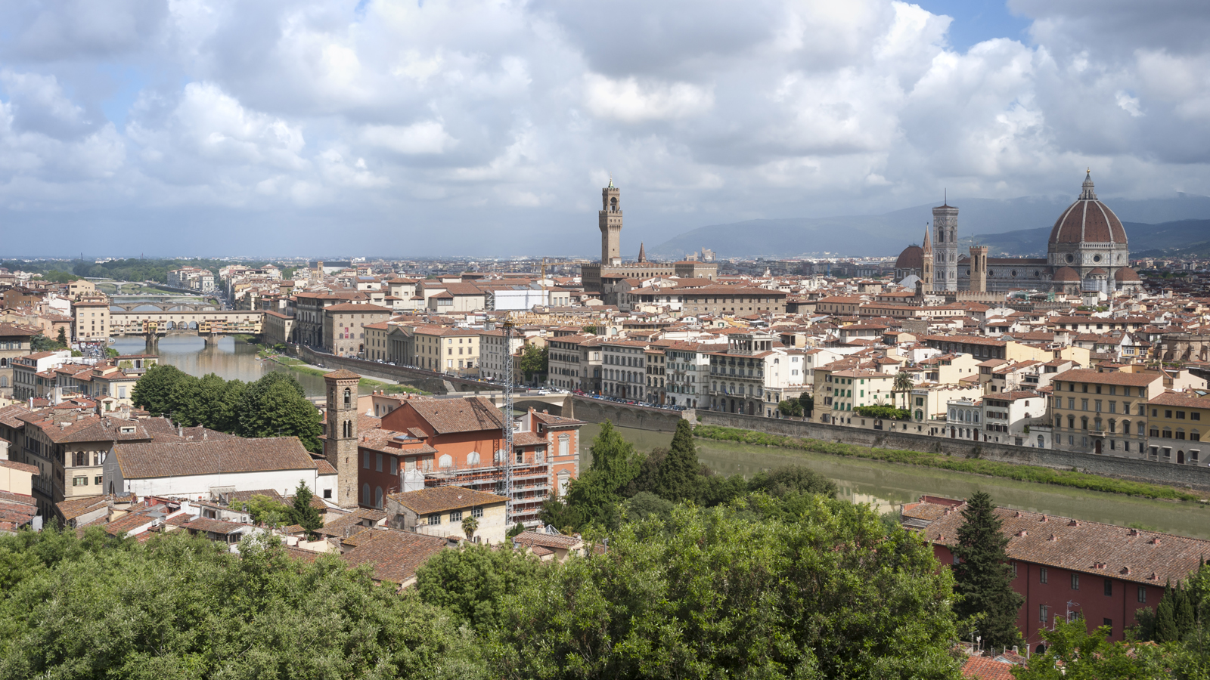 | 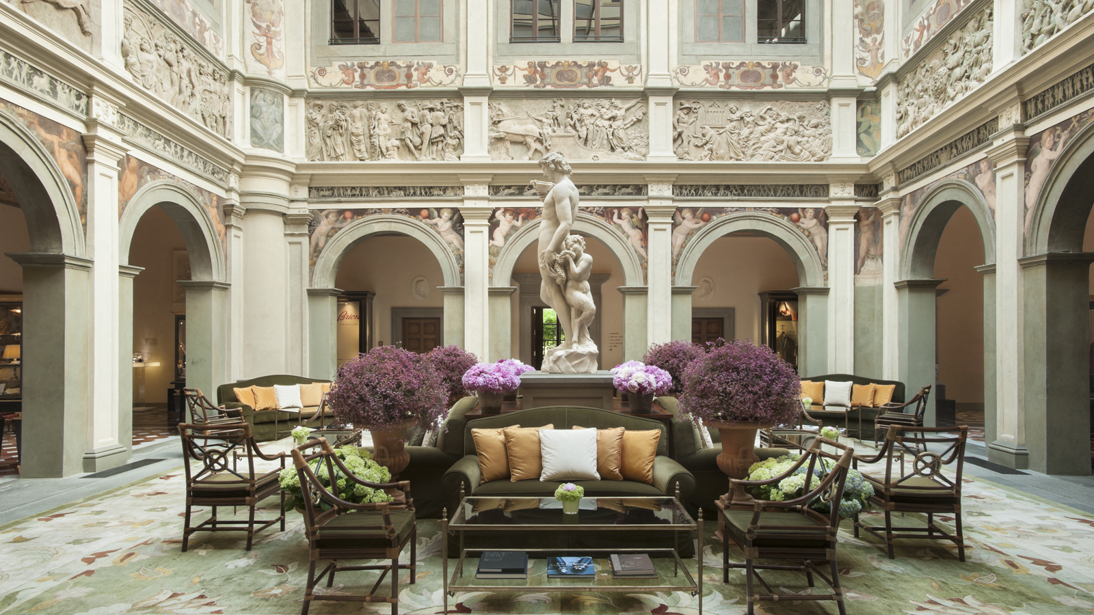
Four Seasons Hotels and Resorts, one of the world’s leading luxury hospitality companies, today unveils Beyond by Four Seasons, An Exclusive Driving Journey Through Tuscany, a week-long curated drive experience designed to showcase the best of the Italian countryside by luxury car. From September 24 to 30, 2022, the brand’s first-of-its-kind journey from behind the wheel explores captivating landscapes, special access to must-see sites, and remarkable culinary offerings, with Four Seasons Hotel Firenze as a home base.
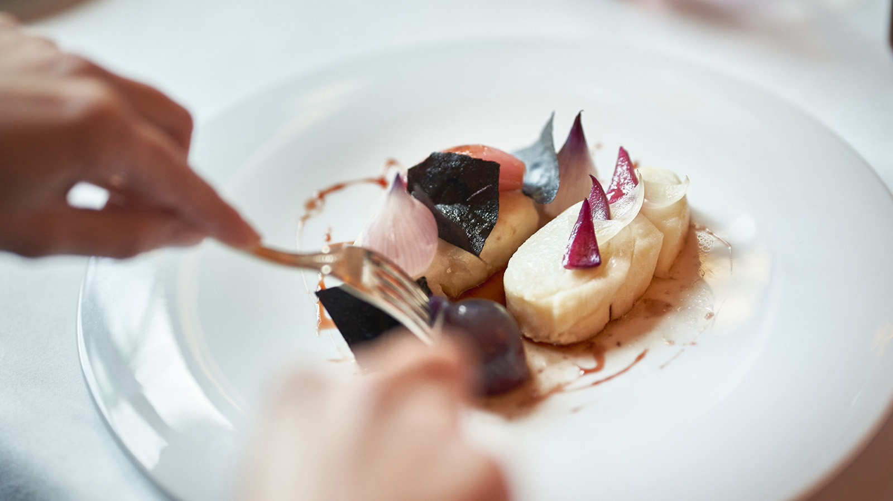 |  | 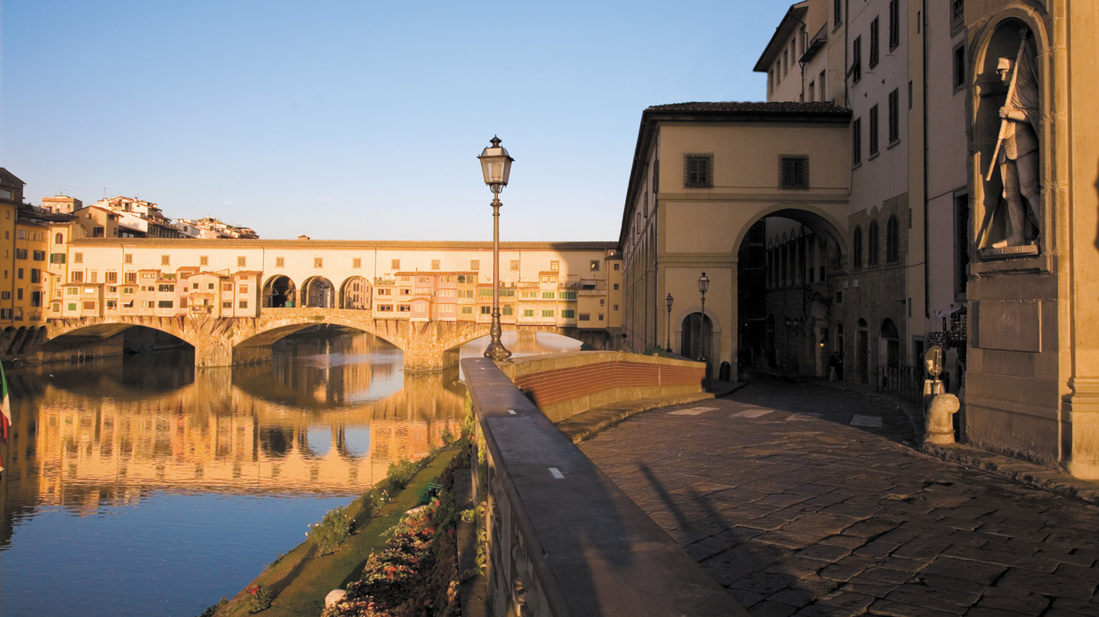
Working in collaboration with leader in lifestyle driving experiences Canossa Events, as well as the city of Florence, travellers are invited to meet in the Tuscan capital and enjoy an Italian escape from the comfort of their own vehicle or a vintage classic or luxury sportscar arranged by a dedicated guest services team. Every step of the guest journey – from the accommodations and daily activities to the exclusively curated drives and local recommendations – is thoughtfully managed with the attention to detail and genuine service for which Four Seasons is renowned.
“The guest experience is at the heart of everything we do, inspiring our teams to innovate and elevate each new Four Seasons offering,” says Christian Clerc, President – Hotels and Resorts. “We came together with Canossa Events to create something truly spectacular for our guests – an ultra-luxury drive adventure where the journey is to be enjoyed just as much as the destination. Against the backdrop of the Tuscan countryside, punctuated by the region’s best wine and culinary offerings, and delivered by our talented and caring craftspeople, Beyond by Four Seasons sets a new standard for luxury road travel.”
The inaugural Tuscan driving journey will debut with an al fresco welcome dinner in the Faggio Garden at Four Seasons Hotel Firenze, launching a week’s worth of discovery. In the days that follow, guests will explore the vineyards of “Chiantishire” with a private tour and wine tasting at the historic Antinori Cellars; drive the colourful landscapes of Siena, enjoying lunch under the storied arcades of the Montalcino City Hall; and journey through idyllic seaside towns and the famous green cypresses of Bolgheri to the famed vineyards of Ornellaia.
“Creating memorable events and unforgettable celebrations centred around a love for cars is what we do best,” says Luigi Orlandini, Chairman and CEO, Canossa Events. “Partnering with Four Seasons, we have designed an incredibly unique offering, allowing guests to enjoy every special moment spent on the road and inspiring them to immerse themselves in the splendours of all that Tuscany can offer.”
While exploring locally, guests will be granted private entry to venues normally closed to the public, indulging in a memorable Florentine dining experience as well as an unforgettable evening at the Opera. Programming also features built-in time to rest and recharge, offering guests a chance to explore the grounds of Four Seasons Hotel Firenze, their home away from home, relaxing amid the city’s largest private garden, by the pool or with a rejuvenating spa treatment.
“Working with Four Seasons and Canossa Events, it is an honour to shine a spotlight on our beautiful capital city and the scenic roads of Tuscany,” says Dario Nardella, Mayor, Florence, Italy. “Our unique collaboration gives travellers a rare view of the region’s must-see sites, hidden routes, and best-kept secrets – the makings of an incredibly memorable Italian holiday.”
Whether guests are on property or en route, a dedicated guest services team ensures seamless delivery and exceptional service at every touchpoint, allowing travellers to focus on the true charm and romance of road travel.
“Beyond by Four Seasons is a testament to our continued focus on gaining deeper insights that inspire and enhance the guest experience,” says Marc Speichert, Chief Commercial Officer, Four Seasons Hotels and Resorts. “By designing programs influenced by the passions and preferences of Four Seasons travellers, our guests become the authors of how they connect with our brand. Championing a guest-centric approach in all that we do remains our priority as we look to the future and the myriad opportunities ahead.”
With a luxury lifestyle offering that spans a bespoke Private Jet; a growing collection of luxury villa and vacation home rentals; a line of curated home and travel goods; and a global portfolio of Private Residences, Four Seasons now brings its expertise to the road, tapping into its extensive network of local artisans and experts to elevate every mile.
Booking Information
As space is limited, travellers interested in finding out more about Beyond by Four Seasons, An Exclusive Driving Journey Through Tuscany are invited to click here for additional booking details or or email beyond@fourseasons.com. Reservations can also be made by phone at +39 0522 421096 (Italy) or +1 831 521 5190 (US).
Health and Safety
Guests can take comfort in the peace of mind that comes with travelling with Four Seasons. In partnership with Canossa Events, a leader in lifestyle driving experiences, and in adherence with Four Seasons global health and safety program Lead With Care, Four Seasons works closely with leading medical experts to enhance the health, wellbeing and safety of every guest and employee. Throughout their stay, guests are invited to use the Four Seasons App for contactless communication with Four Seasons people at any time, 24 hours a day.
About Canossa Events
Canossa Events was formed in 2010 and is synonymous with excellence in road touring events. The company organizes almost 300 events a year, including the legendary Modena Cento Ore that cuts a swath across the stunning scenery of Italy also featuring races in some of the most famous circuits. Canossa is best known for its classic car rallies and its supercar motor touring events that blend exotic collectable cars, world-class hospitality and road adventures set in some of the world’s most picturesque landscapes across Europe, the US and the Middle East. The Canossa family also includes Cavallino, publisher of the famous eponymous magazine since 1978 and organizer of the world’s most important Concorso d’Eleganza devoted entirely to Ferrari. Since 2019 Canossa is part of Motorsport Network.

RELATED

March 31, 2022, Toronto, Canada
Four Seasons porta l’eccellenza del servizio sulle strade d'Europa con Beyond by Four Seasons, An Exclusive Driving Journey Through Tuscany
https://publish.url/news-releases/2022/beyondtuscany-2.html

March 1, 2022, Florence, Italy
The Spa al Four Seasons Hotel Firenze presenta Hydrafacial, il trattamento viso amato dalle star
https://publish.url/it/florence/hotel-news/2022/hydrafacial-at-the-spa-2.html

PRESS CONTACTS

Sarah Tuite
Vice President, Corporate Public Relations
1165 Leslie Street
Toronto
Canada
prsm@fourseasons.com

+1 416 441 4350

