Discover the "New" New York

August 16, 2016, New York, U.S.A.

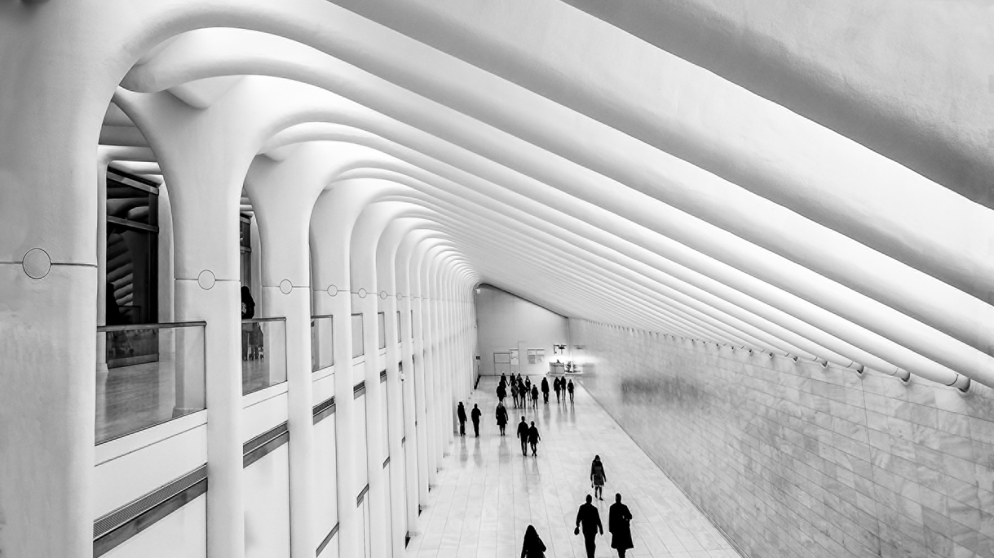
Next time you’re in NYC, you’ll discover something south of 14th Street. Downtown has become the new neighbourhood of places to see and be seen, and there's no need to head to other parts of the city to have fun. The after-hours scene happens right here, from the Meatpacking District to Tribeca and on down.
By day, the transformation is clear, too. Wall Street will always be Wall Street, but what’s different now is the tone. The workers in the lofts or glass towers along Downtown streets come from creative worlds. Advertising, technology start-ups, new media and high-fashion and art magazines. They now stay in Downtown to live, eat and play, as do traveller at the new
Four Seasons
New York Downtown.
A symbol of this change is Oculus, the new WTC transportation hub. Some call its architect Santiago Calatrava neofuturistic, and his winged, sculptural design for Oculus marks a welcoming transformation for the rebirth of Lower Manhattan.
Oculus allows New Yorkers to trip Downtown by transit as never before. Plus, it gives them more reasons to venture Downtown: some of the biggest names in luxury retail will be here. Above it all, the One World Observatory offers a bird’s-eye view of the bold new city unfolding at its feet.
Galleries, boutiques, gastropubs and restaurants still emerge, word-of-mouth style, like hidden gems in Tribeca’s lofts and Soho’s historic cast iron buildings. But the surrounding change is intensifying the attraction of Downtown NYC’s reinvented neighbourhoods. It’s pushing the boundaries of places like the East Village, with speakeasies and clubs popping up on the margins.
Sensing the buzz, museums have moved Downtown. The New Museum soars above the Bowery. The new Whitney Museum in the trend-setting Meatpacking District anchors the steps to the High Line, which has captured the attention of world travellers and NYC denizens. The spirit of renewal is felt throughout Downtown. At the Seaport District on the East River, the historic Fulton Fish Market and fashionable Pier 17 are transforming into a new cultural hub, a place to shop, eat and be entertained.
The next time you’re Downtown, there’ll be something new again. Guaranteed.

RELATED

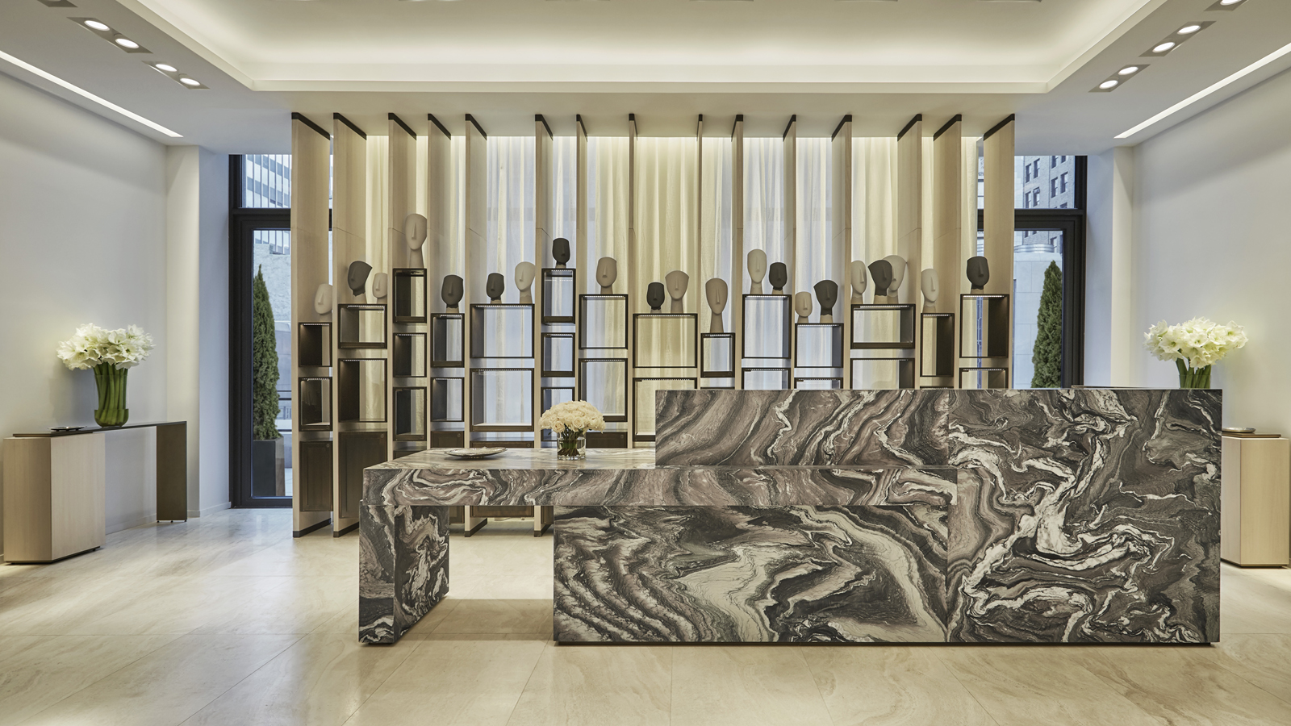 | April 3, 2017, New York, U.S.A.  Four Seasons Hotel New York Downtown Unveils Signature Spa  http://publish.url/newyorkdowntown/hotel-news/2017/spa-now-open.html
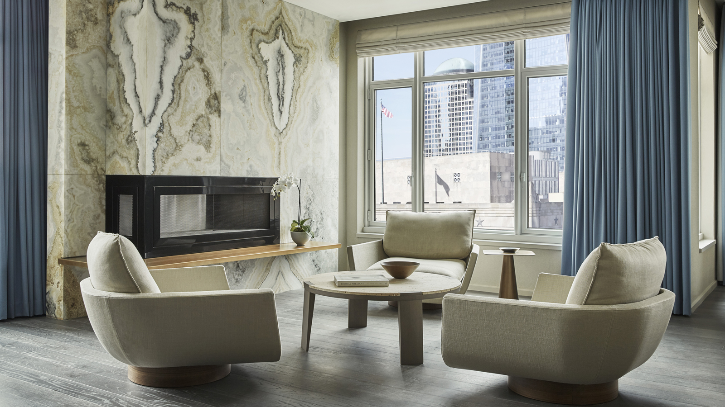 | January 3, 2017, New York, U.S.A.  Luxurious New Specialty Suites Unveiled at Four Seasons Hotel New York Downtown  http://publish.url/newyorkdowntown/hotel-news/2017/luxury-specialty-suites.html

PRESS CONTACTS

Kristi Blake
Director of Public Relations and Communications
27 Barclay Street
New York
U.S.A.
kristi.blake@fourseasons.com

+1 (646) 880-1917

